Magic Quiz Manual
version 1.0

Project Overview
App sources consist of 3 parts (Code classes, Resources, Libraries).
Open project in Xcode and you will see the picture at the left
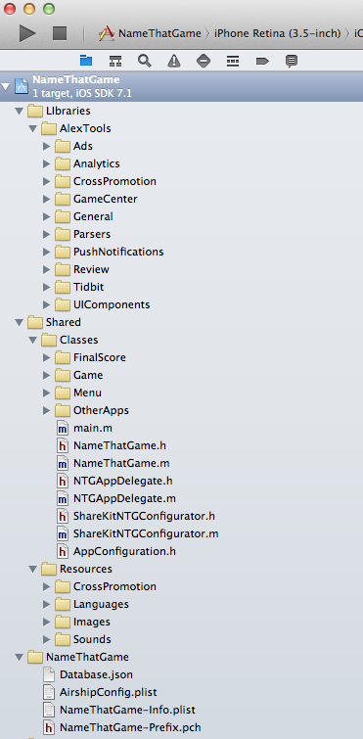
1) Libraries (Different third-party frameworks and base app classes)
Tidbit folder is a place where all quiz engine superclasses are placed
2) Classes - the set of app source code files.
Code files are separated into logical groups (FinalScore, Game, Menu etc)
Menu group is a first game screen. It has 5 buttons and manages with NTGRootViewController class. The buttons are:

- Start Game
- Game Center Leaderboards
- Game Center Achievments
- Sound Control
- More Apps Page

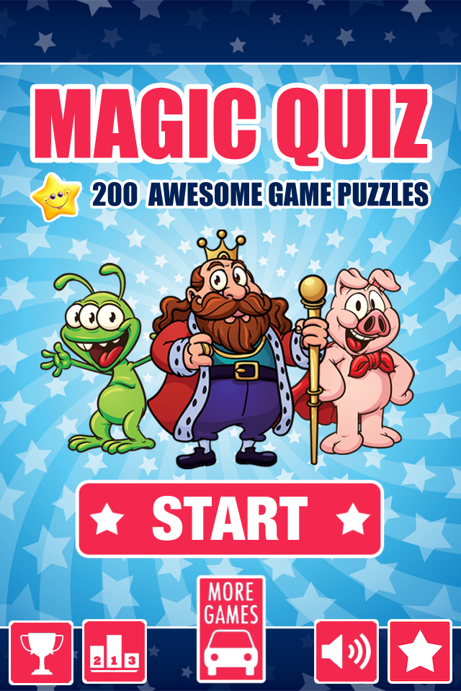
Game Group contains sources for gameplay. It manages with NTGImageGameViewController class
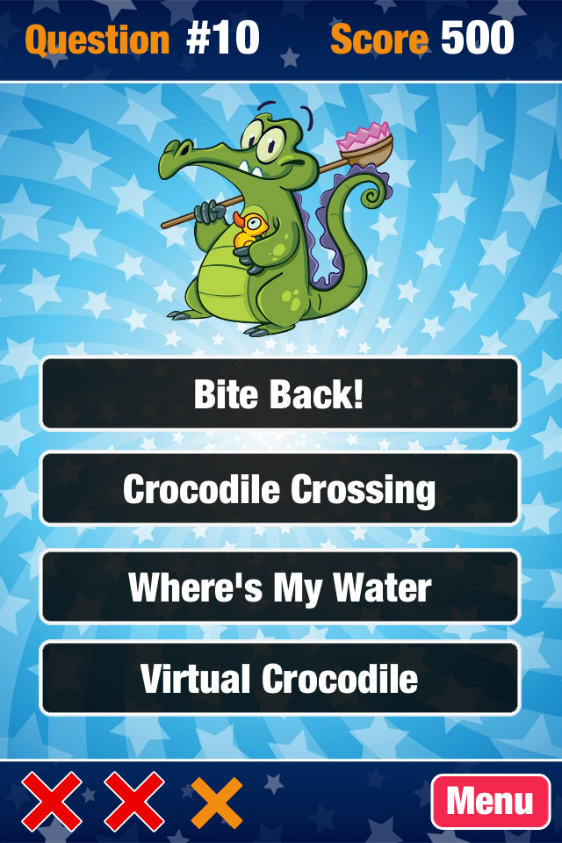
Final Score contains code for the final game screen. It manages with NTGFinalScoreViewController class. Final score depends on correct answers count and time spent on playing game. Each correct answer will give you +100 points. At the game end your scores will be sent to GameCenter
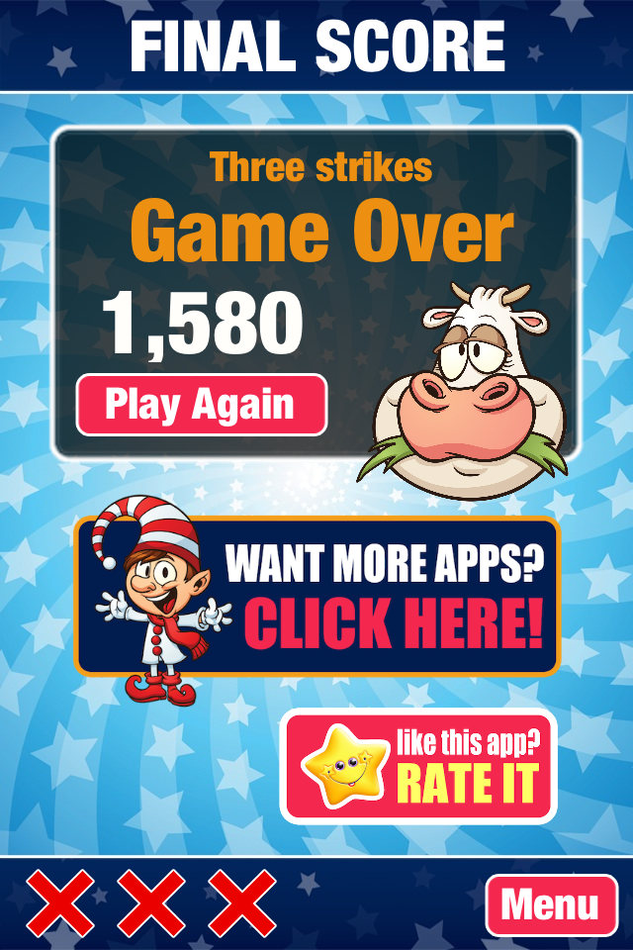
You can find score formula at "viewWillAppear" method. Also you can find 2 buttons (Want more apps and Rate it) here. You need to replace button actions with links to your apps page in appstore and page for leaving review.

3) Resources (Images, Sounds, Localization files etc)

Database File
Database file is in JSON format. You can edit it with xCode or simple text editor.
Root element is "questions" which is array of dictionaries. For example first element is
{
"id": "0001",
"right": "Angry Birds",
"answers": [
"Angry Birds",
"Zoo Story",
"Wildlings",
"Bubble Birds"
],
"imageUrl": "angrybirds2.png"

},
To add new question you need to set 4 parameters
id - question identifier
right - correct answer
answers - array of answers
imageUrl - picture name to load

Localization
App supports localization to different languages. Localization files are located in Resources - > Languages folder.
To localize file using Interface builder set UILabel or UIButton title to some parameter defined in localization files. For example "_Loc_Final_Score_Title". It should always have _Loc_ prefix to work.
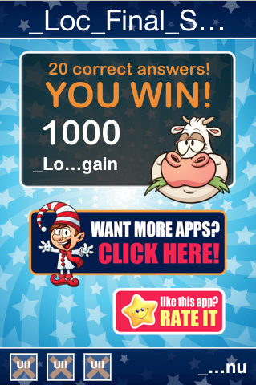
To localize question database you need to create new Database.json file and set answers in different language. Then you need to load it in MagicQuiz - > loadGameData method according localization settings in your iPhone.
NSString *dateFile = @"Database.json";

NSString *lang = [VSUtils getLocalLanguage];
if([lang isEqualToString:@"es"])
{
dateFile = @"Database_es.json";
}

Steps for reskinning
1) Replacing Splash Logo
Navigate to Resources - > Images - > IPhone4 folder and replace 3 files with your company logo ( Default.png, Default@2x.png, Default-568h@2x.png)
Navigate to Resources - > Images - > IPad folder and replace 2 files with your company logo (Default_ipad.png, Default_ipad@2x.png)
2) Replacing GUI images
Navigate to Resources - > Images - > IPhone4 folder and replace all GUI files to yours. You need to make 2 versions of every image file (retina and non-retina)
Navigate to Resources - > Images - > IPad folder and replace all GUI files to yours. You need to make 2 versions of every image file (retina and non-retina)
Navigate to Resources - > Images - > Achievments and replace achievments for sharing in Facebook with your achievments or leave them as they where.
Navigate to Resources - > Images - > Icons and replace 4 icons
Navigate to Resources - > Images - > Puzzles and replace quiz images with some other set of objects depending on app theme (cats, dogs, flowers etc, anything you like)
Don't forget to change Database.json file with new image names and questions
Navigate to Resources - > Images - > Actors. Actors folder has picture elements that are same for all your future apps. It has 3 images
Chicken - Final Screen image when game is won
Cow - Final Screen image when game is lost
Want More button - link to your more apps page in itunes

3) Configuration File Setup
The main configuration file is placed at MagicQuiz - > MagicQuiz-Prefix.pch
You need this file to set different global parameters
App supports 3 advertising frameworks (Chartboost, PlatHaven, RevMob) If you want to use them you need to replace parameters in MagicQuiz-Prefix.pch with yours
PlayHaven
#define PLAYHAVAN_TOKEN @"c0ea47f51d99472ba4a7d9e986c0fe8c"
#define PLAYHAVAN_SECRET @"a2711632e9ca45af8828678f9c08daaf"
#define PLAYHAVAN_PLACE @"game_launch"
RevMob
#define REVMOB_ID @"5214a15fc6931c7dc7000152
Chartboost
#define ChartsBoostsAppID @"517150a717ba47873c00000e"
#define ChartBoostsAppSignature @"b7d0aa849fe7c404d2cc7ed749a5119b4dc94487"
To show advertising in some place you need to add this method for some GUI action
To show Chartboost ads
[[MagicQuiz sharedInstance] showChartboostAdsWithName:@"AppStart"];
To show RevMob ads
[[RevMobAds session] showFullscreen];
To show PlayHaven ads
[[MagicQuiz sharedInstance] showPlayhavenAds];

4) Analytics
If you need to track user actions you can set Google Analytics Identifier (GANTrackerID parameter) at MagicQuiz-Prefix.pch file
#define GANTrackerID @"UA-12359260-16"
Each button has special command to notify you about certain event. For example
[[ApplicationTools sharedInstance] eventHappened:@"Main: Rate clicked." label:nil value:0];
Then you can statistics in your google analytics dashboard

5) Application Setup
The main source file is a MagicQuiz.h It has the main app logic. Open this file in xCode and take a look on it. At startup app initializes with main parameters in "initEnvironment" method of MagicQuiz class.
Navigate to initEnvironment method.
By default the app font is HelveticaNeue-CondensedBlack but you can change it to another font with globalFont and globalFontIPad parameters

6) Game Center Setup
First of all you need to set "#define GAME_CENTER 1" at MagicQuiz - > MagicQuiz-Prefix.pch
If you want to share your achievment images to Facebook or Twitter you need to set
#define SHK_ENABLED 1 there
By default app supports two Game Center leaderboards "Local Scores" and "Cumulative scores". Local Scores is a result of one game session. Cumulative Scores is a sum of all results during all games.
To set leaderboards identifier you need to change this parameters in MagicQuiz class - > initEnvironment method
self.gcGlobalScoresTableID = @"12";
self.gcLocalScoresTableID = @"10";
You can't clone achievment names while cloning games because of itunes policy. So you need to make them different for each game. In that case you can add special prefix before achievments names.
self.itunesGCAppSuffix = @"NTG";
You can see base achievment names in MagicQuiz - > createAchievment method
If you want to share your achievment images to Facebook or Twitter you need to set
self.sharingAchievmentEnabled = YES;
7) Leave Review Popup Screen
Navigate to NTGAppDelegate.h and find didFinishLaunchingWithOptions method.
Replace [Appirater setAppId:@"550895050"] string with your app identifier
8) Achievment Images Sharing
If you want to use this feature navigate to ShareKitNTGConfigurator.m and change social network identifiers to yours.
9) Cross Promotion Feature
App supports special more page feature where you can advertise your other games even if you are offline. You can set such games in Resources - > CrossPromotion - > CrossPromotion_en.json file. You can edit it like Database.json for questions and localize the same way.
If you don't want to setup this feature you can make simple call of
[UIApplication sharedApplication] openURL
and redirect to your apps page in Appstore

