**Database Solution**

**For**

**Australian Native Plants**

By Emil Gustafsson

LL

# Table of Contents

Table of Contents ii

1. Database Design 1

1.1 Entity Relationship Diagram 1

1.2 Relational Schema 1

2. Supplementary Design Requirements 2

3. Assumptions 2

LL

# Database Design

## Entity Relationship Diagram

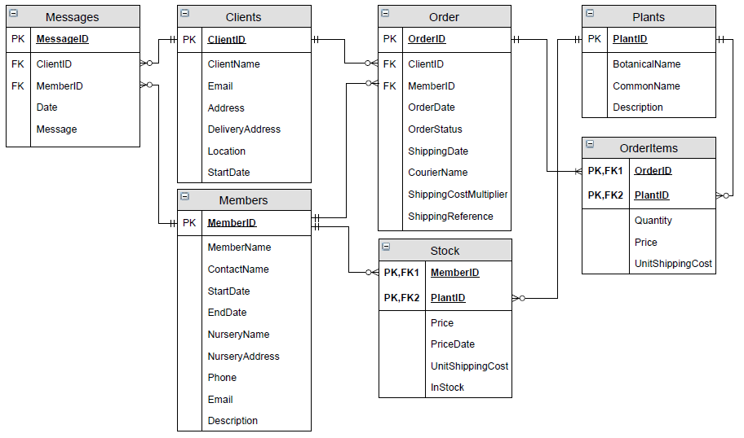

## Relational Schema

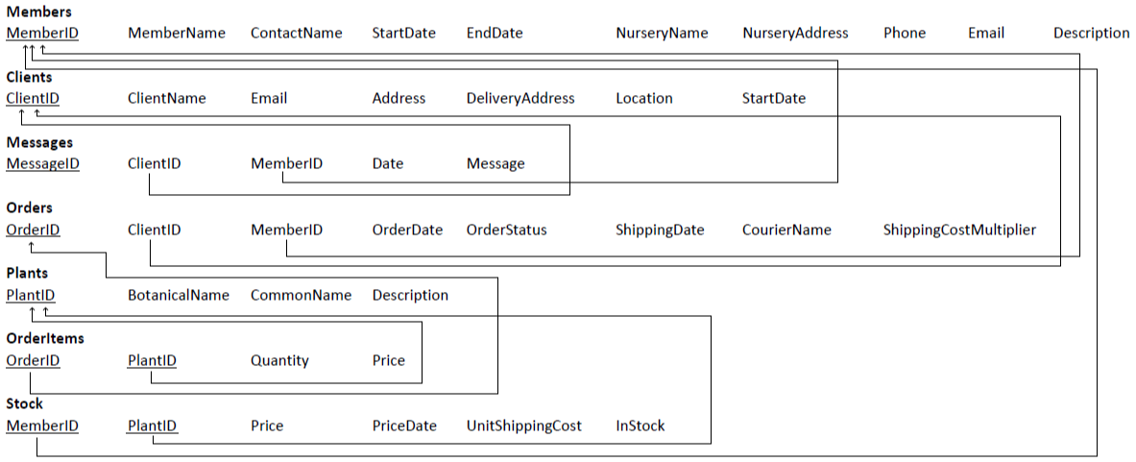

# Supplementary Design Requirements

The Shipping Multiplier table has not been considered in this design since it’s out of scope, even though it exists in the database. Currently the shipping multiplier is retrieved from the Order, as specified by the client. You could make the shipping multiplier generated by matching the client state and the nursery state and retrieve the correct multiplier. But that is outside the scope of this design. Therefore, it is not reflected in the Entity Relationship Diagram or the Relational Schema.

The attributes Client StartDate, Order Date, Message Date and Price Date are generated when an insert is made with CURRENT_TIMESTAMP.

The attribute InStock is of type bit, one or zero representing if the product is in stock or not.

# Assumptions

In this design I have assumed the following.

* That the client and member names are less than 50 characters long.
* That the phone numbers could contain the plus sign (+) and therefore are of type varchar instead of integer, otherwise it would be an integer.
* That the prices are decimal values no longer than 10 digits long and 2 trailing decimals.
* That the shipping status should be a short (20) varchar-status, e.g. “On its way”. Instead of perhaps a tinyint with different numbers representing different statuses.