## Homework 3: GhostCo Analysis Report

## A screenshot of a graph Description automatically generatedStory 1

**Interpretation:** *Fashion products* dominate the top 10 positions, and the *Home & Furniture* category dominates the bottom 10.*Auto & Accessories* products show relatively higher profits in the bottom 10 but still underperform.

**Recommendations: -** *Fashion* clearly outperforms other categories, thus, focusing on expanding the Fashion category can bring more profit.Optimize marketing or promotion strategies for higher-priced items like Car Mats and Car Seat Covers to move them out of the bottom tier.Consider creating bundles that combine high-performing fashion items with low-performing categories (e.g., a fashion and home bundle). This can drive sales for weaker categories while leveraging the strength of the fashion segment.

The image shows two bar charts displaying the Top 10 Products and Bottom 10 Products by profit for GhostCo Wholesale.

## A map of the united states Description automatically generatedStory 2

This map illustrates average profit across different regions in the USA.

**Interpretation:**

The map shows geographic disparities in profit levels across different US states. Regions with higher average profit indicates areas where demand is strong, customer engagement is high, or operational efficiencies exist. Likewise, regions with lower average profit signal potential issues such as underperformance, high competition, or lack of market penetration.

**Recommendation:** Focus on high-profit regions by expanding the product range, intensifying marketing efforts, and offering region-specific promotions. These areas are already yielding strong returns and represent growth opportunities. Analyse the factors contributing to lower profits in underperforming areas. Consider directing region-specific strategies, such as tailored advertising, to increase market penetration.

## Story 3

**Interpretation:**

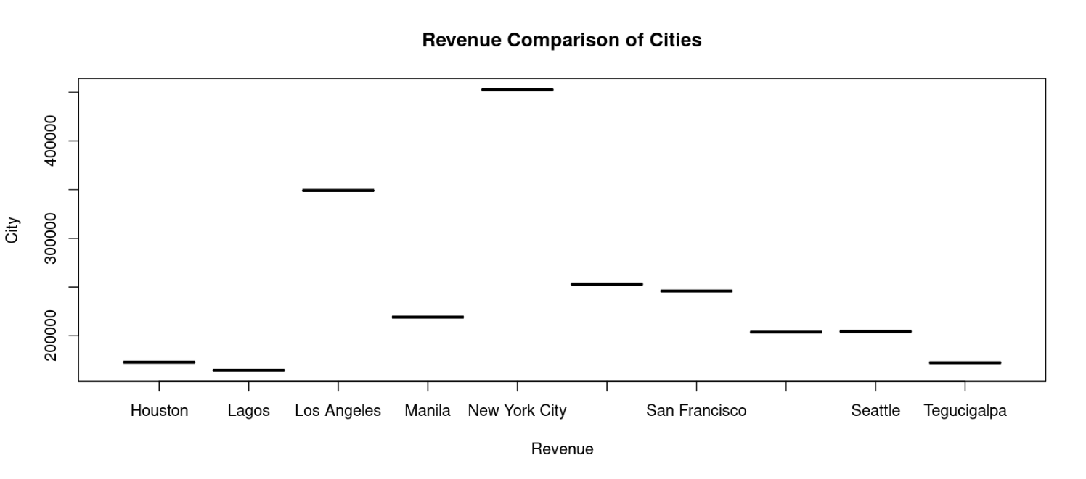This boxplot highlights the differences in profitability across major cities, offering insight into which urban areas are contributing most to the company’s goal and which are lagging. Cities with high average profit suggest strong customer bases, effective marketing, and/or efficient distribution networks, while cities with lower profits may reflect operational challenges, competition, or poor market penetration.

Figure 1: This visualization focuses on profit data across various global cities.

**Recommendations:** Analyze the supply chain and distribution network in cities with lower profits. There could be inefficiencies or higher costs that are reducing profit margins. Streamlining logistics could help cut costs and improve profitability in these regions.If certain cities have been consistently underperforming, consider pilot programs like new product launches, pop-up events, or collaborations with local influencers to generate buzz and improve engagement.

## Story 4

Categories with high shipping costs but low profits might indicate inefficiencies, while categories with lower shipping costs and higher profits suggest more cost-effective product lines. Understanding how shipping costs impact profit margins can help identify opportunities for cost savings or optimization.

**Recommendations:** For product categories where high shipping costs significantly reduce profit margins, consider exploring alternative shipping methods, consolidating shipments, or negotiating better rates with carriers. Reducing shipping expenses can directly boost profitability in these categories.Categories that are profitable and have *lower shipping costs should be prioritized*. Consider increasing inventory, promoting these products, or expanding their availability, as they provide a better return on investment.

## A screenshot of a graph Description automatically generatedStory 5

**Interpretation:** This bar chart shows how different combinations of priority and shipping mode impact overall sales and profitability. For instance, high-priority orders with expedited shipping could result in higher sales but may also incur higher shipping costs.

**Recommendations:** Make sure that high-priority orders are *paired* with fast and reliable shipping options, even if they incur higher costs, as these orders are likely driven by urgent customer needs. However, for lower-priority orders, standard or economy shipping may be sufficient, which can help save on costs while still meeting customer expectations. Analyze trends in order priority over time. If there is a growing trend toward higher-priority orders, ensure the company is equipped to handle this demand with efficient logistics. Conversely, if lower-priority orders are increasing, focus on optimizing cost-effective shipping options to preserve margins.

Story 6 **Interpretation:** This visualization breaks down sales performance across various customer segments (e.g., corporate, consumer, and home office). Each segment shows different sales volumes, revealing which customer groups drive the most revenue and which are underperforming. High-sales segments represent strong customer bases, while lower-performing segments may need additional focus or a revised strategy.

**Recommendations:** Focus on high-performing segments by offering targeted promotions, loyalty programs, or new product offerings that align with their preferences. Increasing investment in these segments can help drive even greater returns. For segments with lower sales, examine why they are not performing as well. Consider running targeted campaigns or promotional offers to boost engagement within these groups. Tailor marketing messages to resonate with each customer segment. For example, corporate customers might be more responsive to bulk discounts or longer-term contracts, while consumers might prefer personalized offers or product bundles.

## A graph of a line Description automatically generated with medium confidenceStory 7

This line graph illustrates how sales vary by month for different product categories. It reveals seasonal trends, preferences for specific categories at certain times of the year, and how product performance shifts throughout the year.

**Recommendations:** Monitortrends over the months for each product category to identify shifts in consumer behaviour. If certain categories are consistently growing, it may be worthwhile to expand product offerings or invest in marketing efforts specific to those categories.Consider seasonal productlaunches to show potential for growth during specific months, consider launching new products or lines tailored to those trends. For instance, introducing seasonal items in advance of peak sales months can help capture market interest.

## Story 8

Figure 2: This graph likely shows the volume of returns associated with different products.

**Interpretation:** High return rates for specific items may indicate issues such as quality concerns, customer dissatisfaction, or actual performance. Conversely, products with low return rates may suggest high customer satisfaction and effective marketing.A graph with numbers and letters

**Recommendations:** Conduct a detailed analysis of products with high return rates to identify common reasons for returns. This could involve gathering customer feedback, reviewing product quality, and examining packaging or shipping issues. Addressing these concerns can help reduce return rates and improve customer satisfaction. Increase quality control and inspection processes for products with high return rates to ensure that defects or inconsistencies are caught before they reach customers. This may involve working with suppliers to improve product quality.