SPREADSHEETS IN *ACTION*: The Antler Presentation

New York Times reporter Deborah Sontag was assigned in 2014 to write about the environmental aspects of the North Dakota oil boom. After doing some reporting in the state, she realized that there were a lot of oil spills occurring, but she wondered about the spill rate. If the number of spills was increasing in line with production, that would suggest that the environmental costs were growing along with the economic benefits. However, if the number of incidents was growing faster than production, it would raise additional questions about the oil companies and government regulators.

The state did not publish any official statistics summarizing the number of spills. However, Sontag attended a presentation in Antler, N.D. on afternoon where one of the top regulators showed this slide:

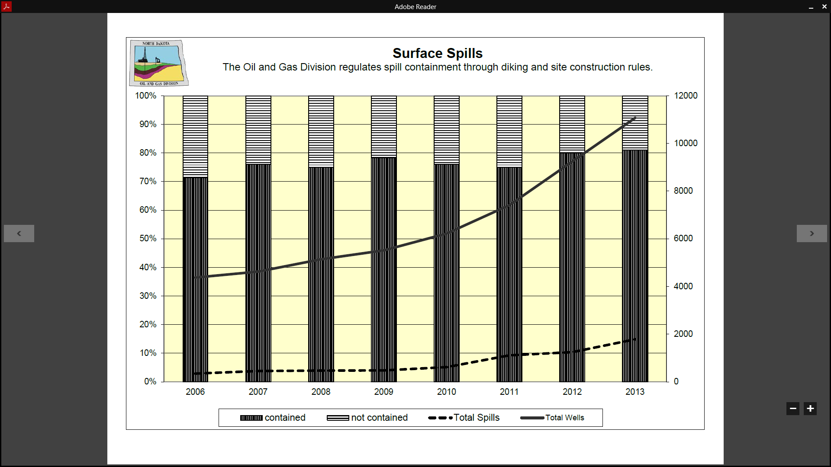

"A little bit of good news is that even though the number of spills has gone up significantly, and you would expect that with the drilling activity, it hasn’t gone up nearly as rapidly as the number of wells so per capita the spill rate is steady or down.'' -- Lynn D. Helms, the director of the Department of Mineral Resources

As you can see, the graphic does imply that the number of wells in production (solid line) is increasing faster than the number of spills (dotted line). Sontag was skeptical. She had earlier asked colleague Robert Gebeloff in New York to help assess the situation, and what they had discovered is that while the state hadn’t published any summary statistics until this point, they had a) created a Web site that contained individual incidents and b) posted summary statistics on production.

By harvesting the individual records, the pair had calculated their own summary statistics and those suggested the spill rate was in fact rising. But now the top environmental regulator in the state was saying exactly the opposite.

One possible explanation: The Times reporters were comparing the number of spills to the number of gallons of fuel being produced, and Mr. Helms was using a different metric, comparing the number of spills to the number of wells. Perhaps that would explain the different conclusions.

In any event, the reporters decided to ask the state to provide the data underlying the Helms graphic to gain greater clarity into the situation.

In this exercise, we’ll walk through what they did to assess the validity of the graphic.

Please open up excel and then open up the file in the class folder called spilltable.xls

1. It’s always a good practice to save a copy of the original data before doing any work. One way to do this is to make a new worksheet and to copy the source data into this new sheet. So on the bottom of your workbook, click the button for adding a new sheet, and copy and paste the data over.
2. Surprise! The first thing you notice when you paste the data into the new worksheet is there’s even more data than in the original. This is because the original file had “hidden” data that the spreadsheet author had removed from view but had not erased from the spreadsheet. In this case, the hidden material is irrelevant but you never know what you might find.
3. So let’s figure out which data elements the state used in its graphic. The graphic suggests a number above 11,000 for 2013 for Total Wells – that appears to be row 18. And for spills, it looks like a number approaching 2,000, that would be row 14.
4. So let’s stop here and discuss what to do with this information. For those not in class but reading this material, see spilltable_analyzed.xls.