# Getting started with Fusion Tables

Sarah Cohen / [sarah.cohen@nytimes.com](mailto:sarah.cohen@nytimes.com) / October 2015

Fusion Tables is an add-in to Google Spreadsheets that lets you do something important: put information on a map. It doesn’t scale well – be prepared to wait for anything but the smallest dataset – but it gives you a good sense of how data journalists get data into maps, and what the pitfalls are.

We’re going to work with a small set of restaurant inspections in upper Manhattan from September and October 2015. I’ve summarized these inspections for you and pulled out the most recent one for each restaurant.

## Turn on Fusion tables

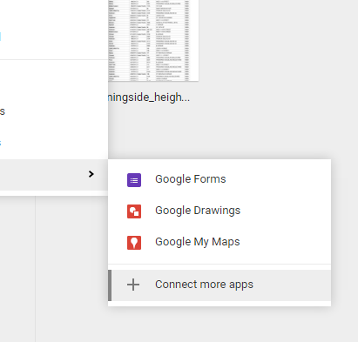The first time you want to use Fusion Tables, you have to add them to your Google Drive. Do this by going into your Google Docs, choose New and then navigate to “Connect more apps”. You should be able to search for Fusion Tables in the search box, then add it to your Google docs. This should only be required once.

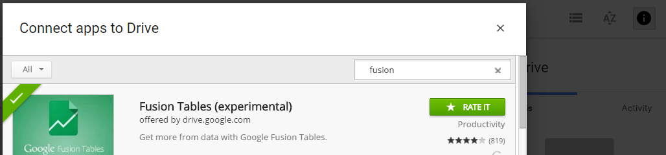

## Our data

Our data is the current list of restaurant inspections for the Morningside Heights neighborhood, downloaded in October 2015 from the Department of Health and Mental Hygiene , <http://www.nyc.gov/html/doh/html/home/home.shtml> . Note that although the DOHMH calls this the “Morningside Heights” neighborhood, the data is only for Zip Code 10026. This is a common problem in data reporting – your definition of a term doesn’t match the official or another definition.

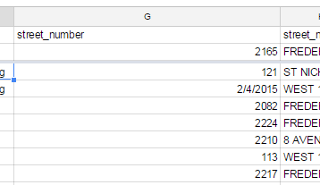One reason to start in Excel and then move to Google Sheets is that Google Sheets won’t allow you to define the data types for each column. In this case, it would turn some of your addresses into dates, others into numbers and leave some alone if you imported directly into Sheets.

Using what you’ve learned earlier, import the data into Excel the right way, using the import wizard rather than double-clicking on the file name. When you get to the last screen, be sure to define the street number and zip codes as “text”, not “general”.

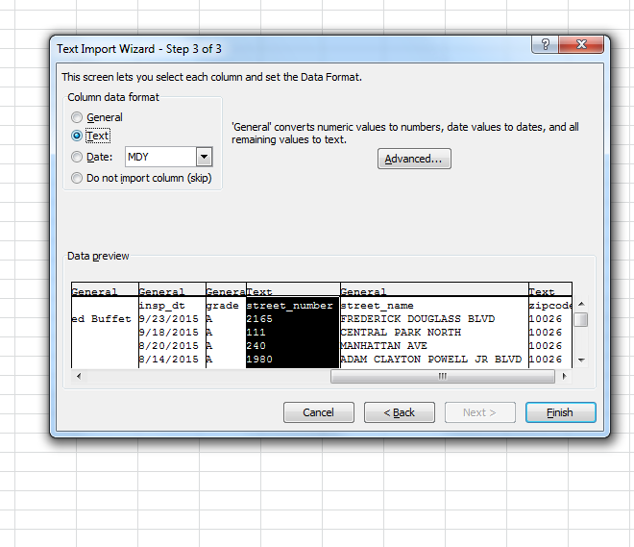

## Make necessary edits in Excel

This data came with the street number, street name and zip code separated into different columns, and didn’t contain a city or state.

Most mapping programs require a state, and often a city or post office name to accurately place it on a map. Fusion Tables will allow you to map data if you have just the zip code and state name.

But it’s worth trying out before you go to the effort. Pick one of the items in your list, and go to Google Maps to see if it finds it with the information you provide

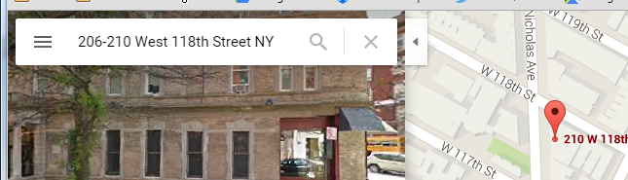

That means you have to combine three columns, and add a state, before you upload to fusion tables. The function in most computer programs to mash together text fields is called “concatenating”. In Excel, you can either use the function =CONCAT(words, words, words), or you can use an ampersand to stitch together cells:

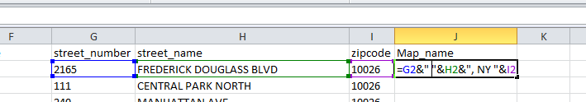

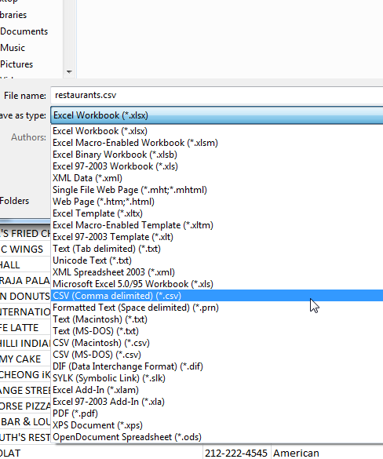Fusion Tables will not import Excel files, so you have to save your work as a csv. To do that, choose File, Save As or Export, and choose the “csv” format. Make sure to change the name so you don’t over-write the original data you imported.

## Create your fusion table

When you import your CSV file, you might notice that Google thinks that your phone number field is the one that should be used for the map. It will be highlighted in yellow, and there may even be a map icon on the screen. Just ignore it.

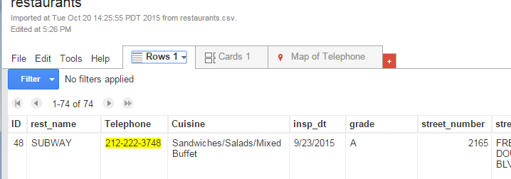

Instead, we have to tell Fusion table which field should be used to map the data. In the drop-down box next to the field you created (“Map_name” here), choose “Change,” then set it as “Location”.

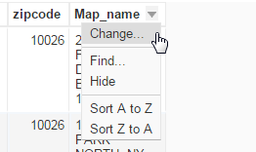 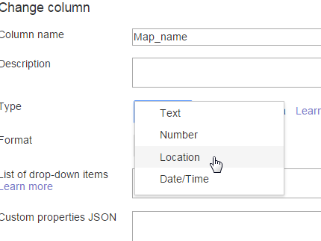

Now you can create your map by clicking on the red plus sign, choosing “Add map”, and identifying the field you want to use as the Location, in this case map_name.

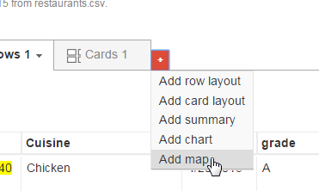

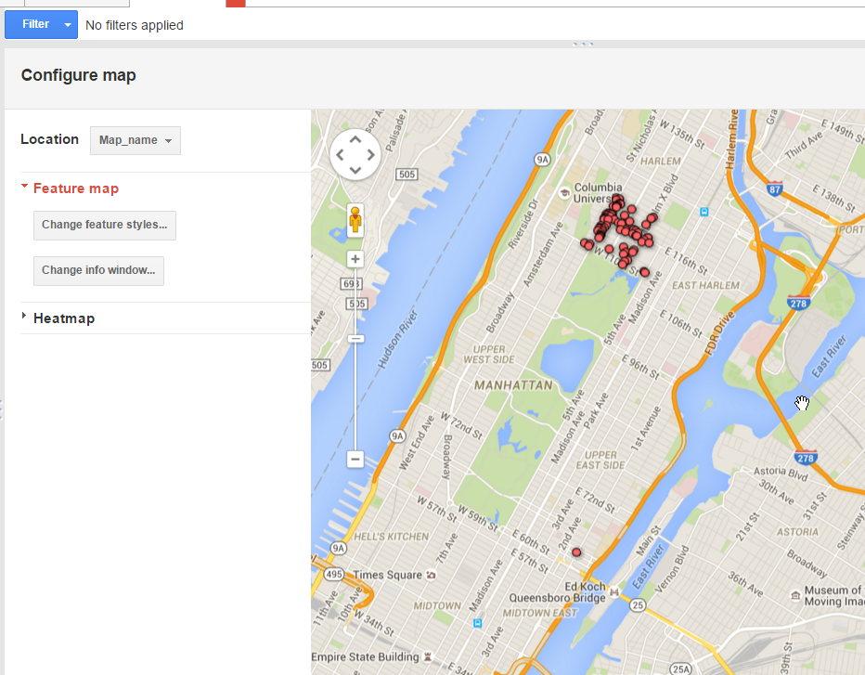

When it’s done, you’ll see that there is one stray dot on the map – what appears to be an error in a zip code, since the address appears correct. This, too, is common – and something you’ll have to resolve when you do your own work.