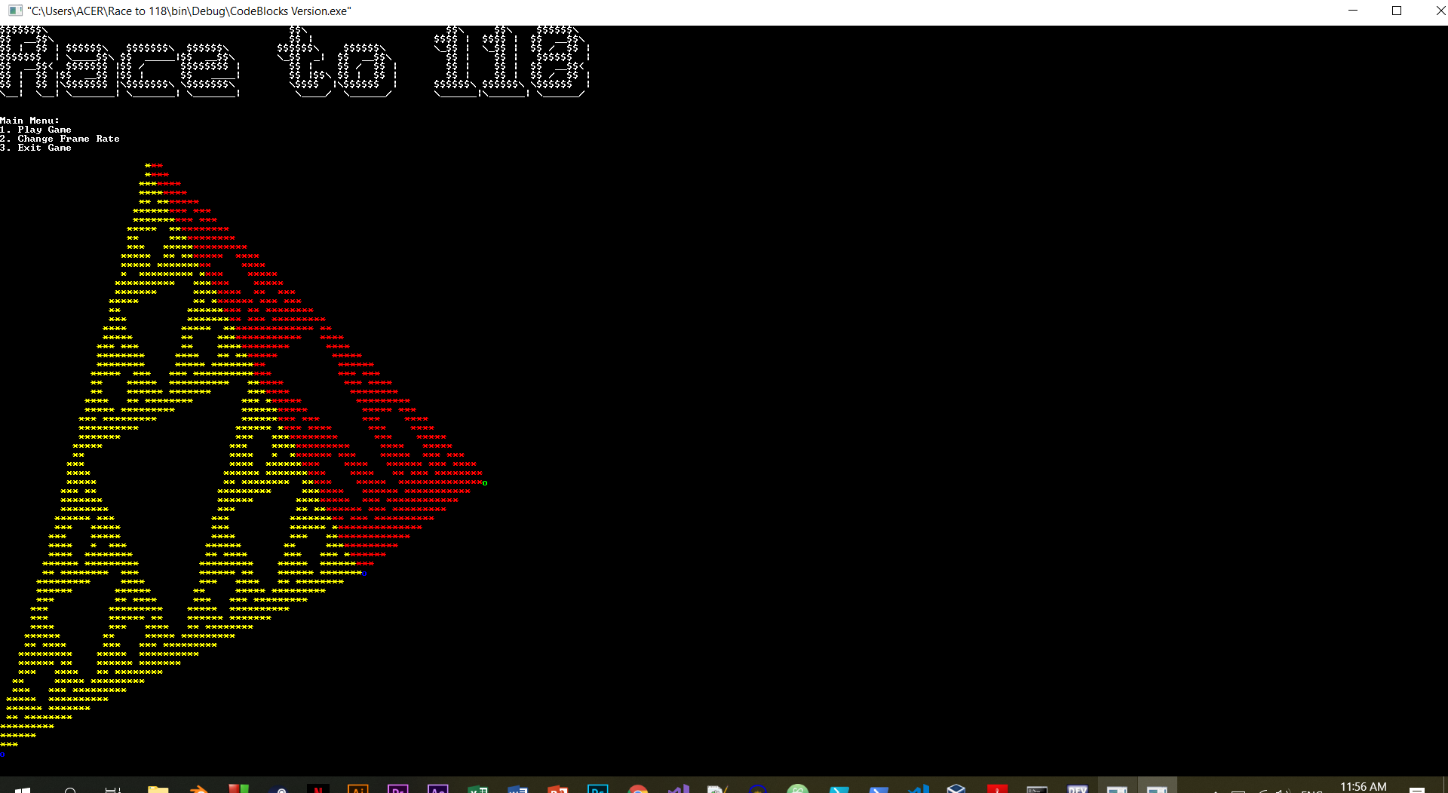

1. When the program is first initialized, the main menu is launched. Here, the player may choose to start playing, edit the frame rate, or exit the game. A random loading design will be loaded before these options become available. One of the main designs, this pyramid, is the logo of the game.

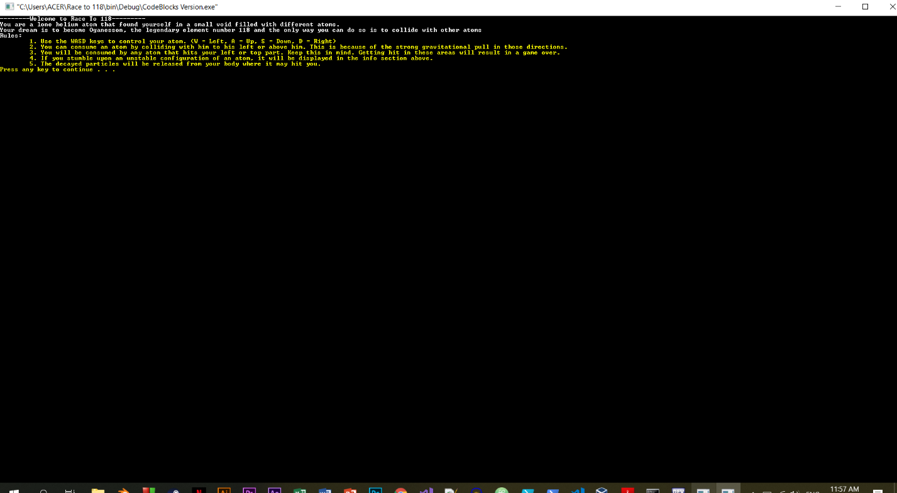

1. If the player opts to start the game, a launching page with all the mechanics will be shown to the player.

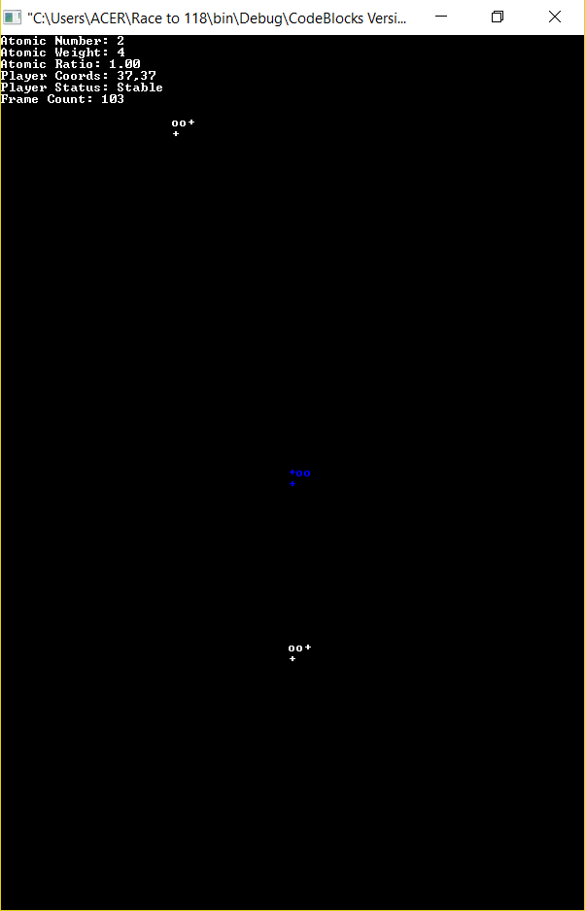

1. At the start of the game, the player (blue) is placed at the middle of the playing field and a bunch of atoms are randomly scattered about. Information on the player’s atom, like the current nuclear weight and stability, is shown above. Using the WASD keys, the player may move in any direction.

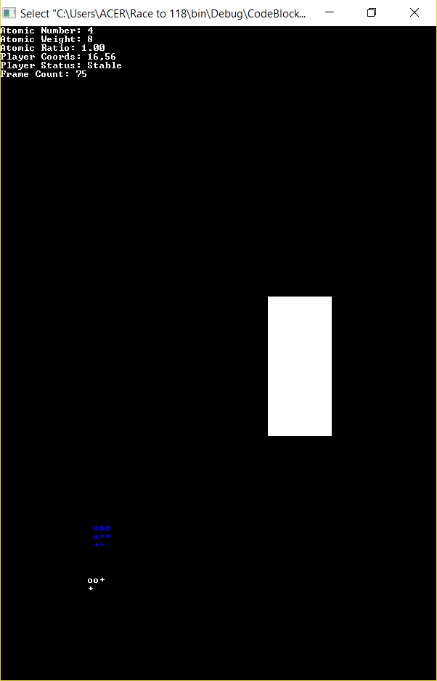

1. The player here is going to collide with the white atom from the top. As shown in the rules earlier, an atom must attack another particle from the top or the left to eat it; otherwise, it will be dominated and subsequently defeated.

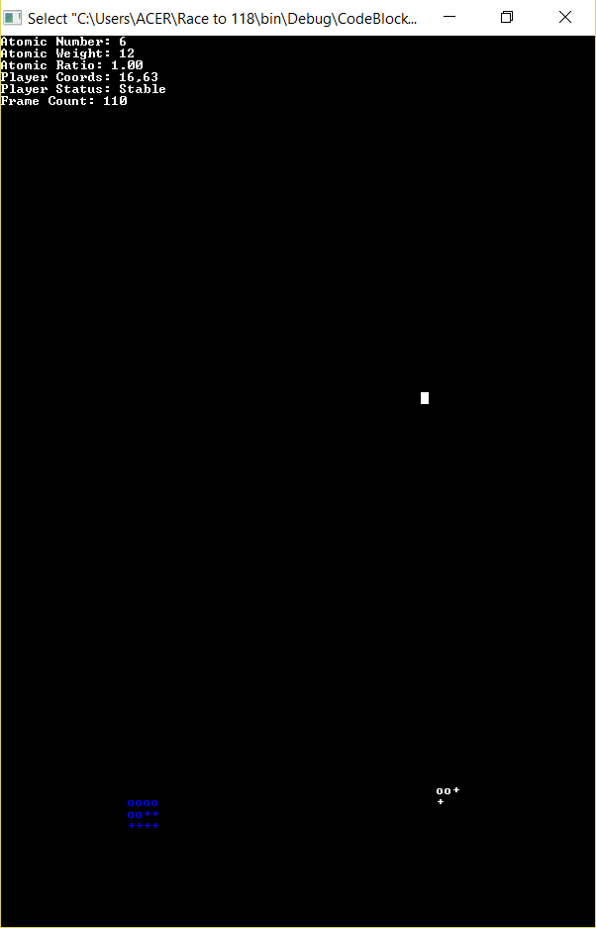

1. After colliding with the atom, we see here that the blue atom (player) has successfully eaten the white atom and has grown by the size of the atom it ate.

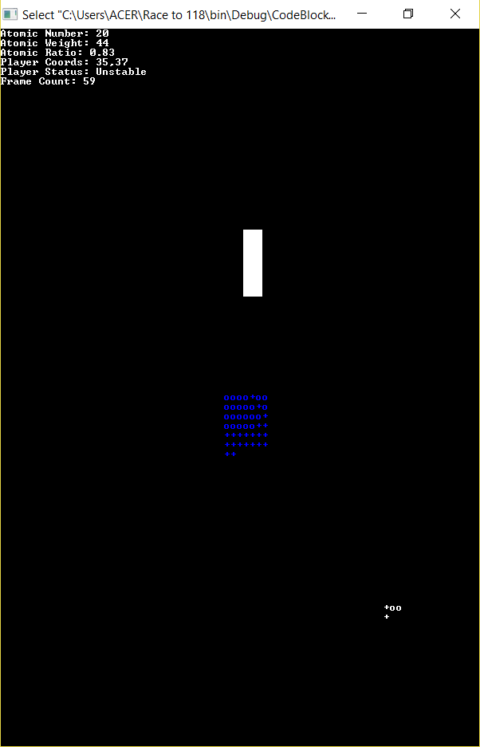

1. Here we see that the atom is unstable, meaning it will undergo some kind of decay soon. This will depend solely on atomic number and atomic weight of the atom. The guidelines for radioactive decays can be seen here: <https://chem.libretexts.org/Bookshelves/Physical_and_Theoretical_Chemistry_Textbook_Maps/Supplemental_Modules_(Physical_and_Theoretical_Chemistry)/Nuclear_Chemistry/Nuclear_Energetics_and_Stability/Nuclear_Magic_Numbers>

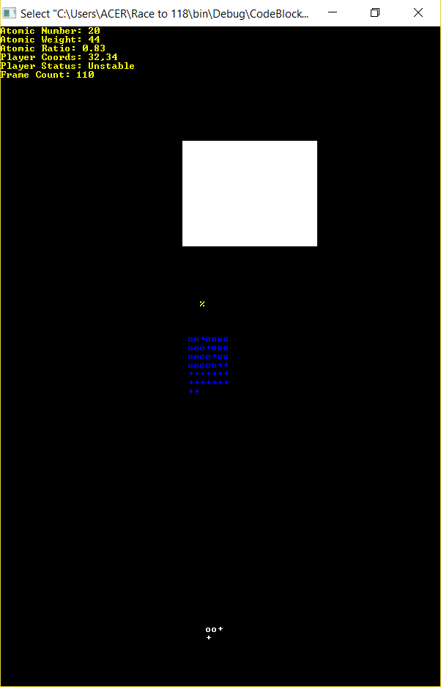

1. Due to the player’s instability, it released a positron (atomic ratio < 0.75 and atomic number > 20) represented by the ‘%’

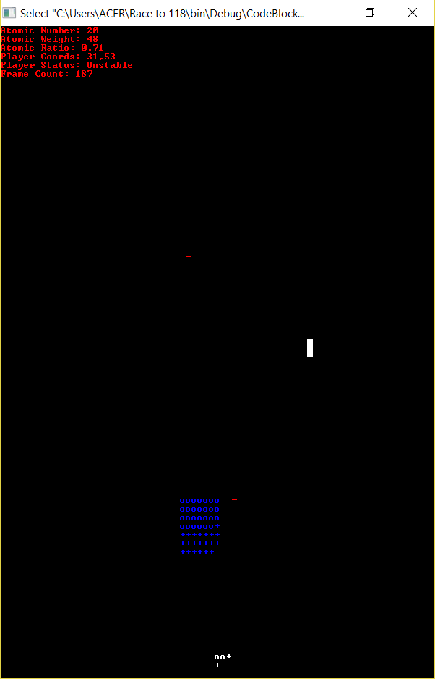

1. Similarly, an atomic ratio less than 0.75 resulted in the player releasing an electron, represented by the ‘- ‘.

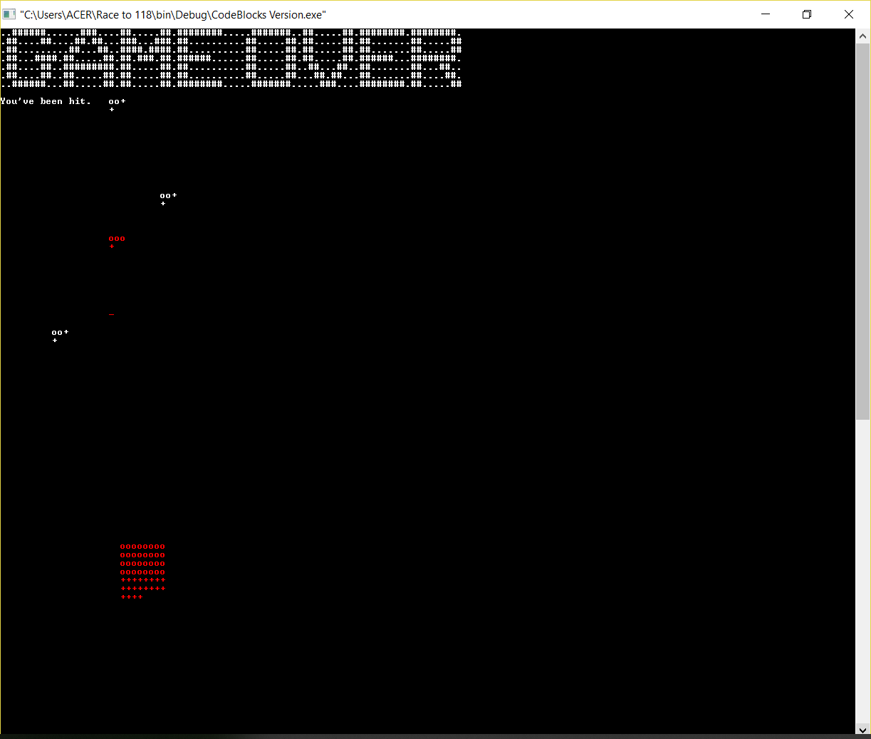

1. Having collided with an electron from the wrong side, we can see here that it resulted in a game over for the player.