This is application which generates CRUD MSSQL Procedures

Types of procedures:

Insert

Update

Delete

GET takes all columns from the table without any filters.

GET takes all columns from the table filtered by FK.

GET takes all columns from the table filtered by PK.

GET takes all columns from the table filtered by any column with and combination between supplied columns.

Creates non clustered indexes for FK columns

Creates non clustered covering indexes for FK columns

Creates non clustered covering indexes for All FK columns

Creates unique indexes for All FK columns

It reads the meta data from the SQL Server and generate the procedures

There is option for the Insert to choose the result either result set with all data or PK as output

“Gen Procs”

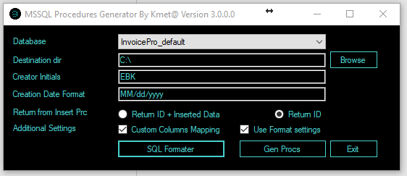

There is an option to set specific mappings for columns in the Stored procedures and Parameters

They can be configured from this file Configurations-> CustomColumsMappings.xlsx

Column Name – Colum name from database

Value - the value that you want to be returned for example if its audit date column you can set GETDATE() or SYSUTCDATETIME()

INSERT PARAMETER – Enables or disables the column as parameter in the SP

INSERT COLUMNS – Enables or disables the column in the Insert SP

The rest follow the same principle

There is an option to have different template files for the different Operations (INSERT,UPDATE,GETBYID……..)

There are settings files in the Configurations directory.

This configuration is saved in this file: Configurations -> TemplateConfigurations.xlsx

In the file there are file name templates and the operation for which is the template.

Other options format SQL Code for free

Search Stored procedures by different criteria for the chosen database.

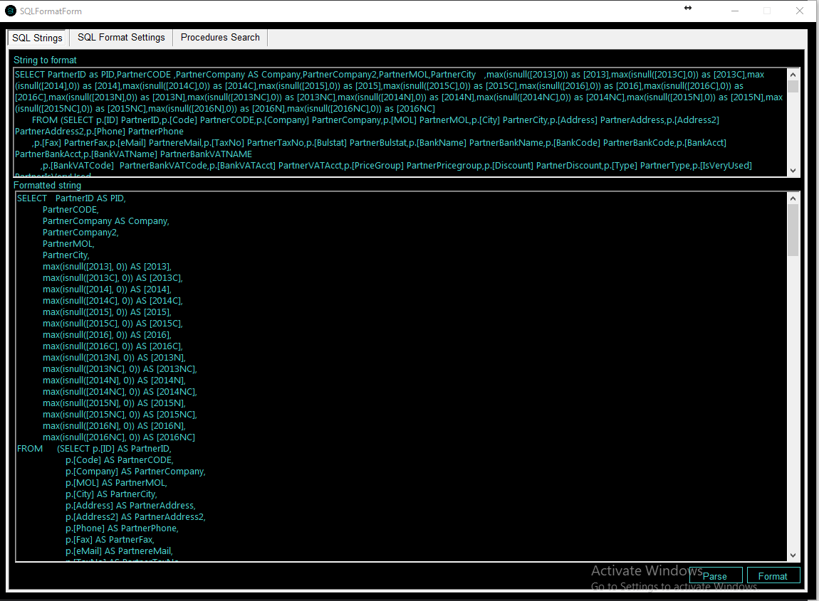

SQL Connection Settings

<?xml version="1.0" encoding="utf-8" ?>

<configuration>

<appSettings>

<add key="ServerAddress" value="localhost "/>

<add key="ServerUser" value="test"/>

<add key="ServerUserPassword" value="123456"/>

</appSettings>