IMPORTANT: This guide assumes that you have the needed .wad files (doom.wad, doom2.wad, plutonia.wad, tnt.wad) to run the game. I will be giving and example with my configuration and as such simply replace “emil” with your user name.

Doomseeker configuration

1. Go to Options → Configure (or press F5)
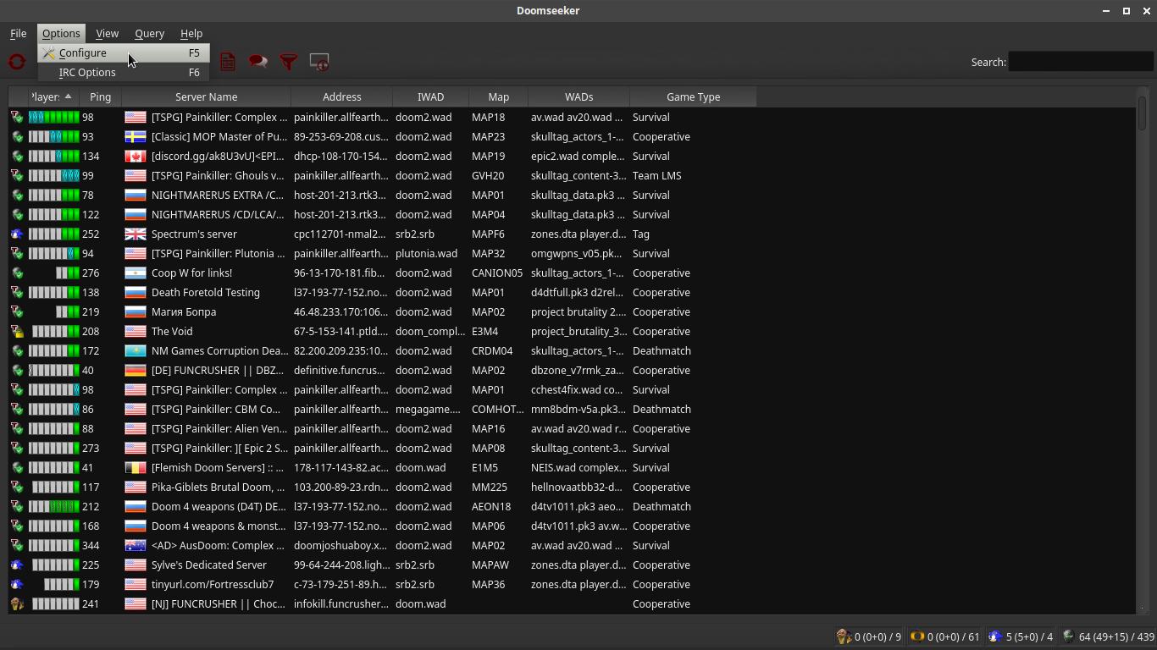
2. Check the executable paths for the engine you wish to use for on-line play. In our case they should both be in /usr/bin since that is where the install script places the executable paths for Zandronum.
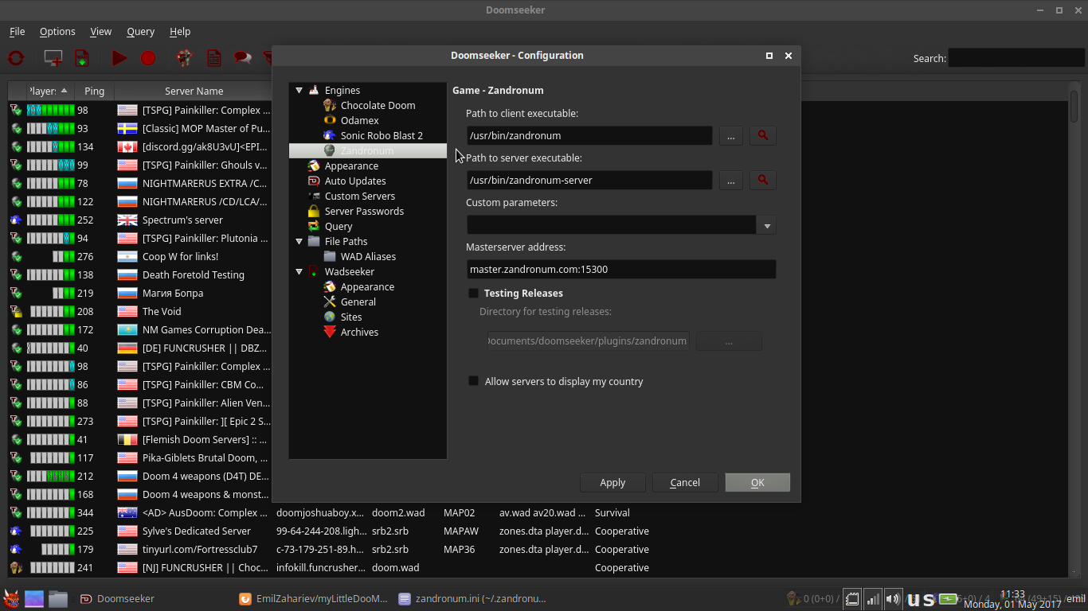
3. Under File Paths add the location of where your .wad files are located and where you would like Wadseeker to download new .wad files. In my case the I have added the last two paths, respectively.
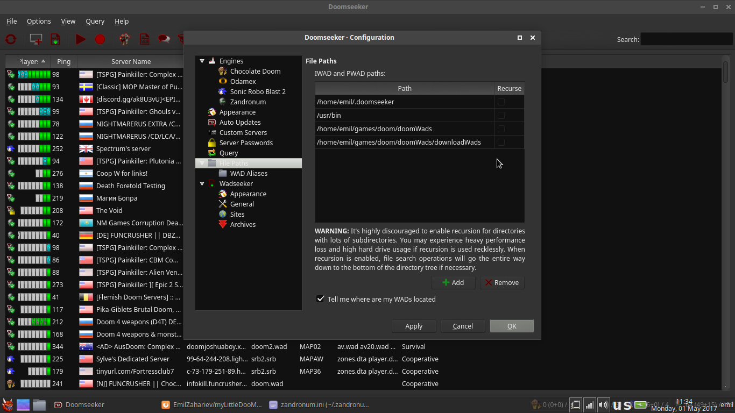
4. Under Wadseeker → General simply select the desired downloads folder. In my case it is the last one from the list.
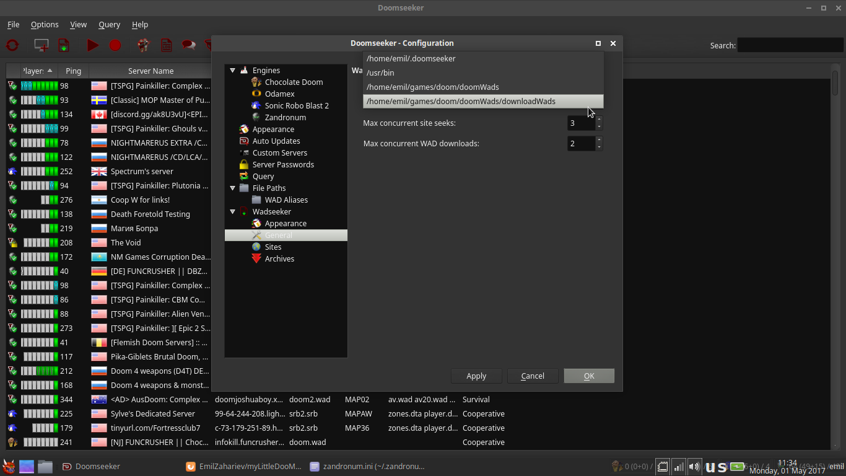
Zandronum and GZDoom (ZDoom, QZDoom) configuration

The image bellow shows my Zandronum configuration however this works for almost all source ports. The last two lines in both [IWADSearch.Directories] and [FileSearch.Directories] categories are the important ones.

1. Find the appropriate .ini file. For all three it will be located in either your home folder as a hidden folder (like ~/.zandronum/ or ~/.gzdoom/) or in the ~/.config/gzdoom/ folder.
2. There add the paths to your .wad files as shown bellow. In both [IWADSearch.Directories] and [FileSearch.Directories] I have added the last two paths. The wadsToLoad/ to load directory is there so that when the -file flag is used to load one or more .wad or .pk3 files the source port knows where to look for them

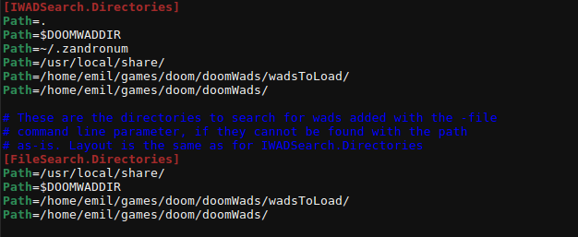
That is it! Good Luck and Have Fun!

