???

View-Model-First

Web api authentication (OAuth)

Using Microsoft.AspNet.Identity

String userId = RequestContext.Principal.Identity.GetUserId();

Registre :

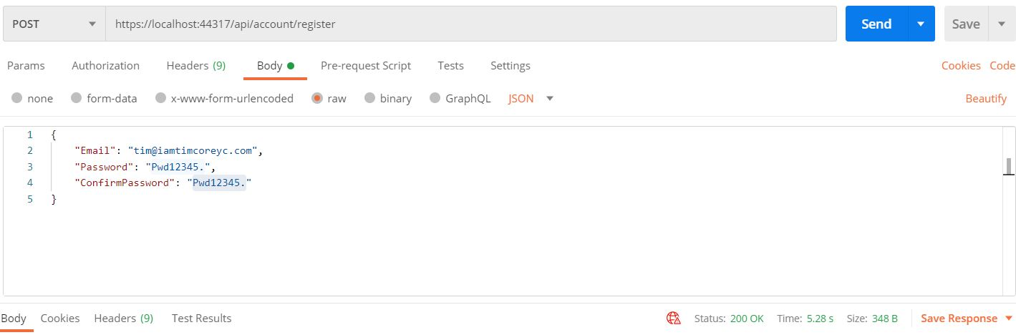

Token :

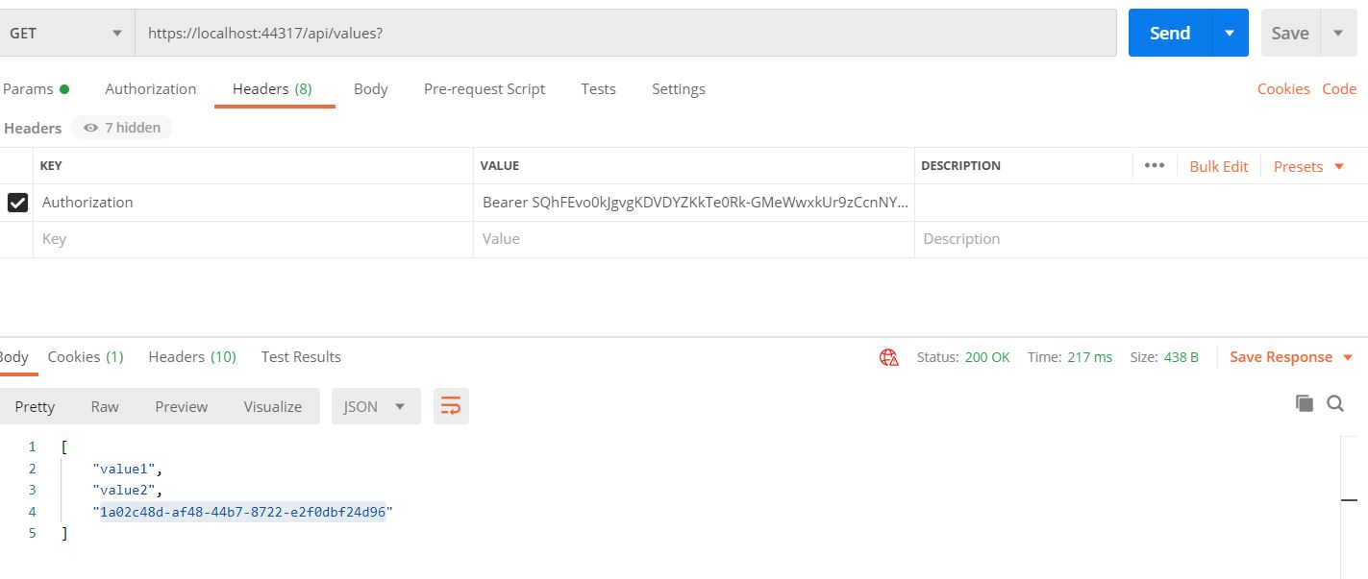

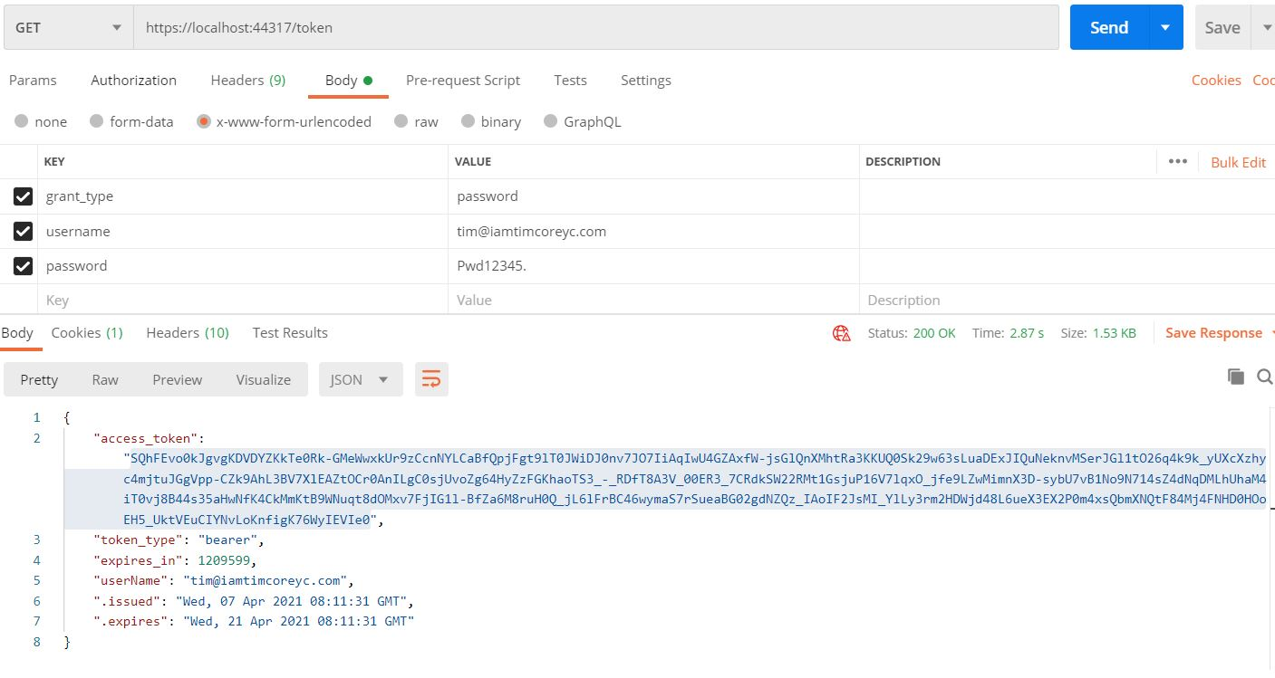

Swagger : installer in webapi

Swashbuckle

Add : token

Add  : how to create a space to add this token

WPF

* Caliburn Micro
* SimpleContainer
* Passwordbox : not activate INotifyProperty
* BooleanToVisibilityConverter : static resource
* Anonymous object : var p = new {Id = Id}
* SalesViewModel
  + Add same item, how to refresh the cart
* Update authtication database
  + Code first (early refactoring)
* AutoMapper