**4. Implementation**

**4.a. Social Force Model Algorithm**

**4.a.b Force between people**

….

….

….

**4.x.y. Destination Change**

When people first reach to the Apéro hall, their first destination is the big table with the food on it. After they take their food, they usually want to carry their food to one of the small distributed tables on the hall. They tend to choose the table which is closer, not full and the one with, not more other people, than the capacity of the table goes to the table. In other words, if the maximum number of people that the table can afford is 5, and 7 people already on their way to that table, that person would not try to reach that table, because s/she knows s/he cannot make it. In our algorithm, people choose which table to go with the same logic. Pseudo code of this behavior given in **Fig. X**

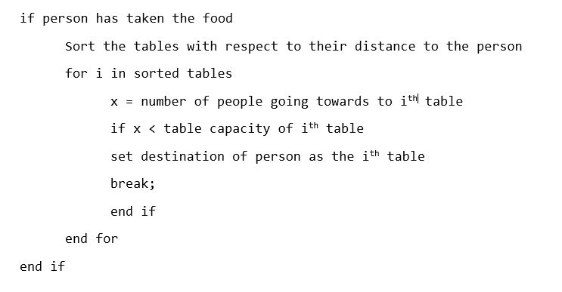

By using this algorithm, a realistic behavior of people going to tables are obtained. Detailed results can be seen under the simulation section.