**4. Implementation**

**4.a. Social Force Model Algorithm**

**4.a.b Force between people**

Under the description of the model section, it is explained that, it is a good idea to obtain the force from a monotonically decreasing potential field. Due to the fact that as the distance between people increase, their effects to each other decreases faster than the distance, an exponentially decreasing potential is used as in **Eq [yy].**



Where, V0αβ is taken 2m2s-2 and σ = 0.2m. Moreover, force between two agents is post multiplied by a constant depending on their heading and angle between them. If the angle between heading direction of pedestrian α and the position vector of pedestrian β is more than 60°, calculated force exerted from β to α is multiplied by 0.3 to decrease the effect. One may expect to think that the force exerted from α to β to be equal to the force exerted from β to α. However, this is sometimes not the case. For example, there are 2 people going to a same destination, one in front of the other. While there is a great force exerted from the person in front to the behind, the force exerted from the person on behind to the fron one is much less.

**4.x.y. Destination Change**

When people first reach to the Apéro hall, their first destination is the big table with the food on it. After they take their food, they usually want to carry their food to one of the small distributed tables on the hall. They tend to choose the table which is closer, not full and the one with, not more other people, than the capacity of the table goes to the table. In other words, if the maximum number of people that the table can afford is 5, and 7 people already on their way to that table, that person would not try to reach that table, because s/she knows s/he cannot make it. In our algorithm, people choose which table to go with the same logic. Pseudo code of this behavior given in **Fig. Y+1**

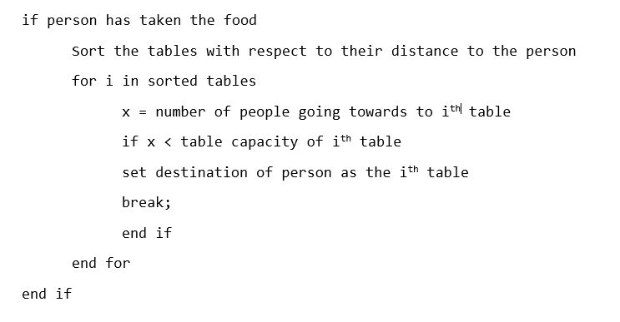

By using this algorithm, a realistic behavior of people going to tables are obtained. Detailed results can be seen under the simulation section.