
SWEN 221
SWEN 221
Marco Servetto
Marco Servetto
CO258
CO258
www.youtube.com/MarcoServetto
www.youtube.com/MarcoServetto



A Minecraft (bug) story
A Minecraft (bug) story

To ‘if’ or not to ‘if’
//Marco said to avoid ifs...
int myCode1(boolean condition){
//..
if (condition){ return code1(); }
return code2();
}
//no problem, I can just do this...
int myCode2(boolean condition){
//..
return Map.<Boolean,Supplier<Integer>>of(
true,()->code1(),
false,()->code2())
.get(condition).get();
}
int myCode1(boolean condition){
//..
if (condition){ return code1(); }
return code2();
}
//no problem, I can just do this...
int myCode2(boolean condition){
//..
return Map.<Boolean,Supplier<Integer>>of(
true,()->code1(),
false,()->code2())
.get(condition).get();
}
//Actually... both version are equally bad in the sense that
//both versions are hiding the decision in the method body
//and there is no way for the user to customize it.
//Now I will tell you a story, to explain why they are both bad,
//and in turn, why the ‘if’ is bad.
To ‘if’ or not to ‘if’
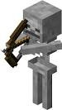


A story of minecraft Skeletons
●
Originally in Minecraft that was only
on kind of skeleton:
●
It was simply called “skeleton”.
●
When a skeleton is killed by a
charged creeper,
it would drop a skeleton head.
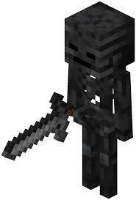
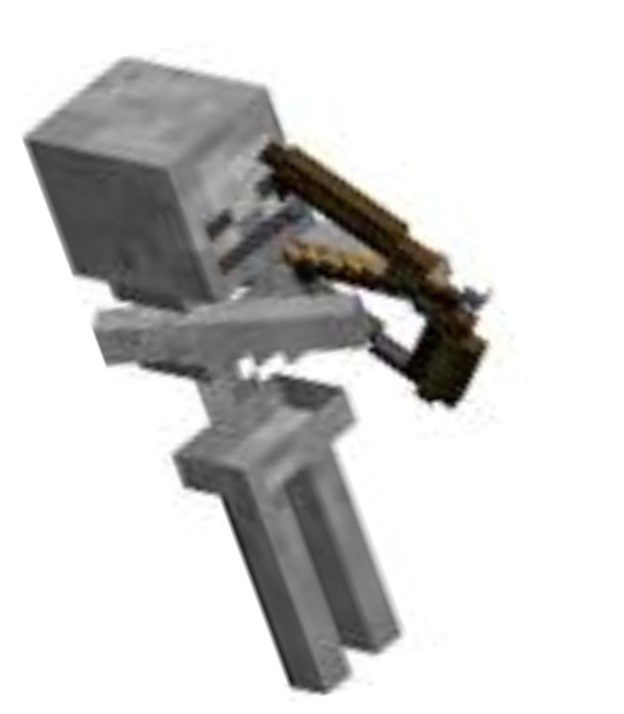
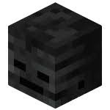
A story of minecraft Skeletons
●
Then, minecraft added
“wither skeletons”
●
When a wither skeleton is killed by a
charged creeper,
it would drop a wither skeleton head.
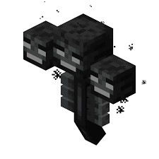
A story of minecraft Skeletons
Wither Skeleton heads are very important
in the game, they can be used
to summon the Wither.
A story of minecraft Skeletons
●
The code looked like that (pseudocode):
Skeleton.die:
when killed by a charged creeper:
if (the_skeleton_is_normal)
drop(skeleton_skull)
else
drop(wither_skull)
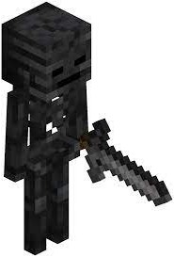
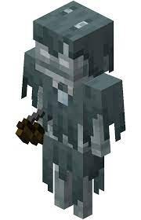
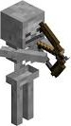
A story of minecraft Skeletons
●
Many years passed, everyone forgot that specific code.
●
Then they introduced a new kind of skeleton.
●
The “Stray”
Hi Guys, it will be a
pleasure to work
with you!
A story of minecraft Skeletons
●
Many years passed, everyone forgot that specific code.
●
Then they introduced a new kind of skeleton.
●
The “Stray”
Poor guy, he have no idea
what is coming...
A story of minecraft Skeletons
●
Many years passed, everyone forgot that specific code.
●
Then they introduced a new kind of skeleton.
●
The “Stray”
Poor guy, he have no idea
what is coming...

A story of minecraft Skeletons
●
Many years passed, everyone forgot that specific code.
●
Then they introduced a new kind of skeleton.
●
The “Stray”
A story of minecraft Skeletons
●
Many years passed, everyone forgot that specific code.
●
https://bugs.mojang.com/browse/MCPE-35876
????
A story of minecraft Skeletons
●
Compare those two different uses of ‘if’:
Skeleton.die:
when killed by a charged creeper:
if (the_skeleton_is_normal)
drop(skeleton_skull)
else
drop(wither_skull)
Skeleton.die:
when killed by a charged creeper:
if (the_skeleton_is_wither)
drop(wither_skull)
else
drop(skeleton_skull)
A story of minecraft Skeletons
●
Compare those two different uses of ‘if’:
If there are only two kinds of
skeletons, they behave the
same.
Skeleton.die:
when killed by a charged creeper:
if (the_skeleton_is_normal)
drop(skeleton_skull)
else
drop(wither_skull)
Skeleton.die:
when killed by a charged creeper:
if (the_skeleton_is_wither)
drop(wither_skull)
else
drop(skeleton_skull)
A story of minecraft Skeletons
●
Compare those two different uses of ‘if’:
If there are only two kinds of
skeletons, they behave the
same.
If there are three kinds of
skeletons, they behave
differently!
Skeleton.die:
when killed by a charged creeper:
if (the_skeleton_is_normal)
drop(skeleton_skull)
else
drop(wither_skull)
Skeleton.die:
when killed by a charged creeper:
if (the_skeleton_is_wither)
drop(wither_skull)
else
drop(skeleton_skull)
A story of minecraft Skeletons
●
Compare those two different uses of ‘if’:
Not a ‘truly’ boolean
condition: hiding a
‘case analysis’
If skeletons had a ‘dropSkull’
dynamically dispatched
method, this would have not
happened.
Skeleton.die:
when killed by a charged creeper:
if (the_skeleton_is_normal)
drop(skeleton_skull)
else
drop(wither_skull)
Skeleton.die:
when killed by a charged creeper:
if (the_skeleton_is_wither)
drop(wither_skull)
else
drop(skeleton_skull)
The good code
Mob.die:
when killed by a charged creeper:
this.dropSkull()
abstract Mob.dropSkull() //to be overridden
-----------------------------------
NormalSkeleton.dropSkull():
drop(skeleton_skull) //overridden
-----------------------------------
WitherSkeleton.dropSkull():
drop(wither_skull) //overridden
-----------------------------------
StraySkeleton.dropSkull():
drop(skeleton_skull) //overridden
Easy to see in retrospective.
But in retrospective is
pointless, the bug happened
already.
●
How to code so that the bug
would not happen in the first
place?
●
Having abstract ‘dropSkull’
forces to add a specific
behavior for each new mob!
Why ifs are bad?
●
An if/switch hides a decision about classifications inside the
hidden body of a method.
●
When the code evolves,
this decision stays hidden and slowly rot.
https://en.wikipedia.org/wiki/Software_rot
Why ifs are bad?
●
On the other side, dynamic dispatch works on public* methods.
●
We need a method to override in order to make our dynamic
dispatch; thus this method becomes the explicit documentation
point for those classification decisions!
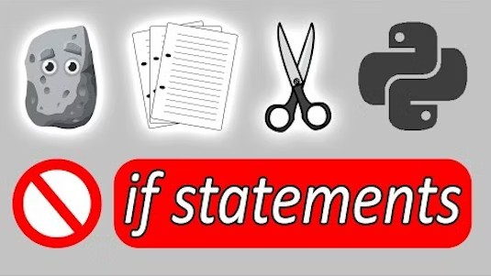




Unconditional
Unconditional
programming
programming
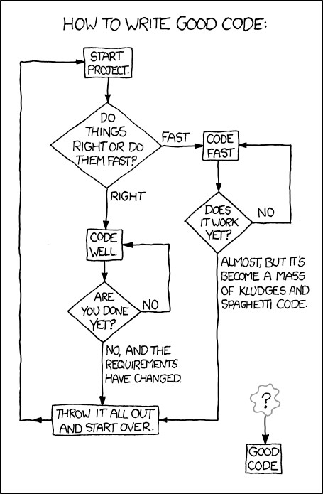

http://xkcd.com/844/
When to if? (disclaimer: precognition required)
●
When a choice is really, really binary:
●
A point is either inside or outside of a bounding box
●
An element is inside or outside a list
●
A list is empty or not
●
When working with legacy code / methods returning booleans
When to if? (disclaimer: precognition required)
●
When a choice is really, really binary:
●
A point is either inside or outside of a bounding box
●
An element is inside or outside a list
●
A list is empty or not
●
When working with legacy code / methods returning booleans
●
What if we just assumed that the choice was binary, but the
future proves us wrong?
When to if? (disclaimer: precognition required)
●
When a choice is really, really binary:
●
A point is either inside or outside of a bounding box
●
An element is inside or outside a list
●
A list is empty or not
●
When working with legacy code / methods returning booleans
●
What if we just assumed that the choice was binary, but the
future proves us wrong?
When not to if? (disclaimer: precognition required)
●
When a choice appears to be binary, or at least to range on a
finite set of options, but the future then proves you wrong
●
When you would like to ‘if’ just because you have no idea how
else to code!
●
When choosing an action over an open set options
●
When the set of options may change over time
●
When the behavior in response to an option may change over
time, or may need to be customized by the user code
●
It is a way to ‘document’ at the ‘public’ level that that choice is
really binary.
●
It is exactly what a boolean .isEmpty() method is doing.
●
All of ‘if’, ‘switch’, ‘try-catch’, ‘
myOpt.ifPresent(()->..)
’, and even
Map.of(true,()->a,false,()->b).get(condition).get();
allows to bury/hard-code decisions inside of the code.
●
It is not always bad, sometimes it make sense to hard-code a
decision. Just… only sometimes…
●
But what times?
Precognition is required to answer this question.
When to if? (disclaimer: precognition required)
Taking a step back
●
The problem is not the “if”, the problem is that we reached a
point in our code where we are trying to explicitly hardcode a
decision.
●
For example, key bindings:
●
switch(key){ case:‘a’→ goLeft() …}
●
BAD solution.
●
Good solution: use a Map<Key, Action>
class KeyMap{
private Game game;
private Map<String, Runnable> keyMap;
public KeyMap(Supplier<Game> newGame){
this.game= newGame.get();
Map<String, Runnable> map= Map.of(//could be a separate method
"W", game::goUp,
"A", game::goLeft,
"S", game::goDown,
"D", game::goRight,
" ", game::jump
);
keyMap= new HashMap<>(map);
}
public void updateKey(String key, Runnable action) {
keyMap.put(key,action);
}
public void executeAction(String keyPress) {
keyMap.getOrDefault(keyPress.toUpperCase(),()->{}).run();
}
}
interface Game{
void goUp();
void goLeft();
void goRight();
void goDown();
void jump();
}
Good way to handle
key-mapping
Can we really avoiding using ifs?
●
Exercise: Peano numbers.
●
Zero is a Number
●
For every number, there is a successor number.
●
We can define addition and multiplication
●
We can define a toInt/fromInt so we can test it/print it.
N
Zero
Succ
An N can be either zero or a successor of an N
N is our top level concept
public interface N {
static N zero() { return new N(){}; }
default N add(N other){ return other; }
default N times(N other){ return this; }
default N succ(){
N pred= this;
return new N(){
public N add(N other){ return pred.add(other).succ(); }
public N times(N other){ return pred.times(other).add(other); }
public int toInt(){ return pred.toInt()+1; }
}; }
default int toInt(){ return 0; }
static N fromInt(int i){
N res= zero();
while(i --> 0){ res= res.succ(); }
return res;
}
}

public interface N {
static N zero() { return new N(){}; }
default N add(N other){ return other; }
default N times(N other){ return this; }
default N succ(){
N pred= this;
return new N(){
public N add(N other){ return pred.add(other).succ(); }
public N times(N other){ return pred.times(other).add(other); }
public int toInt(){ return pred.toInt()+1; }
}; }
default int toInt(){ return 0; }
static N fromInt(int i){
N res= zero();
while(i --> 0){ res= res.succ(); }
return res;
}
}
Just to print/test
We can look at it
later
public interface N {
static N zero() { return new N(){}; }
default N add(N other){ return other; }
default N times(N other){ return this; }
default N succ(){
N pred= this;
return new N(){
public N add(N other){ return pred.add(other).succ(); }
public N times(N other){ return pred.times(other).add(other); }
};
}
}
public interface N {
static N zero() { return new N(){}; } //The zero constant
default N add(N other){ return other; }
default N times(N other){ return this; }
default N succ(){
N pred= this;
return new N(){
public N add(N other){ return pred.add(other).succ(); }
public N times(N other){ return pred.times(other).add(other); }
};
}
}
public interface N {
static N zero() { return new N(){}; } //The zero constant
default N add(N other){ return other; } //0 + b = b
default N times(N other){ return this; }
default N succ(){
N pred= this;
return new N(){
public N add(N other){ return pred.add(other).succ(); }
public N times(N other){ return pred.times(other).add(other); }
};
}
}
public interface N {
static N zero() { return new N(){}; } //The zero constant
default N add(N other){ return other; } //0 + b = b
default N times(N other){ return this; }//0 * b = 0
default N succ(){
N pred= this;
return new N(){
public N add(N other){ return pred.add(other).succ(); }
public N times(N other){ return pred.times(other).add(other); }
};
}
}
public interface N {
static N zero() { return new N(){}; } //The zero constant
default N add(N other){ return other; } //0 + b = b
default N times(N other){ return this; }//0 * b = 0
default N succ(){
N pred= this; //by creating my successor, I’m the predecessor
return new N(){
public N add(N other){ return pred.add(other).succ(); }
public N times(N other){ return pred.times(other).add(other); }
};
}
}
public interface N {
static N zero() { return new N(){}; } //The zero constant
default N add(N other){ return other; } //0 + b = b
default N times(N other){ return this; }//0 * b = 0
default N succ(){
N pred= this; //by creating my successor, I’m the predecessor
return new N(){
public N add(N other){ return pred.add(other).succ(); }
//(a+1) + b = (a+b) + 1
public N times(N other){ return pred.times(other).add(other); }
};
}
}
public interface N {
static N zero() { return new N(){}; } //The zero constant
default N add(N other){ return other; } //0 + b = b
default N times(N other){ return this; }//0 * b = 0
default N succ(){
N pred= this; //by creating my successor, I’m the predecessor
return new N(){
public N add(N other){ return pred.add(other).succ(); }
//(a+1) + b = (a+b) + 1
public N times(N other){ return pred.times(other).add(other); }
//(a+1)*b = (a*b) + b
};
}
}
public interface N {
static N zero() { return new N(){}; }
default N add(N other){ return other; }
default N times(N other){ return this; }
default N succ(){
N pred= this;
return new N(){
public N add(N other){ return pred.add(other).succ(); }
public N times(N other){ return pred.times(other).add(other); }
public int toInt(){ return pred.toInt()+1; }
}; }
default int toInt(){ return 0; }
static N fromInt(int i){
N res= zero();
while(i --> 0){ res= res.succ(); }
return res;
}
}
Just to print/test
Now we can look
at it
public interface N {
static N zero() { return new N(){}; }
default N add(N other){ return other; }
default N times(N other){ return this; }
default N succ(){
N pred= this;
return new N(){
public N add(N other){ return pred.add(other).succ(); }
public N times(N other){ return pred.times(other).add(other); }
public int toInt(){ return pred.toInt()+1; }
}; }
default int toInt(){ return 0; }
static N fromInt(int i){
N res= zero();
while(i --> 0){ res= res.succ(); }
return res;
}
}
Zero.toInt ==0
public interface N {
static N zero() { return new N(){}; }
default N add(N other){ return other; }
default N times(N other){ return this; }
default N succ(){
N pred= this;
return new N(){
public N add(N other){ return pred.add(other).succ(); }
public N times(N other){ return pred.times(other).add(other); }
public int toInt(){ return pred.toInt()+1; }
}; }
default int toInt(){ return 0; }
static N fromInt(int i){
N res= zero();
while(i --> 0){ res= res.succ(); }
return res;
}
}
Succ.toInt ==
recursive call + 1
public interface N {
static N zero() { return new N(){}; }
default N add(N other){ return other; }
default N times(N other){ return this; }
default N succ(){
N pred= this;
return new N(){
public N add(N other){ return pred.add(other).succ(); }
public N times(N other){ return pred.times(other).add(other); }
public int toInt(){ return pred.toInt()+1; }
}; }
default int toInt(){ return 0; }
static N fromInt(int i){
N res= zero();
while(i --> 0){ res= res.succ(); }
return res;
}
}
In fromInt we can
simply start from
zero and then ….
use the ‘runs to
zero’ operator to
iterate up to ‘i’.

You have seen
the ‘runs to zero’
operator, right?

You have NOT
seen the ‘runs to
zero’ operator?
This is
unforgivable!
The runs to zero operator
if( stuff --> 0 ){...}
while( stuff --> 0 ){...}
●
You DID learn about it in the first year, right?
●
It is in C, C++, C#, Java, Python, Javascript, PHP, Swift
and many more languages….
The runs to zero operator
if( stuff --> 0 ){...}
while( stuff --> 0 ){...}
●
You DID learn about it in the first year, right?
●
It is in C, C++, C#, Java, Python, Javascript, PHP, Swift
and many more languages….
●
Really, you have never seen it?

The runs to zero operator
if( stuff --> 0 ){...}
while( stuff --> 0 ){...}
●
Troll lol lol lol lol….
Trollololala!
Trollololala!
The runs to zero operator
if( stuff-- > 0 ){...}
while( stuff-- > 0 ){...}
●
Troll lol lol lol lol….
Trollololala!
Trollololala!
The runs to zero operator
if( stuff -- > 0 ){...}
while( stuff -- > 0 ){...}
●
It is just two operators in sequence
https://stackoverflow.com/questions/1642028/what-is-the-operator-in-c
●
If you have not seen this page, you need to read it now, it is gem!
Don't forget about the Extra Long Arrow operator which moves twice as fast, x ----> 0

The runs to zero operator
if( stuff --> 0 ){...}
while( stuff --> 0 ){...}
●
However,….
●
It works.
●
It reads well.
●
It is fun.
●
It is maintainable.
●
It has localized impact on the code.
●
Would you use it, even if it is basically just a joke?
●
If enough people chose to use it, would it still be just a joke?
The runs to zero operator
if( stuff --> 0 ){...}
while( stuff --> 0 ){...}
●
However,….
●
It works.
●
It reads well.
●
It is fun.
●
It is maintainable.
●
It has localized impact on the code.
●
Would you use it, even if it is basically just a joke?
●
If enough people chose to use it, would it still be just a joke?
●
Who is laughing now?
●
Yes… many of the best programming techniques
are born as ‘jokes’, ‘tricks’, ‘challenges’ or ‘dares’
The biggest ‘joke’: dynamic dispatch
●
Imperative mindset:
●
When you call a method in a certain point is because you know what this method is
doing and you want that behavior to apply here.
●
Dynamic dispatch: You have no idea what this method is going to do.
If you have no idea what this method does, why would you ever want to call it?
●
The OO Programming Paradigm: programming where the most common and the most
fundamental operation is the dynamically dispatched method call, so that you will have no
clue what a method is actually going to do.
●
It looks insane, right?
However…. Everyone is using it.
May be it is not insane?
class Range {
static void check(double val, double min, double max){
if (val < min || val > max){ throw new IllegalArgumentException(); }
}
}
record GeoPoint(double latitude, double longitude){
public String toString(){ return toString(8); }
public String toString(int precision){
if (precision < 0){ throw new IllegalArgumentException(); }
String template =
"[latitude: %."+precision+"f, longitude: %."+precision+"f]";
return template.formatted(latitude,longitude);
}
GeoPoint{
Range.check(latitude,-90d,90d);// Code reuse here!
Range.check(longitude,-180d,Math.nextDown(180d));
}
GeoPoint average(GeoPoint gp){
double avgLat= (this.latitude + gp.latitude) / 2d;
double avgLon= (this.longitude + gp.longitude) / 2d;
double longDiff= Math.abs(this.longitude - gp.longitude);
if (longDiff > 180){ avgLon += (avgLon < 0) ? 180 : -180; }
// If the points are on opposite sides of the anti-meridian
return new GeoPoint(avgLat,avgLon);
}
}
Lab
Week3&4
model
solutions
record GeoBox(GeoPoint ne, GeoPoint sw){
GeoPoint se(){ return new GeoPoint(sw.latitude(),ne.longitude()); }
GeoPoint nw(){ return new GeoPoint(ne.latitude(),sw.longitude()); }
GeoPoint center(){ return ne.average(sw); }
GeoBox{
Range.check(ne.latitude(),-80,80);
Range.check(sw.latitude(),-80,80);
var vSpan = ne.latitude() - sw.latitude();
Range.check(vSpan,0,30);
var hSpan = ne.longitude() - sw.longitude();
if (hSpan >= 0){ Range.check(hSpan,0,30); }
else { Range.check(hSpan,-360,-330); }
}
}
Lab
Week3&4
model
solutions
record Street(GeoBox boundingBox, String name, int length) {
Street{
Objects.requireNonNull(boundingBox);
Objects.requireNonNull(name);
if (length < 0) { throw new IllegalArgumentException(); }
}
public String toString(){ return name; }
}
record Address(Street street, City city, String number){
Address{
Objects.requireNonNull(street);
Objects.requireNonNull(city);
Objects.requireNonNull(number);
var invalidStreet= !city.streets().contains(street);
if(invalidStreet){ throw new IllegalArgumentException(); }
}
}
Lab
Week3&4
model
solutions
class City{
private String name;
private int population;
private HashSet<Street> streets= new HashSet<>();
public void population(int population){
if (population < 0) { throw new IllegalArgumentException(); }
this.population= population;
}
public String name(){ return name; }
public int population(){ return this.population; }
public void addStreet(Street s){ this.streets.add(s); }
public Set<Street> streets(){ return Collections.unmodifiableSet(streets); }
public City(String name, int population){
this.name= Objects.requireNonNull(name);
population(population);
}
public String toString() { return name; }
}
Lab
Week3&4
model
solutions
interface Building{
GeoBox boundingBox();
Address primaryAddress();
default Set<Address> secondaryAddresses(){ return Set.of(); }
static Building of(GeoBox boundingBox, Address primary, Set<Address> secondary){
return new BigBuilding(boundingBox,primary,Set.copyOf(secondary));
}
static Building of(GeoBox boundingBox, Address primary){
return new SingleAddressBuilding(boundingBox,primary);
}
static void checkOverlap(GeoBox box1, GeoBox box2){
double s= Math.max(box1.sw().latitude(), box2.sw().latitude());
double w= Math.max(box1.sw().longitude(), box2.sw().longitude());
double n= Math.min(box1.ne().latitude(), box2.ne().latitude());
double e= Math.min(box1.ne().longitude(), box2.ne().longitude());
new GeoBox(new GeoPoint(n,e),new GeoPoint(s,w));//will fail if empty
}
}
record BigBuilding(
GeoBox boundingBox, Address primaryAddress, Set<Address> secondaryAddresses)
implements Building{
BigBuilding{
Building.checkOverlap(boundingBox, primaryAddress.street().boundingBox());
if (secondaryAddresses.isEmpty()){ throw new IllegalArgumentException(); }
for (var s:secondaryAddresses){
Building.checkOverlap(boundingBox, s.street().boundingBox());
}
}
}
record SingleAddressBuilding(GeoBox boundingBox, Address primaryAddress) implements Building{
SingleAddressBuilding{
Building.checkOverlap(boundingBox, primaryAddress.street().boundingBox());
}
}

