
SWEN 221
SWEN 221
Marco Servetto
Marco Servetto
CO258
CO258
www.youtube.com/MarcoServetto
www.youtube.com/MarcoServetto
SWEN221 Lecture 3
Introduction to Inheritance and Subtyping
Interfaces and Records
●
We are going to explore how to support inheritance and subtyping using
interfaces and records.
●
Then we will see how it was done in older Java with classes and single
inheritance.
●
Inheritance: enables Code reuse within a class hierarchy
(most often it means less code in our own internal API)
●
Subtyping: enables Code reuse for our users
(most often it means less code in the program at large)

overall look without Inheritance
class/record A
StuffOfA
CommonStuff
CommonStuff
CommonStuff
CommonStuff
CommonStuff
CommonStuff
CommonStuff
class/record B
StuffOfB
CommonStuff
CommonStuff
CommonStuff
CommonStuff
CommonStuff
CommonStuff
CommonStuff
class/record C
StuffOfC
CommonStuff
CommonStuff
CommonStuff
CommonStuff
CommonStuff
CommonStuff
CommonStuff
class/record D
StuffOfD
CommonStuff
CommonStuff
CommonStuff
CommonStuff
CommonStuff
CommonStuff
CommonStuff
overall look with Inheritance
class/record A
StuffOfA
class/record B
StuffOfB
class/record C
StuffOfC
class/record D
StuffOfD
Interface Common
AbstractOps
CommonStuff
CommonStuff
CommonStuff
CommonStuff
CommonStuff
CommonStuff
CommonStuff
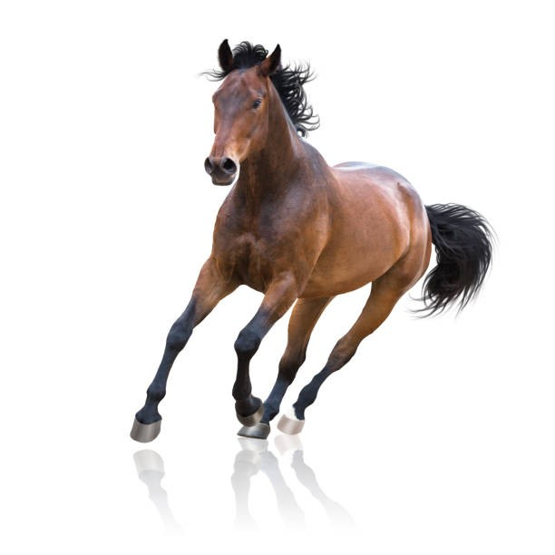
A running horse
record Point2D(double x, double y){}
record Horse(String name, Point2D location){
Horse withLocation(Point2D dest){ return new Horse(name,dest); }
double speed(){ return 10d; }
void draw(Graphics2D g){/*...*/}
Horse run(Point2D dest){
double s = this.speed(); //Local vars initialized when declared
double diffX = dest.x() - location.x();
double diffY = dest.y() - location.y();
double distance= Math.sqrt(diffX * diffX + diffY * diffY);
if (distance < s){ return this.withLocation(dest); }//Early exit (guard) when possible
double dir= Math.atan2(diffY,diffX);//Local vars as late as possible
return this.withLocation(new Point2D(
location.x() + s * Math.cos(dir),//complex subexpressions are fine
location.y() + s * Math.sin(dir) //if well formatted
));
}
}

A running dog
record Point2D(double x, double y){}
record Dog(String name, Point2D location){
Dog withLocation(Point2D dest){ return new Dog(name,dest); }
double speed(){ return 5d; }
void draw(Graphics2D g){/*...*/}
Dog run(Point2D dest){ //Same cutpasted code here.
double s = this.speed(); //Can we reuse the code before somehow?
double diffX = dest.x() - location.x();
double diffY = dest.y() - location.y();
double distance= Math.sqrt(diffX * diffX + diffY * diffY);
if (distance < s){ return this.withLocation(dest); }
double dir= Math.atan2(diffY,diffX);
return this.withLocation(new Point2D(
location.x() + s * Math.cos(dir),
location.y() + s * Math.sin(dir)
));
}
}
interface Animal{ //interface animal: a generalization of dog/horse
String name(); //fields are now just methods
Point2D location(); //speed() was a method originally
double speed(); //note how there is no difference any more!
void draw(Graphics2D g); //abstract methods for unique behavior
Animal withLocation(Point2D dest); //abstract methods for unique behavior
default Animal run(Point2D dest){ //default methods for common behavior
double s = this.speed();
double diffX = dest.x() - location().x();
double diffY = dest.y() - location().y();
double distance= Math.sqrt(diffX * diffX + diffY * diffY);
if (distance < s){ return this.withLocation(dest); }
double dir= Math.atan2(diffY,diffX);
return this.withLocation(new Point2D(
location().x() + s * Math.cos(dir),
location().y() + s * Math.sin(dir)
));
}
}
A running animal
A running animal
record Horse(String name, Point2D location) implements Animal{
public Horse withLocation(Point2D dest){ return new Horse(name,dest); }
public double speed(){ return 10d; }
public void draw(Graphics2D g){/*..*/}
}
record Dog(String name, Point2D location) implements Animal{
public Dog withLocation(Point2D dest){ return new Dog(name,dest); }
public double speed(){ return 5d; }
public void draw(Graphics2D g){/*..*/}
}
//Now Horse and Dog code is minimal and without duplication
//Note: fields name and location automatically generate getters
//suitable to satisfy the abstract getters in the interface.
//That is one of the biggest advantages of records+interfaces!

But.. the dog is not moving...
We are just making a new dog that looks like the old one but it is in another
location.
●
This way of coding is actually quite good at preventing subtitle aliasing
mistakes, and given the improvements in java objects allocation speed, it
is not a big problem for performance.
●
However, what if we DO WANT to actually mutate our dog?
interface Animal{
String name();
Point2D location();
void location(Point2D location); //new method: a setter!
double speed();
void draw(Graphics2D g);
default void run(Point2D dest){
double s = this.speed();
double diffX = dest.x() - location().x();
double diffY = dest.y() - location().y();
double distance= Math.sqrt(diffX * diffX + diffY * diffY);
if (distance < s){ this.location(dest); return; } //acceptable in 1 line
double dir = Math.atan2(diffY,diffX);
this.location(new Point2D(
location().x() + s * Math.cos(dir),
location().y() + s * Math.sin(dir)
));
}
}
A mutable running animal
class Horse implements Animal{
public Horse(String name, Point2D location){ this.name= name; this.location= location; }
private String name; private Point2D location;
public String name(){ return name; }
public Point2D location(){ return location; }
public void location(Point2D location){ this.location = location; }
public double speed(){ return 10d; }
public void draw(Graphics2D g){/*..*/}
}
class Dog implements Animal{
public Dog(String name, Point2D location){ this.name= name; this.location= location; }
private String name; private Point2D location;
public String name(){ return name; }
public Point2D location(){ return location; }
public void location(Point2D location){ this.location = location; }
public double speed(){ return 5d; }
public void draw(Graphics2D g){/*..*/}
}
//The interface is about the same size, but the classes are bigger then the records
//Also: I’ve not declared toString, equals and hashCode.
A mutable running animal
class Horse implements Animal{
public Horse(String name, Point2D location){ this.name= name; this.location= location; }
private String name; private Point2D location;
public String name(){ return name; }
public Point2D location(){ return location; }
public void location(Point2D location){ this.location = location; }
public double speed(){ return 10d; }
public void draw(Graphics2D g){/*..*/}
}
class Dog implements Animal{
public Dog(String name, Point2D location){ this.name= name; this.location= location; }
private String name; private Point2D location;
public String name(){ return name; }
public Point2D location(){ return location; }
public void location(Point2D location){ this.location = location; }
public double speed(){ return 5d; }
public void draw(Graphics2D g){/*..*/}
}
//The interface is about the same size, but the classes are bigger then the records
//Also: I’ve not declared toString, equals and hashCode.
A mutable running animal

Animal x= ....
x.run(myDest);
class Horse implements Animal{
..
public double speed(){
return 10d;
}
..
}
interface Animal{
..
default void run(Point2D dest){
double s= this.speed();
..
}
}

Animal x= ....
x.run(myDest);
Animal x= new Horse(...);
x.run(myDest);
class Horse implements Animal{
..
public double speed(){
return 10d;
}
..
}
interface Animal{
..
default void run(Point2D dest){
double s= this.speed();
..
}
}
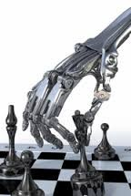
Animal x= ....
x.run(myDest);
Animal x= new Horse(...);
x.run(myDest);
class Horse implements Animal{
..
public double speed(){
return 10d;
}
..
}
interface Animal{
..
default void run(Point2D dest){
double s= this.speed();
..
}
}
Animal x= new Horse(...);
x.run(myDest); <-- Animal.run
… double s= this.speed();
Animal x= ....
x.run(myDest);
… double s= this.speed();
class Horse implements Animal{
..
public double speed(){
return 10d;
}
..
}
interface Animal{
..
default void run(Point2D dest){
double s= this.speed();
..
}
}
Animal x= ....
x.run(myDest);
… double s= this.speed();
class Horse implements Animal{
..
public double speed(){
return 10d;
}
..
}
interface Animal{
..
default void run(Point2D dest){
double s= this.speed();
..
}
}
Animal x= ....
x.run(myDest);
… double s= this.speed();
Animal x= new Horse(...);
x.run(myDest);
… double s= this.speed();
class Horse implements Animal{
..
public double speed(){
return 10d;
}
..
}
interface Animal{
..
default void run(Point2D dest){
double s= this.speed();
..
}
}
Animal x= ....
x.run(myDest);
… double s= this.speed();
Animal x= new Horse(...);
x.run(myDest);
… double s= this.speed();
Animal x= new Horse(...);
x.run(myDest);
… double s= 10;
class Horse implements Animal{
..
public double speed(){
return 10d;
}
..
}
interface Animal{
..
default void run(Point2D dest){
double s= this.speed();
..
}
}
Overriding
●
Defining a new implementation for an existing method.
●
That is,
One method → many different implementations
Two mental models
●
Look up: (as shown in the example)
At run time, the computer explores the hierarchy and searches
for the most specific implementation.
●
Flattening:
At compile time, the methods are imported from the base
(Animal) into the heir (Horse and Dog). Then the runtime simply
takes the methods from the code of the current class.
●
Both are good mental model. Chose the one you prefer
Quiz 1: what happens here?
A > B > C What does it print?
interface A{
default String m() {return "A";}
}
interface B extends A{
default String m() {return "B";}
}
class C implements B{
public String m() {return "C";}
}
System.out.println(new C().m());
RULE:
It explores the hierarchy
and searches for
the most specific
implementation.
Quiz 1: what happens here?
A > B > C What does it print?
“C”
●
Method is defined directly in C, so A.m and B.m are ignored
C.m is selected
interface A{
default String m() {return "A";}
}
interface B extends A{
default String m() {return "B";}
}
class C implements B{
public String m() {return "C";}
}
System.out.println(new C().m());
RULE:
It explores the hierarchy
and searches for
the most specific
implementation.
Quiz 2: what happens here?
A > B > C What does it print?
interface A{
default String m() {return "A";}
}
interface B extends A{
default String m() {return "B";}
}
class C implements B{
}
System.out.println(new C().m());
RULE:
It explores the hierarchy
and searches for
the most specific
implementation.
Quiz 2: what happens here?
A > B > C What does it print?
“B”
●
Method is defined in B and A, but B is more specific than A
B.m is selected
interface A{
default String m() {return "A";}
}
interface B extends A{
default String m() {return "B";}
}
class C implements B{
}
System.out.println(new C().m());
RULE:
It explores the hierarchy
and searches for
the most specific
implementation.
Quiz 3: what happens here?
A > B > C What does it print?
interface A{
default String m() {return "A";}
}
interface B extends A{
default String m() {return "B";}
}
class C implements A,B{
}
System.out.println(new C().m());
RULE:
It explores the hierarchy
and searches for
the most specific
implementation.
A > B > C What does it print?
“B”
●
B is still more specific then A. B.m is selected.
This would change in other languages (python)
interface A{
default String m() {return "A";}
}
interface B extends A{
default String m() {return "B";}
}
class C implements A,B{
}
System.out.println(new C().m());
Quiz 3: what happens here?
RULE:
It explores the hierarchy
and searches for
the most specific
implementation.
Quiz 4: what happens here?
A > B > C What does it print?
interface A{
default String m() {return "A";}
}
interface B extends A{
}
class C implements B{
}
System.out.println(new C().m());
RULE:
It explores the hierarchy
and searches for
the most specific
implementation.
Quiz 4: what happens here?
A > B > C What does it print?
“A”
●
Method is only defined in A, so A.m is selected
interface A{
default String m() {return "A";}
}
interface B extends A{
}
class C implements B{
}
System.out.println(new C().m());
RULE:
It explores the hierarchy
and searches for
the most specific
implementation.
Quiz 5: what happens here?
A > B, A > C What does it print?
interface A{
default String m() {return "A";}
}
interface B extends A{
default String m() {return "B";}
}
class C implements A{
}
System.out.println(new C().m());
RULE:
It explores the hierarchy
and searches for
the most specific
implementation.
Quiz 5: what happens here?
A > B, A > C What does it print?
“A”
●
C only implements A, thus A.m is selected
interface A{
default String m() {return "A";}
}
interface B extends A{
default String m() {return "B";}
}
class C implements A{
}
System.out.println(new C().m());
RULE:
It explores the hierarchy
and searches for
the most specific
implementation.
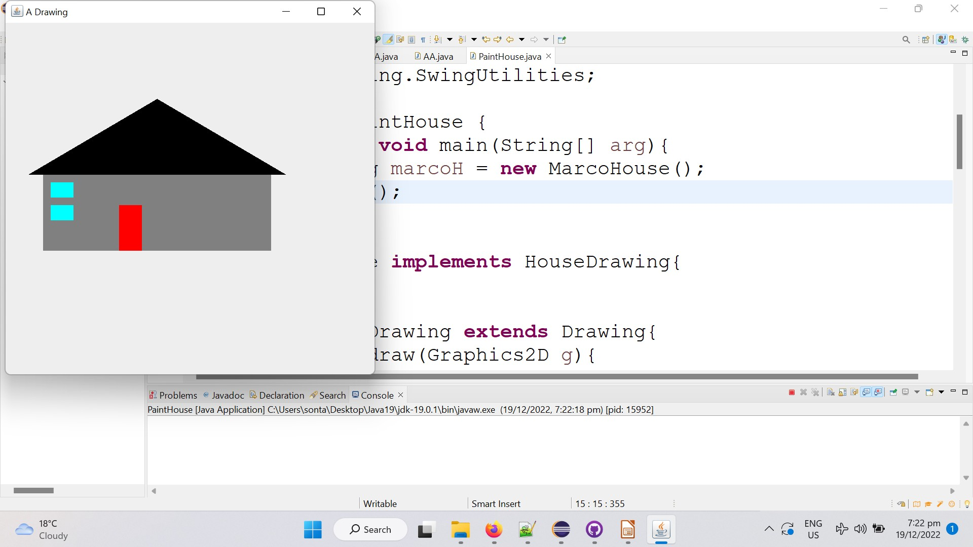
public class PaintHouse {
public static void main(String[] arg){
HouseDrawing marcoH= new MarcoHouse();
marcoH.show();
}
}
class MarcoHouse implements HouseDrawing{
//EMPTY!
}
interface HouseDrawing extends Drawing{
..
}
●
How are we getting a house
if the ‘MarcoHouse’ class
is empty??
●
By inheriting the behavior of
HouseDrawing!
Code reuse example
Code reuse example
interface HouseDrawing extends Drawing{
default void draw(Graphics2D g){
drawWall(g);
drawWindows(g);
drawDoor(g);
drawRoof(g);
}
default void drawWall(Graphics2D g){
g.setColor(Color.GRAY);
g.fillRect(50,200,300,100);
}
default void drawWindows(Graphics2D g){
g.setColor(Color.CYAN);
g.fillRect(60,210,30,20);
g.fillRect(60,240,30,20);
}
default void drawDoor(Graphics2D g){
g.setColor(Color.RED);
g.fillRect(150,240,30,60);
}
default void drawRoof(Graphics2D g){
g.setColor(Color.BLACK);
g.fillPolygon(new int[]{30,200,370},
new int[]{200,100,200},3);
}
}
Method HouseDrawing.draw
it calls many sub methods with
descriptive name.
Why it is good?
We could just have a single
method, right?
interface HouseDrawing extends Drawing{
default void draw(Graphics2D g){
g.setColor(Color.GRAY);
g.fillRect(50,200,300,100);
g.setColor(Color.CYAN);
g.fillRect(60,210,30,20);
g.fillRect(60,240,30,20);
g.setColor(Color.RED);
g.fillRect(150,240,30,60);
g.setColor(Color.BLACK);
g.fillPolygon(new int[]{30,200,370},
new int[]{200,100,200},3);
}
}
We could just have a single
method, right?
Here it is how it would look
like… so much smaller,…
so.. why it is worst?
Code reuse example
interface HouseDrawing extends Drawing{
default void draw(Graphics2D g){
//draw wall
g.setColor(Color.GRAY);
g.fillRect(50,200,300,100);
//draw windows
g.setColor(Color.CYAN);
g.fillRect(60,210,30,20);
g.fillRect(60,240,30,20);
//draw door
g.setColor(Color.RED);
g.fillRect(150,240,30,60);
//draw roof
g.setColor(Color.BLACK);
g.fillPolygon(new int[]{30,200,370},
new int[]{200,100,200},3);
}
}
We could just have a single
method, right?
Ok, now with comments…
Now it is near as long as the
original code, and it is still
worst.
Sub method with good name
>
comments for code sections
Code reuse example
interface HouseDrawing extends Drawing{
default void draw(Graphics2D g){
drawWall(g);
drawWindows(g);
drawDoor(g);
drawRoof(g);
}
default void drawWall(Graphics2D g){
g.setColor(Color.GRAY);
g.fillRect(50,200,300,100);
}
default void drawWindows(Graphics2D g){
g.setColor(Color.CYAN);
g.fillRect(60,210,30,20);
g.fillRect(60,240,30,20);
}
default void drawDoor(Graphics2D g){
g.setColor(Color.RED);
g.fillRect(150,240,30,60);
}
default void drawRoof(Graphics2D g){
g.setColor(Color.BLACK);
g.fillPolygon(new int[]{30,200,370},
new int[]{200,100,200},3);
}
}
Method HouseDrawing.draw
So, why it is so good in this
form?
What are those methods good
for?
Code reuse example
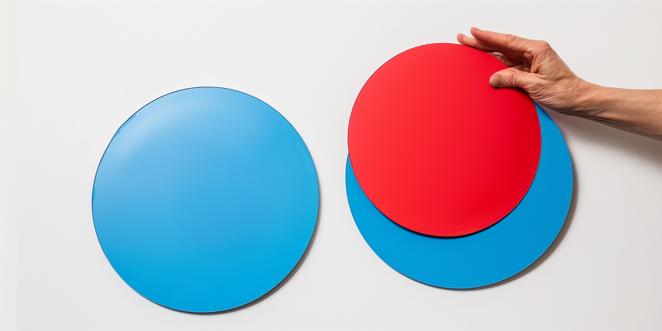
interface HouseDrawing extends Drawing{
default void draw(Graphics2D g){
drawWall(g);
drawWindows(g);
drawDoor(g);
drawRoof(g);
}
default void drawWall(Graphics2D g){
g.setColor(Color.GRAY);
g.fillRect(50,200,300,100);
}
default void drawWindows(Graphics2D g){
g.setColor(Color.CYAN);
g.fillRect(60,210,30,20);
g.fillRect(60,240,30,20);
}
default void drawDoor(Graphics2D g){
g.setColor(Color.RED);
g.fillRect(150,240,30,60);
}
default void drawRoof(Graphics2D g){
g.setColor(Color.BLACK);
g.fillPolygon(new int[]{30,200,370},
new int[]{200,100,200},3);
}
}
Method HouseDrawing.draw
So, why it is so good in this
form?
What are those methods good
for?
OVERRIDING!
Code reuse example
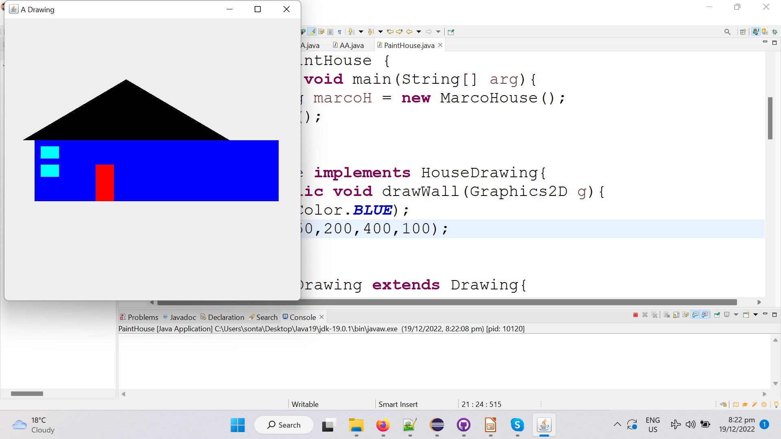
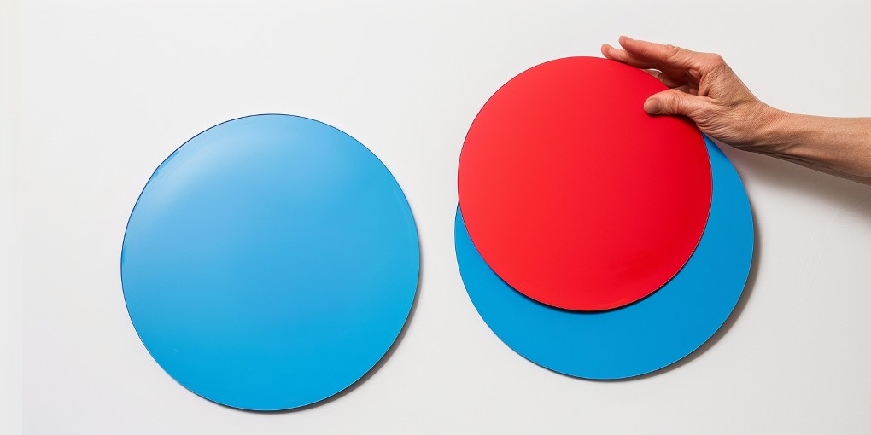
public class PaintHouse {
public static void main(String[] arg){
HouseDrawing marcoH= new MarcoHouse();
marcoH.show();
}
}
class MarcoHouse implements HouseDrawing{
@Override
public void drawWall(Graphics2D g){
g.setColor(Color.BLUE);
g.fillRect(50,200,400,100);
}
}
●
By Overriding just the
behavior we need, we can
specify the changes we want.
No need to repeat all the
code.
Code reuse example
Template method pattern
●
This way of programming is called
“The template method pattern”
●
PaintHouse.draw is the template method
●
The methods called by PainHouse.draw are the hook methods.
(PaintHouse.drawWall, PaintHouse.drawWindow ..)
The rest of the code
//At this stage, you can ignore this code
interface Drawing{//It is just to connect with Swing
void draw(Graphics2D g);
default void show(){ SwingUtilities.invokeLater(this::_show); }
default void _show(){
JFrame f=new JFrame("A Drawing");
f.setDefaultCloseOperation(JFrame.DISPOSE_ON_CLOSE);
f.setPreferredSize(size());
f.add(new JPanel(){//Anonymous inner class, will see later
private static final long serialVersionUID= 1L;
@Override protected void paintComponent(Graphics g){
super.paintComponent(g); //super call, will see later
draw((Graphics2D)g);
}});
f.pack();
f.setVisible(true);
}
default Dimension size(){ return new Dimension(500,500); }
}
●
If you curios, here
is the rest of the
code needed to
draw the house.
●
A ‘Drawing’
interface allowing
to draw stuff using
a ‘show’ method.

See you on
Monday!
●
Lecture 4:
Time travel!

