
SWEN 221
SWEN 221
Marco Servetto
Marco Servetto
CO258
CO258
www.youtube.com/MarcoServetto
www.youtube.com/MarcoServetto

Time
Time
Travel
Travel
Time
Time
Travel
Travel
Good object oriented code can transcend time
Good object oriented code can transcend time
and invert the usual flow of control
and invert the usual flow of control
Normal flow of time, normal flow of control
record Cat(String name,int age){//Cat from 2020
@Override public String toString(){
return ">^.^<"+name;
}
}
2020
Normal flow of time, normal flow of control
record Cat(String name,int age){//Cat from 2020
@Override public String toString(){
return ">^.^<"+name;
}
}
record Person(String name, Cat cat){//Person from 2022
@Override public String toString(){
return name + " & " + cat.toString();//Calls the code of Cat from 2020
}
}
2022
2020
Code from the future can call code from the past.
Normal expected flow of control
Normal flow of time, normal flow of control
record Cat(String name,int age){//Cat from 2020
@Override public String toString(){
return ">^.^<"+name;
}
}
record Person(String name, Cat cat){//Person from 2022
@Override public String toString(){
return name + " & " + cat.toString();//Calls the code of Cat from 2020
}
}
class Main{//Main from 2023
public static void main(String[] arg){
var bob = new Person("Bob",new Cat("Meow",2)).toString();
//Calls the code of Person from 2022
//Person calls code from 2020
System.out.println(bob);//Bob & >^.^<Meow
}
}
2023
2022
2020
Code from the future can call code from the past.
Normal expected flow of control

Time travel! Inverted flow of control
import java.util.List; //List was written in the far past (probably 1996)
record Cat(String name,int age){//Cat from 2020
@Override public String toString(){
return ">^.^<"+name;
}
}
class Main{//written today (2023)
public static void main(String[] arg){
var cats= List.of(new Cat("Molly",4),new Cat("Meow",2)).toString();
//Calls the code of List from 1996
//List calls code from 2020!!
System.out.println(cats);//[>^.^<Molly, >^.^<Meow]
}
}
2023
1996
2020
Code from the past calls code from (its) future.
Time travel!
●
The trick: list just knows about ‘Object’,
●
Object was written before List.
●
Cat extends Object.
●
In this case, Object.toString works as a time wormhole
I call it "a time wormhole" to emphasize the idea that
the calling code is able to access code written in the
future through some kind of shortcut.
To convey the idea that the flow of control is able to
bend or circumvent the normal time dependency flow.
How can this be?
2023
1996
2020

We have seen this already!
interface HouseDrawing extends Drawing{
default void draw(Graphics2D g){
this.drawWall(g);
this.drawWindows(g);
this.drawDoor(g);
this.drawRoof(g);
}
default void drawWall(Graphics2D g){
g.setColor(Color.GRAY);
g.fillRect(50,200,300,100);
}
default void drawWindows(Graphics2D g){
g.setColor(Color.CYAN);
g.fillRect(60,210,30,20);
g.fillRect(60,240,30,20);
}
default void drawDoor(Graphics2D g){
g.setColor(Color.RED);
g.fillRect(150,240,30,60);
}
default void drawRoof(Graphics2D g){
g.setColor(Color.BLACK);
g.fillPolygon(new int[]{30,200,370},
new int[]{200,100,200},3);
}
}
HouseDrawing was written
some time ago
But MarcoHouse written today
can override method drawWall
Now the code of
HouseDrawing.draw can call
code written in the future!
class MarcoHouse implements HouseDrawing{
@Override
public void drawWall(Graphics2D g){
g.setColor(Color.BLUE);
g.fillRect(50,200,400,100);
}
}

We have seen this already!
interface HouseDrawing extends Drawing{
default void draw(Graphics2D g){
this.drawWall(g);
this.drawWindows(g);
this.drawDoor(g);
this.drawRoof(g);
}
default void drawWall(Graphics2D g){
g.setColor(Color.GRAY);
g.fillRect(50,200,300,100);
}
default void drawWindows(Graphics2D g){
g.setColor(Color.CYAN);
g.fillRect(60,210,30,20);
g.fillRect(60,240,30,20);
}
default void drawDoor(Graphics2D g){
g.setColor(Color.RED);
g.fillRect(150,240,30,60);
}
default void drawRoof(Graphics2D g){
g.setColor(Color.BLACK);
g.fillPolygon(new int[]{30,200,370},
new int[]{200,100,200},3);
}
}
HouseDrawing was written
some time ago
But MarcoHouse written today
can override method drawWall
Now the code of
HouseDrawing.draw can call
code written in the future!
class MarcoHouse implements HouseDrawing{
@Override
public void drawWall(Graphics2D g){
g.setColor(Color.BLUE);
g.fillRect(50,200,400,100);
}
}


t
h
i
s
.
d
r
a
w
W
a
l
l
(
g
)
;
The receiver
(
this
, in this case)
is the key
to time travel.
Static type and Dynamic type
●
Every time the static type of a value is different from its dynamic
type, time traveling can happen!
●
Static type: the type of a value as seen by the compiler
‘
this
’ static type is
HouseDrawing
●
Dynamic type: the type of a value at run time
‘
this
’ dynamic type is
MarcoHouse
●
Time traveling: code from the past calls code from the future
Example hierarchy
interface Animal {
default void run(..){ . . . }
}
class Horse implements Animal{
. . .
}
class Dog implements Animal{
. . .
}
Animal
Horse
Dog
Superclass : Animal
Subclass: Horse, Dog
Mental Model of Typing
x
Horse
Horse(“fury”)
Object
y
Animal
St
a
t
i
c
(
or
D
e
c
l
ar
e
d)
t
y
p
e
of
y
i
s
“
A
ni
m
a
l
”
Dyn
am
i
c
(
o
r
Ru
nt
i
m
e)
t
ype
o
f
x
an
d
y
i
s
“
Ho
r
se”
•
Static Type:
–
Declared type of a variable
•
Dynamic Type:
–
Type of object referred to by variable
–
potentially different in different moments
interface Animal {
default void run(..){ . . . }
}
class Horse implements Animal{
. . .
}
class Dog implements Animal{
. . .
}
Horse x = new Horse(“fury”);
Animal y = x;
//y is still a horse.
//But it is ‘dressed’ like an animal
Again!
●
Every time the static type of a value is different from its dynamic
type, time traveling can happen!
●
What is the static type?
●
What is the dynamic type?
●
What is time traveling?

Animal x = ....
x.run(myDest);
class Horse implements Animal{
..
public double speed(){
return 10d;
}
..
}
interface Animal{
..
default void run(Point2D dest){
double s = this.speed();
..
}
}

Animal x = ....
x.run(myDest);
Animal x = new Horse(...);
x.run(myDest);
class Horse implements Animal{
..
public double speed(){
return 10d;
}
..
}
interface Animal{
..
default void run(Point2D dest){
double s = this.speed();
..
}
}
Is there time traveling
in this moment?
Animal x = ....
x.run(myDest);
Animal x = new Horse(...);
x.run(myDest);
class Horse implements Animal{
..
public double speed(){
return 10d;
}
..
}
interface Animal{
..
default void run(Point2D dest){
double s = this.speed();
..
}
}
The selected implementation
is the one inside Animal
-Animal is the static type
No time travel
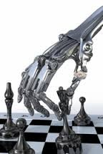
Animal x = ....
x.run(myDest);
Animal x = new Horse(...);
x.run(myDest);
class Horse implements Animal{
..
public double speed(){
return 10d;
}
..
}
interface Animal{
..
default void run(Point2D dest){
double s = this.speed();
..
}
}
Animal x = new Horse(...);
x.run(myDest); <-- Animal.run
… double s = this.speed();
Animal x = ....
x.run(myDest);
… double s = this.speed();
class Horse implements Animal{
..
public double speed(){
return 10d;
}
..
}
interface Animal{
..
default void run(Point2D dest){
double s = this.speed();
..
}
}
Animal x = ....
x.run(myDest);
… double s = this.speed();
class Horse implements Animal{
..
public double speed(){
return 10d;
}
..
}
interface Animal{
..
default void run(Point2D dest){
double s = this.speed();
..
}
}
Animal x = new Horse(...);
x.run(myDest);
… double s = this.speed();
Animal x = ....
x.run(myDest);
… double s = this.speed();
class Horse implements Animal{
..
public double speed(){
return 10d;
}
..
}
interface Animal{
..
default void run(Point2D dest){
double s = this.speed();
..
}
}
Animal x = ....
x.run(myDest);
… double s = this.speed();
Animal x = new Horse(...);
x.run(myDest);
… double s = this.speed();
Animal x = new Horse(...);
x.run(myDest);
… double s = 10;
class Horse implements Animal{
..
public double speed(){
return 10d;
}
..
}
interface Animal{
..
default void run(Point2D dest){
double s = this.speed();
..
}
}
The selected implementation
is the one inside Horse
Time traveling may happen here!
Animal.run is calling Horse.speed
Time travelling pros/cons
●
Pros: Open code
–
Future users of your code (this includes you) can make
better use/reuse of your code.
–
Most OO programming patterns are based on dynamic dispatch.
–
(we will see later) Enables for better testing and Mock objects
Time travelling pros/cons
●
Cons: open code
●
What can this code do?
interface Point{ int x(); int y(); }
...
void usePoint(Point p){
System.out.println(p.x());
}

Time travelling pros/cons
●
Cons: open code
●
What can this code do?
●
It could format the hard drive, for what I know!
●
The future can come to hunt us down
–
The future is very, very big; and could get antagonistic and violent.
●
Design for dynamic dispatch or prevent it!
The Future
The Future
interface Point{ int x(); int y(); }
...
void usePoint(Point p){
System.out.println(p.x());
}
Blocking time travelling:
Final classes, final methods
●
In Java the ‘final’ keyword means different things depending on
where it is used.
●
A final field or local variable can not be updated
●
A final class can not be extended
–
prevents further time traveling from that type!
●
A final method can not be overridden
–
prevents further time traveling from that method
●
Record are always final!
●
New: 'sealed' interfaces / classes are now available (see more later)
Exercises
record Person(String name, Cat cat){}
...
void usePerson(Person bob){
bob.name();
}
●
Q1 What is the static type of bob?
–
????
●
Q2 What is the dynamic type of bob?
–
????
●
Q3 Is there dynamic dispatch in the call
bob.name() ?
–
????
????
●
Q4 Is there time travel in the call
bob.name()?
–
????
Exercises
●
Q1 What is the static type of bob?
–
Person
●
Q2 What is the dynamic type of bob?
–
????
●
Q3 Is there dynamic dispatch in the call
bob.name() ?
–
????
????
●
Q4 Is there time travel in the call
bob.name()?
–
????
record Person(String name, Cat cat){}
...
void usePerson(Person bob){
bob.name();
}
Exercises
●
Q1 What is the static type of bob?
–
Person
●
Q2 What is the dynamic type of bob?
–
Person (records are final)
●
Q3 Is there dynamic dispatch in the call
bob.name() ?
–
????
????
●
Q4 Is there time travel in the call
bob.name()?
–
????
record Person(String name, Cat cat){}
...
void usePerson(Person bob){
bob.name();
}
Exercises
●
Q1 What is the static type of bob?
–
Person
●
Q2 What is the dynamic type of bob?
–
Person (records are final)
●
Q3 Is there dynamic dispatch in the call
bob.name() ?
–
No, the method name()
originates in Person (the static type)
●
Q4 Is there time travel in the call
bob.name()?
–
????
record Person(String name, Cat cat){}
...
void usePerson(Person bob){
bob.name();
}
Exercises
●
Q1 What is the static type of bob?
–
Person
●
Q2 What is the dynamic type of bob?
–
Person (records are final)
●
Q3 Is there dynamic dispatch in the call
bob.name() ?
–
No, the method name()
originates in Person (the static type)
●
Q4 Is there time travel in the call
bob.name()?
–
No, name() is final / Person is final
No time travel is possible:
Person needs to exists
to compile usePerson.
usePerson can predict the
behavior of .name
record Person(String name, Cat cat){}
...
void usePerson(Person bob){
bob.name();
}
interface Person{
String name();
Cat cat();
}
...
void usePerson(Person bob){
bob.name();
}
Exercises
●
Q1 What is the static type of bob?
–
????
●
Q2 What is the dynamic type of bob?
–
????
●
Q3 Is there dynamic dispatch in the call
bob.name() ?
–
????
????
●
Q4 Is there time travel in the call
bob.name()?
–
????
????
Exercises
●
Q1 What is the static type of bob?
–
Person
●
Q2 What is the dynamic type of bob?
–
????
●
Q3 Is there dynamic dispatch in the call
bob.name() ?
–
????
????
●
Q4 Is there time travel in the call
bob.name()?
–
????
????
interface Person{
String name();
Cat cat();
}
...
void usePerson(Person bob){
bob.name();
}
Exercises
●
Q1 What is the static type of bob?
–
Person
●
Q2 What is the dynamic type of bob?
–
Who knows! (interface)
●
Q3 Is there dynamic dispatch in the call
bob.name() ?
–
????
????
●
Q4 Is there time travel in the call
bob.name()?
–
????
????
interface Person{
String name();
Cat cat();
}
...
void usePerson(Person bob){
bob.name();
}
Exercises
●
Q1 What is the static type of bob?
–
Person
●
Q2 What is the dynamic type of bob?
–
Who knows! (interface)
●
Q3 Is there dynamic dispatch in the call
bob.name() ?
–
Yes, since name is abstract in
Person (the static type)
●
Q4 Is there time travel in the call
bob.name()?
–
????
????
interface Person{
String name();
Cat cat();
}
...
void usePerson(Person bob){
bob.name();
}
Exercises
●
Q1 What is the static type of bob?
–
Person
●
Q2 What is the dynamic type of bob?
–
Who knows! (interface)
●
Q3 Is there dynamic dispatch in the call
bob.name() ?
–
Yes, since name is abstract in
Person (the static type)
●
Q4 Is there time travel in the call
bob.name()?
–
Can be. Alice implements Person
can be written after usePerson is
compiled
interface Person{
String name();
Cat cat();
}
...
void usePerson(Person bob){
bob.name();
}
interface Person{
String name();
Cat cat();
}
record APerson(String name, Cat cat)
implements Person {}
...
void usePerson(Person bob){
bob.name();
}
Exercises
●
That is: the existence of ‘
APerson
’
changes none of the answers.
●
Open world mindset: we do not know
how many classes extends ‘
Person
’!
●
Q1 What is the static type of bob?
–
Person
●
Q2 What is the dynamic type of bob?
–
Who knows! (interface)
●
Q3 Is there dynamic dispatch in the call
bob.name() ?
–
Yes, since name is abstract in
Person (the static type)
●
Q4 Is there time travel in the call
bob.name()?
–
Can be. Alice implements Person
can be written after usePerson is
compiled
Exercises
interface Person{
String name();
Cat cat();
}
record APerson(String name, Cat cat)
implements Person {}
...
void usePerson(APerson bob){
bob.name();
}
●
Q1 What is the static type of bob?
–
????
●
Q2 What is the dynamic type of bob?
–
????
●
Q3 Is there dynamic dispatch in the call
bob.name() ?
–
????
????
●
Q4 Is there time travel in the call
bob.name()?
–
????
Exercises
interface Person{
String name();
Cat cat();
}
record APerson(String name, Cat cat)
implements Person {}
...
void usePerson(APerson bob){
bob.name();
}
●
Q1 What is the static type of bob?
–
APerson
●
Q2 What is the dynamic type of bob?
–
????
●
Q3 Is there dynamic dispatch in the call
bob.name() ?
–
????
????
●
Q4 Is there time travel in the call
bob.name()?
–
????
Exercises
interface Person{
String name();
Cat cat();
}
record APerson(String name, Cat cat)
implements Person {}
...
void usePerson(APerson bob){
bob.name();
}
●
Q1 What is the static type of bob?
–
APerson
●
Q2 What is the dynamic type of bob?
–
APerson (records are final)
●
Q3 Is there dynamic dispatch in the call
bob.name() ?
–
????
????
●
Q4 Is there time travel in the call
bob.name()?
–
????
Exercises
interface Person{
String name();
Cat cat();
}
record APerson(String name, Cat cat)
implements Person {}
...
void usePerson(APerson bob){
bob.name();
}
●
Q1 What is the static type of bob?
–
APerson
●
Q2 What is the dynamic type of bob?
–
APerson (records are final)
●
Q3 Is there dynamic dispatch in the call
bob.name() ?
–
Yes*, the implementation could be
either in Person or APerson
●
Q4 Is there time travel in the call
bob.name()?
–
????
Exercises
interface Person{
String name();
Cat cat();
}
record APerson(String name, Cat cat)
implements Person {}
...
void usePerson(APerson bob){
bob.name();
}
●
Q1 What is the static type of bob?
–
APerson
●
Q2 What is the dynamic type of bob?
–
APerson (records are final)
●
Q3 Is there dynamic dispatch in the call
bob.name() ?
–
Yes*, the implementation could be
either in Person or APerson
●
Q4 Is there time travel in the call
bob.name()?
–
No, name() is final / APerson is final
Exercises
interface Person{
String name();
Cat cat();
}
record APerson(String name, Cat cat)
implements Person {}
...
void usePerson(APerson bob){
((Person)bob).name();
}
●
Q1 What is the static type of bob?
–
APerson
●
Q2 What is the dynamic type of bob?
–
APerson (records are final)
●
Q3 Is there dynamic dispatch in the call
((Person)bob).name() ?
–
Yes*, the implementation could be
either in Person or APerson
●
Q4 Is there time travel in the call
bob.name()?
–
No, name() is final / APerson is final
Exercises
interface Person{
default String name(){return "Adam";}
Cat cat();
}
record APerson(String name, Cat cat)
implements Person {}
...
void usePerson(APerson bob){
bob.name();
}
●
That is: Person.name having a default
implementation changes nothing
since it is overridden in the static type
*since name() is overridden in the final
APerson, the dynamic dispatch may be
optimized away
●
Q1 What is the static type of bob?
–
APerson
●
Q2 What is the dynamic type of bob?
–
APerson (records are final)
●
Q3 Is there dynamic dispatch in the call
bob.name() ?
–
Yes*, the implementation could be
either in Person or APerson
●
Q4 Is there time travel in the call
bob.name()?
–
No, name() is final / APerson is final
Exercises
interface Person{
default String name(){return "Adam";}
Cat cat();
}
record APerson(Cat cat)//Note: no name
implements Person {}
...
void usePerson(APerson bob){
bob.name();
}
●
Q1 What is the static type of bob?
–
APerson
●
Q2 What is the dynamic type of bob?
–
APerson (records are final)
●
Q3 Is there dynamic dispatch in the call
bob.name() ?
–
Yes, the implementation could be
either in Person or APerson
●
Q4 Is there time travel in the call
bob.name()?
–
No, (final) APerson must exists for
usePerson to compile.
Exercises
interface Destiny{
default void accept(){
System.out.println("Oh, well..");
}
default int fight(){
this.accept();
return Integer.MAX_VALUE;
}
}
●
Q1 What is the static type of ‘this’?
–
????
●
Q2 What is the dynamic type of ‘this’?
–
????
●
Q3 Is there dynamic dispatch in the call
this.accept() ?
–
????
????
●
Q4 Is there time travel in the call
this.accept()?
–
????
????
Exercises
●
Q1 What is the static type of ‘this’?
–
Destiny
●
Q2 What is the dynamic type of ‘this’?
–
????
●
Q3 Is there dynamic dispatch in the call
this.accept() ?
–
????
????
●
Q4 Is there time travel in the call
this.accept()?
–
????
????
interface Destiny{
default void accept(){
System.out.println("Oh, well..");
}
default int fight(){
this.accept();
return Integer.MAX_VALUE;
}
}
Exercises
●
Q1 What is the static type of ‘this’?
–
Destiny
●
Q2 What is the dynamic type of ‘this’?
–
Who knows
●
Q3 Is there dynamic dispatch in the call
this.accept() ?
–
????
????
●
Q4 Is there time travel in the call
this.accept()?
–
????
????
interface Destiny{
default void accept(){
System.out.println("Oh, well..");
}
default int fight(){
this.accept();
return Integer.MAX_VALUE;
}
}
Exercises
●
Q1 What is the static type of ‘this’?
–
Destiny
●
Q2 What is the dynamic type of ‘this’?
–
Who knows
●
Q3 Is there dynamic dispatch in the call
this.accept() ?
–
Yes, the implementation could be in
the subclass of Destiny
●
Q4 Is there time travel in the call
this.accept()?
–
????
????
interface Destiny{
default void accept(){
System.out.println("Oh, well..");
}
default int fight(){
this.accept();
return Integer.MAX_VALUE;
}
}
Exercises
●
Q1 What is the static type of ‘this’?
–
Destiny
●
Q2 What is the dynamic type of ‘this’?
–
Who knows
●
Q3 Is there dynamic dispatch in the call
this.accept() ?
–
Yes, the implementation could be in
the subclass of Destiny
●
Q4 Is there time travel in the call
this.accept()?
–
Who knows; it depends on the
dynamic type of ‘this’
interface Destiny{
default void accept(){
System.out.println("Oh, well..");
}
default int fight(){
this.accept();
return Integer.MAX_VALUE;
}
}
The iconic set up
interface Paintable{ void paint(Graphics2D g); }
...
void paintAll(List<Paintable> ps, Graphics2D g){
for(Paintable p:ps) { p.paint(g); }
}
●
This is the iconic example for Time travelling / inversion of control.
●
Any kind of object can implement
Paintable
●
Code taking a list of
Paintable
can treat them uniformly.
●
p.paint(g)
: we purposely call a function with no exact idea of what is doing. It
looks silly at first, but it is the best feature of OO.
●
Dynamic dispatch works like an ‘if’ on an unbounded amount of options.
●
If
Paintable
is implemented again after we complete
paintAll
,
time travel may happen
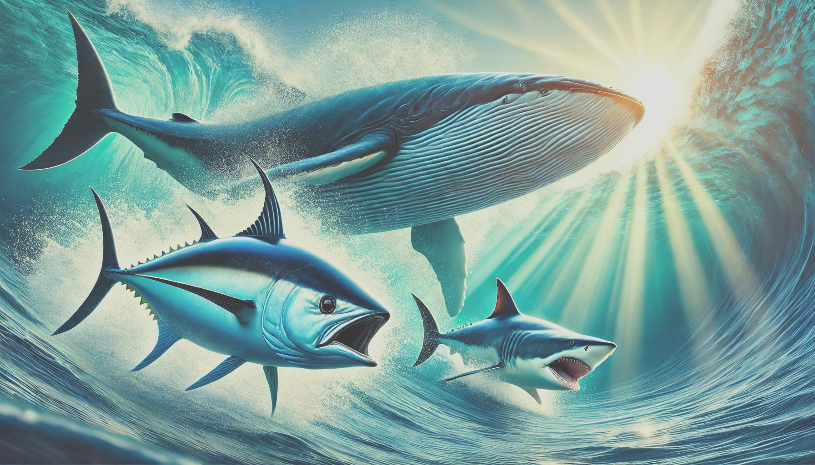


class Fish{/*primitive vertebrate features*/}
class BonyFish extends Fish{/*skeleton made of bone*/}
class CartilaginousFish extends Fish{/*skeleton made of cartilage*/}
//CartilaginousFish includes
class Shark extends CartilaginousFish{/*Mighty*/}
//BonyFish includes
class RayFinnedFish extends BonyFish{/*most modern fish, thin fins supported by rays*/}
class Tuna extends RayFinnedFish{/*fast, powerful swimmer*/}
class Goldfish extends RayFinnedFish{/*tiny, cute, but still bony!*/}
class LobeFinnedFish extends BonyFish{/*fleshy fins with bones inside*/}
class EarlyTetrapod extends LobeFinnedFish{/*first real limbs*/}
class Amphibian extends EarlyTetrapod{/*lays eggs in water, can also breath air*/}
class Reptiliomorph extends Amphibian{/*more land-adapted, tougher skin, stronger legs*/}
class Reptile extends Reptiliomorph{/* scaly skin, lays eggs on land*/}
class Mammal extends Reptile{/*warm-blooded, produces milk*/}
class Cetacean extends Mammal{/*fully aquatic mammal*/}
class Whale extends Cetacean{/*Mighty*/}
class Human extends Mammal{/*tool-using, occasionally intelligent*/}

class Fish{/*primitive vertebrate features*/}
class BonyFish extends Fish{/*skeleton made of bone*/}
class CartilaginousFish extends Fish{/*skeleton made of cartilage*/}
//CartilaginousFish includes
class Shark extends CartilaginousFish{/*Mighty*/}
//BonyFish includes
class RayFinnedFish extends BonyFish{/*most modern fish, thin fins supported by rays*/}
class Tuna extends RayFinnedFish{/*fast, powerful swimmer*/}
class Goldfish extends RayFinnedFish{/*tiny, cute, but still bony!*/}
class LobeFinnedFish extends BonyFish{/*fleshy fins with bones inside*/}
class EarlyTetrapod extends LobeFinnedFish{/*first real limbs*/}
class Amphibian extends EarlyTetrapod{/*lays eggs in water, can also breath air*/}
class Reptiliomorph extends Amphibian{/*more land-adapted, tougher skin, stronger legs*/}
class Reptile extends Reptiliomorph{/* scaly skin, lays eggs on land*/}
class Mammal extends Reptile{/*warm-blooded, produces milk*/}
class Cetacean extends Mammal{/*fully aquatic mammal*/}
class Whale extends Cetacean{/*Mighty*/}
class Human extends Mammal{/*tool-using, occasionally intelligent*/}
Fish f= new Whale();//All good! winner on Fish
Fish f= new Shark();//All good, but not as mighty
RayFinnedFish f= new Tuna();// Arguably, the mightiest of this category
Yes, phylogenetically whales (and us) are fish.
In programming, this is called transitivity of subtyping.
Breathing water:
We lost the ability to breathe water because our ancestors crawled onto land
and never looked back… until whales regretted the decision, but by then, it
was too late, LSP was broken.
(LSP = Liskov Substitution Principle)
Breathing water:
We lost the ability to breathe water because our ancestors crawled onto land and never looked
back… until whales regretted the decision, but by then, it was too late, LSP was broken.
Liskov Substitution Principle (LSP) states:
"A subtype should be able to replace its parent type without altering
the correctness of the program."
Reframed:
"If a type inherits from another, it should never lose the abilities of its parent."
In biological evolution, we do lose skills over time (like breathing water).
In good OOP design, we shouldn’t lose core functionality when subclassing.
Liskov Substitution Principle
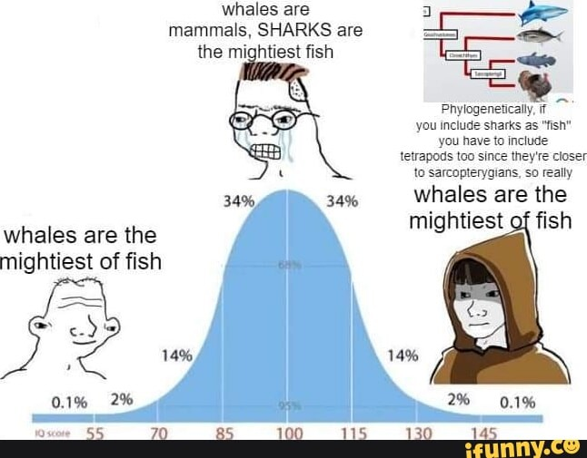


Next! Old Java and New Java goes to battle!

