
SWEN 221
SWEN 221
Marco Servetto
Marco Servetto
CO258
CO258
www.youtube.com/MarcoServetto
www.youtube.com/MarcoServetto

nit tests
nit tests


Unit testing with
JUnit
JUnit
a Unit Testing Framework
–
Kent Beck (XP, Smalltalk)
–
Erich Gamma (Eclipse, Patterns)
Using Junit:
–
Tests are Java methods
–
Test suites are Java classes
–
Annotations mark them out
–
API for writing tests
–
IDE support (Eclipse…)
Anatomy of a
JUnit
Test
In your test class
–
(typically 1-1 with top level modeling concepts)
import static org.junit.jupiter.api.Assertions.*;
import org.junit.jupiter.api.Test;
●
Annotate methods with @Test
The
JUnit
API
A range of assert** methods:
●
assertTrue(boolean)
●
assertTrue(String message, boolean)
●
assertEquals(Object expect, Object actual) //has graphical support for string diffs!!
●
assertEquals(float expected, float actual, float delta)
●
assertNull, assertNotNull
●
assertFalse
●
assertSame, assertNotSame
●
assertThrows(Err.class,()->myCode)
●
fail(), fail(String message)
import static org.junit.jupiter.api.Assertions.*;
import org.junit.jupiter.api.Test;
public class MyTestSuit{
@Test public void testDogBarks(){
Dog dog = new Dog(...);
String sound = dog.bark();
assertEquals("Woof", sound);
}
}
record MyDate(int day, int month, int year){
MyDate{
// check invariants hold
if (day <= 0 || month < 0){ throw new IllegalArgumentException(..); }
if (day > 31 || month > 12){ throw new IllegalArgumentException(..); }
var aprJunSepNov= month == 4 || month == 6 || month == 9 || month == 11;
if (aprJunSepNov && day > 30){ throw new IllegalArgumentException(..); }
var badFeb= month == 2
&& (day > 29 || (day > 28 && !isLeapYear(year)));
if (badFeb){ throw new IllegalArgumentException(..); }
}
private static boolean isLeapYear(int year){
//Every year that is exactly divisible by four is a leap year,
//except for years that are exactly divisible by 100,
//but these centurial years are leap years
//if they are exactly divisible by 400
return year % 4 == 0 && (year % 100 != 0 || year % 400 == 0);
}
}
E xample:
how to test this code
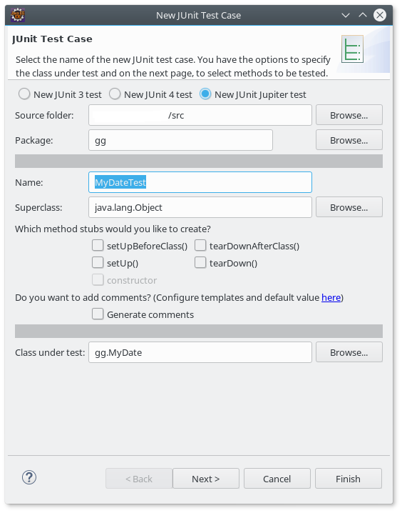
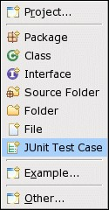
Starting
JUnit
A simple JUnit test
public class MyDateTest{
@Test public void testConstructValidDate(){
// all these dates are right!
new MyDate( 1, 1, 1);
new MyDate( 1, 5, 2006);
new MyDate(28, 2, 2006);
new MyDate(29, 2, 2008);
new MyDate(31, 5, 2008);
}
}
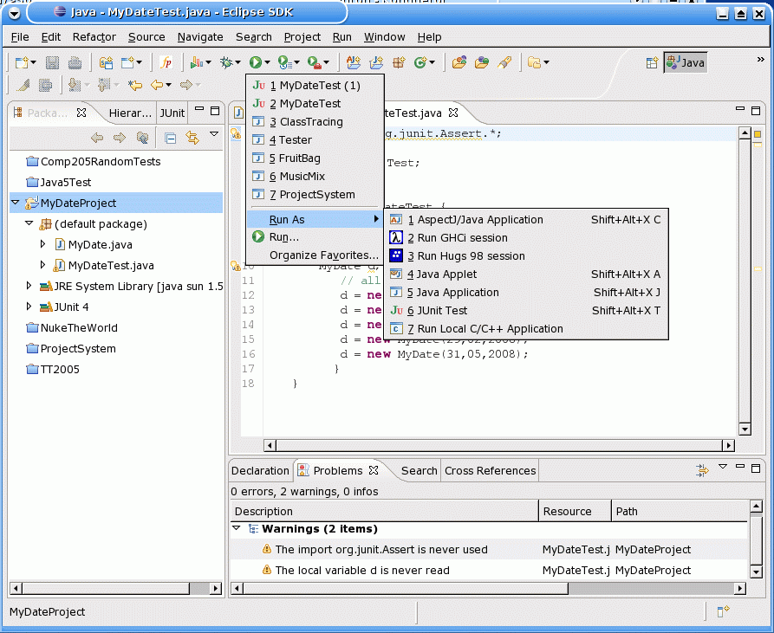
Testing the Happy Path
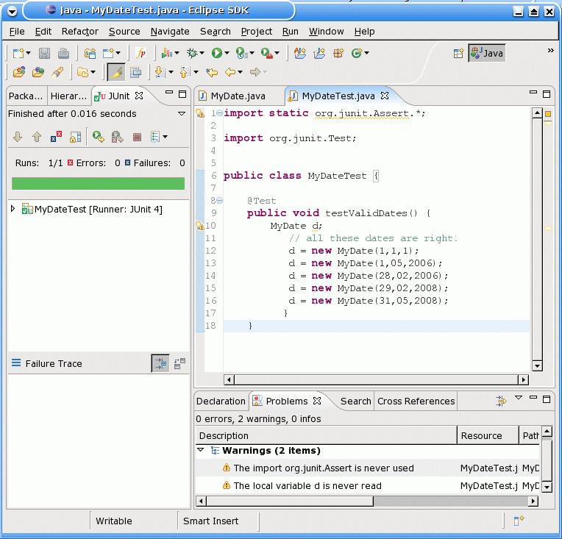
Testing the Happy Path
public class MyDateTest{
@Test public void testConstructValidDate(){
// all these dates are right!
new MyDate( 1, 1, 1);
new MyDate( 1, 5, 2006);
new MyDate(28, 2, 2006);
new MyDate(29, 2, 2008);
new MyDate(31, 5, 2008);
}
}
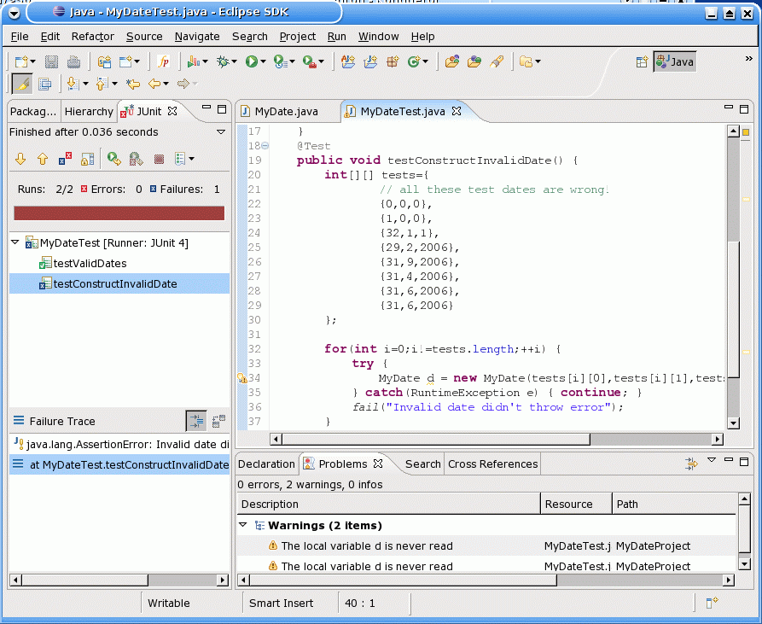
Testing the Unhappy Path
@Test public void testConstructInvalidDate(){
// all these dates are wrong!
var re= RuntimeException.class;
assertThrows(re, ()->new MyDate(0,0,0) );
assertThrows(re, ()->new MyDate(1,0,0) );//accepted?!?
assertThrows(re, ()->new MyDate(32, 1, 1) );
assertThrows(re, ()->new MyDate(29, 2,2006) );
assertThrows(re, ()->new MyDate(31, 9,2006) );
assertThrows(re, ()->new MyDate(31, 4,2006) );
assertThrows(re, ()->new MyDate(31, 6,2006) );
assertThrows(re, ()->new MyDate( 1, 1, -1) );
}
record MyDate(int day, int month, int year){
MyDate{
// check invariants hold
if (day <= 0 || month < 0){ throw new IllegalArgumentException(..); }
if (day > 31 || month > 12){ throw new IllegalArgumentException(..); }
var aprJunSepNov= month == 4 || month == 6 || month == 9 || month == 11;
if (aprJunSepNov && day > 30){ throw new IllegalArgumentException(..); }
var badFeb= month == 2
&& (day > 29 || (day > 28 && !isLeapYear(year)));
if (badFeb){ throw new IllegalArgumentException(..); }
}
private static boolean isLeapYear(int year){
//Every year that is exactly divisible by four is a leap year,
//except for years that are exactly divisible by 100,
//but these centurial years are leap years
//if they are exactly divisible by 400
return year % 4 == 0 && (year % 100 != 0 || year % 400 == 0);
}
}
Why?
record MyDate(int day, int month, int year){
MyDate{
// check invariants hold
if (day <= 0 || month < 0){ throw new IllegalArgumentException(..); }
if (day > 31 || month > 12){ throw new IllegalArgumentException(..); }
var aprJunSepNov= month == 4 || month == 6 || month == 9 || month == 11;
if (aprJunSepNov && day > 30){ throw new IllegalArgumentException(..); }
var badFeb= month == 2
&& (day > 29 || (day > 28 && !isLeapYear(year)));
if (badFeb){ throw new IllegalArgumentException(..); }
}
private static boolean isLeapYear(int year){
//Every year that is exactly divisible by four is a leap year,
//except for years that are exactly divisible by 100,
//but these centurial years are leap years
//if they are exactly divisible by 400
return year % 4 == 0 && (year % 100 != 0 || year % 400 == 0);
}
}
Why?
How does JUnit works?
●
Where is the main? We know there must be a main to start a
Java program, right?
●
Yes, the main is inside the Junit library.
●
That main is receiving the name of the test class/classes in input
and is using reflection to run the test methods.
●
Then the IDE takes the output of that main and renders it nicely.
●
An imperative test is divided in 3 main parts:
–
(1) Initialize the data
–
(2) Run the operation
–
(3) Check that the result satisfy our expectations
●
So, code is testable if:
–
It is easy to create objects to tests
–
It is easy to run operations on those objects, no need to be inside the full system
–
It is easy to check the result of the operations
Test structure
●
Code is testable if:
–
It is easy to create objects to tests
–
It is easy to run operations on those objects, no need to be inside the full system
–
It is easy to check the result of the operations
●
Hazards to testability (AVOID):
–
To create this object you need many other objects
–
To create this object, certain static fields in
various classes must be set to be ‘just right’
–
To run this operation is not enough to pass parameters: some files needs to be in
place on the file system, a database needs to be available, …
–
The result of this operation does not just depend on the input, or it contains some
intrinsically non deterministic components.
Test structure
Exercise
●
We are now going to see some code sorting a list with
the simple ‘selection sort’ algorithm.
The algorithm sorts the list left to right, selecting the lowest
element from the unsorted portion of the list and swapping it with
the first element of the unsorted portion.
Sorting, as in high school programming
class Sorter{
void sort(List<Double> ds){
for (int i= 0; i < ds.size() - 1; i++){
int jMin= i;
for (int j= i + 1; j < ds.size(); j++){
if (ds.get(j) < ds.get(jMin)){ jMin = j; }
}
double tmp= ds.get(jMin);
ds.set(jMin,ds.get(i));
ds.set(i,tmp);
}
}
}
class Sorter{
void sort(List<Double> ds){
for (int i= 0; i < ds.size() - 1; i++){
int jMin= i;
for (int j= i + 1; j < ds.size(); j++){
if (ds.get(j) < ds.get(jMin)){ jMin = j; }
}
double tmp= ds.get(jMin);
ds.set(jMin,ds.get(i));
ds.set(i,tmp);
}
}
}
We can improve it, by method decomposition
This is a SWAP
We can improve it, by method decomposition
class Sorter{
void sort(List<Double> ds){
for (int i= 0; i < ds.size() - 1; i++){
int jMin= i;
for (int j= i + 1; j < ds.size(); j++){
if (ds.get(j) < ds.get(jMin)){ jMin = j; }
}
swap(i,jMin,ds);
}
}
void swap(int i, int j, List<Double> ds) {
double tmp= ds.get(i);
ds.set(i,ds.get(j));
ds.set(j, tmp);
}
}
We can improve it, by method decomposition
This finds the minIndex
class Sorter{
void sort(List<Double> ds){
for (int i= 0; i < ds.size() - 1; i++){
int jMin= i;
for (int j= i + 1; j < ds.size(); j++){
if (ds.get(j) < ds.get(jMin)){ jMin = j; }
}
swap(i,jMin,ds);
}
}
void swap(int i, int j, List<Double> ds) {
double tmp= ds.get(i);
ds.set(i,ds.get(j));
ds.set(j, tmp);
}
}
Sorting, with sub methods
class Sorter{
void sort(List<Double> ds){
for (int i= 0; i < ds.size() - 1; i++){
swap(i,minIndex(i,ds),ds);
}
}
int minIndex(int i, List<Double> ds){
int res= i;
for (int j= i + 1; j < ds.size(); j++){
if (ds.get(j) < ds.get(res)){ res = j; }
}
return res;
}
void swap(int i, int j, List<Double> ds) {
double tmp= ds.get(i);
ds.set(i,ds.get(j));
ds.set(j, tmp);
}
}
●
Now in addition
to testing ‘sort’,
we can also test
‘swap’ and ‘minIndex’
Sorting, as in second year university
●
Statements are falling out
of fashion in modern java.
●
It is now much more
common to use streams,
as we will see later in the
course.
class Sorter{
void sort(List<Double> ds){
IntStream
.range(0,ds.size() - 1)
.forEach(i->swap(i,minIndex(i,ds),ds));
}
int minIndex(int i, List<Double> ds){
return IntStream
.range(i + 1,ds.size())
.reduce(i,
(res,j)->ds.get(j) < ds.get(res) ? j : res);
}
void swap(int i, int j, List<Double> ds) {
double tmp= ds.get(i);
ds.set(i,ds.get(j));
ds.set(j,tmp);
}
}
●
Get your priorities right:
Good division in methods is many,
many times more important that
having streams instead of statements.
Testing sort!
class TestSort {
//auxiliary testing helper method!!
void sorted(List<Double> expected, List<Double> in){
var res= new ArrayList<Double>(in);
new Sorter().sort(res);
assertEquals(expected,res);
}
//Many tests just using the auxiliary helper method!
@Test void isSorted123(){sorted(
List.of(1d,2d,3d), //formatting to show clearly the expected result (first)
List.of(1d,2d,3d));}//and the input (second)
@Test void isInverted321(){sorted(
List.of(1d,2d,3d),
List.of(3d,2d,1d));}
@Test void isSortedEmpty(){sorted(
List.of(),
List.of());}
@Test void isSortedNegatives(){sorted(
List.of(-5d,-3d,-2d,-1d), //compact formatting: important for tests,
List.of(-1d,-2d,-5d,-3d));}//since you should write thousands of tests
}
Testing minIndex!
class TestSort {
//also testing the sub methods!
//auxiliary testing helper method!!
void isMinIndex(int expected, List<Double> in){
assertEquals(expected,new Sorter().minIndex(0,in));
}
//Many tests just using the auxiliary helper method!
@Test void sorted123(){isMinIndex(
0,
List.of(1d,2d,3d));}
@Test void inverted321(){isMinIndex(
2,
List.of(3d,2d,1d));}
@Test void isEmpty(){isMinIndex(
0, //Surprising? May be minIndex should be
List.of());} //defined better; for example throwing an error
@Test void negatives(){isMinIndex(
2,
List.of(-1d,-2d,-5d,-3d));}
}

Property testing
Instead of just testing that an operation on a specific input does exactly
what we expect, we can generate some input and check for general
properties, for example with minIndex we could generate random
sequences of numbers and test that the number at the resulting input is
indeed smaller than all the other ones.
Watch: https://www.youtube.com/watch?v=IYzDFHx6QPY
“The lazy programmer's guide to writing thousands of tests”
- Scott Wlaschin
This talk is also known as “The enterprise developer from hell”

Next time:
Next time:
Exceptions
Exceptions

