
SWEN 221
SWEN 221
Marco Servetto
Marco Servetto
CO258
CO258
www.youtube.com/MarcoServetto
www.youtube.com/MarcoServetto
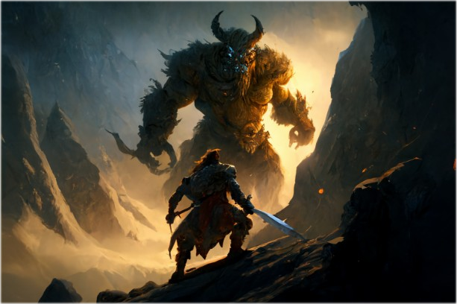
Exceptions
Exceptions
Error Handling (wrong way)
/**
if n >= 0 return n! else return -1
*/
public static int factorial(int n){
if(n < 0){ return -1; }//represents an error condition
if(n == 0){ return 1; }
return n * factorial(n - 1);
}
•
Pre-exception solution. Still used in some situations…
–
But, what about
Object ArrayList.get(int index)
?
Error Handling (wrong way)
/**
if n >= 0 return n! else return -1
*/
public static int factorial(int n){
if(n < 0){ return -1; }//represents an error condition
if(n == 0){ return 1; }
return n * factorial(n - 1);
}
•
Pre-exception solution. Still used in some situations…
–
But, what about
Object ArrayList.get(int index)
?
–
Relies on client to check for error
•
Amazing how often this is neglected. E.g. C
malloc()
•
Does not promote robust programs
Error Handling (wrong way)
/**
if n >= 0 return n! else return -1
*/
public static int factorial(int n){
if(n < 0){ return -1; }//represents an error condition
if(n == 0){ return 1; }
return n * factorial(n - 1);
}
•
Pre-exception solution. Still used in some situations…
–
But, what about
Object ArrayList.get(int index)
?
–
Relies on client to check for error
•
Amazing how often this is neglected. E.g. C
malloc()
•
Does not promote robust programs
–
Error-checking code often horribly entangled with normal code
Error Handling (wrong way)
/**
if n >= 0 return n! else return -1
*/
public static int factorial(int n){
if(n < 0){ return -1; }//represents an error condition
if(n == 0){ return 1; }
return n * factorial(n - 1);
}
I f there is no good answer
●
If there is no good answer, do not make up a random answer.
●
If there is no good answer, throw an exception!
Why?
●
Invalid answers are normal values and can be stored for a long time before
they are involved in execution in some way
●
Exceptions have to be handled before execution can resume.
Example:
●
You make a
tallestPerson(listPersons)
method
returning
null
on empty lists.
●
User code calls
tallestPerson(_)
and save the result in a field. Long after
that, we get a
NullPointerException
about a field somewhere else in the
code, far from the point in space/time where the error originated!
A language construct designed to deal with
•
errors
•
exceptional behaviour
Sometimes they can be also useful for terminating complex computations.
Differences between:
•
return new Foo();
•
throw new Foo();
Introducing Exceptions
Introducing Exceptions
class MyList{
public int size(){...}
public Object get(int index){
var outBound= index < 0 || index >= size();
if (outBound){ throw new ArrayIndexOutOfBoundsException(); }
...// happy path here
}
}
Introducing Exceptions
class MyList{
public int size(){...}
public Object get(int index){
var outBound= index < 0 || index >= size();
if (outBound){ throw new ArrayIndexOutOfBoundsException(); }
...// happy path here
}
}
...
MyList v= new MyList();
try { v.get(0); } // error
catch (ArrayIndexOutOfBoundsException e){
// deal with error
}
Introducing Exceptions
•
Exceptions signal exceptional behaviour
–
Method can terminate normally by returning result
–
Or abruptly, by throwing an exception
class MyList{
public int size(){...}
public Object get(int index){
var outBound= index < 0 || index >= size();
if (outBound){ throw new ArrayIndexOutOfBoundsException(); }
...// happy path here
}
}
...
MyList v= new MyList();
try { v.get(0); } // error
catch (ArrayIndexOutOfBoundsException e){
// deal with error. Crucially, this can be far away from the .get call
}
Try-Catch Blocks
void bar(){ throw new NullPointerException(); }
void foo(){
try { bar(); }
catch (IndexOutOfBoundsException e) {
System.out.println("foo");
}
}
void main(...){
try { foo(); }
catch (NullPointerException e){
System.out.println("main");
}
}
A: “foo”
B: “main”
Try-Catch Blocks
•
When an Exception is thrown
–
Control passes to enclosing try-catch block
which matches exception type
A: “foo”
B: “main”
void bar(){ throw new NullPointerException(); }
void foo(){
try { bar(); }
catch (IndexOutOfBoundsException e) {
System.out.println("foo");
}
}
void main(...){
try { foo(); }
catch (NullPointerException e){
System.out.println("main");
}
}
Try-Catch Blocks
This try-
catch block
doesn’t
match
Control
transferred
here
•
When an Exception is thrown
–
Control passes to enclosing try-catch block
which matches exception type
void bar(){ throw new NullPointerException(); }
void foo(){
try { bar(); }
catch (IndexOutOfBoundsException e) {
System.out.println("foo");
}
}
void main(...){
try { foo(); }
catch (NullPointerException e){
System.out.println("main");
}
}
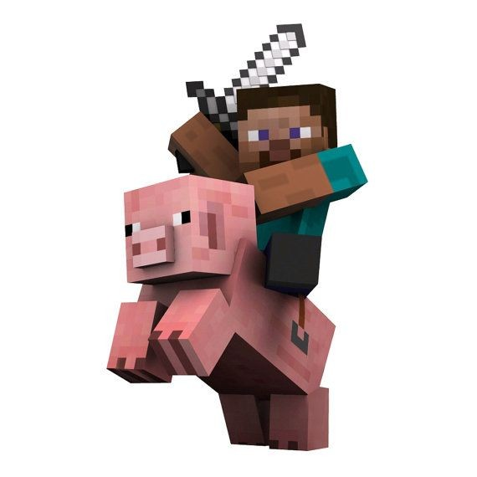
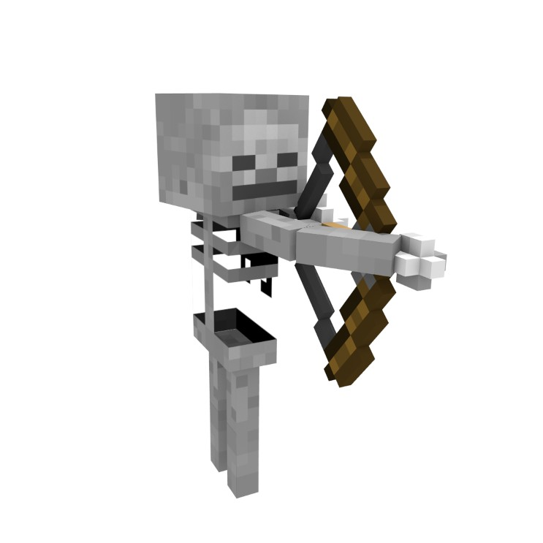
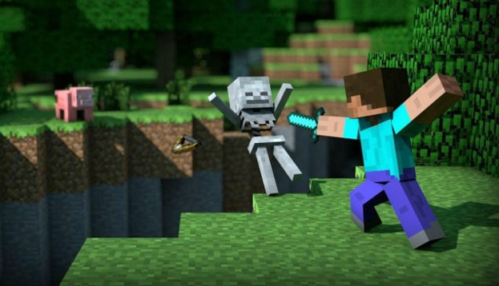
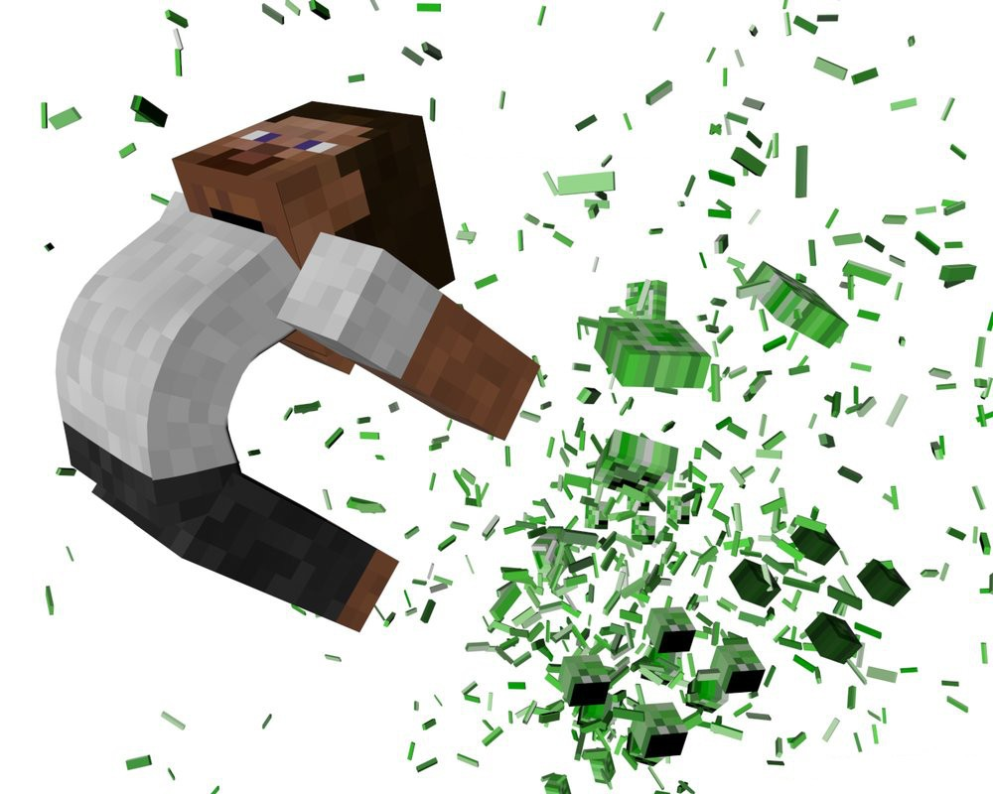
void bar(){throw new NullPointerException();}
void foo(){
try { bar(); }
catch (IndexOutOfBoundsException e) {
System.out.println("foo");
}
}
void main(...){
try { foo(); }
catch (NullPointerException e){
System.out.println("main");
}
}
Nesting Exceptions
•
Exceptions might have a message and/or a cause associated
•
Methods:
getCause(), getMessage(), getStackTrace(),
etc.
•
Exceptions are a language feature
•
Chain of exceptions (
getCause()
) is a library feature, that is,
a convention programmers use to propagate complex exceptions
try { lowLevelOp(); }
catch (LowLevelException e){
throw new HighLevelException("my msg", e);
}
Java exceptions
and
Norse mythology

Java exceptions and
Norse mythology
●
Odin.
●
The father of all gods.
●
Throwable
●
The father of all kinds of
exceptions.
●
It is very rare to do
new Throwable(..).
●
Sometime used as a type.
●
Quite rare to do
catch(Throwable t){..}

Java exceptions and
Norse mythology
●
Thor.
●
The most iconic.
●
Exception
●
The most iconic kind of
Exception, the first that
comes to mind.
●
Rare to do
new Exception(…)
●
catch(Exception e){..}
is often overkill

Java exceptions and
Norse mythology
●
Loki.
●
The sneaky guy
●
Error
●
The one whose name
causes the most dread.
●
Common to do
new Error(e)
●
catch(Error e){..}
is common in library code

Java exceptions and
Norse mythology
●
Heimdall: The Unseen Sentinel
●
Heimdall’s watch, exists without
explicit declarations, yet ready to
alert and respond when needed.
●
RuntimeException
●
Helps us to solve limitations of
Java by tunneling (Bifröst)
errors around the type system.
●
Common to do
new RuntimeException(e)
●
catch(RuntimeException e){..}
is common in library code




Throwable
Exception
Error
Family relationships:
Throwable(Odin) is the father (supertype) of
●
Error (Loki) and
●
Exception (Thor). Exception is the father of
●
RuntimeException (Heimdall)
They all spawn their minions
RuntimeException
Throwable
Exception
Error
C
h
eck
ed
C
h
eck
ed
C
h
eck
ed
RuntimeException
U
n
ch
ec
k
e
d
U
n
ch
ec
k
e
d
U
n
ch
ec
k
e
d
U
n
ch
ec
k
e
d
Throwable
Exception
Error
An Error is a subclass of Throwable
that indicates serious problems that a reasonable application should not try to
catch. Most such errors are abnormal conditions.
AssertionError, AWTError, CoderMalfunctionError, IOError,
LinkageError, ThreadDeath, VirtualMachineError, ...
RuntimeException
Throwable
Exception
Error
The class Exception and its subclasses are a form of Throwable that indicates
conditions that a reasonable application might want to catch.
The class Exception and any subclasses that are not also subclasses of
RuntimeException are checked exceptions. Checked exceptions need to be declared
in a method or constructor's throws clause if they can be thrown by the execution of
the method or constructor and propagate outside the boundary.
Tons of kids:
ExecutionException, FontFormatException, GeneralSecurityException,
InterruptedException, IOException, MarshalException,
MidiUnavailableException, MimeTypeParseException, ParseException,
ReflectiveOperationException, SQLException, TimeoutException,
TooManyListenersException, XMLParseException, ...
RuntimeException
RuntimeException
Throwable
Exception
Error
RuntimeException is the superclass of those exceptions that can be thrown during
the normal operation of the Java Virtual Machine.
RuntimeException and its subclasses are unchecked exceptions. Unchecked
exceptions do not need to be declared in a method or constructor's throws clause
Tons of kids. Those are actually useful/relevant:
ArithmeticException, ArrayStoreException,ClassCastException,
CompletionException, ConcurrentModificationException,
EnumConstantNotPresentException,
IllegalArgumentException, IndexOutOfBoundsException,
NegativeArraySizeException, NoSuchElementException, NullPointerException,
SecurityException, UnmodifiableSetException, UnsupportedOperationException,
Resource Handling
•
This code has a problem
void foobar(){
FileOutputStream tmp= new FileOutputStream("tmp.dat");
try {
... // do some complicated computation
... // writing results to temporary file
tmp.close();
new File("tmp.dat").delete(); // delete temporary file
}
catch (IOException e) {
... // report write error and return
}
}
Finally
void foobar(){
FileOutputStream tmp= new FileOutputStream("tmp.dat");
try {
... // do some complicated computation
... // writing results to temporary file
}
catch (IOException e) {
... // report write error and return
}
finally {
tmp.close();
new File("tmp.dat").delete(); // delete temporary file
}
}
•
Finally clause:
–
Gets executed regardless of how try-block exited
•
E.g. by normal execution, by caught exception or uncaught exception
–
Useful for “cleaning up” allocated resources
Try with resource
•
From Java7, is a compact and more elegant solution to close resources
–
Convenient alternative to finally
–
Any object that implements java.lang.AutoCloseable (includes
java.io.Closeable) can be used as a resource
–
Not as flexible; for example here we do not delete our file, we only close it.
try (var tmp= new FileOutputStream("out.dat")){//newer, better solution
... // do some complicated computation
... // writing results to file
}
catch(IOException e) {
... // report write error and return
}
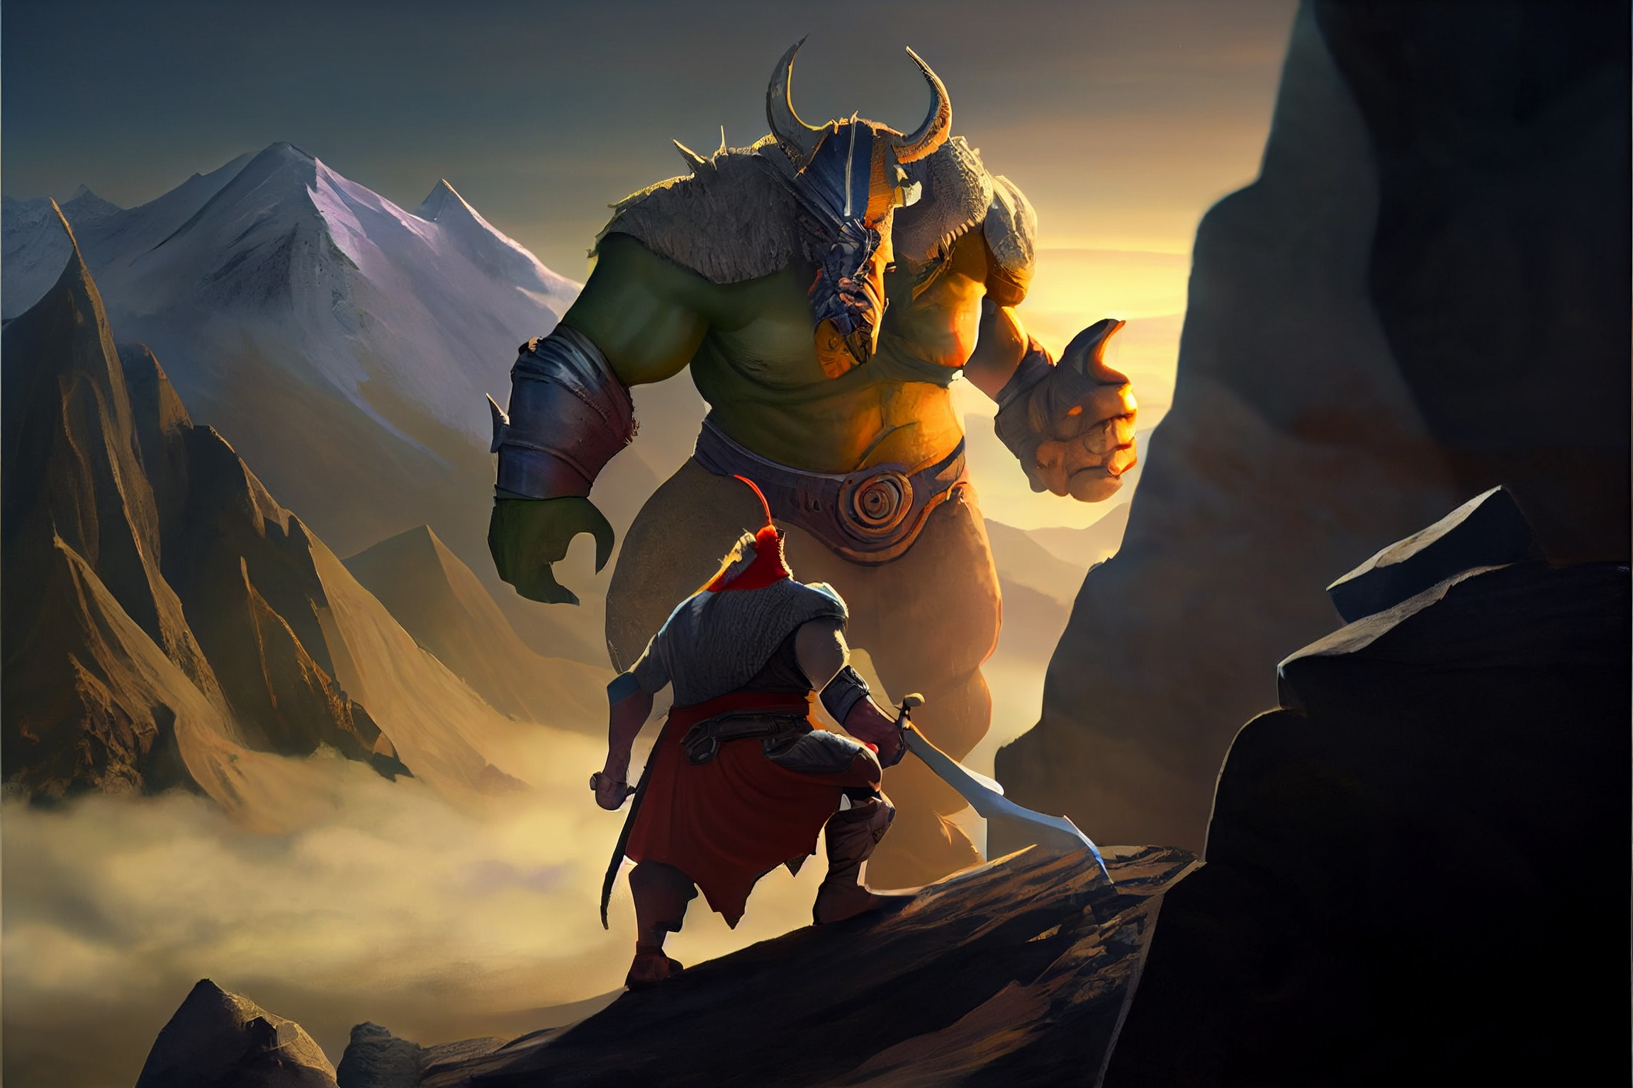
More metaphors: throw something
●
A monster rises from the
darkeness.
●
It will destroy everything
onto his path.
●
This is representing stack
unwinding:
The exception consumes
the stack until it is catch-ed.
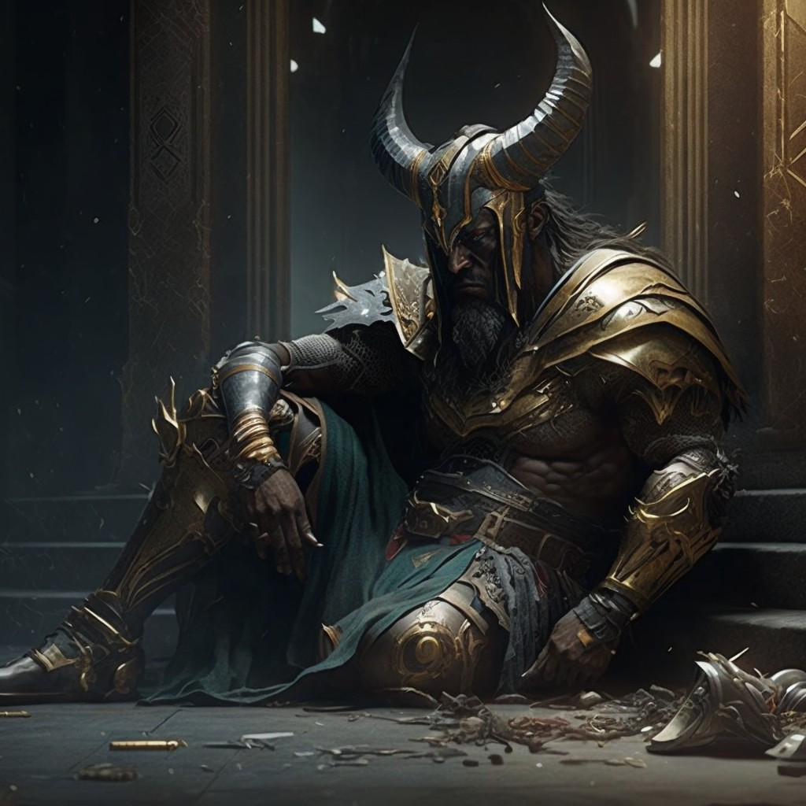
More metaphors: catch something
●
The catch block is like a hero trying
to stop the monster.
●
It can go both ways.
●
If the hero is too weak, the monster
will win and the hero will be
defeated!

More metaphors: catch something
●
If the hero is too weak, the monster
will win and the hero will be
defeated.
●
However, with the ‘finally’ block, the
hero can say their last words!
●
No matter if they win or lose, they
will say those words before the stack
unwinds away from them, sending
them back into oblivion.
More metaphors: catch something
●
If the hero is too weak, the monster
will win and the hero will be
defeated.
●
However, with the ‘finally’ block, the
hero can say their last words!
●
No matter if they win or lose, they
will say those words before the stack
unwinds away from them, sending
them back into oblivion.
Defend the
main loop!
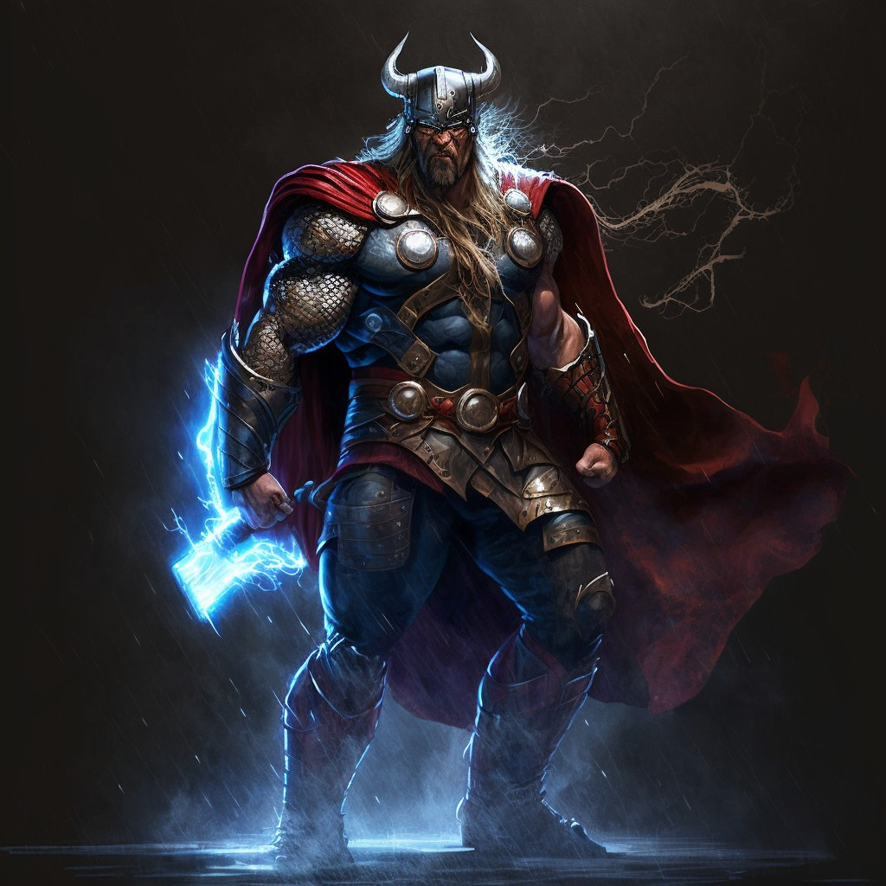
More metaphors: catch something
●
The catch block is like a hero trying to
stop the monster.
●
It can go both ways.
●
If the hero is too strong, the hero will
squash the monster,...
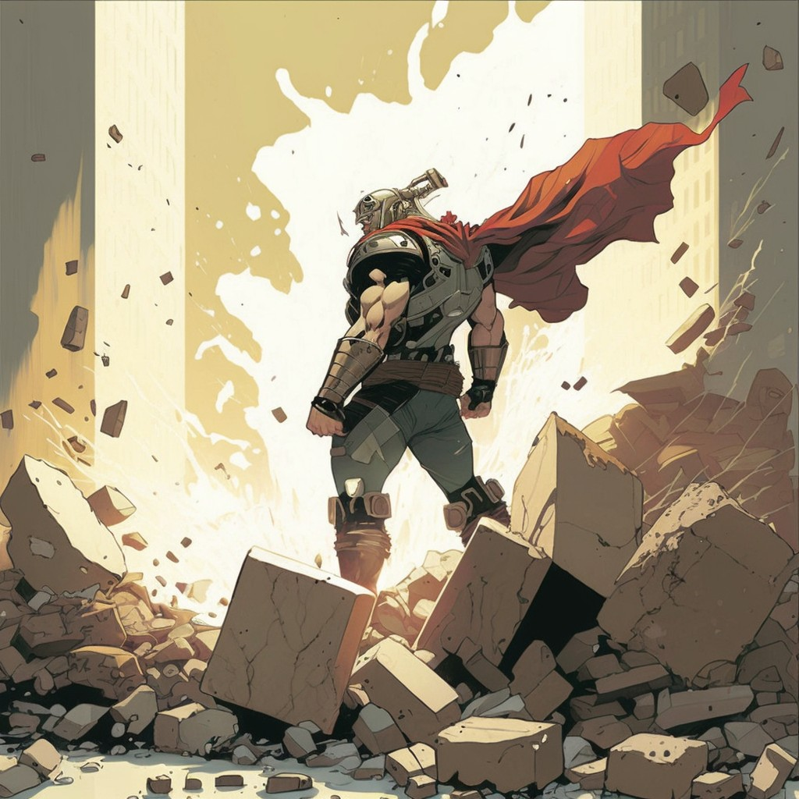
More metaphors: catch something
●
The catch block is like a hero trying to
stop the monster.
●
It can go both ways.
●
If the hero is too strong, the hero will
squash the monster, together with a
few city blocks.
(too much collateral damage)

More metaphors: catch something
●
We need a Goldilocks hero
●
The catch block should
use a hero that
is ‘just right’
●
Not too strong
●
Not too weak
Otherwise we would capture
more than we intend to
== collateral damage
What is the difference?
try { /*a*/ }
catch (SomeException e){ /*b*/ }
/*c*/
try { /*a*/ }
catch (SomeException e){ /*b*/ }
finally { /*c*/ }
try {
}
catch (SomeException e){
}
finally {
}
Write down a minimal example of code where
the presence of finally produces a
different behavior!
try {
}
catch (SomeException e){
}
Is this a valid solution?
try { /*a*/ }
catch (SomeException e){ /*b*/ }
/*c*/
try { /*a*/ }
catch (SomeException e){ /*b*/ }
finally { /*c*/ }
try {
throw new SomeException();
}
catch (SomeException e){
System.out.println(“Hello”);
}
finally {
System.out.println(“World”);
}
try {
throw new SomeException();
}
catch (SomeException e){
System.out.println(“Hello”);
}
System.out.println(“World”);
A: YES
B: NO
Is this a valid solution?
try { /*a*/ }
catch (SomeException e){ /*b*/ }
/*c*/
try { /*a*/ }
catch (SomeException e){ /*b*/ }
finally { /*c*/ }
try {
throw new AnotherException();
}
catch (SomeException e){
System.out.println(“Hello”);
}
finally {
System.out.println(“World”);
}
try {
throw new AnotherException();
}
catch (SomeException e){
System.out.println(“Hello”);
}
System.out.println(“World”);
A: YES
B: NO
Is this a valid solution?
try { /*a*/ }
catch (SomeException e){ /*b*/ }
/*c*/
try { /*a*/ }
catch (SomeException e){ /*b*/ }
finally { /*c*/ }
try {
throw new SomeException();
}
catch (SomeException e){
throw e;
}
finally {
System.out.println(“World”);
}
try {
throw new SomeException();
}
catch (SomeException e){
throw e;
}
System.out.println(“World”);
A: YES
B: NO
Again: Types of Exception
•
Unchecked Exceptions
Subclasses of
RuntimeException
and
Error
–
E.g.
NullPointerException
and
IndexOutOfBoundsException
•
Checked Exceptions
–
Subclasses of
Exception
, but not
RuntimeException
–
e.g. IOException
–
Must be declared in a method’s throws clause:
•
If it throws one, or doesn’t catch one thrown by called method
•
Otherwise compile-time error
Checked Exceptions
void foo() throws IOException {
...
throw new IOException("...");
}
void bar(){ foo(); }
//Compile time error
void bar() throws IOException { foo(); }
//OK
void bar(){
//OK
try { foo(); }
catch (IOException e){...}
}
Checked Exceptions
•
Why checked exceptions?
–
Signal recoverable problems
•
E.g.
FileNotFoundException
(in an interactive program)
versus
NullPointerException
or
ArithmeticException
•
Programs can typically recover from such errors
–
*Force* clients to deal with problem
•
Programmer cannot ignore possible error
•
Compile time errors are better than runtime errors!
Checked vs Unchecked
•
Checked exceptions:
–
Signal recoverable problems / expected behaviour
•
Unchecked exceptions:
–
Observed bug (not always a fatal one)
Deal with
Unchecked
exceptions
class MyCheckedException extends Exception{
MyCheckedException(){ super(); }
MyCheckedException(String m){ super(m); }
MyCheckedException(String m, Throwable c){ super(m,c); }
}
...
try {...}
catch (MyCheckedException e){
/*provide alternative behaviour*/
}
class MyUncheckedException extends RunTimeException{
MyUncheckedException(){super();}
MyUncheckedException(String m){super(m);}
MyUncheckedException(String m, Throwable c){ super(m,c);}
}
...
try {...}
catch (MyUncheckedException e){
/*resume the execution. In older java usually only used in the
artisan/tool (ex master/slave) pattern.
Used in more situations in the new Java style*/
}
Deal with
Checked
exceptions
Turn Checked Exceptions into Errors
•
Checked exceptions means there is still (potential) hope for a solution
–
Sometimes, you know there is no hope
–
You know something just should not happen.
•
Scenario (this really happened)
–
Designed and built “Simple Program Interpreter”
–
In first version of language no InputStatement
•
Statements don’t declare “throws IOException”
–
Added InputStatement, which reads input!
•
But, InputStream.read() throws IOException
•
What to do?
Problems with Checked Exceptions
•
This is the situation:
•
Options:
–
Declare Statement.execute() (+ all subclasses) throws IOException
–
Deal with Exception in InputStatement somehow
interface Statement{
void execute();
}
class InputStatement implements Statement{
public void execute(){
InputStream input= ...;
input.read(); //throws IOException
}
}
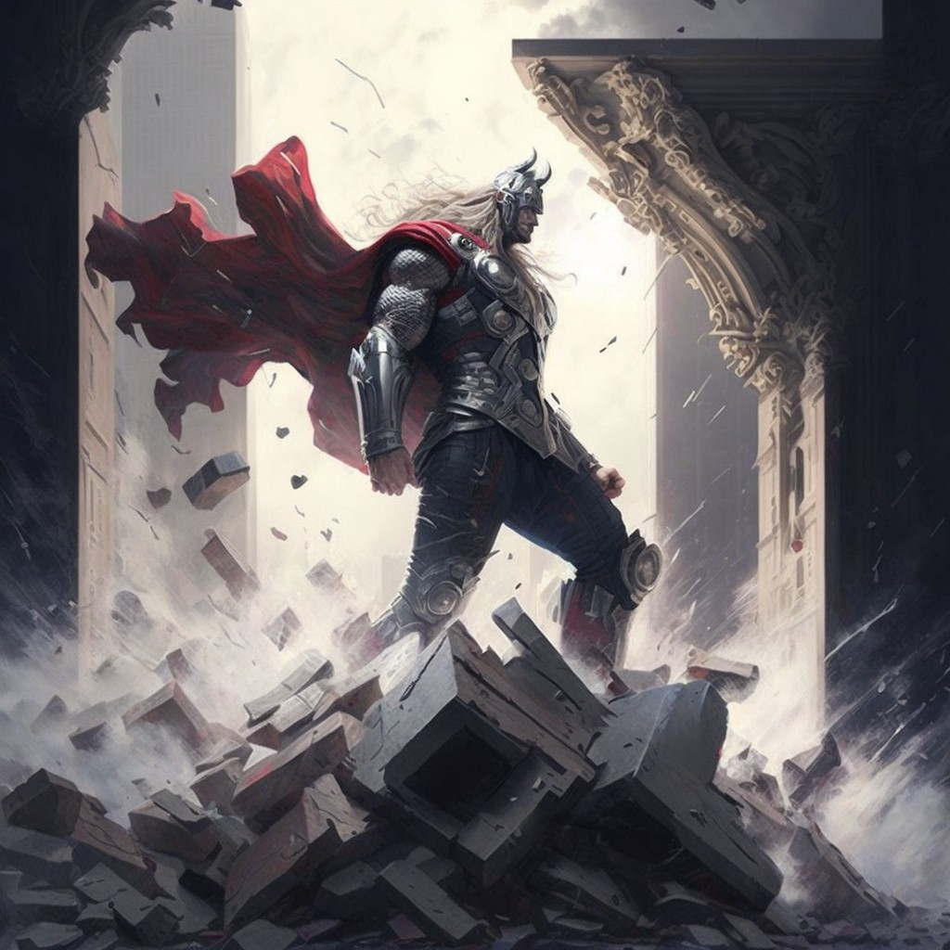
What not to do!
interface Statement{
void execute();
}
class InputStatement implements Statement{
public void execute(){
InputStream input= ...;
try { input.read(); }//throws IOException
catch (Exception e){}
}
}
•
All exceptions (including
RuntimeException
) are “swallowed”
•
This is equivalent of calling a hero too strong for the monster
too much unneeded collateral damage!
What not to do!
interface Statement{
void execute();
}
class InputStatement implements Statement{
public void execute(){
InputStream input= ...;
try { input.read(); }//throws IOException
catch (IOException e){}
}
}
IOException
is still being “swallowed”

What not to do!
●
IOException
written on the “standard output”; and than “swallowed”!
●
Sadly, this is the eclipse “template”
This is equivalent of the application faking their own death before
going to hide happily in a tropical paradise.
interface Statement{
void execute();
}
class InputStatement implements Statement{
public void execute(){
InputStream input= ...;
try { input.read(); }//throws IOException
catch (IOException e){
e.printStackTrace();
}
}
}
YES! The right thing to do:
Turn Checked Exceptions into Errors
●
Exception rethrown as unchecked exception!
●
Just mark the error as being an observed bug.
●
(AssertionError would work too...)
interface Statement{
void execute();
}
class InputStatement implements Statement{
public void execute(){
InputStream input= ...;
try { input.read(); } //throws IOException
catch (IOException e){ throw new Error(e); }
}
}

