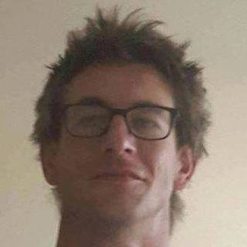

Emile De Wilde

063 237 5654

emiledewilde2@gmail.com

Summary

I never give up! I like to get things just right!  
I pursue self-improvement and skills development.  
I'm better thanlast year and the year before, greater things are still to come!  
From Data Capturing to Web Application System Design and Development.   
I’m still learning to master all the languages involved in Web application development, so still growing.   
I spent my early days in the food industry, one day I got a computer and started learning HTML, it’s been a struggle and uphill journey but I’ve fallen in love with it.

Education

**Central University of Technology**

Diploma (N.Dip IT)

Bloemfontein, Free State

July 2014

Was working at the same time, was not able to complete it.  
CCNA3 – Networking and Routing, CCNA2, CCNA1,  
C#,  
Java,  
Microsoft Access, Excel 2010,  
 Web Design and Development (HTML5, CSS3, JavaScript),  
System Analysis and Design,  
E-Business and Business Management.

Professional Skills

System Analysis and Design: Advanced

Administration: Advanced  
Agile :SCRUM: Intermediate

Project Management: Intermediate

RDBMS design & development: Advanced

T-SQL: Advanced

MySQL: Advanced

C#: Beginner

Java: Beginner

Bootstrap: Beginner

HTML5 & CSS3: Intermediate

Vanilla Javascript: Intermediate

PHP: Intermediate

Cake PHP: Beginner  
MVC design: Beginner

Employment History

**\*\*\* Current**

**IT Manager**

Port Elizabeth, Eastern Cape

April 2018 – Present

Server administrator - Fedora & Ubuntu servers.  
 Network Administrator.  
 System Engineer - Designed, Developed and Maintain a Personnel Management System for personnel.  
General IT support - Computer literacy, MS Office and General IT support.

**Self**

**Programmer, IT Consultant**

Bloemfontein, Free State

February 2017 – March 2018

I've started working for myself; my chief focus is Information Management Systems.

**One Push Consulting**

**Programmer**

Bloemfontein, Free State

Programmer  
T-SQL - complex queries, procedures and reporting.  
Appwizard Web interface.  
System Design and Development: T-SQL &Appwizard interface & Vanilla Javascript

**Anipharm - Pharamceutical Business**

**Admin**

Bloemfontein, Free State

Filing

**Beriyth Foundation (First Love Church) – Theology College**

**Chef - Assistant Manager - Barista**

Wellington, Western Cape

Catering (cooking) for groups averaging 30- 50.  
Event - Organization.  
Management of stock.  
Barista (Cappucino's, Latte Art).  
Cash up.

**Heartbeat Café’ (Fountain Head Church)**

**Coffee Shop Manager**

Bloemfontein, Free State

Event organization.  
Barista.  
Cash Up.  
Small meals.

**Breakthru Consulting**

**Admin assistant - Data Capturer**

Bloemfontein, Free State

Managed the business filing.  
General administrative duties.  
Data - Capturing

**Lebone Land Orphanage**

**Store Manager**

Bloemfontein, Free State

Store Manager.

Hobbies & Interests

I love learning about self-development and self-management, becoming the best me!  
I love water sports.  
Enjoy dancing.

Problem Solving: Advanced

Server Administration - Fedora & Ubuntu: Intermediate

Languages

English: Native