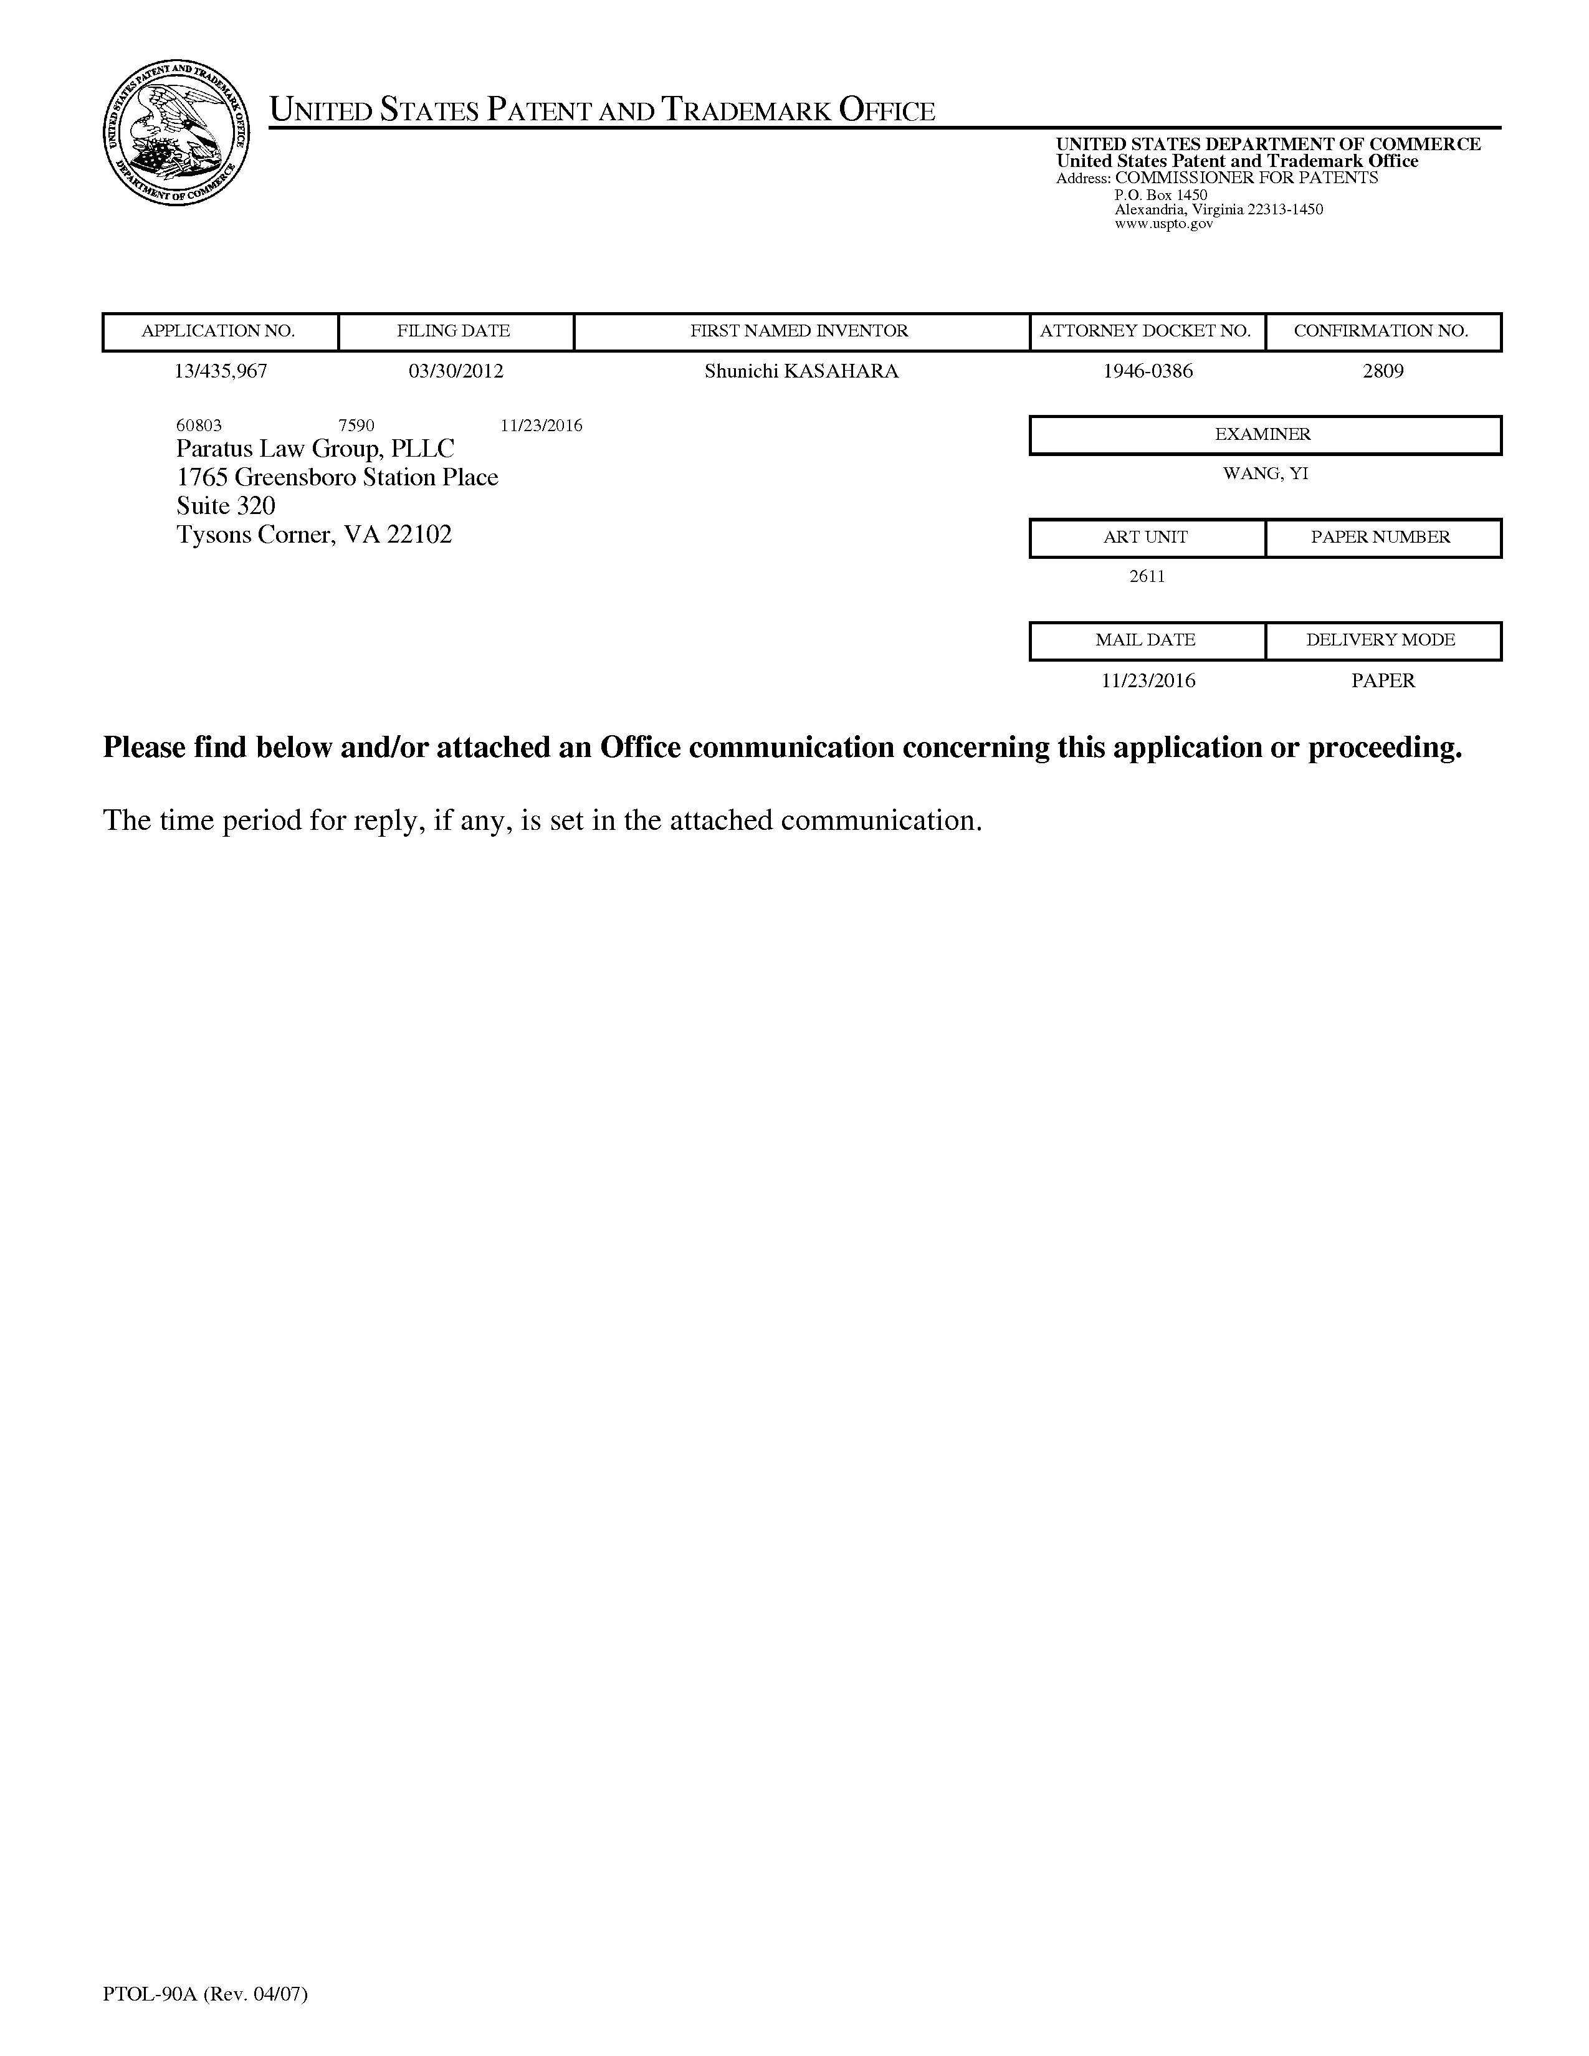

UnitedStatesPatentandTrademarkOffice   
 UNITEDSTATES DEPARTMENTOFCOMMERCE UnitedStatesPatentandTrademarkOffice Address:COMMISSIONERFORPATENTS P.O.Box1450   
 Alexandria,Virginia22313-1450   
 www.uspto.gov

|  |  |  |  |  |  |
| --- | --- | --- | --- | --- | --- |
| APPLICATIONNO. | FILINGDATE | | FIRSTNAMEDINVENTOR | ATTORNEYDOCKETNO. | CONFIRMATIONNO. |
| 13/435,967 | 03/30/2012 | | ShunichiKASAHARA | 1946-0386 | 2809 |
| 60803 7590  Paratus LawGroup,PLLC | | 11/23/2016 | EXAMINER | |
| 1765GreensboroStationPlace | | | WANG,YI | |
| Suite320 | | | ARTUNIT | PAPERNUMBER |
| TysonsCorner,VA22102 | | |

2611

MAILDATE DELIVERYMODE

11/23/2016 PAPER

Pleasefindbelowand/orattached anOfficecommunicationconcerningthis applicationor proceeding.

Thetimeperiodforreply,ifany,issetintheattachedcommunication.

PTOL-90A(Rev.04/07)

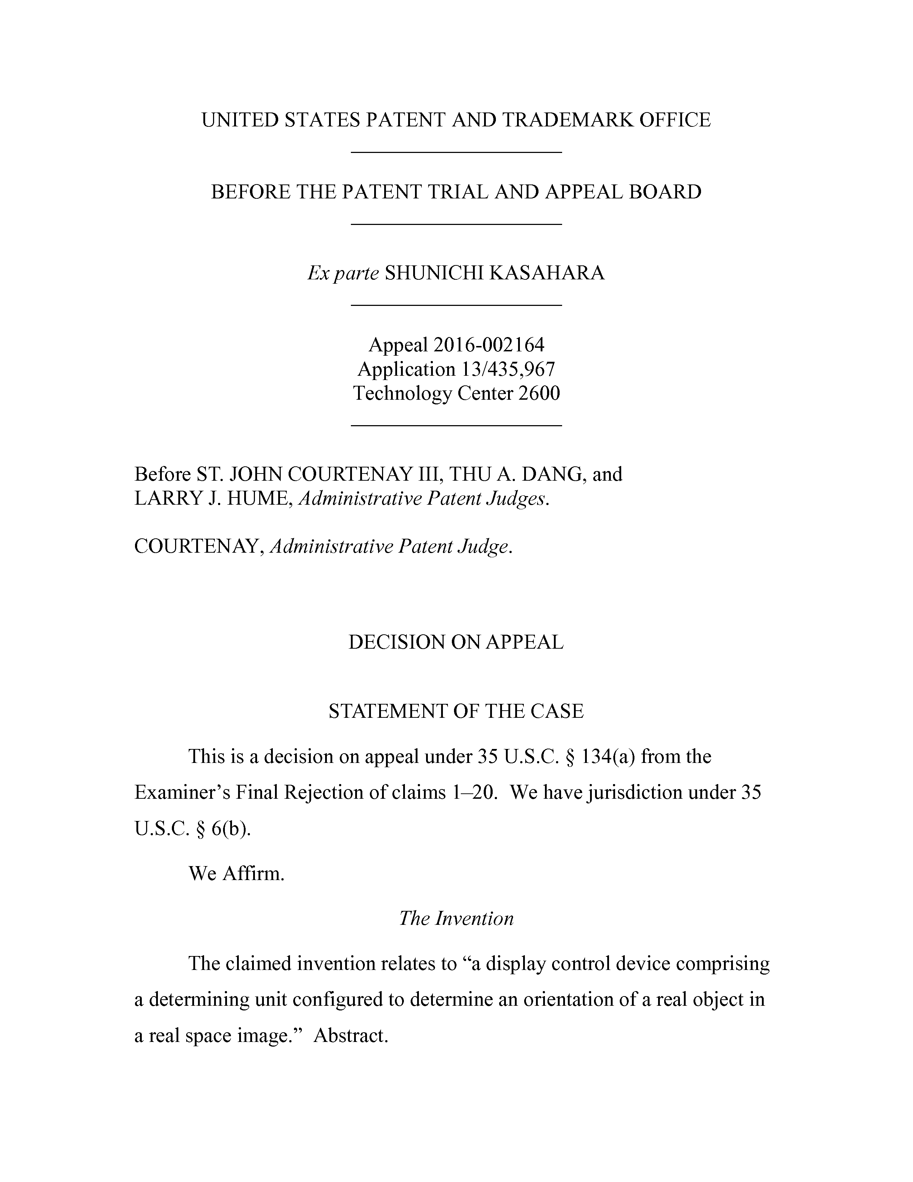

UNITEDSTATESPATENTANDTRADEMARKOFFICE

BEFORETHEPATENTTRIAL ANDAPPEALBOARD

*Exparte*SHUNICHIKASAHARA

Appeal2016-002164

Application13/435,967

TechnologyCenter2600

BeforeST.JOHN COURTENAYIII,THUA.DANG,and

LARRYJ.HUME,*AdministrativePatentJudges.*

COURTENAY,*AdministrativePatentJudge.*

DECISIONONAPPEAL

STATEMENTOFTHECASE

Thisisadecisiononappealunder35U.S.C.§134(a)fromthe

Examiner’sFinalRejectionofclaims1—20.Wehavejurisdictionunder35

U.S.C.§6(b).

WeAffirm.

*TheInvention*

Theclaimedinventionrelatesto“a display controldevicecomprising

adeterminingunitconfiguredtodetermineanorientation ofarealobjectin

arealspaceimage.”Abstract.

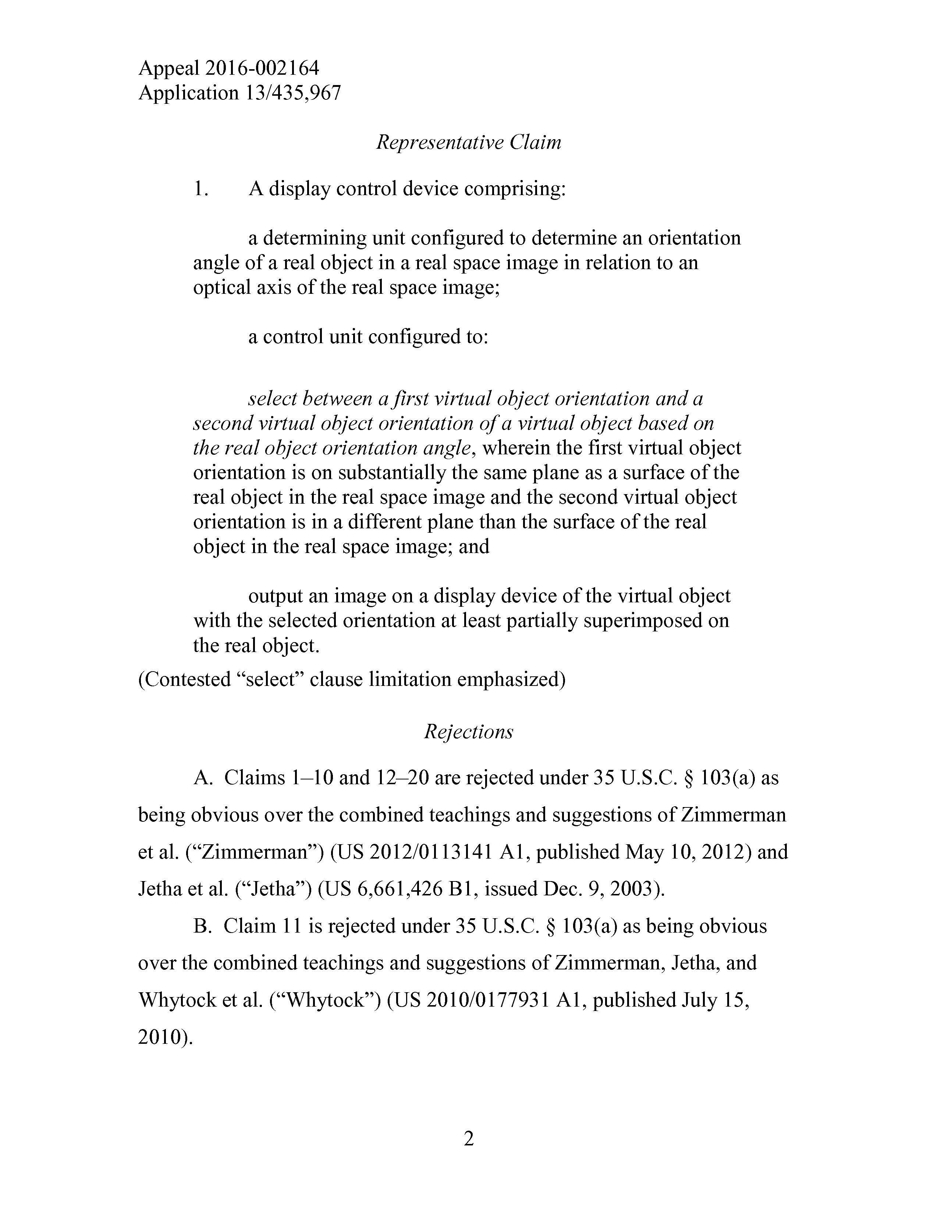

Appeal2016-002164   
Application13/435,967

*RepresentativeClaim*

1. A display controldevicecomprising:

adeterminingunitconfiguredtodetermineanorientation angleofarealobjectin arealspaceimageinrelationtoan opticalaxisoftherealspaceimage;

a control unit configured to:

*selectbetweenafirstvirtualobjectorientationanda secondvirtualobjectorientationofavirtualobjectbased on therealobjectorientationangle,*wherein thefirstvirtualobject orientationisonsubstantiallythesameplaneasasurfaceofthe realobjectintherealspaceimageand thesecondvirtualobject orientationisinadifferent planethan thesurfaceofthereal objectin therealspaceimage;and

outputanimageona display deviceofthevirtualobject withtheselectedorientationatleastpartiallysuperimposedon therealobject.

(Contested“select”clauselimitationemphasized)

*Rejections*

A.Claims1—10and12—20arerejectedunder35U.S.C.§103(a)as

beingobviousoverthecombined teachingsandsuggestionsofZimmerman

etal.(“Zimmerman”)(US2012/0113141Al,publishedMay10,2012)and

Jethaetal.(“Jetha”)(US6,661,426Bl,issuedDec.9,2003).

B.Claim11isrejectedunder35U.S.C.§103(a)asbeingobvious

overthecombinedteachingsandsuggestionsofZimmerman,Jetha,and

Whytocketal.(“Whytock”)(US2010/0177931Al,publishedJuly15,

2010).

2

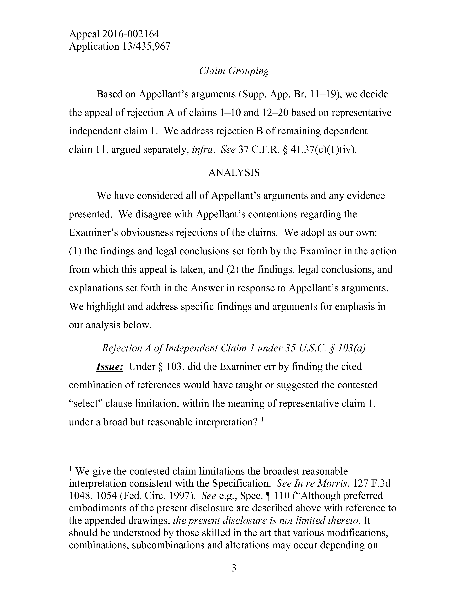

Appeal2016-002164   
Application13/435,967

*ClaimGrouping*

BasedonAppellant’sarguments(Supp.App.Br.11—19),wedecide

theappealofrejectionAofclaims1—10and12—20basedon representative

independentclaim1.Weaddressrejection B ofremainingdependent

claim11,arguedseparately,*infra.See*37C.F.R.§41.37(c)(l)(iv).

ANALYSIS

WehaveconsideredallofAppellant’sargumentsandanyevidence

presented.WedisagreewithAppellant’scontentionsregardingthe

Examiner’sobviousnessrejectionsoftheclaims.Weadoptasourown:

(1)thefindingsandlegalconclusionssetforthbytheExaminerintheaction

fromwhichthisappealistaken,and(2)thefindings,legalconclusions,and

explanationssetforthintheAnswerinresponsetoAppellant’sarguments.

Wehighlight andaddressspecificfindingsandargumentsforemphasisin

our analysisbelow.

*RejectionA ofIndependentClaim1under35U.S.C.§103(a)*

*Issue:*Under§103,didtheExaminererrbyfinding thecited

combinationofreferenceswould havetaughtorsuggested thecontested

“select”clauselimitation,within themeaningofrepresentativeclaim1,

underabroadbut reasonableinterpretation?1

1Wegivethecontestedclaim limitationsthebroadest reasonable   
interpretationconsistentwiththeSpecification.*SeeInreMorris,111*F.3d 1048,1054(Fed.Circ.1997).*See*e.g.,Spec.1110(“Althoughpreferred embodimentsofthepresentdisclosurearedescribedabovewithreferenceto theappendeddrawings,*thepresentdisclosureisnot limitedthereto.*It shouldbeunderstoodbythoseskilledin theartthatvariousmodifications, combinations,subcombinationsandalterationsmayoccurdependingon

3

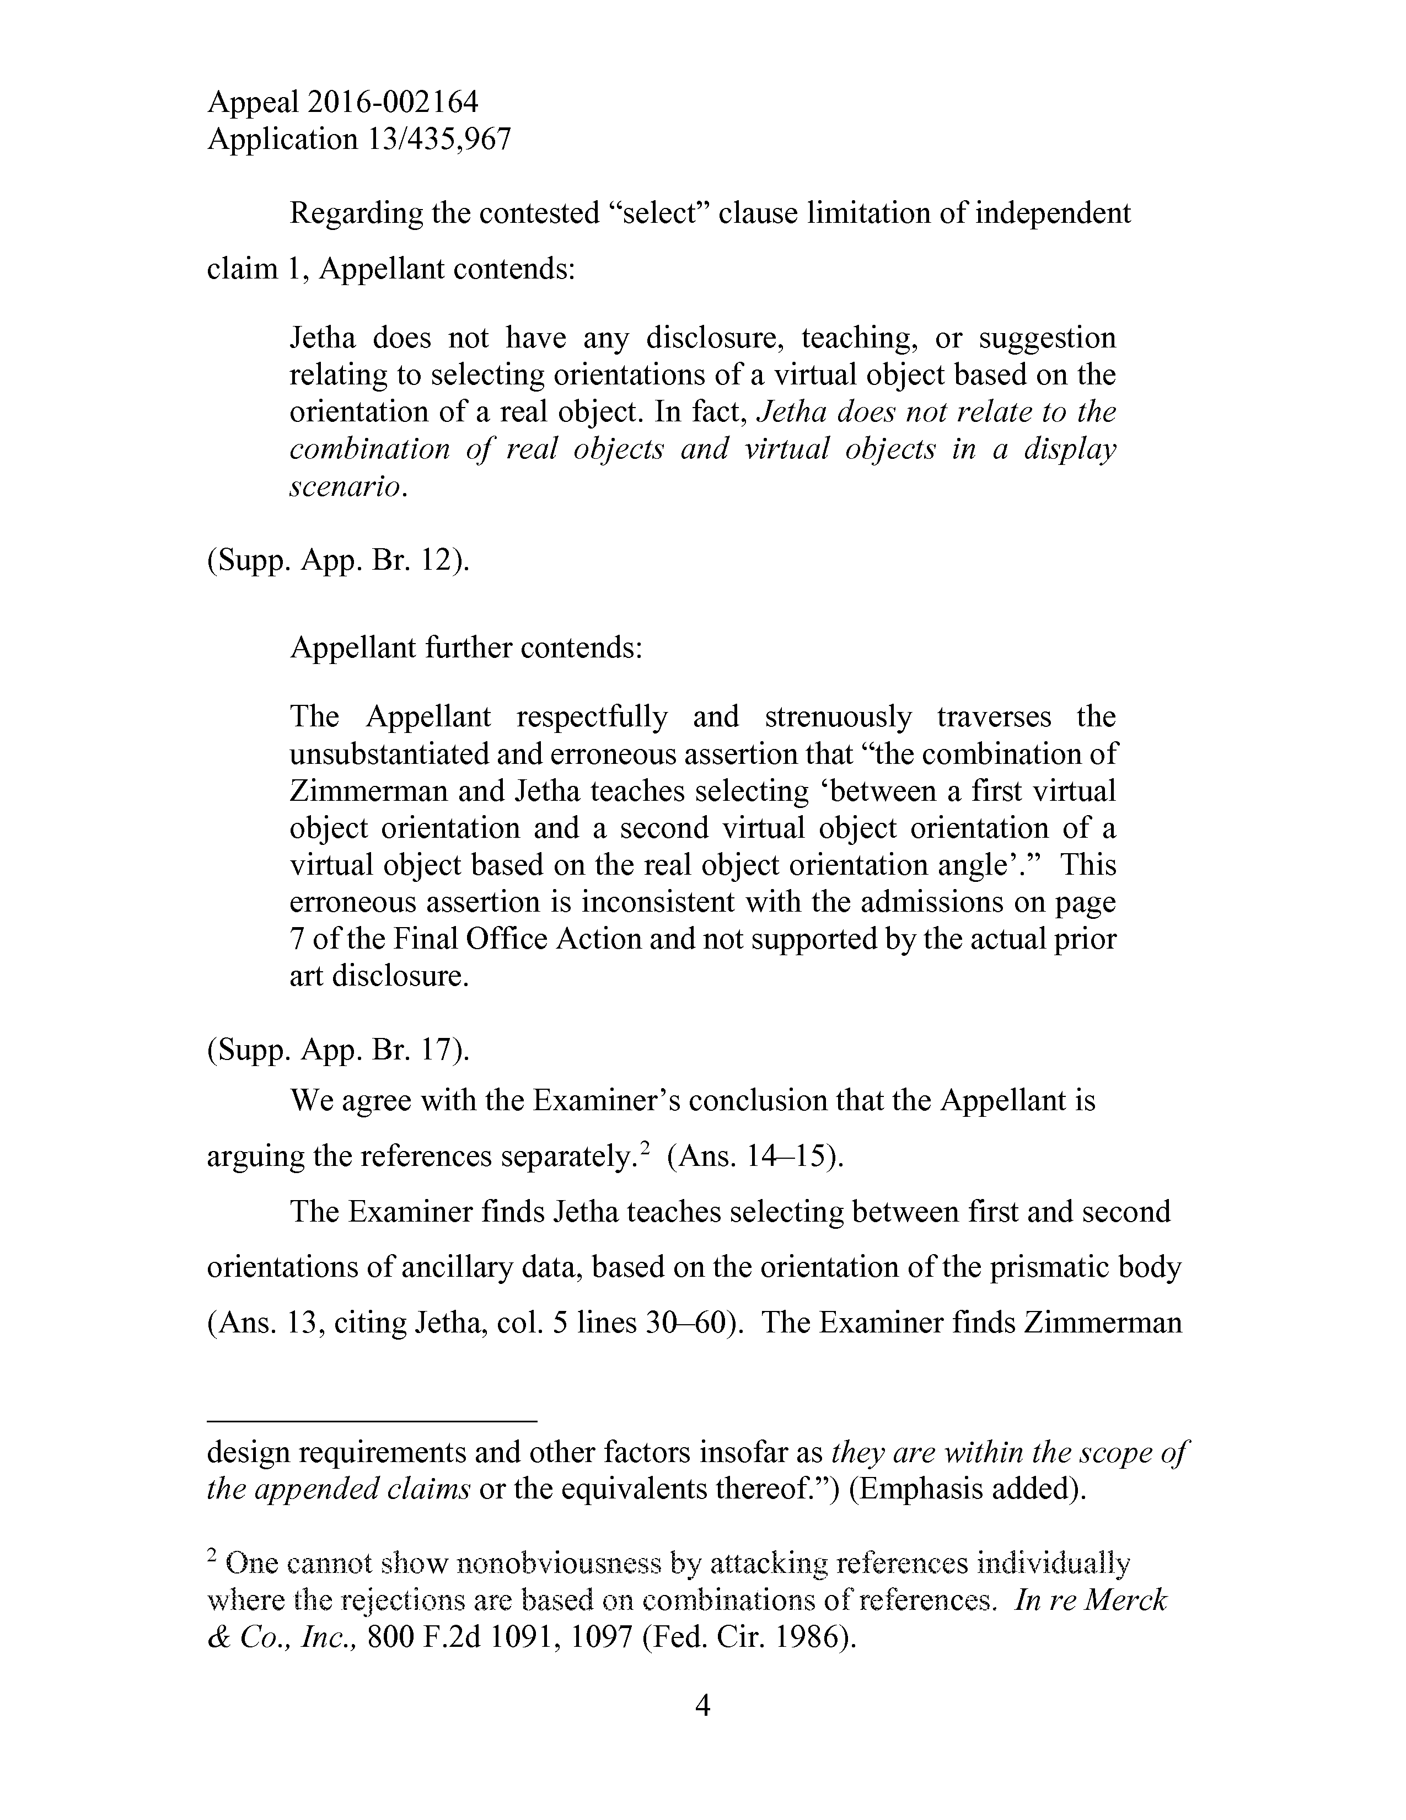

Appeal2016-002164   
Application13/435,967

Regardingthecontested“select”clauselimitationofindependent

claim1,Appellantcontends:

Jethadoesnothaveanydisclosure,teaching,orsuggestion relatingtoselectingorientationsofavirtualobjectbasedonthe orientationofarealobject.Infact,*Jethadoesnotrelatetothe combinationofrealobjectsandvirtualobjectsinadisplay scenario.*

(Supp.App.Br.12).

Appellantfurthercontends:

TheAppellantrespectfullyandstrenuouslytraversesthe unsubstantiatedand erroneousassertionthat“thecombinationof ZimmermanandJethateachesselecting‘betweenafirstvirtual objectorientationandasecondvirtualobjectorientationofa virtualobjectbasedontherealobjectorientationangle’.”This erroneousassertionisinconsistentwiththeadmissionsonpage 7ofthe Final OfficeActionandnot supportedbytheactualprior artdisclosure.

(Supp.App.Br.17).

WeagreewiththeExaminer’sconclusionthattheAppellantis

arguingthereferencesseparately.* 2(Ans.14—15).

TheExaminer findsJethateachesselectingbetweenfirstandsecond

orientationsofancillarydata,basedontheorientationoftheprismaticbody

(Ans.13,citingJetha,col.5lines30—60).TheExaminer findsZimmerman

design requirementsandotherfactorsinsofaras*theyarewithinthe scopeof theappendedclaims*ortheequivalentsthereof.”)(Emphasisadded).

2Onecannotshownonobviousnessbyattackingreferences   
wheretherejectionsarebasedoncombinationsofreferences.*InreMerck &Co.,Inc.,*800F.2d1091,1097(Fed.Cir.1986).

4

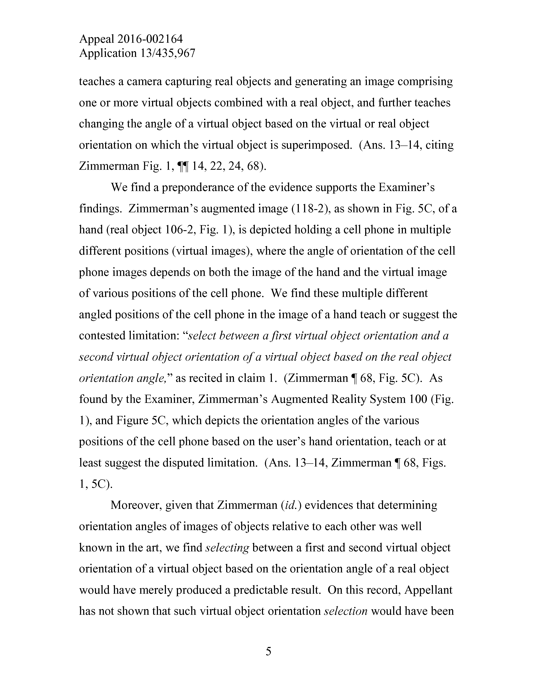

Appeal2016-002164   
Application13/435,967

teachesacameracapturingrealobjectsandgeneratinganimagecomprising oneormorevirtualobjectscombinedwitharealobject,andfurtherteaches changingtheangleofavirtualobjectbasedonthevirtualorrealobject orientationonwhichthevirtualobjectissuperimposed.(Ans.13—14,citing ZimmermanFig.1,||14,22,24,68).

WefindapreponderanceoftheevidencesupportstheExaminer’s findings.Zimmerman’saugmentedimage(118-2),asshowninFig.5C,ofa hand(realobject106-2,Fig.1),isdepictedholdinga cell phoneinmultiple differentpositions(virtualimages),wheretheangleoforientationofthecell phoneimagesdependsonboththeimageofthehandand thevirtualimage ofvariouspositionsofthecellphone.Wefindthesemultipledifferent angledpositionsofthecell phoneintheimageofahand teachorsuggestthe contestedlimitation:“*selectbetweenafirstvirtualobjectorientationanda secondvirtualobjectorientationofavirtualobjectbasedontherealobject orientationangle,”*asrecitedinclaim1.(Zimmerman|68,Fig.5C).As foundbytheExaminer,Zimmerman’sAugmentedRealitySystem100(Fig.

1),andFigure5C,whichdepictstheorientationanglesofthevarious positionsofthecell phonebasedon theuser’shandorientation,teachor at leastsuggestthedisputedlimitation.(Ans.13—14,Zimmerman|68,Figs. 1,5C).

Moreover,giventhatZimmerman*(id.)*evidencesthatdetermining orientationanglesofimagesofobjects relative toeachotherwaswell knownin theart,wefind*selecting*betweenafirst andsecondvirtualobject orientationofavirtualobjectbasedontheorientationangleofarealobject would havemerelyproducedapredictableresult.Onthisrecord,Appellant has notshownthatsuchvirtualobjectorientation*selection*wouldhavebeen

5

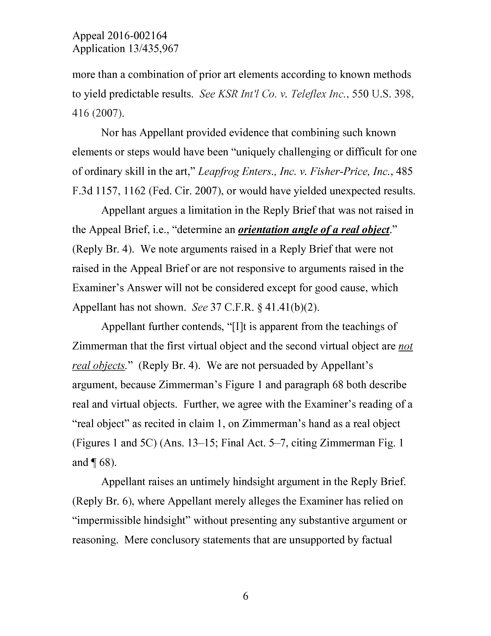

Appeal2016-002164   
Application13/435,967

morethanacombinationofpriorartelementsaccordingtoknownmethods toyieldpredictableresults.*See KSRInt'lCo.v.TeleflexInc.,*550U.S.398, 416(2007).

Nor hasAppellantprovidedevidencethatcombiningsuchknown elementsorstepswouldhavebeen“uniquelychallengingor difficult forone ofordinaryskill intheart,”*LeapfrogEnters.,Inc.*v.*Fisher-Price,Inc.,*485 F.3d1157,1162(Fed.Cir.2007),orwouldhave yielded unexpected results.

AppellantarguesalimitationintheReplyBriefthatwas notraisedin theAppealBrief,i.e.,“determinean*orientationangle ofa realobject* (ReplyBr.4).Wenoteargumentsraisedina ReplyBriefthatwerenot raisedin theAppealBriefor are notresponsivetoargumentsraisedinthe Examiner’sAnswerwill notbeconsideredexcept forgoodcause,which Appellanthas notshown.*See*37C.F.R.§41.41(b)(2).

Appellantfurthercontends,“[I]tisapparentfromtheteachingsof Zimmermanthatthefirstvirtualobjectandthesecondvirtualobjectare*not realobjects.”*(ReplyBr.4).Wearenotpersuaded byAppellant’s   
argument,becauseZimmerman’sFigure1andparagraph68bothdescribe realandvirtualobjects.Further,weagreewiththeExaminer’sreadingofa“realobject”asrecitedinclaim1,onZimmerman’shandasarealobject (Figures1and5C)(Ans.13—15;FinalAct.5—7,citingZimmermanFig.1 and 168).

Appellantraisesanuntimelyhindsightargument intheReplyBrief.

(ReplyBr.6),whereAppellant merely allegestheExaminerhasreliedon“impermissible hindsight”withoutpresentinganysubstantiveargumentor reasoning.Mereconclusorystatementsthatareunsupportedbyfactual

6

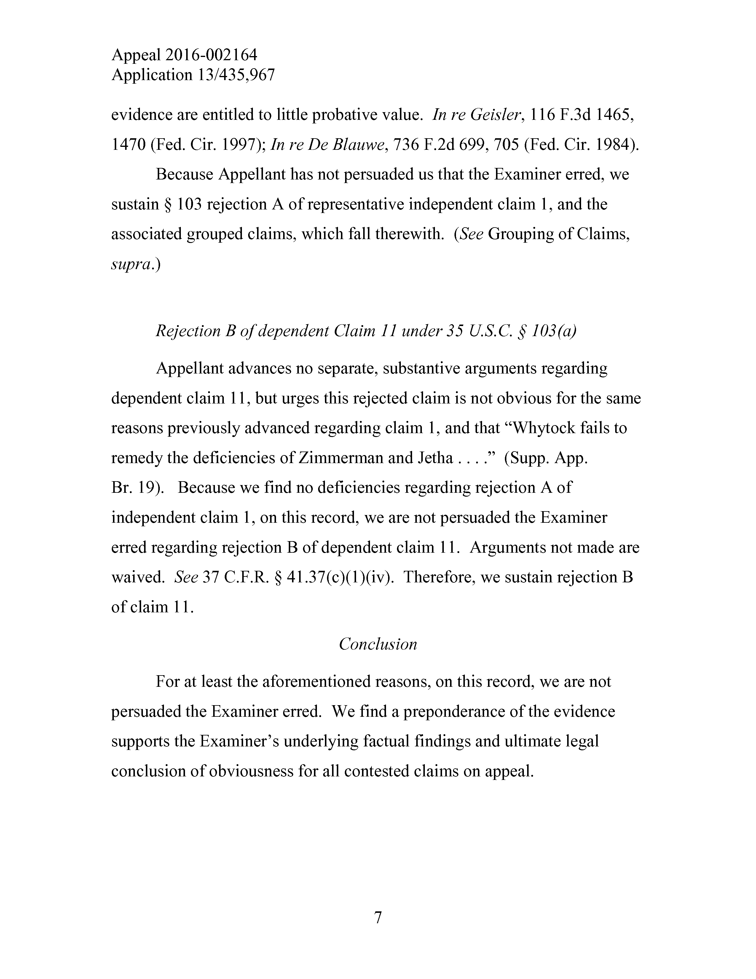

Appeal2016-002164   
Application13/435,967

evidenceareentitledtolittleprobativevalue.*InreGeisler,*116F.3d1465, 1470(Fed.Cir.1997);*InreDeBlauwe,*736F.2d699,705(Fed.Cir.1984).

BecauseAppellanthas not persuaded usthat theExaminererred,we sustain§103rejection Aofrepresentativeindependentclaim1,andthe associatedgroupedclaims,whichfalltherewith.(*See*GroupingofClaims, *supra.)*

*RejectionBofdependentClaim11under35U.S.C.§103(a)*

Appellantadvancesnoseparate,substantiveargumentsregarding dependentclaim11,but urgesthisrejectedclaim is not obviousforthesame reasonspreviouslyadvanced regardingclaim1,andthat“Whytockfailsto remedythedeficienciesofZimmermanandJetha....”(Supp.App.

Br.19).Becausewefindnodeficienciesregarding rejection Aof   
independentclaim1,onthisrecord,weare not persuaded theExaminer erred regarding rejectionBofdependentclaim11.Arguments not madeare waived.*See*37C.F.R.§41.37(c)(l)(iv).Therefore,wesustain rejection B ofclaim11.

*Conclusion*

For atleasttheaforementionedreasons,on this record,weare not persuadedtheExaminererred.Wefind apreponderanceoftheevidence supportstheExaminer’sunderlyingfactualfindingsandultimatelegal conclusionofobviousnessforallcontestedclaimsonappeal.

7

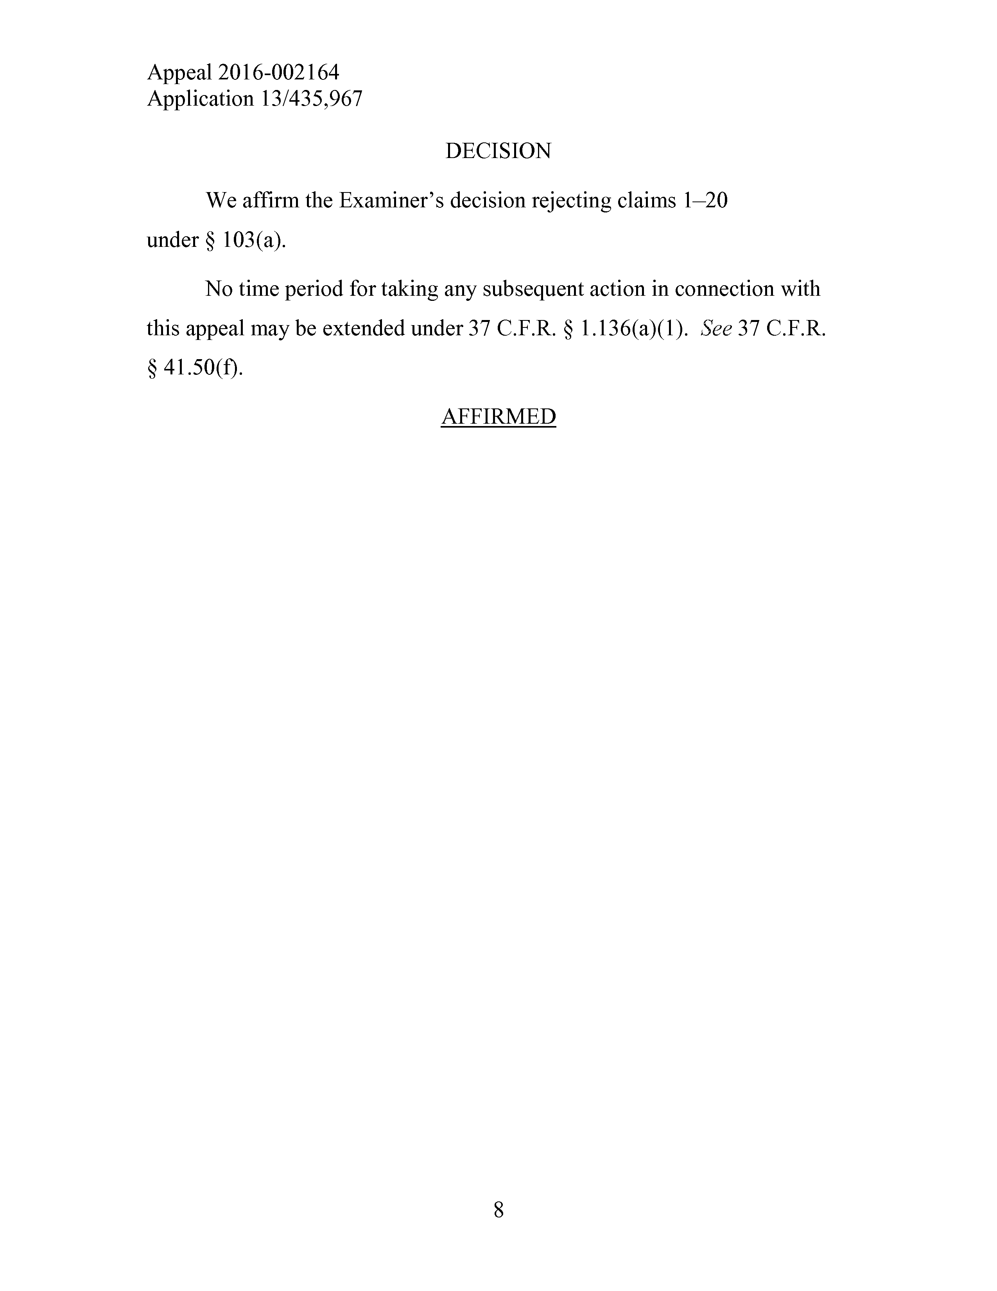

Appeal2016-002164   
Application13/435,967

DECISION

Weaffirm theExaminer’sdecisionrejectingclaims1—20

under§103(a).

Notime period fortakinganysubsequentactioninconnectionwith

thisappealmaybeextended under37C.F.R.§1.136(a)(1).*See*37C.F.R.

§41.50(f).

AFFIRMED

8