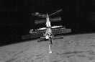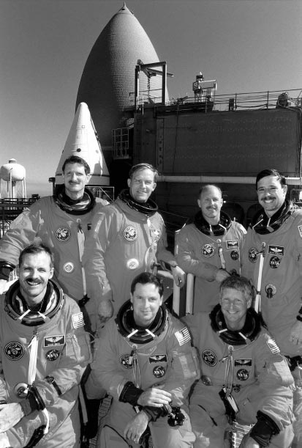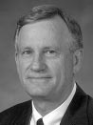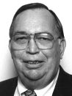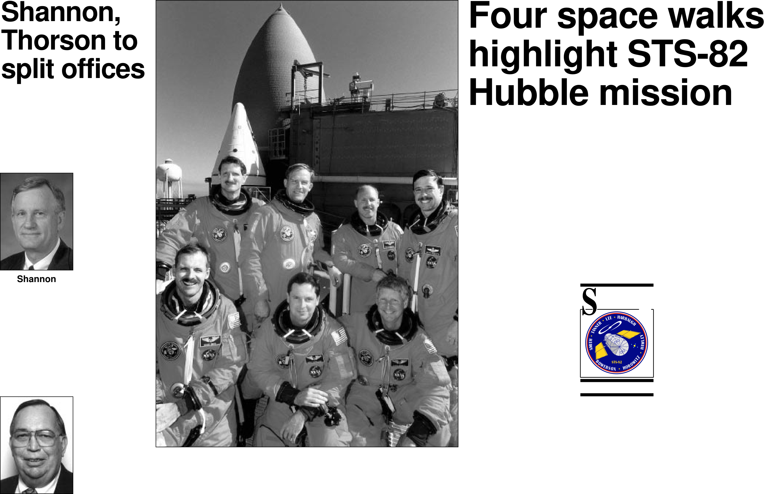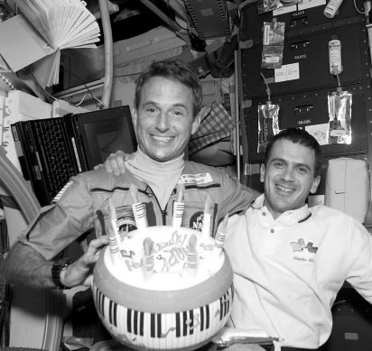

|  |  |  |  |  |  |  |
| --- | --- | --- | --- | --- | --- | --- |
| National Aeronautics and **Mir memories**  **Rodeo days** Space Administration  **Lyndon B. Johnson Space Center**  Houston, Texas   |  | | --- | |  |   STS-81 crew members capture memo- rable moments during docking with the  Russian station. Photos on Page 3.   |  | | --- | |  |   Houston Livestock Show and Rodeo  volunteers entertain JSC employees  and their children. Photos on Page 4.  Vol. 36 **SpaceNewsRoundup** No. 6 | | | | |
| **Shannon,**  **Thorson to split offices** | NASA Photo KSC-97EC-0221 **STS-82 crew members are all smiles as they take a break at Launch Pad 39A in front of Discovery during the Terminal Countdown Demonstration Test. Front row from left are, Mission Specialists Steve Smith, Greg Harbaugh and Steve Hawley. Back row from left are, Mission Specialists Joe Tanner and Mark Lee, Commander Ken Bowersox and Pilot Scott Horowitz. STS-82 will be the second Hubble Space Telescope servicing mission. Liftoff is targeted for Tuesday.** | | **Four space walks highlight STS-82 Hubble mission** | |
| The Business and Information Systems Directorate once again will become two separate direc-torates with Jim Shannon leading the business side and Richard Thorson heading up information systems.  Shannon will serve as acting director of the new Business Management Directorate. As the director, will Shannon   lead the cen- ter’s procure- ment and **Shannon**  r e s o u r c e s functions that previously were part of the Business and Information Systems Directorate. Shannon joined JSC in 1962 and has held progressively responsible positions in the Mission Operations Directorate over his 34-year career. After holding numer-ous managerial positions within MOD, Shannon was appointed assistant direc- tor in 1989 and named was   deputy director in 1995.  Thorson will serve as acting director of the new Informa- tion Systems Directorate. As **Thorson**  the acting di- rector, Thorson will lead the center’s information systems and information technolo-gy programs that previously were part of the Business and Information Systems Directorate. He joined JSC in 1966 and has held numerous managerial posi-tions, including   manager for Station Integration for Space  Freedom; deputy manager of the National   Space Transportation Systems Operations; manager of the Data Management and Opera-tions Office and most recently, deputy director of   Center Operations. |
| **By Ed Campion**  roll maneuver to position it for grap-  The STS-82 astronauts are to pling. Hawley will use the robot arm  arrive at Kennedy Space Center to grab the telescope and berth it in  today as Discovery prepares to lift Discovery’s cargo bay. Once the  off on the second servicing mission telescope is secure and power has  to the orbiting Hubble Space transferred to Discovery, Horowitz  Telescope. will maneuver the shuttle so that  Commander Ken Bowersox, Pilot Hubble’s solar arrays face the sun  Scott Horowitz, and Mission and its internal batteries can  Specialists Mark Lee, Greg recharge.  Harbaugh, Steve Smith, Joe Tanner Beginning Thursday evening, the  and Steve Hawley were to leave first of four space walks over four  Ellington Field early Friday and successive days will be conducted.  spend the next few days in weather During the space walks, Lee,  and mission-related meetings. Harbaugh, Smith and Tanner will  The official STS-82 install two state-of-the-art  early Saturday at 3 a.m.  CST.  Readiness Review meet-At the Flight **STS-82**  icantly upgrade the scien-  tific capabilities of the tele-  scope. They also will countdown isto begin instruments that will signif-  ing on Jan. 30, NASA perform maintenance to  managers set Feb. 11 as keep HUbble functioning  the official launch date for smoothly until the next  the mission. The 65- **STS-82**  scheduled servicing mis-  minute launch window sion in 1999.  opens at 2:56 a.m. CST Once the space walks  Tuesday. **DISCOVERY**  are complete, ground con-  Work at Launch Pad trollers will turn on  39A this week included completion Hubble’s internal power and Hawley,  of payload integration and verifica- who originally deployed Hubble on  tion tests, cooling of the Near STS-31 in April 1990, will release  Infrared Camera and Multi-Object the orbiting observatory to continue  Spectrometer payload and closeout its exploration of distant galaxies.  of the aft compartment. Discovery’s mission is planned for  In addition to standard pre-launch 9 days, 22 hours, 47 minutes. The  processing activities this week, KSC second shuttle mission of the year  technicians also removed and will conclude with a landing at KSC  replaced the nozzle throat plugs on on Feb. 21 at about 1:43 a.m. CST.  the solid rocket boosters. The team While Discovery is poised to begin  examining the nozzle throat erosion its mission, processing work on the  issue asked for the plug changeout other shuttles supporting flight oper-  to give engineers additional data on ations also continues on schedule.  a batch of polysulfide material used Following installation of the  on some recent SRBs. The polysul- Spacelab into Columbia last Friday,  fide material may be a possible con- KSC technicians conducted integra-  tributor to the unusual erosion pat- tion and verification tests on the  tern seen during two previous module. Securing of the three shut-  shuttle launches. tle main engines also was complet-  Assuming an on-time launch on ed. Current plans call for Columbia  Feb. 11, Discovery will rendezvous to be moved to the Vehicle  with the orbiting telescope just Assembly Bldg. on March 3 and to  before 2 a.m. CST on Feb. 13. be moved to the launch pad one  When the shuttle is within 200 feet week later. Columbia’s seven astro-  of the telescope, ground controllers nauts will fly on STS-83, a 16-day  will command Hubble to perform a microgravity sciences flight1. | |
| **Black history artifacts needed for exhibit** | |
| In observance of Black History Month, the Equal Opportunity Programs Office will host a Black History Exhibit from 11 a.m.-1:30 p.m. Feb. 25 and 26 in the Bldg. 3 cafeteria.  JSC employees are encouraged | to submit items for display to enhance the variety and significance of African-Americans in American history.  Employees who have any items to display can contact Patricia Burke at x30606 no later than Feb. 18. |
| **Linenger salutes Houston rodeo from Mir station** | | |  | | --- | |  | | | **JSC workers take buyout advantage** |
| Mir 22 Flight Engineer Jerry Linenger sent his greetings to partic-ipants in the Houston Livestock Show and Rodeo last week but spent most of the week diving into his experiments on the Russian Mir Space Station and preparing for the arrival of the Mir 23 crew next week. “Welcome everybody to the Houston Livestock and Rodeo show,” Linenger said. “It is going to be a fantastic event and I wish I were down there right now to join y’all. I know that there are more than 10,000 volunteers that make the show a success and so we want to salute all those people that put in all their hard work, hard effort to make the show a success every year. And, also to those volunteers at JSC. I know a lot of folks down there also get involved in the Houston Livestock Show and Rodeo.”   Linenger showed off his sheriff-in-space badge and hog socks and roped a couple of aliens as he made deputies of Commander Valery | Korzun and Flight Engineer Alexander Kaleri.  The break in activities came after a busy four weeks on Mir, but Linenger said he is making himself at home and enjoying his stay in space.  “So far it’s been a great experi-ence,” Linenger said last week dur-ing an interview with WDRV in Detroit. “I have been really busy doing some great science experi-ments, but also having an enjoyable time getting use to a new environ-ment. The floating and those things that most people associate with space becomes second nature around here and it feels like I am at home now. The minute I got into space I felt very comfortable physi-cally. You just have to adjust a little bit because everything is fingertip control. You can’t go bounding around or leaping or anything like that, you just basically use your fin-gertips and push yourself in any Please see **MIR**, Page 4 |
| A total of 113 employees took advantage of the latest NASA buy out program and left JSC to pursue other interests.  The following is a breakdown of JSC employees by directorate who elected to voluntarily resign, retire or take an “early out” through the buy-out program.  **Human**  **Resources**  **Office**: Richard Campbell, Curtis Collins, Valerie Michaud and Elaine Trainor. **Office of Public Affairs**: Juanie Campbell, Edna Campos, Bunny Dean and Jim Poindexter.  **Legal Office**: Harold Dantone, Hank Flagg and John Lottinville.  **Business and Information Ser-vices Directorate**: Doris Adams, Bluford Brady, Jane Brandenstein, Anne Brenton, Warren Conner, Dean DesJardins, Ruth Elder, Jackie Fisher, Paula Fyffe, Patricia Kanz, Edward Kenyon, Theodore Please see **WORKERS**, Page 4 |
| NASA Photo STS081-E-5498 **STS-81 Mission Specialist Jeff Wisoff, right, and other Atlantis crew members give Mir 22 Flight Engineer Jerry Linenger a special inflat-able cake to celebrate his 42nd birthday before leaving him on the orbiting laboratory.** | |