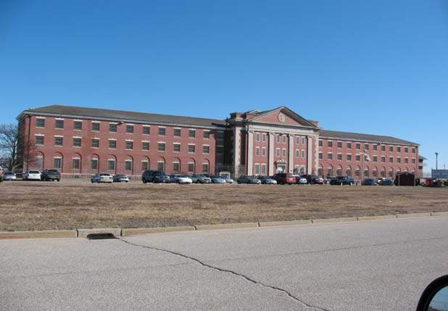

|  |  |
| --- | --- |
| um S  vid M | ld Price  *arden* |

, *Deputy W arden*

|  |
| --- |
| Opened: 1932 (as reformatory for men)  Closed: 1992 (due to opening of John J. Moran Facility) Reopened: 1997 (as Donald Price Facility)  Average Facility Population: 345 (FY’09)  Operational Facility Capacity (FY ’09): 324  Annual Cost Per Offender (FY ’09):$53,255 |

The Donald Price Facility was

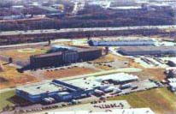 designed and first used to house youthful building closed in 1992 when the John J. Moran Medium Security Facility was built and offenders. The constructed in 1929 and opened in 1932. It was originally

*An aerial view of the Price Facility*  was reopened as the Donald Price Medium Security Facility for sentenced males in 1997. It is named for Correctional Officer Donald Price, killed in the line of duty in 1973.

MISSION STATEMENT

assigned by the Department of Corrections’ Classification process. 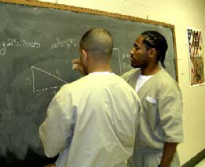

To provide clean, safe, secure, and   
humane housing for inmates

Through staff interaction and *Many inmates take advantage of*  programming, to provide *educational opportunities in the*

opportunities for inmates to *facility.*

develop usable skills in order to   
explore their own potential for becoming law-abiding productive citizens of the community.

To screen the behavior of inmates, to allow for further classification to more appropriate levels of confinement consistent with public safety.

Through team effort and continuous training, to achieve a high level of professionalism which will allow staff to be more effective role models in their interactions with inmates.

AVAILABLE PROGRAMS

Academic

General Education Development (GED), Computer Literacy, Special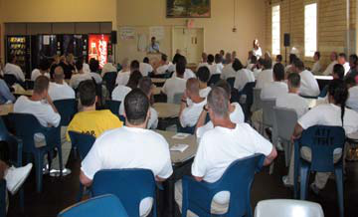

Adult Basic   
Education (ABE),

Education, Title I *Guest speaker Andres Idarraga addresses* Remedial Reading & *inmates receiving degrees and certificates in the* Math, Post *June 2008 Recognition Ceremony held by the* Secondary Program/ *Education Unit.*

CCRI, College CLEP Testing

Vocational/Industrial   
Carpentry Shop

Treatment/Rehabilitative   
Parenting education, religious services, Anger Management class, Spanish and English Spectrum (drug treatment) Program, domestic violence counseling, Alcoholics   
Anonymous, Narcotics Anonymous, health education, art, *Amer I Can* program.