## Problem 1 – Movies

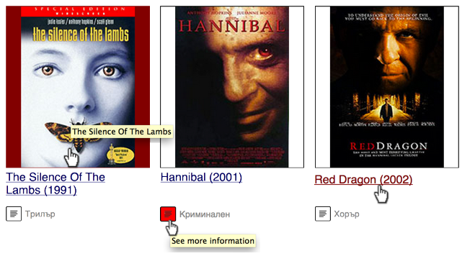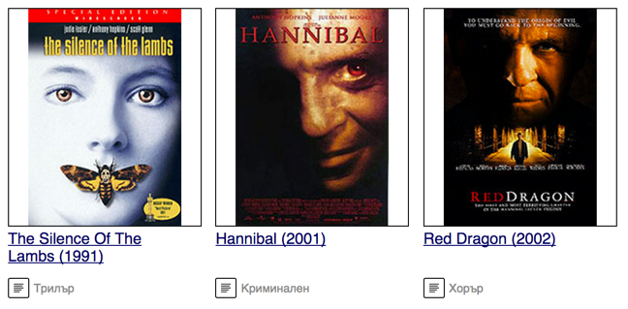Create a Web page (HTML5 + CSS3 + images) that looks and behaves like the screenshots below:

* The mouse hand-pointer in the screenshots is not part of your page, so please skip it. It shows you what happens when the mouse moves over certain elements.

### Input

You are given the above screenshots + all required images + the texts on the site.

### Output

The output should be valid HTML5 + CSS3 + images that implement the above Web page.

### Constraints

* Font: Helvetica / Tahoma / sans-serif (size: 16px for the text, 12px for the genre).
* Column width: 160px.
* The site should open correctly in Chrome 38.
* Responsive design is not required.
* Pixel-perfect implementation is not required.