## Problem 3 – Free Account

Create a Web form (HTML5 + CSS3 + images) that looks and behaves like the screenshots below:

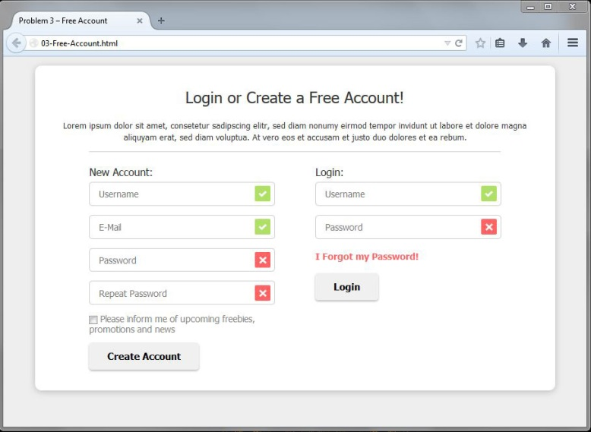 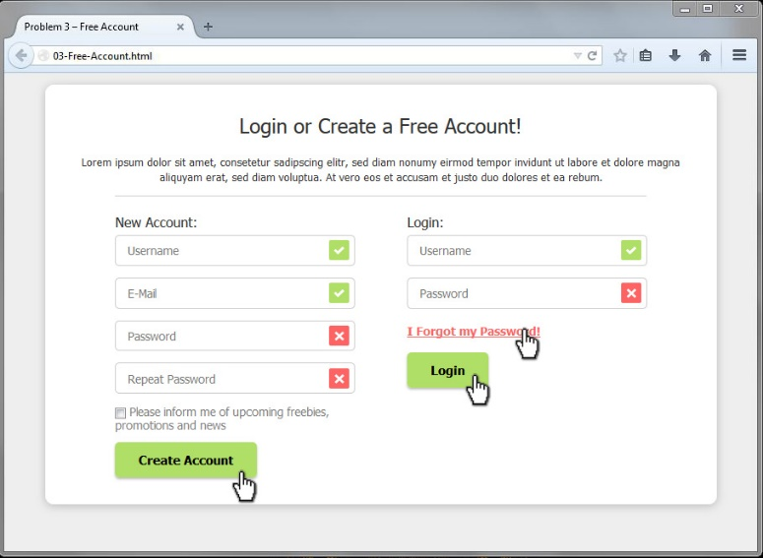

### Input

You are given the above screenshots and all required images.

### Output

The output should be valid HTML5 + CSS3 + images that implement the above Web form.

* You do not need to implement form validation. The images at the end of the fields are static – do not depend on the text inside the field.

### Constraints

* Font: Tahoma, Helvetica, sans-serif.
* Site content: fixed width 800px.
* Heading font-size: 24px.
* Form validation is not required.
* The site should open correctly in Chrome 38.
* Responsive design is not required.
* Pixel-perfect implementation is not required.