## Problem 4 – Planets: Unresponsive to Responsive Site

You are given an unresponsive Web site (**HTML** + **CSS** + images). Your task is to **make the site responsive**. The site layout should change according to the browser viewport / screen size. You need to implement two additional layouts: **width < 756px**, **756px ≤ width < 1000px**. The figures below represent these two layouts + the unresponsive layout:

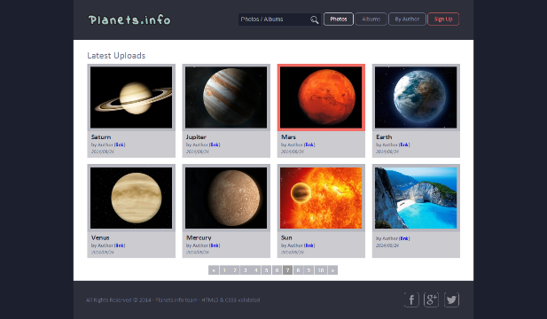 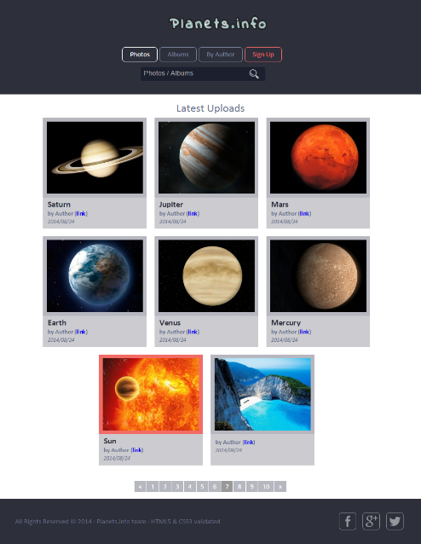 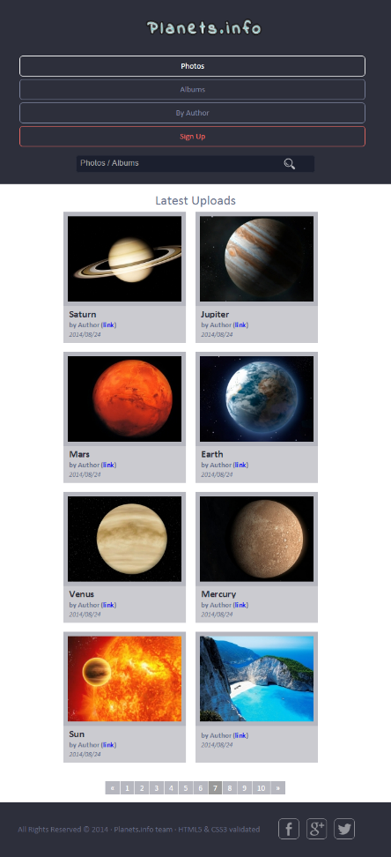

### Input

You are given the unresponsive site as HTML + CSS + images.

### Output

The output should be valid HTML5 + CSS3 + images that implement the above responsive site.

### Constraints

* You are free to change the HTML and CSS, as well as use external frameworks like Bootstrap.
* Pixel-perfect implementation is not required.
* The site should open correctly in Chrome 38.