## Problem 3 – Contact Form

Create a Web form (HTML5 + CSS3 + images) that looks and behaves like the screenshots below:

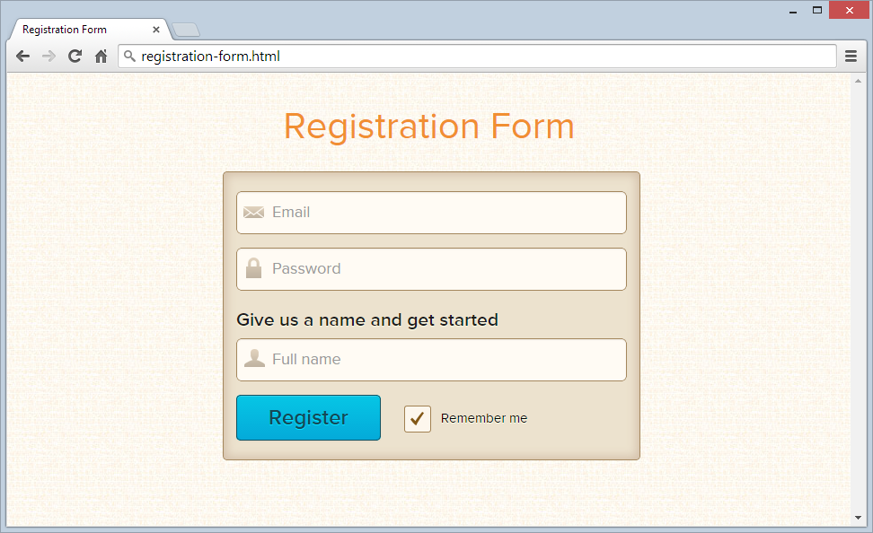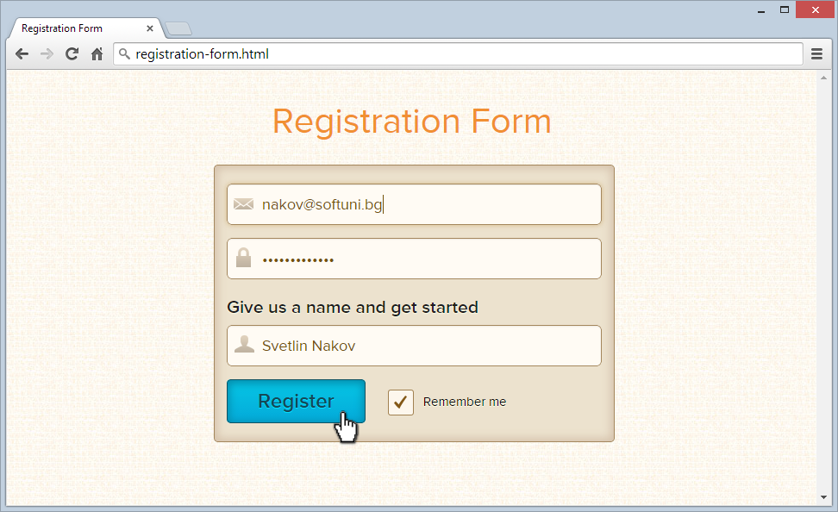

### Input

You are given the above screenshots all required images and fonts.

### Output

The output should be valid HTML5 + CSS3 + images that implement the above Web form.

### Constraints

* Font: Montserrat Regular / sans-serif.
* Form validation: no validation is required.
* The site should open correctly in Chrome 37.
* Responsive design is not required.
* Pixel-perfect implementation is not required.