## Problem 1 – Services

Create a Web page (HTML5 + CSS3 + images) that looks and behaves like the screenshots below:

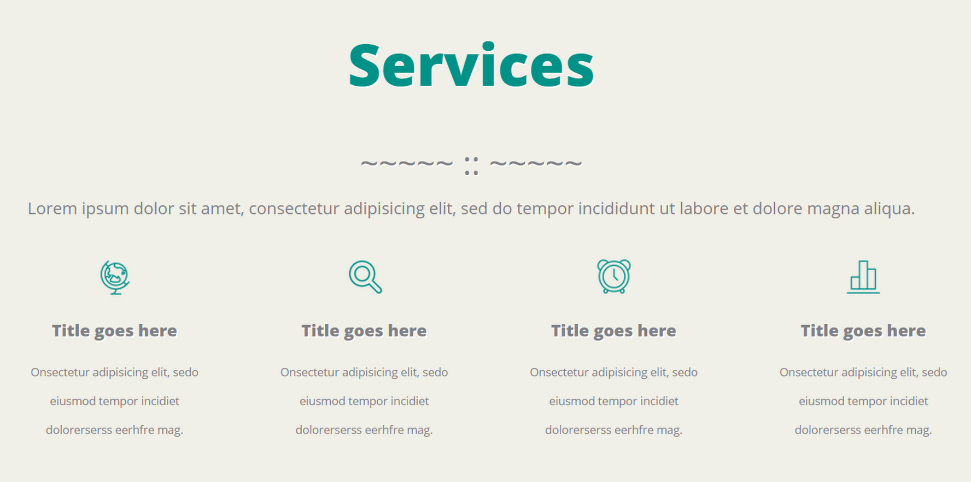

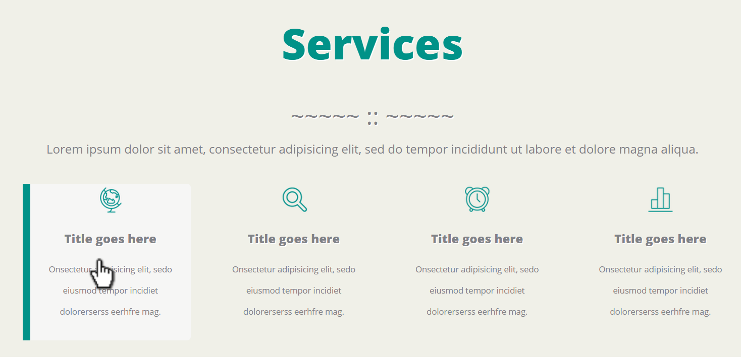

* The mouse hand-pointer in the screenshots is not part of your page, so please skip it. It shows you what happens when the mouse moves over certain elements. The hand-pointer + hover effects should be visible on all four elements.

### Input

You are given the above screenshots + the required font + all required images + the texts on the site.

### Output

The output should be valid HTML5 + CSS3 + images that implement the above Web page.

### Constraints

* The font in the entire page is OpenSans-ExtraBold / Helvetica / sans-serif (size: 56px for the main heading, 16px for the buttons).
* Column width: 220px with all margins + paddings.
* The site should open correctly in **Chrome 38** and above.
* Responsive design is not required.
* Pixel-perfect implementation is not required.