## Problem 2 – SoftUni Events

Create a Web site (HTML5 + CSS3 + images) that looks and behaves like the screenshots below:

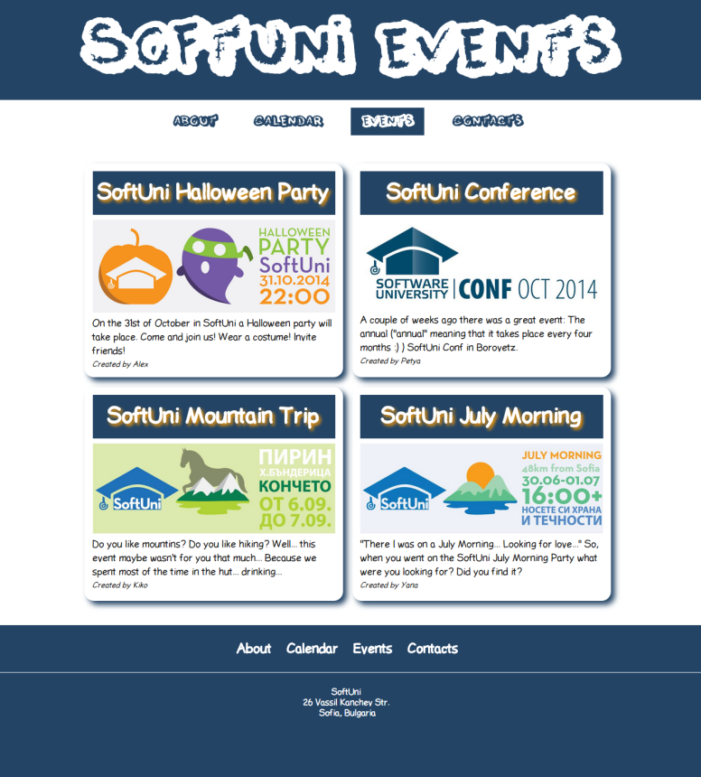 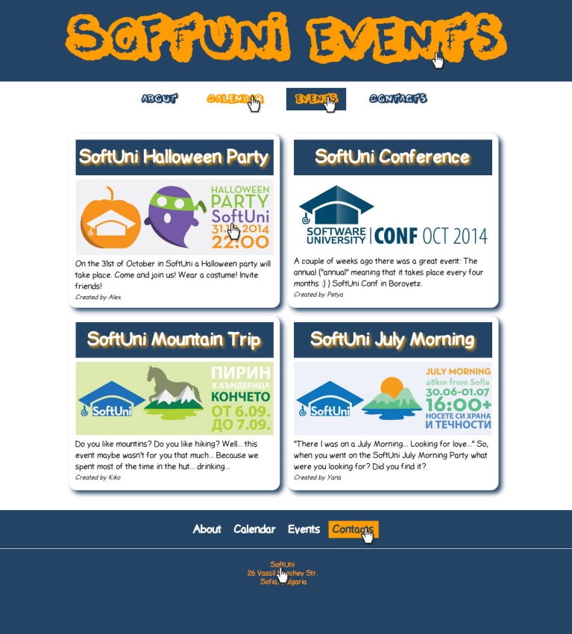

* The hand cursors in the screenshots shows what happens when the mouse moves over certain elements.

### Input

You are given the above screenshots + the texts on the site + the site fonts.

The "ThisNight" and "LDFComicSans" fonts are given as TTF file.

### Output

The output should be valid HTML5 + CSS3 + images that implement the above Web site.

### Constraints

* Header / top navigation font: **ThisNight** / **Helvetica** / **sans**-**serif**.
* Body / footer font: **LDFComicSans**/ **Arial** / **sans**-**serif**.
* Site content width**: fixed @ 960px**.
* Site header / footer width: fluid (fill the entire page width).
* The site should open correctly in **Chrome 38** and above.
* Responsive design is not required.
* Pixel-perfect implementation is not required.