## Problem 3 – Login Form

Create a Web form (HTML5 + CSS3 + images) that looks and behaves like the screenshots below:

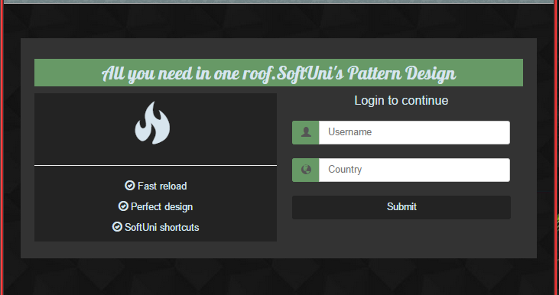 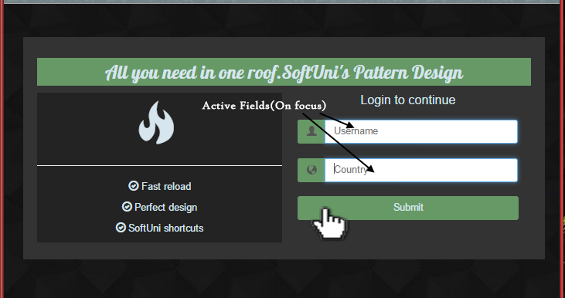

* The mouse hand-pointers, the text "Active Fields (on Focus)" and the black arrows are not part of your form, so please skip them.

### Input

Font on header is “**Google Lobster Font**”. You are **given** a link in the file **GoogleLobsterFont.txt** that you need to import in order to use the font. You are given all needed text as well.

You are given the above **screenshots** + the **background image** + the **form field icons** (as glyph font).

* The "username" glyph icon is the character "\e008" in the "Glyphicons Halflings" font.
* The "planet" glyph icon is the character "\e135" in the "Glyphicons Halflings" font.
* The "fire" glyph icon is the character "\e104" in the "Glyphicons Halflings" font.
* The "ok-circle" glyph icon is the character "\e089" in the "Glyphicons Halflings" font.

### Output

The output should be a valid semantic HTML5 + CSS3 + images that implement the above Web form.

### Constraints

* Fonts: **Arial**, **Helvetica**, **sans-serif**.
* Main container size: **750px** x **320px** (fixed size).
* **Login** form and **Advertisement** container size: **350px** x **215px** (fixed size).
* Form background: stretched to fill the entire page.
* Form validation: no validation is required.
* The site should open correctly in **Chrome 38** and above.
* Responsive design is not required.
* Pixel-perfect implementation is **not required**.