## Problem 4 – Unresponsive to Responsive Site

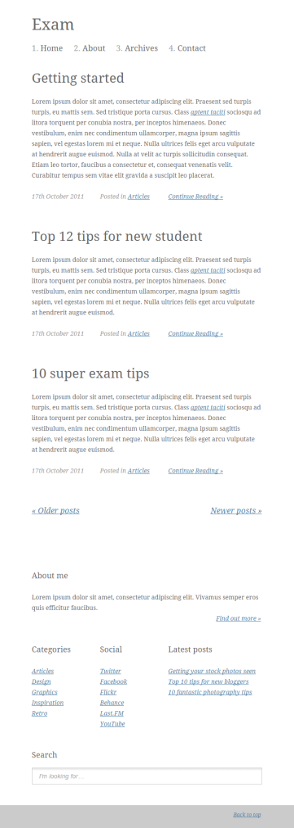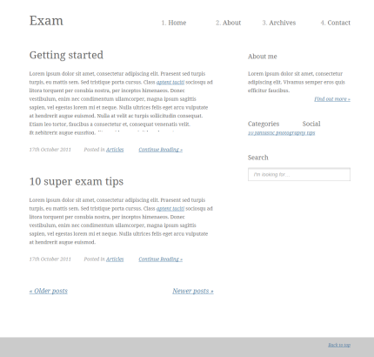You are given an unresponsive Web site (**HTML** + **CSS** + images). Your task is to **make the site responsive**. The site layout should change according to the browser viewport / screen size. You need to implement 4 layouts: **width < 540px**, **540px ≤ width < 760px**, **760px ≤ width < 960px** and **width ≥ 960px**. The figures below represent these 4 layouts:

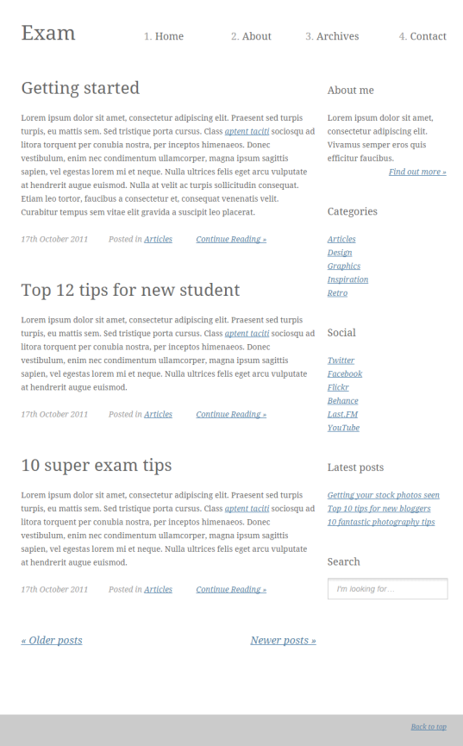

### Input

You are given the unresponsive site as HTML + CSS + images.

### Output

The output should be valid HTML5 + CSS3 + images that implement the above responsive site.

### Constraints

* You are free to change the HTML and CSS, as well as use external frameworks like Bootstrap.
* Pixel-perfect implementation is not required.