## Problem 2 – Awesome Site

Create a Web site (HTML5 + CSS3 + images) that looks and behaves like the screenshots below:

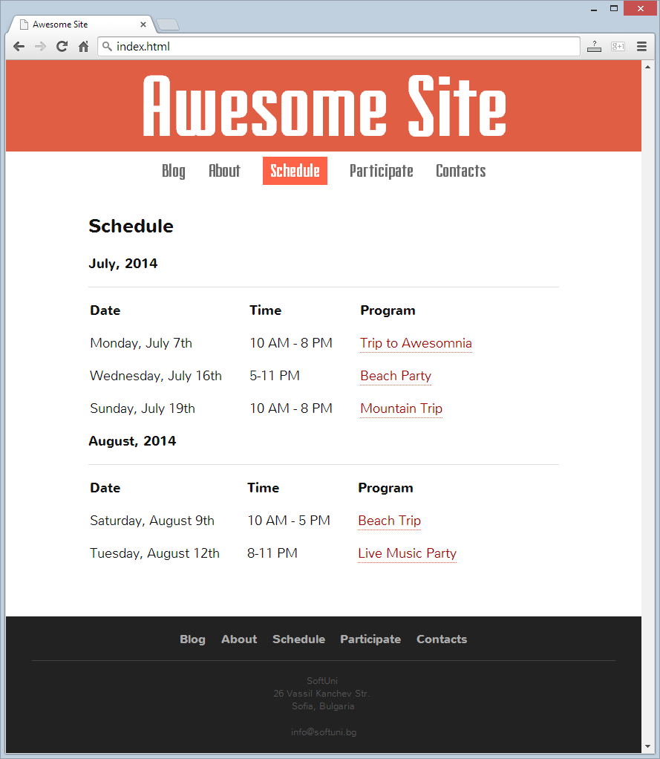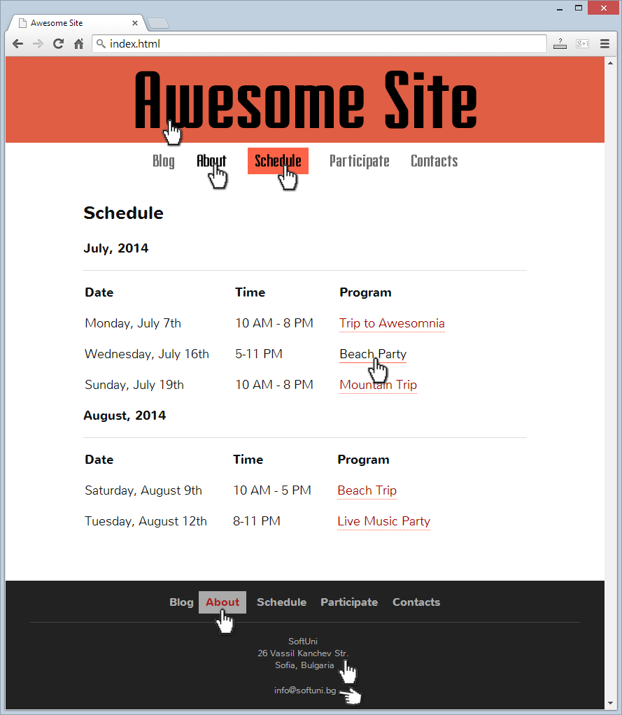

* The hand cursors in the screenshots shows what happens when the mouse moves over certain elements.

### Input

You are given the above screenshots + the texts on the site + the site fonts.

The "Fairview" site is given as TTF file.

The "Nunito" font is available from Google Fonts: <http://fonts.googleapis.com/css?family=Nunito:400,700>.

### Output

The output should be valid HTML5 + CSS3 + images that implement the above Web site.

### Constraints

* Header / top navigation font: Fairview / Helvetica / sans-serif.
* Body / footer font: Nunito / Arial / sans-serif.
* Site content width: fixed @ 670px.
* Site header / footer width: fluid (fill the entire page width).
* The site should open correctly in Chrome 35.
* Responsive design is not required.
* Pixel-perfect implementation is not required.