## Problem 1 – Projects and Groups

Create a Web page (HTML5 + CSS3 + images) that looks and behaves like the screenshots below:

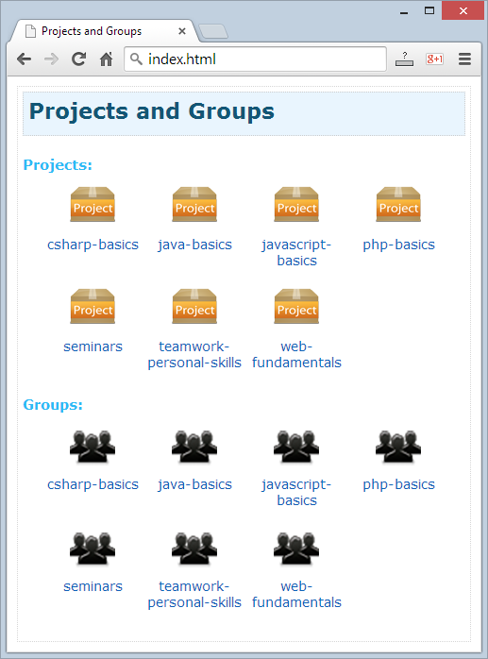 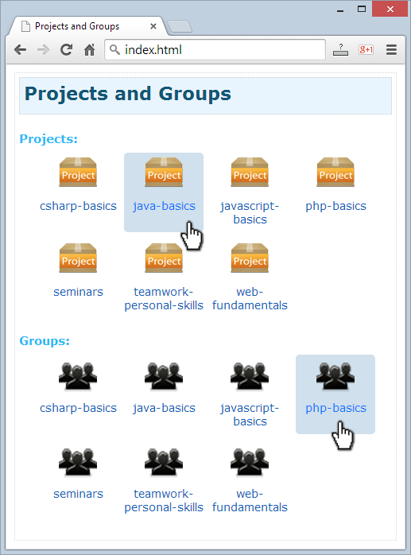

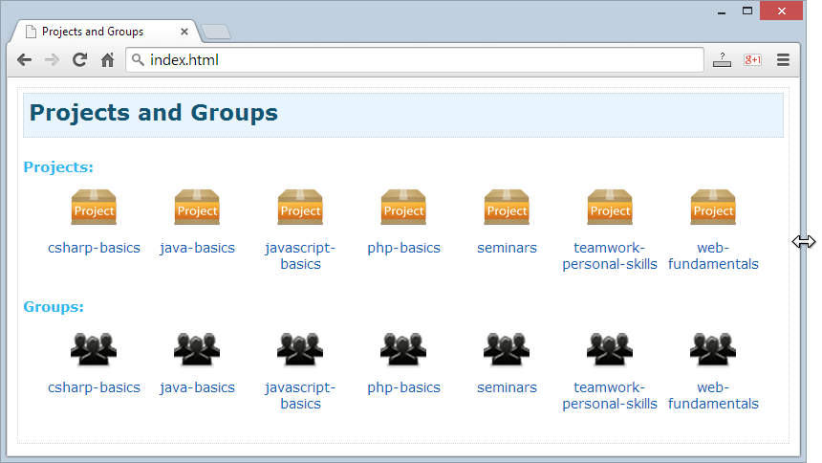

* The mouse cursors in the above screenshots explain what happens when the mouse moves over a project or a group and when the browser window resizes.

### Input

You are given the above screenshots + all required images + the texts on the site.

### Output

The output should be valid HTML5 + CSS3 + images that implement the above Web page.

### Constraints

* The layout should fill the entire page width except 10px empty space at all sides.
* Font: Verdana / Helvetica (size: 23px for the title, 15px for the subtitle, 14px for the items text).
* Item width: 100px.
* Items should be hyperlinks.
* The site should open correctly in Chrome 35.
* Pixel-perfect implementation is not required.