## Problem 1 – Numbers

Create a Web site (HTML5 + CSS3) that looks and behaves like the screenshots below:

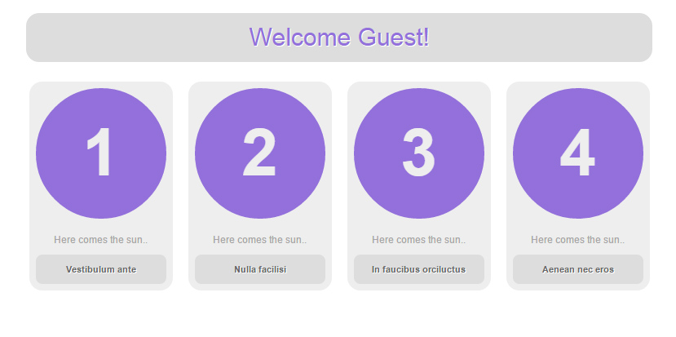

* The hand cursors in the screenshots show what happens when the mouse moves over certain elements.

### Input

You are given two screenshots + the texts on the site.

### Output

The output should be valid HTML5 + CSS3 that implement the above Web site.

### Constraints

* Fonts:
  + Site content: Arial, Helvetica, sans-serif; 12px.
  + Link Read More: 10px.
* Site content: fixed width 800px.
* The site should open correctly in Chrome 35+.
* Responsive design is not required.
* Pixel-perfect implementation is not required.
* Take the colors from the pictures with color picker.