Credit Card Manual

Introduction
This manual will describe how to use the Credit Card web application, for starting the application open command line and go in the directory where the creditcard-0.0.1-SNAPSHOT.jar file is present.
Digit the command
Java –jar creditcard-0.0.1-SNAPSHOT.jar

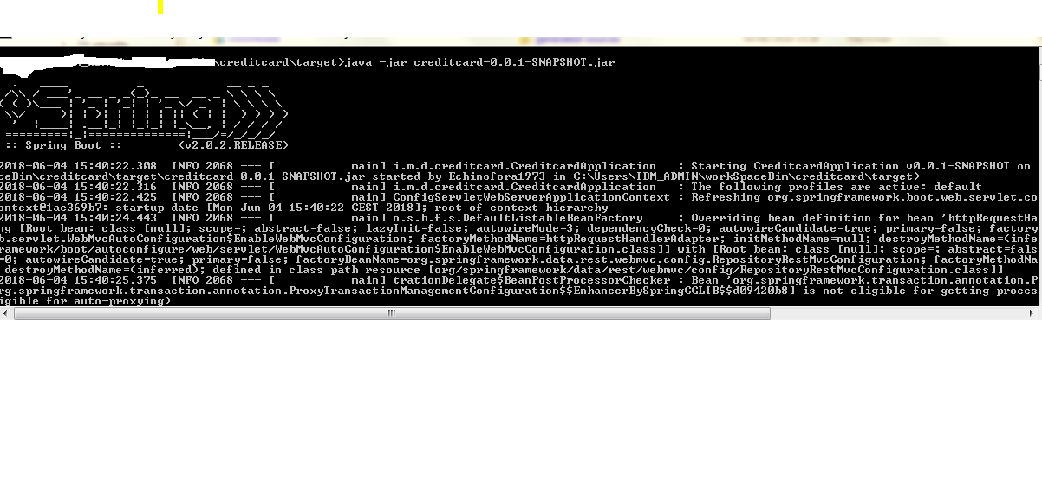

Application login

Open your preferred browser and digit in the address bar http://localhost:8080/creditcards-info
The system will load the login page and login using the following users
User name1 : administrator
`Password1: ADMIN
Role :ADMIN
User name2: OptimusPrime@transfomers.sb
Password 2:megatron
Role2: USER
It is possible to add other users fro the button in the menu add users,
The form is almost identical to the login form, all the users inserted will have just the USER ROLE and they will just manage the credit cards that They have the ownship, while the admin user will be able to see and manage the credit cards owned by all the users
The ROLE user name must be their email address.
After accessed in the application the system will load the credit cards page.
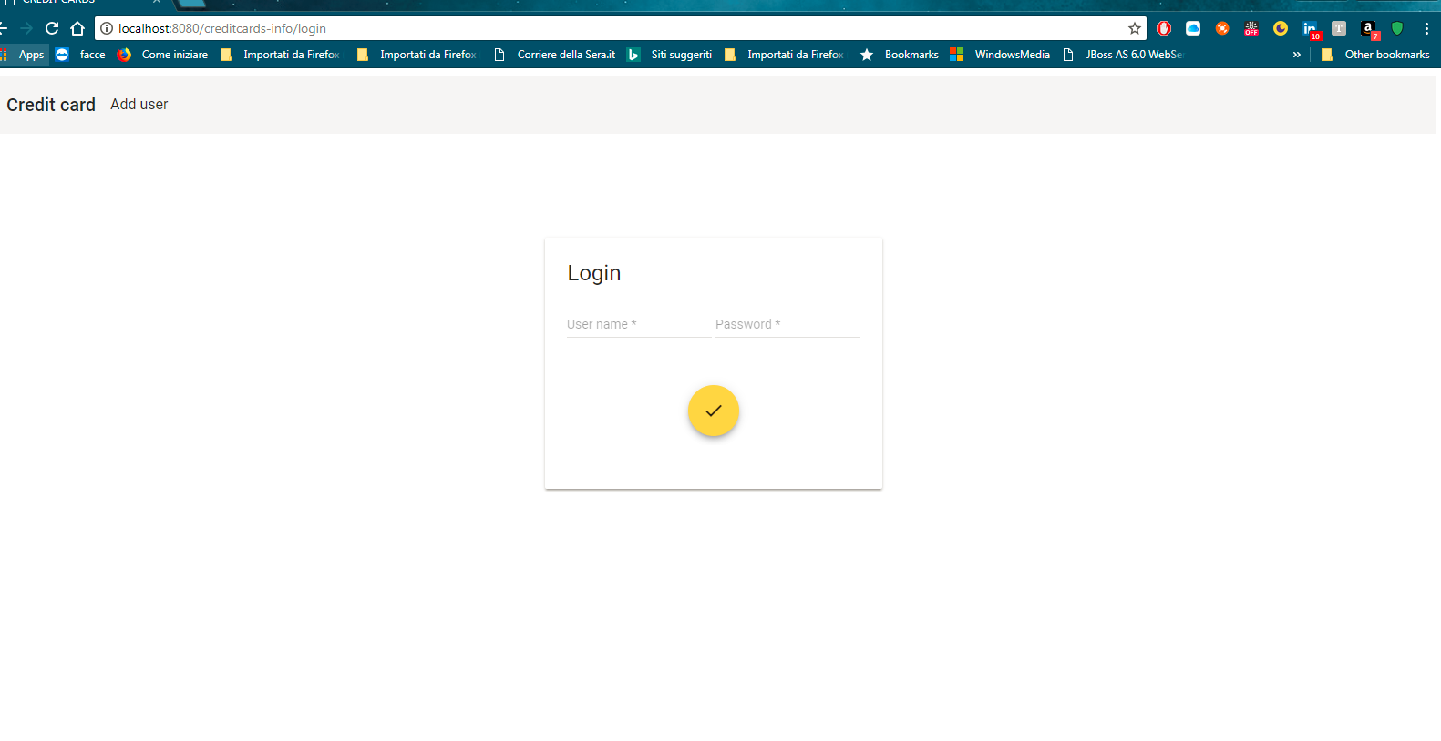

Credit cards page
The page will show the credit cards list managed by the user (all of them if the user is admin role).
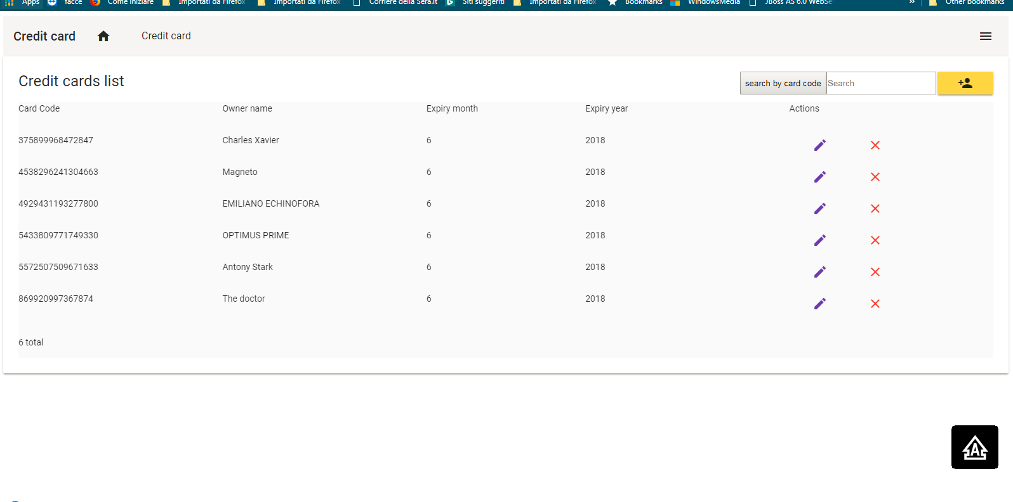
It is possible to filtering the cards by textbox( search like) and pushing the search button,

Add credit card

When the user clicks the insert button(the yellow one) the application will load the form to fill
With the following fields
- Card code, mandatory, numeric code, range between 15 and 16, when the form is submit the system valids the card code through luhn algorithm andcheck if the card code is not already present.
- Name, the card owner name, mandatory
- Expiry month (drop down 1-12), mandatory
- Expiry year mandatory
When the credit card form is submit the data will be stored in db and the credit cards list will be reloaded.

Update credit card
Select the pencil icon in the record to update.
The application will load the update form, after the modified the the fields the data will be updated at submit and the list will reloaded

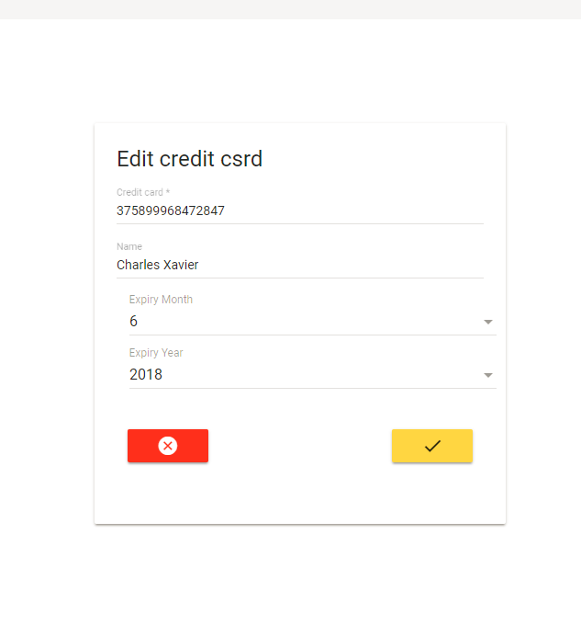

Delete Credit card
Select the icon X in the record to delete, before deleting the application will ask a confirmation,
Confirmed the the deleting, the db will be update and the list will be reloaded .

