Project for URL shortener, with the application deployed in a cloud service using just 100 dollars (borrowed from my dad).

I decided I wanted to become rich and finally buy a Ferrari, so I developed a revolutionary service to shorten the longest URLs, which is useful when you need to share them on Twitter or WhatsApp.

**URL SHORTENER SERVICE**

The service exposes a REST interface in order to generate a short link that is easy to insert in short messages (e.g. on Twitter or WhatsApp). In the real world the short link should redirect to the real link, but in order to simplify this demo, the service just returns the original URL from a MySQL DB. In order to boost the performance and reduce the number of database calls, I added in-memory caching.

**CLOUD CONFIGURATION**

In the first place I need to buy a domain (I got the domain makeMeRich.org for $6).

Then I need to get a cloud host that is not too expensive, since I only have $94 left.

Firstly, I will create a new AWS account and create a new cluster.

These are the steps we need to do to create a cluster using EC2.

* We need to create a MySQL database hosted in AWS. For this purpose we use RDS, which allows to create and configure a MySQL machine for my application. Fortunately it’s just a table to store the short generated URL, which costs around $40. After configuring the database service we need to use a script to create the DB.
* We need to create a cluster of four instances of Linux virtual machines with the following configuration:

t3.nano | Family: t3 | 2vCPU | 0.5 GiB Memory

This costs around $10, and when the servers are up we need to install Kubernetes, after which we have to deploy the Docker container as a service in Kubernetes loading the image from docker registry. After we define the manager node and worker nodes and install the application as a replicated service in the server instances, in the same servers we deploy Redis for caching, in order to boost performance.

* The gateway and balancing services cost around $3 or $5. We will map the service to the entry point, and the gateway will use the load balancer to access the least busy instance of the service and send the request to it. The service instance will return the response to the requester.

**URL Shortener Service Cloud Diagram**

The following diagram describes how our application works inside the AWS cloud.

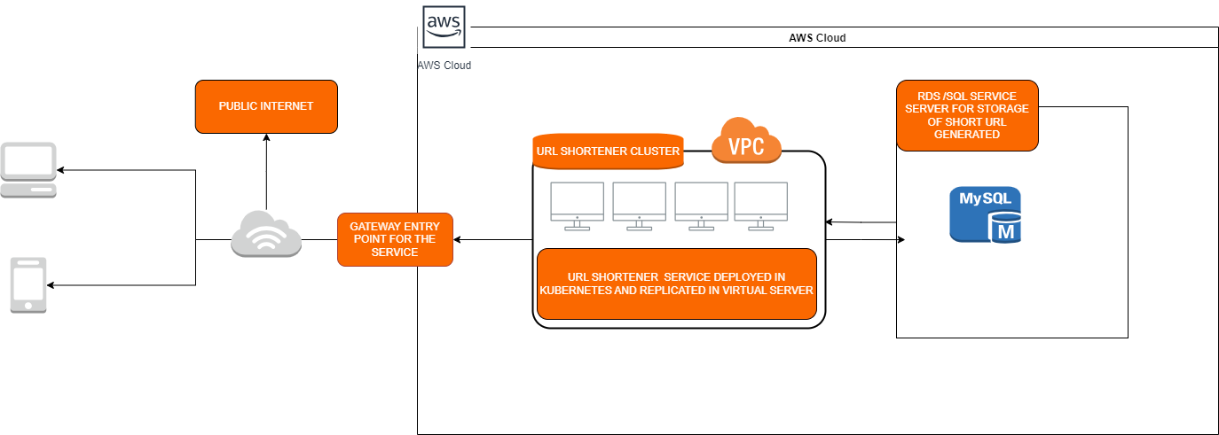

The schema follows these steps:

* Michael found a fascinating blog post about studies into skua mating. He wished to send it to his friend Paul by SMS text, but the URL is too long, so he uses his smartphone to send the URL to be shortened to the service by a RESTful call.
* The request is sent to the gateway. For simplicity’s sake, the schema sub operations are not mentioned. These are the following steps:
  + The gateway looks for the service associated with the name to registry name, where the all the service instances are associated by the name.
  + After the gateway has got all the references to the microservice instances, it passes them to the load balancer.
  + The load balancer checks which of them is the least busy and available to execute the service, and sends the request to the most suitable service.
* The URL Shortener service starts to process it. At first, it checks if the original link was already processed by another request, and in this case it returns the shortened URL directly from the DB, otherwise it proceeds to generate the shortened URL before returning it to the client. The generated URL is also stored in the DB for future requests.
* The response is sent to Michael, who is very happy to share the post about skua mating.
* Paul receives the SMS text and clicks on the shortened link and the link is sent to our service, repeating the steps described above, with the difference that the original URL is needed. If the shortened URL is present in the DB, the original URL will be returned to Paul. After reading the blog post, he texts Michael to insult him.

Well, after developing the service and deploying it in AWS, I spent around $80 and gave them back to my dad – but after some weeks the service became a hit and I and my dad became rich!

He was so happy...

