Assignment 3 Plan

Émilie Mayodon / Akash Singh

420-121-VA

|  |  |  |
| --- | --- | --- |
| **Jobs** | **Average Salary (Entry-Level)** | **Annual Average Raise** |
| Software Developer | $65,000.00 | $1,690.00 |
| Database Administrator | $61,000.00 | $1,586.00 |
| Computer Systems Analyst | $67,460.00 | $1,753.96 |
| Systems Manager | $67,000.00 | $1,742.00 |
| Web Developer | $51,000.00 | $1,326.00 |
| Information Security Analyst | $64,600.00 | $1,679.60 |
| IT Architect | $91,000.00 | $2,938.00 |
| Computer Programmer | $52,000.00 | $2,531.10 |
| Software Engineer | $77,000.00 | $2,002.00 |
| Information Researcher | $86,000.00 | $2,236.00 |
| Video Game Developer | $50,276.00 | $1,307.18 |
| IT Project Manager | $86,126.00 | $2,239.28 |
| Computer Network Architect | $104,650.00 | $2,720.90 |
| Canadian Annual Interest Rate |  | 2.60% |

The following diagram demonstrates the starting salary of common careers in the Computer Science Field, and its annual average raise

The current Canadian annual average salary increase is 2.60%, this leads to a greater pay growth. Jobs with a generally high demand tend to receive a bigger annual increase.

As shown, computer network architect has the highest paying job with a high annual increase, while video game developer, statistically, is the lowest paying job.

|  |  |  |
| --- | --- | --- |
| **Jobs** | **Degree Required** | **Demands** |
| Software Developer | Bachelor's Degree | 21% |
| Database Administrator | Bachelor's Degree | 9% |
| Computer Systems Analyst | Bachelor's Degree | 9% |
| Systems Manager | Bachelor's Degree | 11% |
| Web Developer | Associate | 13% |
| Information Security Analyst | Bachelor's Degree | 32% |
| IT Architect | Bachelor's Degree | 8% |
| Computer Programmer | Bachelor's Degree | -7% |
| Software Engineer | Bachelor's Degree | 21% |
| Information Researcher | Master's Degree | 16% |
| Video Game Developer | Bachelor's Degree | -40% |
| IT Project Manager | Bachelor's Degree | 11% |
| Computer Network Architect | Bachelor's Degree | 6% |

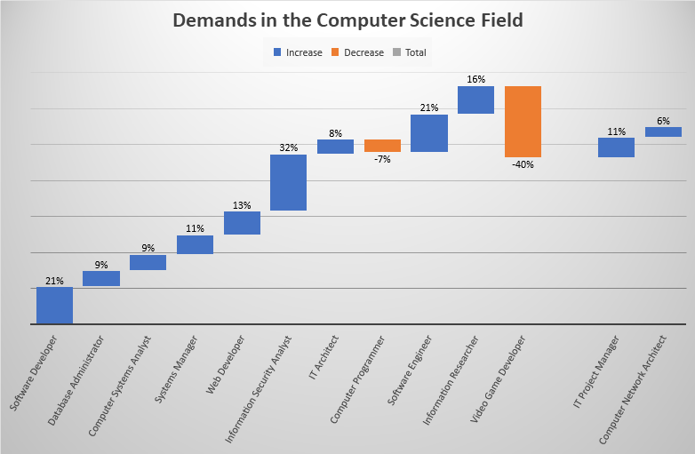

This waterfall chart shows the current percentage of demands for a list of common jobs in the Computer Science Field.

Unfortunately, video game developers are in high decrease of demands, while information security analyst is soaring in demands.