Nom : SlamGZ | LehrO | Slamer | DunkGZ

Username : hoop.slamgz | hoop.lehro | hoop.slamer | hoop.dunkgz

Niche : Basketball Humor Edits

Bio (80 c max) :

  
10k🎯

🏀

Ig @hoop.dunkgz

Learn how to make basketball edits 👇🏾

[linktree]

PPs :

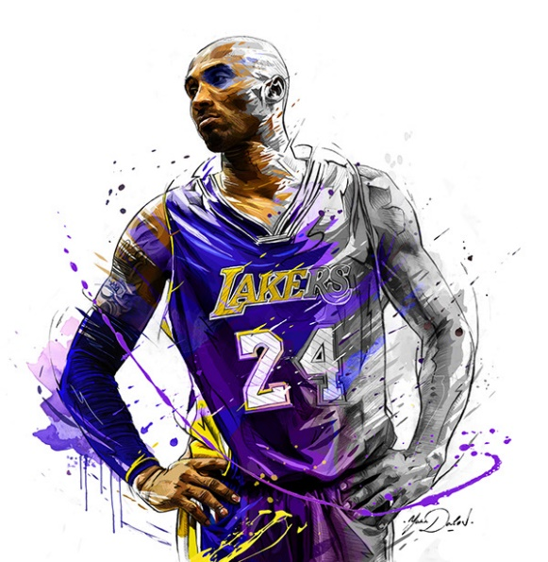

Concurrents :

YT :

Golden Hoops (YT) 2M follow

[UUoDfZzwJNFJ2lVgF41tUX0A](https://www.youtube.com/channel/UCoDfZzwJNFJ2lVgF41tUX0A)

NBA Extra - beIN SPORTS France 200k follow

[UUcMGbm0EYWh1SZZ8MsM75tw](https://www.youtube.com/channel/UCcMGbm0EYWh1SZZ8MsM75tw)

NBA 2.2M follow

[UUWJ2lWNubArHWmf3FIHbfcQ](https://www.youtube.com/channel/UCWJ2lWNubArHWmf3FIHbfcQ)

Hicko 150k follow

[UUvFIKpU9Uc0_iCeVfMXvuNA](https://www.youtube.com/channel/UCvFIKpU9Uc0_iCeVfMXvuNA)

CoshReport 500k follow

[UUOIaQxIvcpPjxgSaYmqaE6g](https://www.youtube.com/channel/UCOIaQxIvcpPjxgSaYmqaE6g)

Sports Mixes 42.7K follow

[UU4qOcb4LTWo3KSzMx7uC5IQ](https://www.youtube.com/channel/UC4qOcb4LTWo3KSzMx7uC5IQ)

TT :

Hoop.wizard2 2500 follow

hoop.mcrushed 8500 follow

silent.dzz 5500 follow

sharphoops 12.9k follow

zzzhoops 45k follow

hoop.demon_d1 35k follow

hoop.crashout 45k follow

hoop.mf 58k follow

lebron8122 10.2k follow

grizzbucks 26k follow

hoop.lordx 46k follow

hoop.angel 1.5M follow

hoop.lightskin0 235k follow

haessik 174.3K follow

Famous songs :

7365726174990142251

7393400841724234529

7406002679330720544

7373754381663750955

7361650848851593985

7356042312964819758

7381137898394995488

7366000135148407584