Genomic heterogeneity among Sima de los Huesos hominins suggests
demographic structure and potentially diachronic accumulation

Running title: Genomic heterogeneity in Sima de los Huesos

Emilio Garcia-Moran
Universidad de Valladolid, Spain
ORCID: 0000-0002-2487-6686
emilio.garcia.moran@uva.es

Short Communication — Journal of Human Evolution

Abstract

The Neandertal lineage exhibits chronically low effective population sizes (Ne ~3,000) during the Late Pleistocene, but when this demographic erosion began remains unresolved. We estimated transversion-restricted heterozygosity (H) and pairwise FST across four Middle Pleistocene hominin genomes (~430 ka) from Sima de los Huesos (SH, Atapuerca, Spain), using a symmetric pipeline cross-calibrated against Vindija 33.19 and independently validated against the Denisova high-coverage genome. Block-bootstrap resampling (n = 100, 5 Mb blocks) suggests higher ancestral genetic diversity (mean calibrated H = 0.000977; heterozygosity-derived Ne ~19,571) than late Neandertals (ratio 1.39x). Two independent estimators converge on significant internal stratification: molar_L35 and femurXIII form a genetically cohesive cluster (FST = 0.041, high H), while scapula shows significantly lower H with non-overlapping confidence intervals. femur_fragment is a genetic outlier (FST ~0.30). This internal structure is consistent with a diachronic accumulation model spanning climatically distinct Marine Isotope Stages. (149 words)

Keywords: Sima de los Huesos; ancient DNA; heterozygosity; FST; effective population size; Neandertals; Middle Pleistocene; taphonomy; Marine Isotope Stages; ANGSD

1. Introduction

Late Pleistocene Neandertals exhibit markedly low genome-wide heterozygosity, with heterozygosity-derived effective population size (Ne) estimates of approximately 3,000 for Vindija 33.19 (~44 ka; Prüfer et al., 2014), ~2,500 for Chagyrskaya 8 (~80 ka; Mafessoni et al., 2020), and ~5,000 for Denisova 5 (~120 ka; Massilani et al., 2026). Whether these values reflect a long-standing demographic characteristic of the ancestral Neandertal lineage or emerged through progressive attrition during the late Middle and Late Pleistocene remains debated.

The recent publication of genomic data from 27 late Neandertals from northwestern Europe (Bossoms Mesa et al., 2026) confirmed that western European Neandertals maintained relatively stable, low genetic diversity between ~54 ka and ~40 ka, with no evidence of progressive deterioration in the final millennia before extinction. Their high-coverage genome of Goyet GN1 (~45 ka) showed heterozygosity comparable to Vindija 33.19, HBD tract patterns indicative of moderate but not extreme inbreeding, and no evidence of gene flow from modern humans. Furthermore, mathematical modeling demonstrates that recurrent small-scale immigration of demographically larger Homo sapiens populations could drive near-complete genetic dilution of Neandertal alleles within 10,000–30,000 years under neutral drift alone, a process most efficient when the Neandertal population is already small (Amadei et al., 2025).

The Sima de los Huesos (SH) hominin assemblage from Atapuerca, Spain, dated to ~430 ka (Arsuaga et al., 2014), offers a rare opportunity to examine genetic diversity at the very beginning of the proto-Neandertal radiation. Nuclear genomic analysis has placed SH within the Neandertal clade as a stem collateral lineage (Meyer et al., 2016). Here we estimate heterozygosity and pairwise genetic distances (FST) across four SH specimens, compare the results to late Neandertal and modern human references, and examine whether the internal genomic structure of the assemblage may reflect demographic variation across Marine Isotope Stages (MIS).

2. Materials and Methods

Sequencing data from five SH specimens (femurXIII, femur_fragment, molar_L35, scapula, and an incisor) were obtained from ENA BioProject PRJEB10597. Reads were mapped to hg38 with BWA-MEM (Li and Durbin, 2009), duplicates marked with Picard (v2.26), and libraries damage-rescaled with mapDamage 2.2.1 (Jönsson et al., 2013). Mean genome-wide coverage was ~1.18x.

Heterozygosity was estimated using transversion sites only (-noTrans 1 in ANGSD v0.941; Korneliussen et al., 2014), with filtering parameters -minMapQ 30, -minQ 20, -remove_bads 1, -uniqueOnly 1. This filter was validated by comparing transition-inclusive vs. transversion-only estimates for femurXIII (H = 0.004119 vs. H = 0.002153; 2x inflation consistent with residual deamination). Site frequency spectra (SFS) were estimated via realSFS. Bootstrap uncertainty was quantified using 100 independent block-bootstrap replicates of 5 Mb genomic blocks.

To evaluate pipeline-specific biases, we applied the identical procedure to two independent high-coverage archaic genomes: Vindija 33.19 (ENA: ERR1025630; Prüfer et al., 2014; ~30x coverage) and the Denisova high-coverage genome (Meyer et al., 2012; ~30x coverage), both mapped to hg19, restricted to 10 million random transversion sites. Our pipeline yielded inflation factors of 1.824x for Vindija and 1.814x for Denisova relative to their published all-site heterozygosity values. The near-identical factors across two archaic species with different divergence times (mean 1.82x ± 0.005 SD) confirm that the inflation is consistent across independent archaic genomes. All SH H values are divided by this factor (calibration multiplier = 0.549). Effective population size was estimated as Ne = H/(4μ(1-H)) with μ = 1.25×10⁻⁸, interpreted as heterozygosity-derived Ne estimates.

Pairwise genetic differentiation was estimated using two-dimensional SFS (2D-SFS) computed with realSFS from individual SAF files, followed by FST estimation with realSFS fst (ANGSD v0.940). Hierarchical clustering (UPGMA) was applied to the resulting pairwise FST matrix.

Runs of Homozygosity analysis using ROHan v2.3 (Mafessoni et al., 2020) yielded mean posterior p(ROH) of 0.033–0.050, with no 3 Mb window exceeding p > 0.50. These analyses are not interpreted at ~1.18x coverage. We note that the scapula specimen yielded zero homozygous derived sites in the SFS (SFS[2] = 0), which is biologically implausible and likely reflects an ascertainment artifact at very low effective coverage for this specimen. This observation precludes derived-allele-fraction-based analyses for this specimen.

3. Results

The incisor specimen showed markedly elevated heterozygosity (H = 0.004438, ~2.7x the mean of others), consistent with modern DNA contamination, and was excluded from all analyses.

Block-bootstrap resampling of the four valid SH specimens yielded the calibrated heterozygosity estimates shown in Table 1 and Figure 1. Mean calibrated H = 0.000977 (95% CI: 0.000577–0.001241), corresponding to a heterozygosity-derived Ne of ~19,571. All specimens yield calibrated H above the Vindija reference (H = 0.000701), with a mean SH/Vindija ratio of 1.39x (range 1.22x–1.72x). The bootstrap distributions reveal significant internal stratification: the 95% CI of scapula (0.000565–0.000612) does not overlap with those of molar_L35 (0.001164–0.001249) or femurXIII (0.001093–0.001236).

Pairwise FST analysis revealed pronounced genetic differentiation among SH specimens (Table 3, Figure 2). The lowest FST was observed between molar_L35 and femurXIII (FST = 0.041), consistent with shared demographic history. femur_fragment showed high FST against all others (FST = 0.284–0.302), marking it as a genetic outlier. UPGMA clustering identified a low-divergence cluster (molar_L35 + femurXIII) with scapula and femur_fragment at substantially greater distances.

Both independent estimators — calibrated heterozygosity and pairwise FST — converge on the same internal structure: a genetically cohesive cluster of molar_L35 and femurXIII (high H, low mutual FST), a genetically distinct scapula (low H, intermediate FST), and an outlier femur_fragment (intermediate H, high FST against all specimens).

Table 1. Calibrated heterozygosity and Ne estimates. Calibration factor 1.82x ± 0.005 SD, validated against Vindija (1.824x) and Denisova (1.814x). Ne = H/(4μ(1-H)), μ = 1.25×10⁻⁸. 95% CI from block-bootstrap (n = 100, 5 Mb blocks).

Specimen | Sites | H calibrated | 95% CI | Ne estimate | SD
femurXIII | 6,489,101 | 0.001183 | 0.001093–0.001236 | ~23,710 | 0.000073
femur_fragment | 9,833,789 | 0.000925 | 0.000744–0.001082 | ~18,551 | 0.000187
molar_L35 | 2,991,570 | 0.001207 | 0.001164–0.001249 | ~24,207 | 0.000068
scapula | 6,354,640 | 0.000590 | 0.000565–0.000612 | ~11,825 | 0.000020
SH mean | — | 0.000977 | 0.000577–0.001241 | ~19,571 | —
Vindija 33.19* | 10,000,000 | 0.000701 | — | ~3,000** | —

* Identical pipeline, hg19. ** Published Ne, Prüfer et al. (2014).

Table 2. Comparative heterozygosity across archaic and modern hominins.

Population | Age (ka) | H | Ne estimate | Source
SH mean (calibrated) | ~430 | 0.000977 | ~19,571 | This study
Vindija 33.19 | ~44 | 0.000700 | ~3,000 | Prüfer et al. 2014
Goyet GN1 | ~45 | 1.51×10⁻⁴ | ~3,200 | Bossoms Mesa et al. 2026
Chagyrskaya 8 | ~80 | ~0.000600 | ~2,500 | Mafessoni et al. 2020
Denisova D5 | ~120 | ~0.001000 | ~5,000 | Massilani et al. 2026
Denisova D17 | ~50 | 0.000500 | ~1,500 | Meyer et al. 2012
Ustʹ-Ishim | ~45 | 0.001000 | ~7,000 | Fu et al. 2014
H. sapiens AFR | ~0 | 0.001300 | ~10,000 | gnomAD

Table 3. Pairwise FST matrix (ANGSD v0.940, transversions only). Number of shared transversion sites per pair shown in parentheses.

 | femurXIII | molar_L35 | scapula | femur_fragment
femurXIII | — | 0.041 (9,437) | 0.123 (17,461) | 0.302 (29,045)
molar_L35 | 0.041 (9,437) | — | 0.241 (11,563) | 0.284 (18,680)
scapula | 0.123 (17,461) | 0.241 (11,563) | — | 0.285 (27,592)
femur_fragment | 0.302 (29,045) | 0.284 (18,680) | 0.285 (27,592) | —

4. Discussion

Our results suggest that the SH proto-Neandertals maintained higher genomic diversity than late Neandertals (calibrated ratio 1.39x, empirically validated calibration factor 1.82x ± 0.005 SD across Vindija and Denisova). This places SH as the earliest data point on a Neandertal demographic decline trajectory: Ne ~19,571 at ~430 ka, declining to ~5,000 at ~120 ka (Massilani et al., 2026), ~2,500 at ~80 ka (Mafessoni et al., 2020), and stabilizing at ~3,000 in the final millennia (Prüfer et al., 2014; Bossoms Mesa et al., 2026). The mathematical model of Amadei et al. (2025) shows that recurrent H. sapiens immigration suffices for near-complete Neandertal genetic dilution under neutral drift, a process most efficient at low Ne — our data indicate that Neandertals arrived at the moment of contact already substantially reduced from the ancestral state measured here.

The convergence of two independent estimators on the same internal structure strengthens the biological interpretation. Calibrated heterozygosity and pairwise FST both separate the specimens into the same groups: a genetically cohesive cluster of molar_L35 and femurXIII (high H, low mutual FST = 0.041), a genetically distinct scapula (low H, intermediate FST), and an outlier femur_fragment (intermediate H, high FST = 0.284–0.302). This convergence is unlikely to result from a single technical artifact, since heterozygosity measures within-individual diversity whereas FST measures between-individual divergence. Notably, the internal genetic heterogeneity among four SH specimens from a single site (FST range 0.0420130.30) exceeds that observed among 10 late Neandertals from multiple sites across northwestern Europe (IBS distance range 0.0420130.16; Bossoms Mesa et al., 2026; Figure 3), consistent with temporally heterogeneous sampling at SH.

The most parsimonious climatic framework involves the Marine Isotope Stages bracketing the ~430 ka date. MIS 12 (~450–424 ka) was one of the most severe glaciations of the Middle Pleistocene, which would have fragmented Iberian proto-Neandertal populations into isolated refugia, reducing local Ne — consistent with the scapula's low H and intermediate FST. The subsequent MIS 11 (~424–374 ka) was an exceptionally long and warm interglacial during which populations could have expanded and reconnected — consistent with the molar_L35/femurXIII cluster's high H and low mutual FST. This hypothesis is directly testable: if the specimens can be independently assigned to distinct stratigraphic levels corresponding to different MIS, the convergence of genomic and geological evidence would substantially strengthen the diachronic model. We note that the archaeological literature on SH has long debated between synchronous mortality models and diachronic accumulation (Arsuaga et al., 2014); our genomic data provide an independent molecular line of evidence.

Several caveats are essential. FST estimates are based on limited shared transversion sites (9,437–29,045 per pair). The scapula shows zero homozygous derived sites in the SFS (SFS[2] = 0), which is biologically implausible and likely reflects an ascertainment artifact at very low effective coverage; derived-allele-fraction analyses were therefore not pursued for this specimen. The calibration factor (1.82x ± 0.005 SD) was empirically validated across two independent archaic genomes (Vindija: 1.824x; Denisova: 1.814x), but remains an approximation based on hg19 reference whereas SH specimens were mapped to hg38. Alternative explanations for the internal structure — including sex differences (scapula is female, the others male), kinship variation, spatial population structure, or residual technical artifacts — cannot be excluded at this coverage depth.

5. Conclusions

Two independent genomic estimators — transversion heterozygosity and pairwise FST — converge on two findings from four Sima de los Huesos specimens (~430 ka). First, mean calibrated heterozygosity exceeds that of late Neandertals (ratio 1.39x, calibration factor empirically validated at 1.82x ± 0.005 SD), anchoring the earliest point of the Neandertal demographic decline. Second, significant internal stratification separates a genetically cohesive, high-diversity cluster (molar_L35 + femurXIII, FST = 0.041) from a genetically distinct, low-diversity scapula and an outlier femur_fragment. This convergence supports a diachronic depositional history spanning climatically distinct Marine Isotope Stages. Stratigraphic assignment of individual specimens to specific MIS would provide a critical independent test.

Data Availability

SH BAM files: ENA PRJEB10597 (Meyer et al., 2016). Vindija 33.19: ENA ERR1025630 (Prüfer et al., 2014). Analysis scripts: github.com/EmilioGarciaMoran/PopSize-SH.

References

Amadei, A., Lin, G., Fattorini, S., 2025. A simple analytical model for Neanderthal disappearance due to genetic dilution by recurrent small-scale immigrations of modern humans. Sci. Reports 15, 38593.

Arsuaga, J.L., Martínez, I., Arnold, L.J., et al., 2014. Neandertal roots: Cranial and endocranial evolution in the middle Pleistocene. Science 344, 1358–1363.

Bossoms Mesa, A., et al., 2026. Genetic diversity of late Neanderthals in northwestern Europe. Nature 655, 409–417.

Fu, Q., Li, H., Moorjani, P., et al., 2014. Genome sequence of a 45,000-year-old modern human from western Siberia. Nature 514, 445–449.

Jönsson, H., Ginolhac, A., Schubert, M., et al., 2013. mapDamage2.0: fast approximate Bayesian estimates of ancient DNA damage parameters. Bioinformatics 29, 1682–1684.

Korneliussen, T.S., Albrechtsen, A., Nielsen, R., 2014. ANGSD: Analysis of Next Generation Sequencing Data. BMC Bioinformatics 15, 356.

Li, H., Durbin, R., 2009. Fast and accurate short read alignment with Burrows-Wheeler Aligner. Bioinformatics 25, 1754–1760.

Mafessoni, F., Grote, S., de Filippo, C., et al., 2020. A high-coverage Neandertal genome from Chagyrskaya Cave. PNAS 117, 14318–14326.

Massilani, D., Iasi, L.N.M., de Filippo, C., et al., 2026. A high-coverage Neandertal genome from the Altai Mountains reveals population structure among Neandertals. PNAS 123, e2534576123.

Meyer, M., Fu, Q., Aximu-Petri, A., et al., 2016. Nuclear DNA sequences from a hominin from Sima de los Huesos. Nature 531, 504–507.

Meyer, M., Kircher, M., Gansauge, M.T., et al., 2012. A high-coverage genome sequence from an archaic Denisovan individual. Science 338, 222–226.

Prüfer, K., Racimo, F., Patterson, N., et al., 2014. The complete genome sequence of a Neandertal from the Altai Mountains. Nature 505, 43–49.

Figures

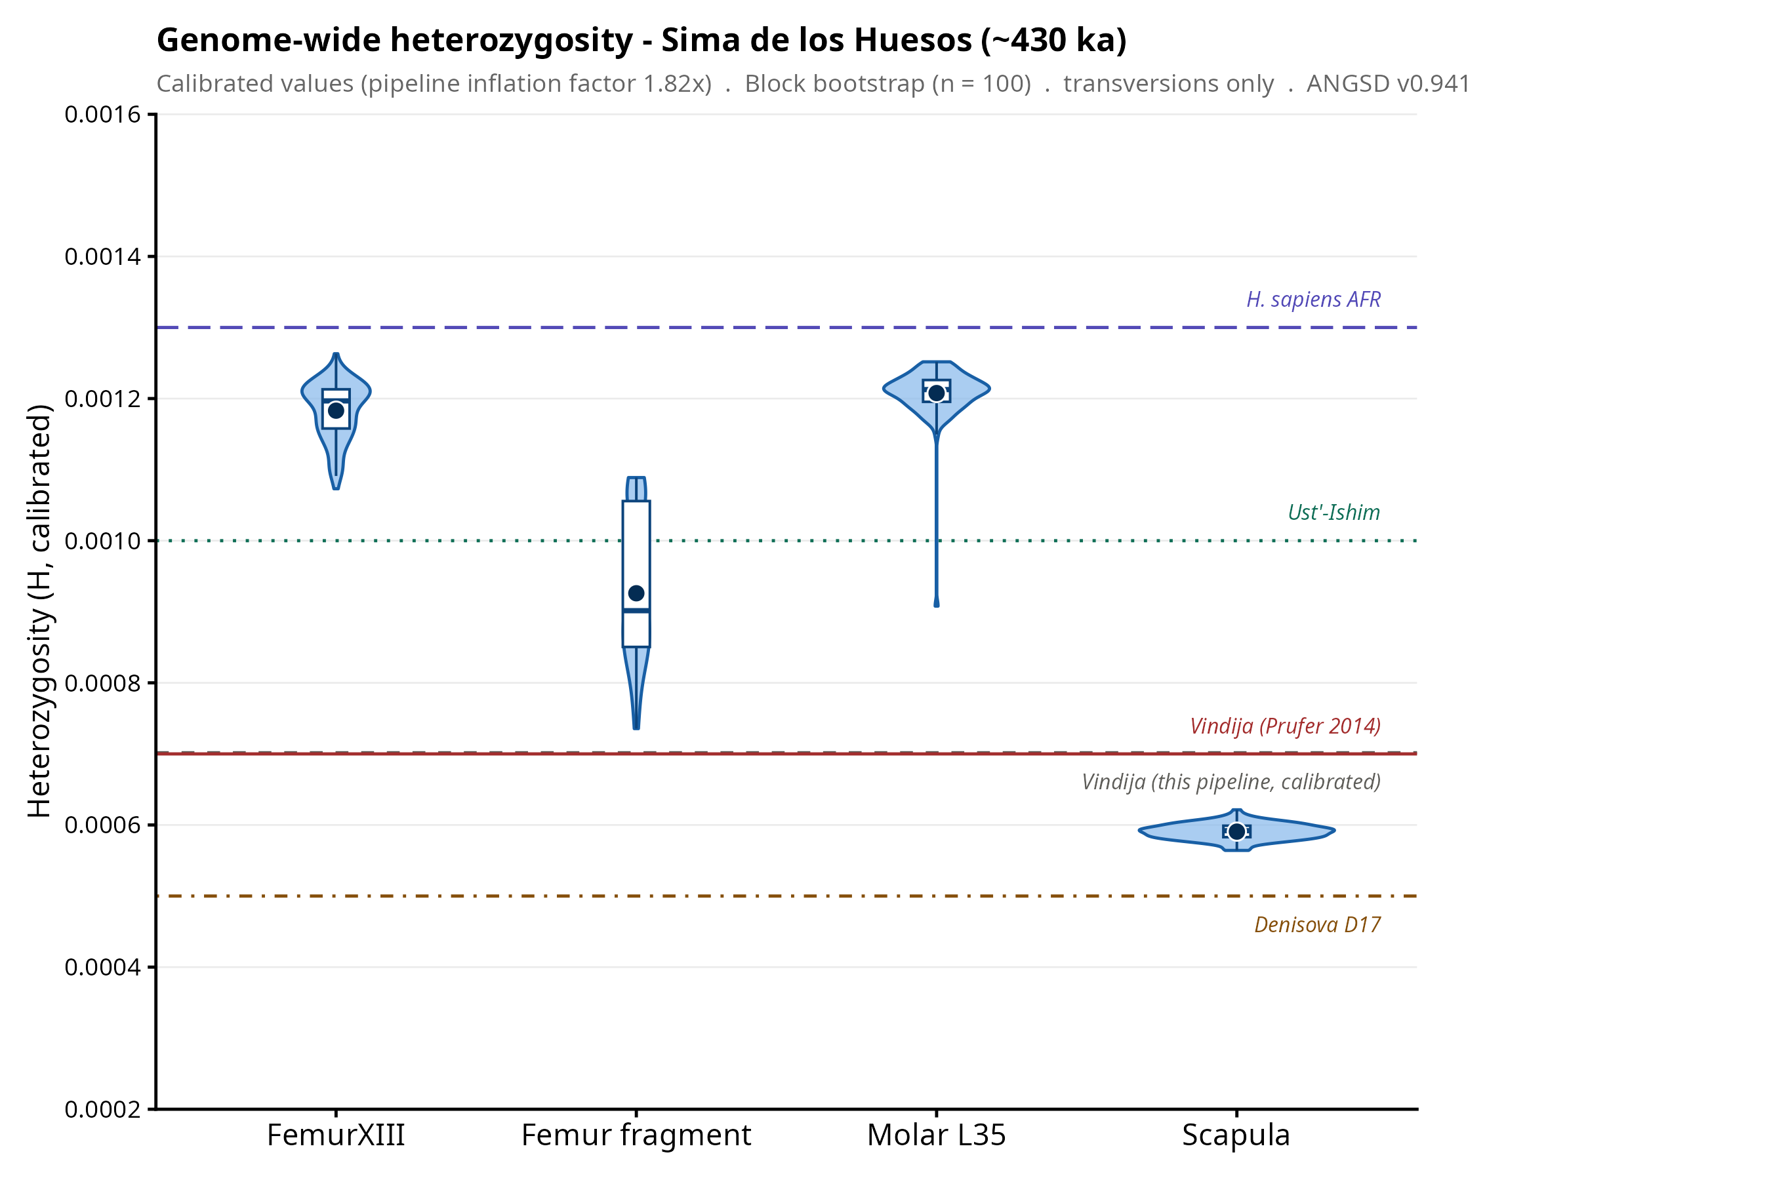
Figure 1. Calibrated genome-wide heterozygosity in Sima de los Huesos (~430 ka). Violin plots show bootstrap distributions (n = 100 replicates, 5 Mb blocks) of calibrated H (pipeline inflation factor 1.82x, validated against Vindija and Denisova). Horizontal lines show published references. Note non-overlapping 95% CI between scapula and molar_L35/femurXIII.

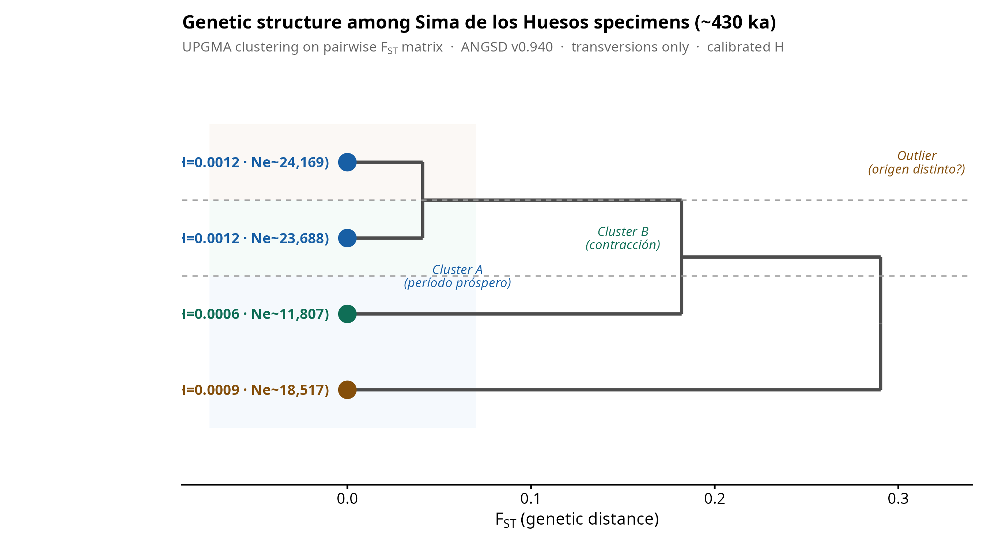
Figure 2. Genetic structure among SH specimens. UPGMA clustering on pairwise FST matrix (transversions only). molar_L35 and femurXIII form a low-divergence cluster (FST = 0.041). femur_fragment is the genetic outlier (FST ~0.30). The same rank order of internal differentiation is recovered by both heterozygosity (Figure 1) and FST, supporting biological rather than technical origin.

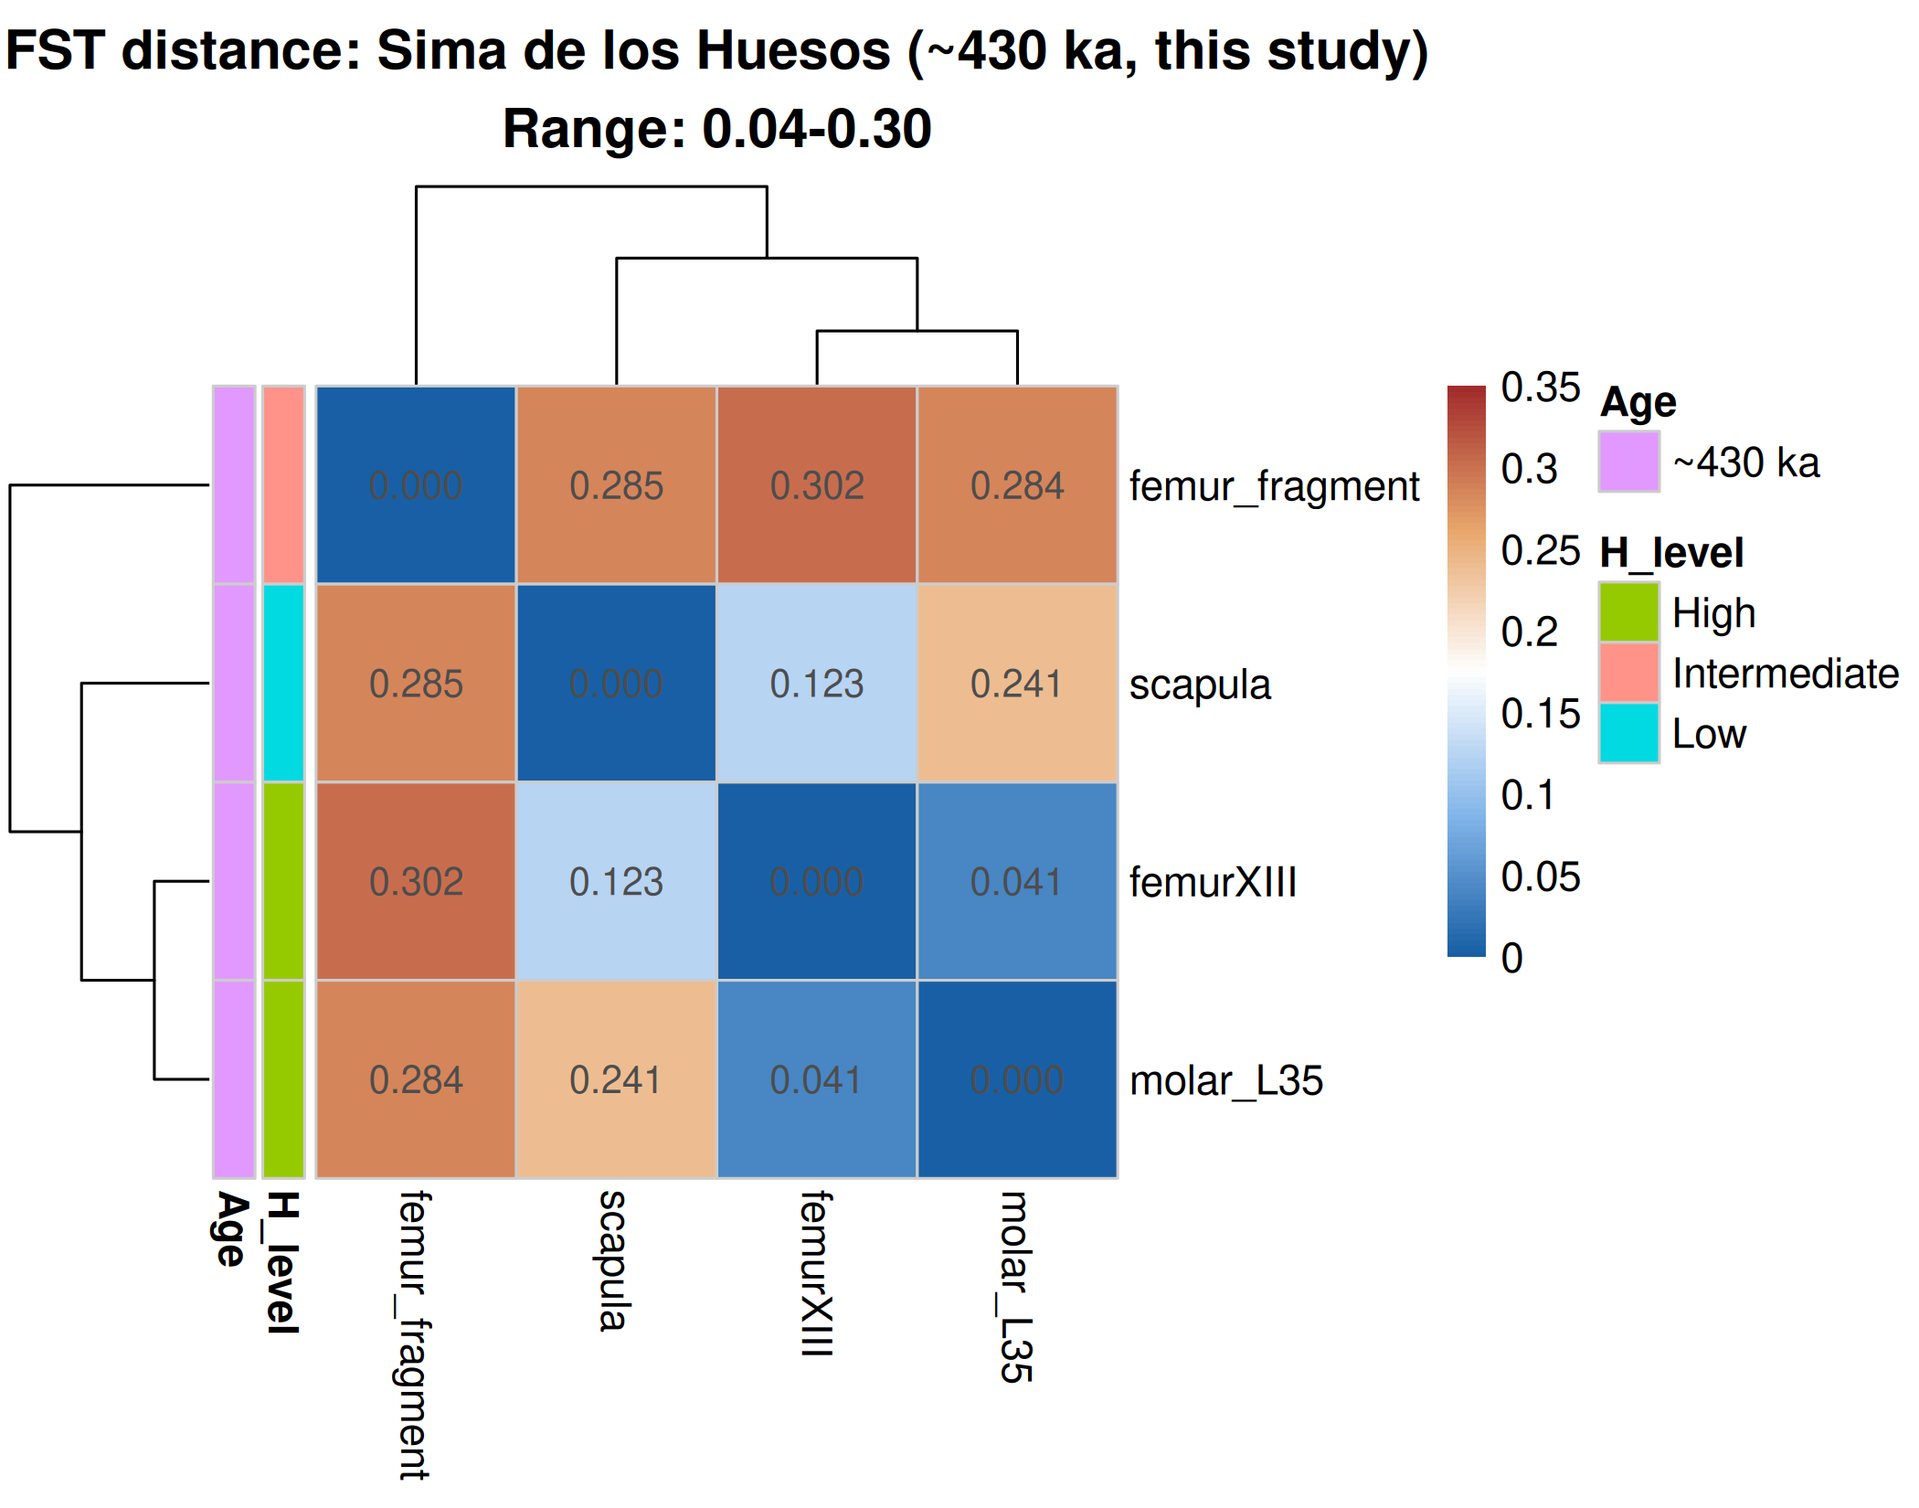

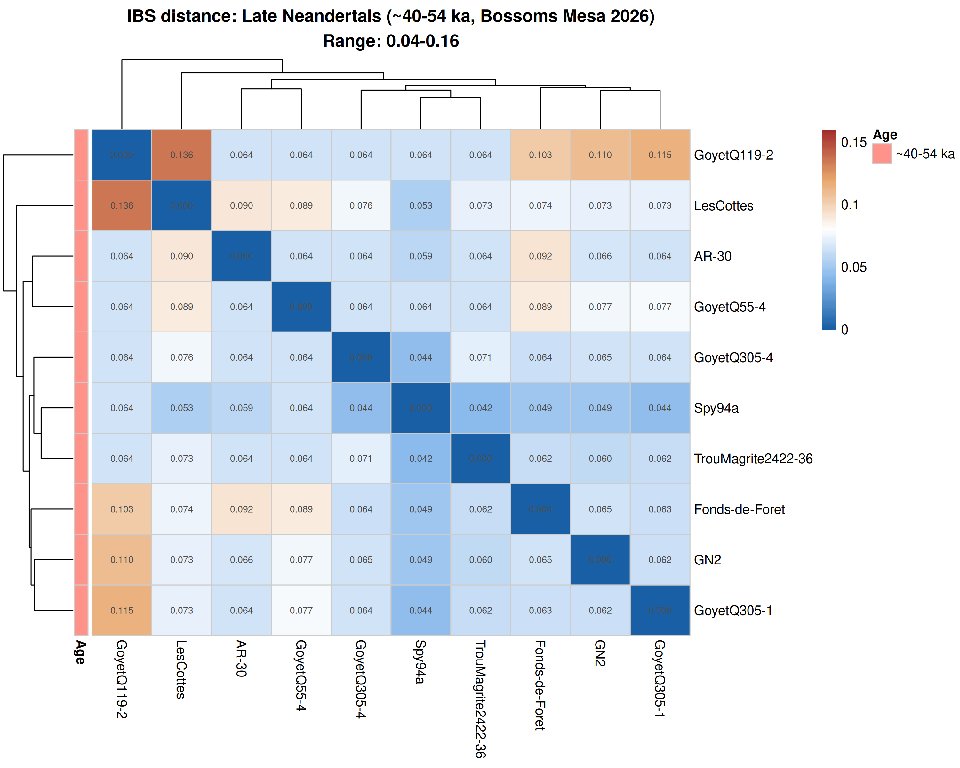
Figure 3. Comparative genetic distance matrices. Top: FST distance among four SH specimens (~430 ka, this study). Clustered heatmap shows two groups: a low-divergence cluster (femurXIII + molar_L35, FST = 0.041) and two outliers (scapula, femur_fragment). Distance range: 0.04-0.30. Bottom: IBS distance among 10 late Neandertals (~40-54 ka, Bossoms Mesa et al. 2026). Distance range: 0.04-0.16. Four specimens from a single site at ~430 ka show greater internal genetic heterogeneity than 10 specimens from multiple sites at ~45 ka, consistent with diachronic accumulation spanning distinct demographic episodes.

