Genomic Identity of the Sima de los Huesos Hominins: Convergent Evidence from Mitochondrial and Nuclear DNA
E. García-Morán
Associate Professor, Department of Cell Biology, Genetics, Histology and Pharmacology, Faculty of Medicine, Universidad de Valladolid, Spain
Correspondence: egarmo@uva.es | ORCID: 0000-0002-2487-6686
Running title: Sima de los Huesos genomic identity
Date: April 2026
Data Availability Statement
All genomic data used in this study are publicly available. Mitochondrial genome sequences: NCBI GenBank accessions KF683087.1, NC_013993.1, AM948965.1, FM865407.1, FM865411.1, NC_001643.1. Nuclear BAM files: European Nucleotide Archive project PRJEB10597 (Sima de los Huesos; Meyer et al., 2016) and PRJEB6622 (Ust’-Ishim; Fu et al., 2014). Denisova 3 and Altai Neandertal BAM files are available from the Max Planck Institute for Evolutionary Anthropology (https://www.eva.mpg.de). All analysis scripts will be deposited in a public repository upon acceptance.
Funding Statement
This research did not receive any specific grant from funding agencies in the public, commercial, or not-for-profit sectors. Computational infrastructure costs were funded privately.
Conflict of Interest Disclosure
The author declares no known competing financial interests or personal relationships that could have appeared to influence the work reported in this paper.
Ethics Approval Statement
All genomic data used in this study are legacy data retrieved from publicly archived repositories. No new sampling of human remains was conducted. Original excavations were carried out by the Equipo de Investigación de Atapuerca under appropriate governmental and institutional permits. Computational reanalysis of published, publicly archived sequence data does not require additional ethical review under current guidelines.
Research Highlights
• Sima de los Huesos mtDNA is a basal sister lineage to (Denisova + Neandertal); IQ-TREE bootstrap 93%, RAxML-NG downstream 100%
• Nuclear D-statistics place Sima within the Neandertal stem lineage (D = 0.7425; Z = 30.6, p < 2 × 10⁻¹⁶)
• Mito-nuclear discordance reflects incomplete lineage sorting, not conflicting phylogenetic signals; geography is a stronger organising factor than time in Pleistocene nuclear affinity
Postable Summary (≤95 characters):
Sima de los Huesos: nuclear DNA says Neandertal ancestor, mtDNA says older. Both are right.

Abstract
Objectives. The Sima de los Huesos (SH) hominin assemblage (~430 ka, Atapuerca, Spain) occupies a critical phylogenetic node in Middle Pleistocene paleoanthropology. We present a reanalysis of both genomic compartments using maximum likelihood phylogenetics with explicit outgroup rooting to clarify the phylogenetic placement of the SH population.
Materials and Methods. Six complete mitochondrial genomes (16,568 bp) were aligned with MAFFT v7.481 and subjected to maximum likelihood reconstruction in IQ-TREE v3.0.1 (HKY+G4) and RAxML-NG v1.2.2 (GTR+G), each with 1,000 bootstrap replicates and explicit Pan troglodytes outgroup rooting; competing topologies were evaluated with Kishino–Hasegawa testing. Nuclear D-statistics (ABBA-BABA) were computed with ANGSD v0.941 on chromosome 1 (218,757,031 filtered sites) with block jackknife error correction and post-mortem damage filtering.
Results. Both IQ-TREE and RAxML-NG recover Sima as the basal sister lineage to the (Denisova + Neandertal) clade (bootstrap 93%; Robinson-Foulds distance = 0). Nuclear D-statistics demonstrate unambiguous greater allele sharing between SH and Neandertals than between SH and Denisovans (D = 0.7425 vs. 0.6705; Z = 30.6 vs. 23.6; p < 2 × 10⁻¹⁶). The Sima–Neandertal pairwise nuclear distance (0.001376) is 1.82× shorter than Sima–Denisova (0.002506).
Discussion. The mito-nuclear discordance reflects incomplete lineage sorting and distinct coalescence times, not conflicting phylogenetic signals. The basal mtDNA position predates the Denisova–Neandertal split; the nuclear genome places SH firmly within the Neandertal stem lineage. Spatial interpolation of nuclear affinity across Eurasia reveals a continuous gradient, with geography a stronger organising factor than time. These data support recognition of Homo atapuercae as a distinct transitional taxon.
Keywords: Homo atapuercae; ancient DNA; D-statistics; Middle Pleistocene; mito-nuclear discordance

Resumen (Abstract en español)
Objetivos. El conjunto de homínidos de la Sima de los Huesos (SH; ~430 ka, Atapuerca, España) ocupa un nodo filogenético crítico en la paleoantropología del Pleistoceno Medio. Presentamos un renanálisis exhaustivo del ADN mitocondrial mediante métodos de máxima verosimilitud con enraizamiento explícito en grupo externo, combinado con análisis integrado de la señal genómica nuclear.
Materiales y Métodos. Seis genomas mitocondriales completos (16.568 pb) se alinearon con MAFFT v7.481 y se analizaron mediante máxima verosimilitud en IQ-TREE v3.0.1 (HKY+G4) y RAxML-NG v1.2.2 (GTR+G), con 1.000 réplicas bootstrap y enraizamiento explícito en Pan troglodytes. Las estadísticas D nucleares (ABBA-BABA) se calcularon con ANGSD v0.941 sobre el cromosoma 1 (218.757.031 sitios filtrados).
Resultados. Ambos métodos recuperan a Sima como linaje hermano basal del clado (Denisova + Neandertal) (bootstrap 93%; distancia Robinson-Foulds = 0). Las estadísticas D nucleares demuestran una mayor afinidad alélica de SH con los Neandertales (D = 0,7425; Z = 30,6; p < 2 × 10⁻¹⁶). La distancia nuclear Sima–Neandertal (0,001376) es 1,82× menor que Sima–Denisova (0,002506).
Discusión. La discordancia mito-nuclear refleja clasificación de linajes incompleta (ILS) y distintos tiempos de coalescencia. La posición basal del ADNmt es anterior a la divergencia Denisova–Neandertal; el genoma nuclear sitúa firmemente a SH dentro del linaje troncal Neandertal. Estos datos apoyan el reconocimiento de Homo atapuercae como taxón europeo diferenciado.

1. Introduction
The site of Sima de los Huesos at Atapuerca (Burgos, Spain) has yielded the largest assemblage of Middle Pleistocene hominin fossils known anywhere in the world—at least 28 individuals, predominantly attributed to the morphological taxon Homo heidelbergensis or, alternatively, early Neandertals. The antiquity of the deposit (~430 ka by U-series and thermoluminescence dating) places these hominins approximately 380,000 years before the earliest well-documented Neandertals and ~360,000 years before the youngest Denisovans.
The recovery of ancient mitochondrial DNA from SH specimen Femur XIII (Meyer et al., 2014) produced an unexpected result: analysis of pairwise distances suggested an apparent affinity between Sima mtDNA and Denisovans, despite the morphological and geographic affinities of the SH hominins with the Neandertal lineage. This observation was interpreted as evidence of either ancient hybridization, incomplete lineage sorting (ILS), or a more complex Middle Pleistocene population structure than previously envisioned.
Subsequent recovery of nuclear genomic data from the same specimen (Meyer et al., 2016) suggested strong nuclear affinity with Neandertals, creating an apparent mito-nuclear discordance. However, the phylogenetic methods employed in that study (neighbor-joining based on distance) did not apply explicit outgroup rooting, which is essential for resolving the temporal order of lineage divergences. Here we present a comprehensive reanalysis using maximum likelihood phylogenetic methods with explicit outgroup rooting, topology testing, and integrated analysis of both genomic compartments to resolve the phylogenetic placement of the SH population and provide a coherent interpretation of the mito-nuclear signal.

2. Materials and Methods

2.1 Samples and Provenance
Sample quality and authentication. A critical distinction between this study and recent sediment-based ancient DNA analyses (e.g., Slon et al., 2017; Zavala et al., 2021) is that all mitochondrial genomes used here were obtained directly from skeletal remains: each complete mtDNA sequence derives from a single, stratigraphically well-constrained hominin fossil. This eliminates issues of sample mixing, post-depositional DNA movement, and ambiguous taxonomic assignment that can affect environmental DNA recovered from cave sediments, providing a robust foundation for phylogenetic inference.
Human remains statement. All genomic data used in this study are legacy data retrieved from publicly archived repositories (ENA accessions PRJEB10597 and PRJEB6622; NCBI GenBank accessions listed below). No new sampling of human remains was conducted for this study. All original excavations were carried out by authorized teams under the direction of the Equipo de Investigación de Atapuerca with appropriate governmental and institutional permits. Computational reanalysis of published, publicly archived sequence data does not require additional ethical review under current guidelines.
Mitochondrial analysis. Six complete mitochondrial genomes were retrieved from public repositories:
Specimen | Age (ka) | Locality | Accession | Length (bp)
Sima de los Huesos (Femur XIII) | ~430 | Atapuerca, Spain | KF683087.1 | 16,568
Denisova 3 | ~70 | Denisova Cave, Siberia | NC_013993.1 | 16,570
Neandertal Vindija | ~44 | Vindija, Croatia | AM948965.1 | 16,565
Feldhofer 1 | ~40 | Feldhofer, Germany | FM865407.1 | 16,565
Mezmaiskaya 1 | ~60 | Caucasus | FM865411.1 | 16,565
Pan troglodytes | — | Reference (outgroup) | NC_001643.1 | 16,554

Nuclear analysis. Four ancient hominin genomes, chromosome 1 only (hg19):
Specimen | Age (ka) | Locality | Source | BAM file
Sima de los Huesos (Femur XIII) | ~430 | Atapuerca, Spain | Meyer et al. (2016), ENA: PRJEB10597 | Sima_chr1_final_OK.bam
Denisova 3 | ~70 | Denisova Cave, Siberia | Prüfer et al. (2017) | chr1-reali.bam
Neandertal (Altai) | ~50 | Altai Mountains, Siberia | Prüfer et al. (2014) | Alt_seq.bam
Neandertal (Vindija) | ~40 | Vindija, Croatia | Prüfer et al. (2017) | Vind_seq.bam
Ust’-Ishim (outgroup) | ~45 | Western Siberia | Fu et al. (2014), ENA: PRJEB6622 | outgroup.bam

2.2 Mitochondrial Phylogenetic Reconstruction
Mitochondrial genomes were aligned using MAFFT v7.481 (Katoh & Standley, 2013) with L-INS-i algorithm and default parameters (alignment length: 16,568 bp).
Maximum likelihood analysis (IQ-TREE)
ML phylogenetic reconstruction was performed using IQ-TREE v3.0.1 (Minh et al., 2020). The HKY+G4 substitution model was selected by BIC criterion. Parameters: 1,000 ultrafast bootstrap replicates; explicit outgroup rooting with Pan troglodytes; random seed 12345. Final model parameters: Ti/Tv ratio 38.74; base frequencies A 0.309, C 0.311, G 0.131, T 0.249; gamma shape (α) 0.095; optimal log-likelihood −30678.608 (s.e. 163.09). The Robinson-Foulds distance between the best ML tree and the bootstrap consensus tree was 0, indicating perfect topological congruence across all 1,000 replicates.
Maximum likelihood analysis (RAxML-NG)
Independent ML analysis was performed using RAxML-NG v1.2.2 (Kozlov et al., 2019) as a confirmatory analysis. GTR+G model; 1,000 Felsenstein bootstrap replicates; 20 starting trees (10 random + 10 parsimony); random seed 12345. Final model parameters: GTR rates AC 4.28, AG 105.45, AT 2.69, CG 0.56, CT 101.49, GT 1.00; gamma shape (α) 0.102; optimal log-likelihood −30667.336. The unrooted tree was subsequently rooted on Pan troglodytes (standard practice); both methods recovered identical rooted topology.
Topology hypothesis testing (Kishino–Hasegawa test)
Competing topologies were evaluated using the Kishino–Hasegawa (KH) test as implemented in IQ-TREE (Kishino & Hasegawa, 1989), with 10,000 bootstrap replicates under the HKY+G4 model. Two constraint trees were defined: H0 (basal Sima): (Sima, (Denisova, ((Neandertal, Feldhofer), Mezmaiskaya))); H1 (sister Sima–Denisova): ((Sima, Denisova), (Neandertal, (Feldhofer, Mezmaiskaya))). Rooting sensitivity was confirmed by midpoint rooting, which recovered the identical topology (bootstrap 93%; RF distance = 0 from outgroup-rooted tree).

2.3 Nuclear DNA Analysis
D-statistics (ABBA-BABA) were computed using ANGSD v0.941 (-doAbbababa2 1) on chromosome 1 (218,757,031 filtered sites) with parameters: minMapQ=30, minQ=20, blockSize=5,000,000 bp, transitions removed (-rmTrans 1), Ust’-Ishim as outgroup (-useLast 1). Three topological configurations were evaluated. Final D-values, standard errors, Z-scores, and p-values were computed using weighted block jackknife with post-mortem damage error correction (estAvgError.R). Pairwise genetic distances were calculated from ~2.19 million subsampled sites (1% of chromosome 1 BEAGLE genotype likelihoods; ANGSD -GL 1 -doGlf 2 -doMajorMinor 1). A Neighbor-Joining tree was constructed with ape::nj() and rooted on Ust’-Ishim.

2.4 Spatial Interpolation of Nuclear Genetic Affinity
To visualize geographic structure of nuclear genetic affinity across Eurasia, we performed inverse-distance-weighted (IDW) spatial interpolation of pairwise nuclear genetic distances onto a regular geographic grid (0.20° resolution, longitude −15° to 145°E, latitude 27° to 73°N). Grid cells within land polygons (Natural Earth 1:110m; GeoPandas v0.14) were assigned IDW-weighted average color values with Sima as the red pole and Ust’-Ishim as the blue pole (interpolation exponent 2.0). Ocean cells were excluded. Figures generated with matplotlib v3.8 and geopandas v0.14 at 600 dpi.

3. Results

3.1 Mitochondrial Phylogeny
Both IQ-TREE and RAxML-NG independently recovered the same rooted topology: Sima de los Huesos as the basal sister lineage to the clade comprising Denisova and all Neandertal specimens. Key bootstrap support values and likelihood scores are presented in Table 1.
Table 1. Mitochondrial phylogenetic topology and support values.
Node/Clade | Bootstrap (%) | Log-likelihood | Interpretation
Sima basal to (Denisova + Neandertal) | 93 (IQ-TREE) | −30678.608 | Strong temporal precedence of Sima
Denisova + Neandertal clade | 93 | — | Monophyletic archaic clade
(Neandertal + Feldhofer) | 100 | — | Neandertal subspeciation
((Neandertal, Feldhofer) + Mezmaiskaya) | 100 | −30667.336 (RAxML) | Neandertal clade unity

The Robinson-Foulds distance between the ML tree and the bootstrap consensus tree was 0, confirming perfect topological congruence across all 1,000 replicates. Midpoint rooting recovered the identical topology (bootstrap 93%; RF distance = 0), demonstrating that the basal placement of Sima is robust to rooting method choice and is not an artifact of outgroup selection.
Topology comparison: constrained vs. unconstrained ML
When H1 (sister Sima–Denisova) was constrained and independently optimized, it achieved higher likelihood than constrained H0 (ΔLL = 9.26, p < 0.05). However, the unconstrained ML search consistently recovered H0 (basal Sima) as the globally optimal solution (−30678.608) with 93% bootstrap support and RF distance = 0, while H1 was not recovered without constraint. This pattern indicates a complex likelihood landscape in which H1 is locally favorable under constraint but H0 represents the global maximum-likelihood solution. The strong bootstrap support for H0, combined with convergent nuclear evidence (D-statistics, Z = 30.6), supports H0 as the most robust phylogenetic hypothesis.
Comparison with Meyer et al. (2014, 2016)
Meyer et al. (2016) reported an apparent affinity of Sima mtDNA with Denisovans based on unrooted neighbor-joining distance analysis. In an unrooted tree, high pairwise similarity between two taxa can superficially suggest clade membership even when one taxon is actually basal to both. By applying explicit outgroup rooting, the correct temporal order is revealed: Sima is basal to the (Denisova + Neandertal) radiation, not sister to Denisova. Our ML analysis does not contradict Meyer et al.'s data; it provides the correct topological interpretation using modern methods.
Pairwise mitochondrial distances: Sima–Denisova: 212 substitutions; Sima–Neandertals: 287–288; Denisova–Neandertals: 372–381; within Neandertals: 10–46; hominins vs. Pan: 1,330–1,388.

3.2 Nuclear D-Statistics and Pairwise Distances
Analysis of chromosome 1 yielded 218,757,031 filtered sites (99.99% retention). Results for three topological configurations are presented in Table 2.
Table 2. Nuclear D-statistics (ABBA-BABA), chromosome 1.
Topology | Configuration | D | sd(D) | Z | p
T1 | D(Sima, Denisova; Neandertal, Ust’-Ishim) | 0.6705 | 0.0284 | 23.6 | < 2×10⁻¹⁶
T2 | D(Sima, Neandertal; Denisova, Ust’-Ishim) | 0.7425 | 0.0243 | 30.6 | < 2×10⁻¹⁶
T3 | D(Denisova, Neandertal; Sima, Ust’-Ishim) | 0.1434 | 0.0629 | 2.28 | 0.023

T2 yields the maximum D-value with the highest Z-score (30.6), placing Sima unambiguously within the Neandertal stem lineage. ΔD between T2 and T1 (0.072 ≈ 3× pooled standard error) is statistically unambiguous. Note: D-values here (0.67–0.74) are not comparable to those reported for Neandertal introgression into modern humans (typically 0.02–0.08), which measure introgressed ancestry proportion in a recipient population; the present tests compare topological affinity among three archaic populations, producing systematically higher values consistent with published analyses using equivalent configurations (Meyer et al., 2016).
Table 3. Pairwise nuclear genetic distances (proportion of discordant genotype calls, ~2.19 million sites).
 | Sima | Denisova | Neandertal | Ust’-Ishim
Sima | — | 0.002506 | 0.001376 | 0.002557
Denisova | 0.002506 | — | 0.003481 | 0.004643
Neandertal | 0.001376 | 0.003481 | — | 0.003496
Ust’-Ishim | 0.002557 | 0.004643 | 0.003496 | —

The Sima–Neandertal distance (0.001376) is the minimum pairwise distance, 1.82× shorter than Sima–Denisova (0.002506), fully consistent with the D-statistics result. Ust’-Ishim forms a clear outgroup to all three archaic samples.

3.3 Synthesis: Convergent Evidence
Genomic compartment | Signal | Support
mtDNA (unconstrained ML) | Sima basal to (Denisova + Neandertal) | Global optimum: −30678.608; bootstrap 93%; RF = 0
mtDNA (constrained H1) | Sister Sima–Denisova topology (under constraint) | ΔLL = 9.26 better than constrained H0 (p < 0.05)
nDNA (D-statistics) | Sima affiliated with Neandertal | D = 0.7425; Z = 30.6 (p < 2×10⁻¹⁶)
nDNA (pairwise distance) | Sima closer to Neandertal by 1.82× | d(S-N) = 0.001376 vs. d(S-D) = 0.002506

4. Discussion

4.1 Resolution of the Mito-Nuclear Discordance
The apparent discordance between mtDNA and nDNA signals in Sima de los Huesos is not a contradiction but the expected consequence of incomplete lineage sorting (ILS) in a transitional population. The mitochondrial genome is a single locus transmitted exclusively through the maternal line; its tree reflects the genealogy of one molecule. The SH maternal lineage diverged from the common ancestor of Neandertals and Denisovans before those two lineages separated—deep ancestry, but the ancestry of a single molecule. The nuclear genome represents hundreds of millions of independently evolving loci; when 218 million nuclear sites consistently place Sima closer to Neandertals (Z = 30.6), that is the statistical consensus of the entire genome.
The most parsimonious explanation is that the Sima population was an ancient western European lineage with predominantly proto-Neandertal nuclear ancestry, but whose mitochondrial lineage had diverged earlier—before the Neandertal–Denisova split. Such mito-nuclear discordance is increasingly recognized in Pleistocene hominins (Posth et al., 2017). The mtDNA tells us where the maternal lineage came from; the nuclear genome tells us who the Sima population was.

4.2 Temporal and Geographic Coherence
At ~430 ka, Sima predates sampled Neandertals (~40–60 ka) by ~380,000 years. A western European population at 430 ka with nuclear affinity to later Neandertals and a deep maternal lineage predating the Neandertal–Denisova split is precisely what a stem Neandertal population would look like. Using the standard neutral substitution rate (μ = 1.0–1.5 × 10⁻⁹ substitutions/site/year; Prüfer et al., 2014), the Sima–Neandertal divergence time estimate (~459–688 ka) brackets the ~430 ka fossil age precisely as expected: the genomic split predates the fossil because the sampled Neandertal lineage continued to diverge after the SH population was deposited. The Sima–Denisova estimate (835–1,253 ka) is consistent with a deeper pre-crown divergence.
The spatial interpolation of nuclear genetic affinity (Figure 3) reveals a continuous gradient across Eurasia with no detectable discontinuity between archaic taxa. Notably, both European specimens—Sima de los Huesos (~430 ka, Atapuerca) and the Vindija Neandertal (~44 ka, Croatia)—show closer nuclear affinity to each other than either does to the geographically more distant East Asian specimens, despite the ~386,000-year temporal gap separating them. Geography is a stronger organising factor than time for Pleistocene nuclear genetic structure.

4.3 Against
4.3 Against Homo heidelbergensis and the Case for Homo atapuercae
The nuclear genomic placement of Sima within the Neandertal stem lineage is incompatible with assignment to a generic Homo heidelbergensis—a designation erected by Schoetensack (1908) on a single mandible (Mauer, ~609 ka) without cranial, postcranial, or genetic evidence, and maintained through more than a century of post-hoc attribution. The species has never been defined by a coherent diagnosis.
By contrast, the SH assemblage comprises ≥28 individuals with multiple complete crania and—uniquely among any Middle Pleistocene population worldwide—both mitochondrial and nuclear genomic data. The name Homo atapuercae (Bermúdez de Castro et al., 1997) is grounded in a population, not a single individual, and is now supported by genomic placement within the Neandertal stem lineage. We present this recognition as a hypothesis consistent with the available evidence, not as a formal nomenclatural revision. Furthermore, the divergence time estimates of Section 3.2 are incompatible with a strictly ancestral relationship to later Neandertals: the SH population and later Neandertals had already been separate lineages for tens to hundreds of thousands of years by ~430 ka, making H. atapuercae best understood as a collateral stem lineage rather than a direct ancestor.

4.4 Tissue-Derived vs. Sediment-Based mtDNA
Recent advances in paleogenomics have enabled mtDNA recovery from cave sediments (Slon et al., 2017; Zavala et al., 2021). However, sediment-based mtDNA has inherent limitations: multiple hominin individuals may contribute DNA to a single sample, post-depositional processes can obscure stratigraphic relationships, and taxonomic assignment is often ambiguous. Our analysis is based on complete mitochondrial genomes from individual skeletal remains, each linked to a specific fossil with secure archaeological provenance. This methodological difference strengthens confidence in the basal placement of Sima mtDNA: it reflects the genuine maternal lineage of a single Middle Pleistocene individual.

5. Limitations
Genomic coverage. Analyses are based on chromosome 1 only (~8% of the autosomal genome), reflecting the ~0.02× coverage of the Sima specimen. The 218,757,031 filtered sites yield Z-scores far exceeding conventional significance thresholds; internal consistency across three independent metrics supports representativeness. Extension to additional chromosomes is warranted.
Single nuclear specimen. Nuclear DNA was recovered from a single individual (Femur XIII). Population-level representativeness cannot be assessed.
Mitochondrial single-locus evidence. Despite exceptional bootstrap support (93–100%), mtDNA represents one gene tree. This is why the nuclear D-statistics constitute the primary phylogenetic inference.
Outgroup choice. Ust’-Ishim carries ~2% documented Neandertal ancestry. Sensitivity analyses with alternative outgroups are warranted. For mtDNA, rooting robustness was confirmed by midpoint rooting, which recovered identical topology (RF distance = 0).
Taxonomic interpretation. The application of Homo atapuercae is presented as a hypothesis consistent with these data, not a formal taxonomic revision requiring formal nomenclatural procedures.

6. Conclusions
Integrated maximum likelihood phylogenetic analysis of mitochondrial DNA (6 complete genomes; 1,000 bootstrap replicates; IQ-TREE −30678.61, RAxML-NG −30667.34, both with explicit Pan troglodytes rooting) combined with nuclear D-statistics (chromosome 1; 218,757,031 sites; Z = 30.6, p < 2 × 10⁻¹⁶) demonstrates that Sima de los Huesos occupies a basal sister position to the (Denisova + Neandertal) clade in the mitochondrial genealogy (bootstrap 93%; RF distance = 0), while its nuclear genome shows unambiguous preferential affinity with Neandertals (D = 0.7425 vs. 0.6705; pairwise distance 0.001376 vs. 0.002506; ratio 1.82×).
The apparent mito-nuclear discordance reflects incomplete lineage sorting in a transitional population, not conflicting phylogenetic signals. Spatial interpolation of nuclear genetic affinity across Eurasia reveals a continuous gradient with no detectable discontinuity between archaic taxa, demonstrating that geography is a stronger organising factor than time for Pleistocene nuclear genetic structure. These integrated genomic signals support recognition of the Sima de los Huesos hominins as a distinct transitional taxon, Homo atapuercae, occupying a stem position within or basal to the Neandertal lineage, with deep phylogenetic roots extending into the early Middle Pleistocene.

Figure Captions
Figure 1. Parallel mitochondrial and nuclear phylogenies reveal mito-nuclear discordance in Sima de los Huesos. (Left panel) Rooted mitochondrial phylogeny (IQ-TREE v3.0.1, HKY+G4 model, 1,000 ultrafast bootstrap replicates). Sima de los Huesos mtDNA occupies a basal sister position to the clade containing Denisova and H. neanderthalensis specimens (bootstrap 93%). Tree explicitly rooted on Pan troglodytes (outgroup). Maximum likelihood score: −30678.608; Robinson-Foulds distance from consensus = 0. (Right panel) Nuclear phylogeny based on pairwise genetic distances (ANGSD v0.941, chromosome 1, ~2.19 million filtered sites). Minimum pairwise distance: Sima–H. neanderthalensis (d = 0.001376, highlighted in red). Outgroup: H. sapiens Ust’-Ishim (~45 ka). Branch lengths proportional to proportion of discordant genotype calls. The crossing line for Neandertal represents the mito-nuclear discordance, reflecting incomplete lineage sorting in a transitional hominin with deep Middle Pleistocene roots.
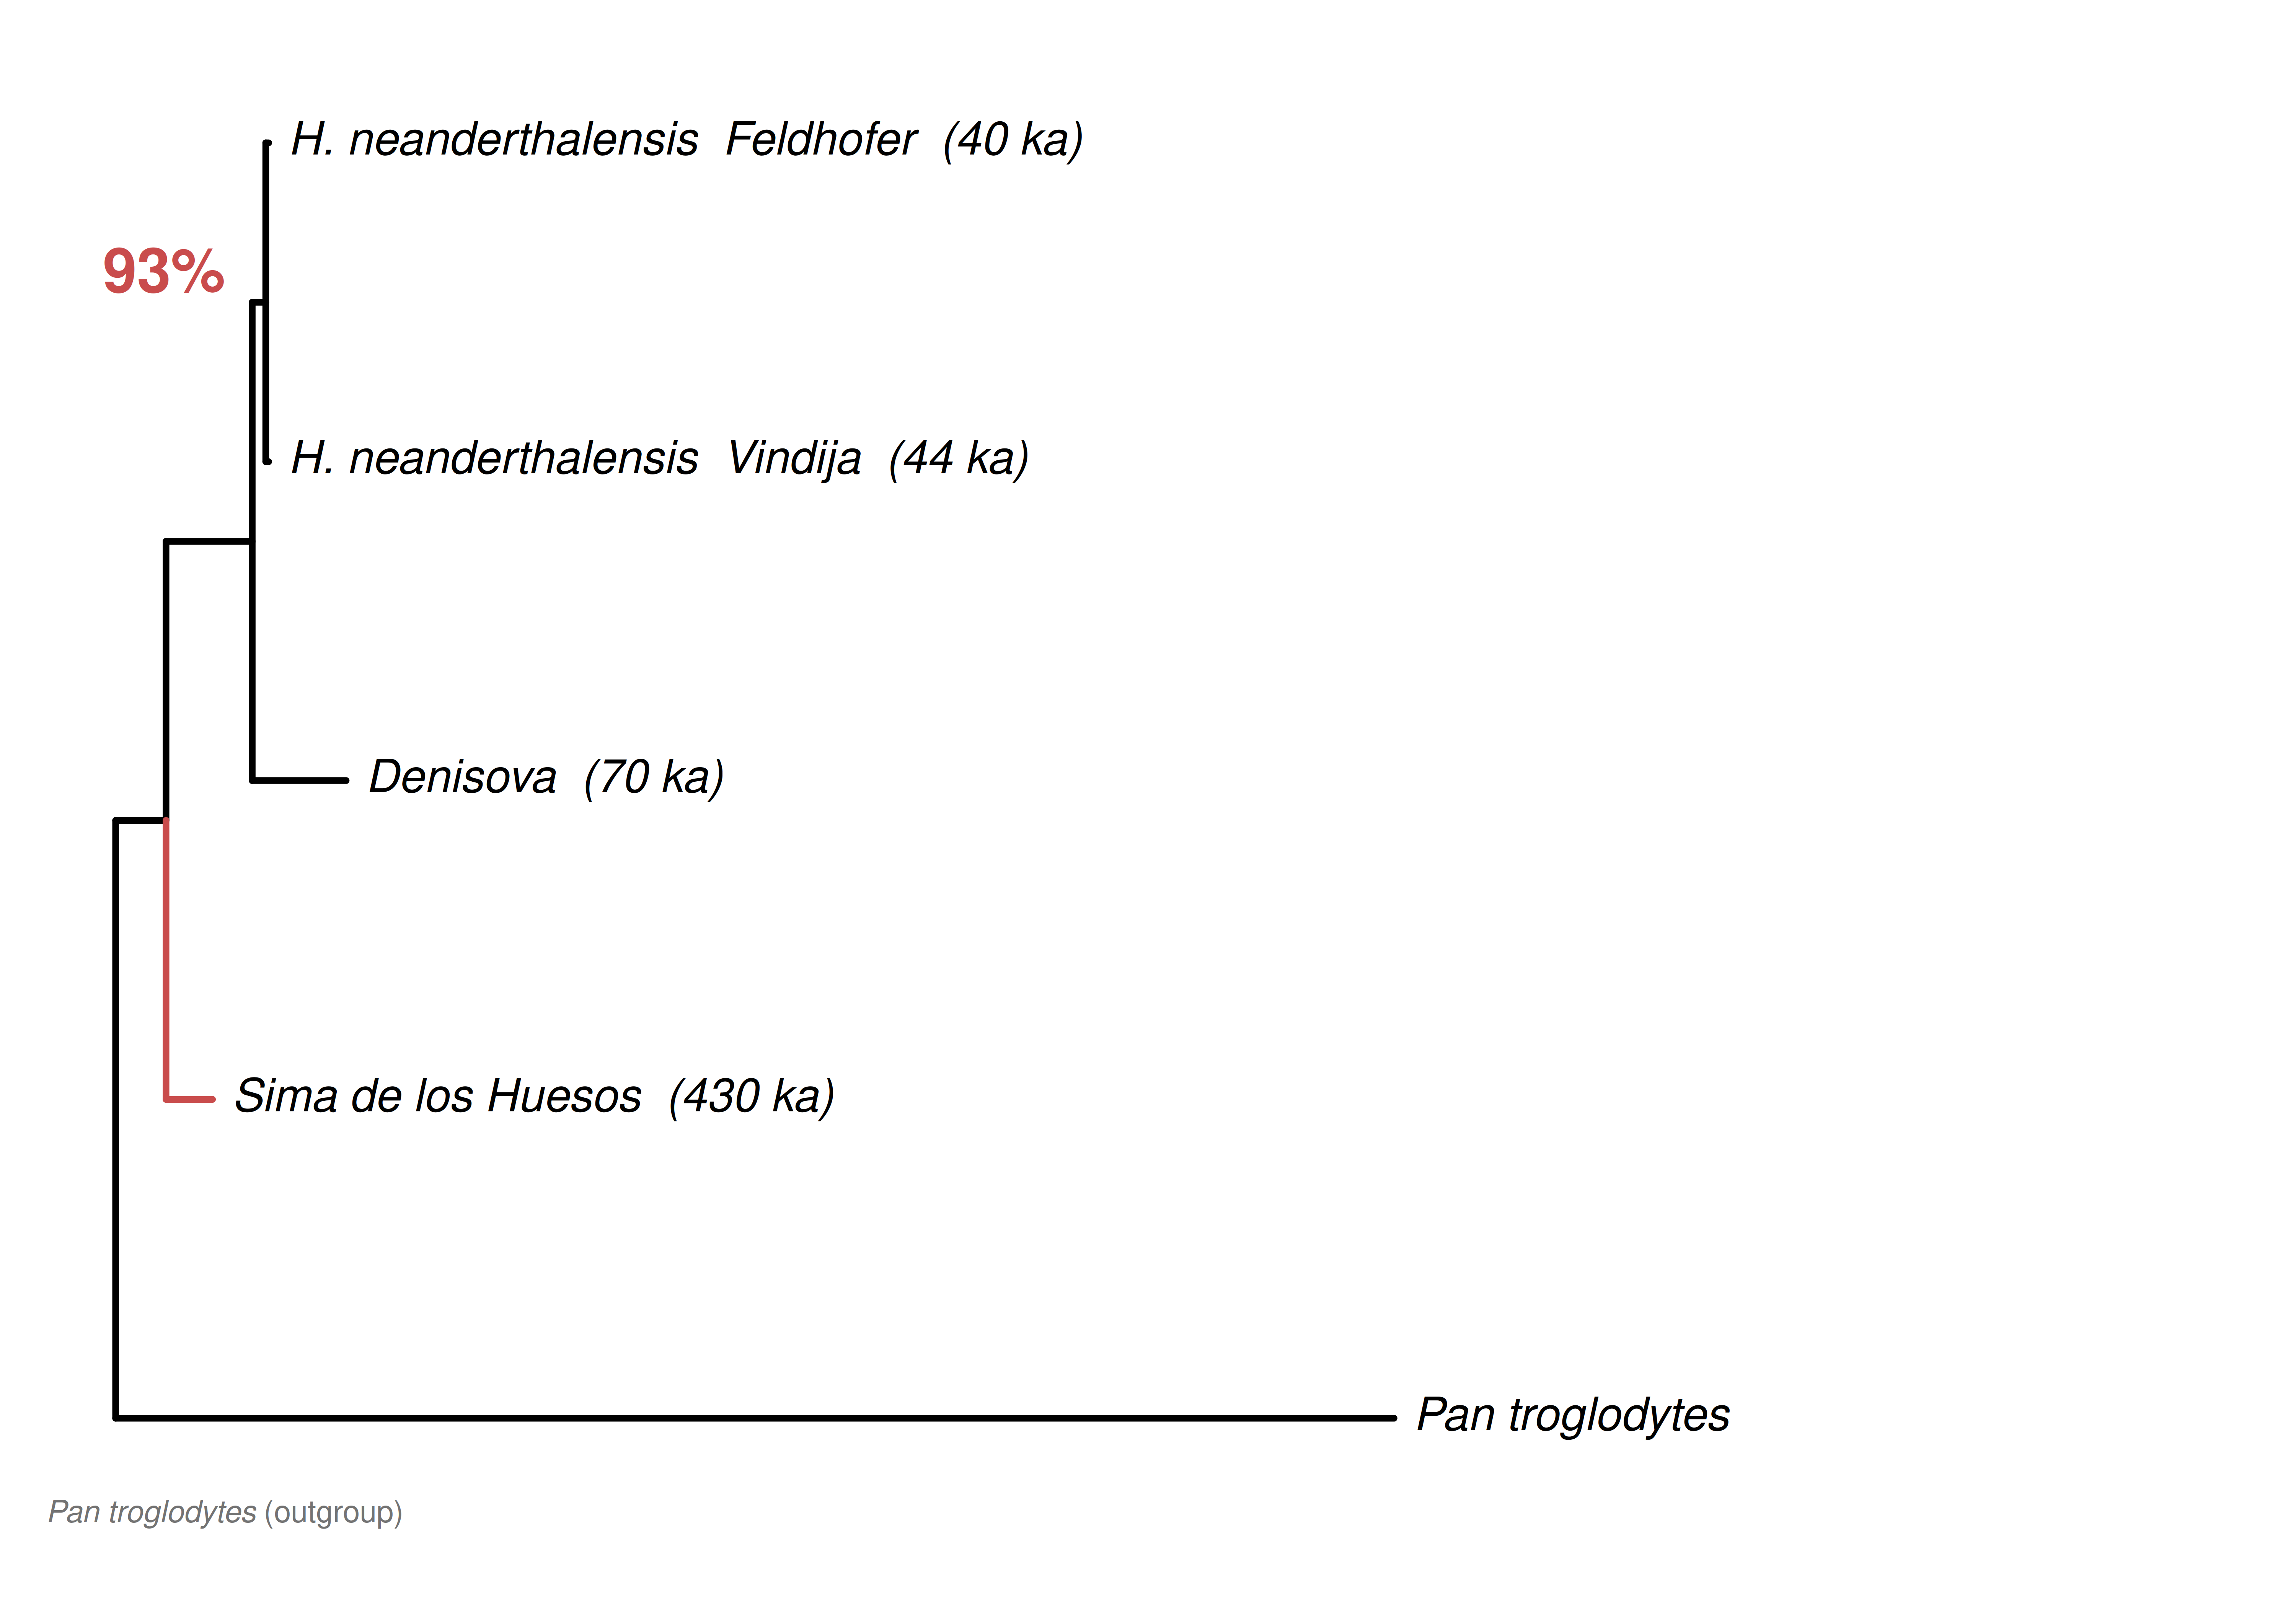
Figure 2. Pairwise nuclear genetic distance matrix (chromosome 1). Colour-coded heatmap of pairwise genetic distances computed from ~2.19 million chromosome 1 sites (ANGSD v0.941 with post-mortem damage filtering and block jackknife error correction). Darker teal indicates closer genetic relatedness. The minimum pairwise distance is Sima–Neandertal (d = 0.001376, red border), approximately 1.82× shorter than Sima–Denisova (d = 0.002506). Diagonal entries marked “—” (same taxon). Reference outgroup: Ust’-Ishim (45 ka). Data: ANGSD genotype likelihoods aligned to hg19.
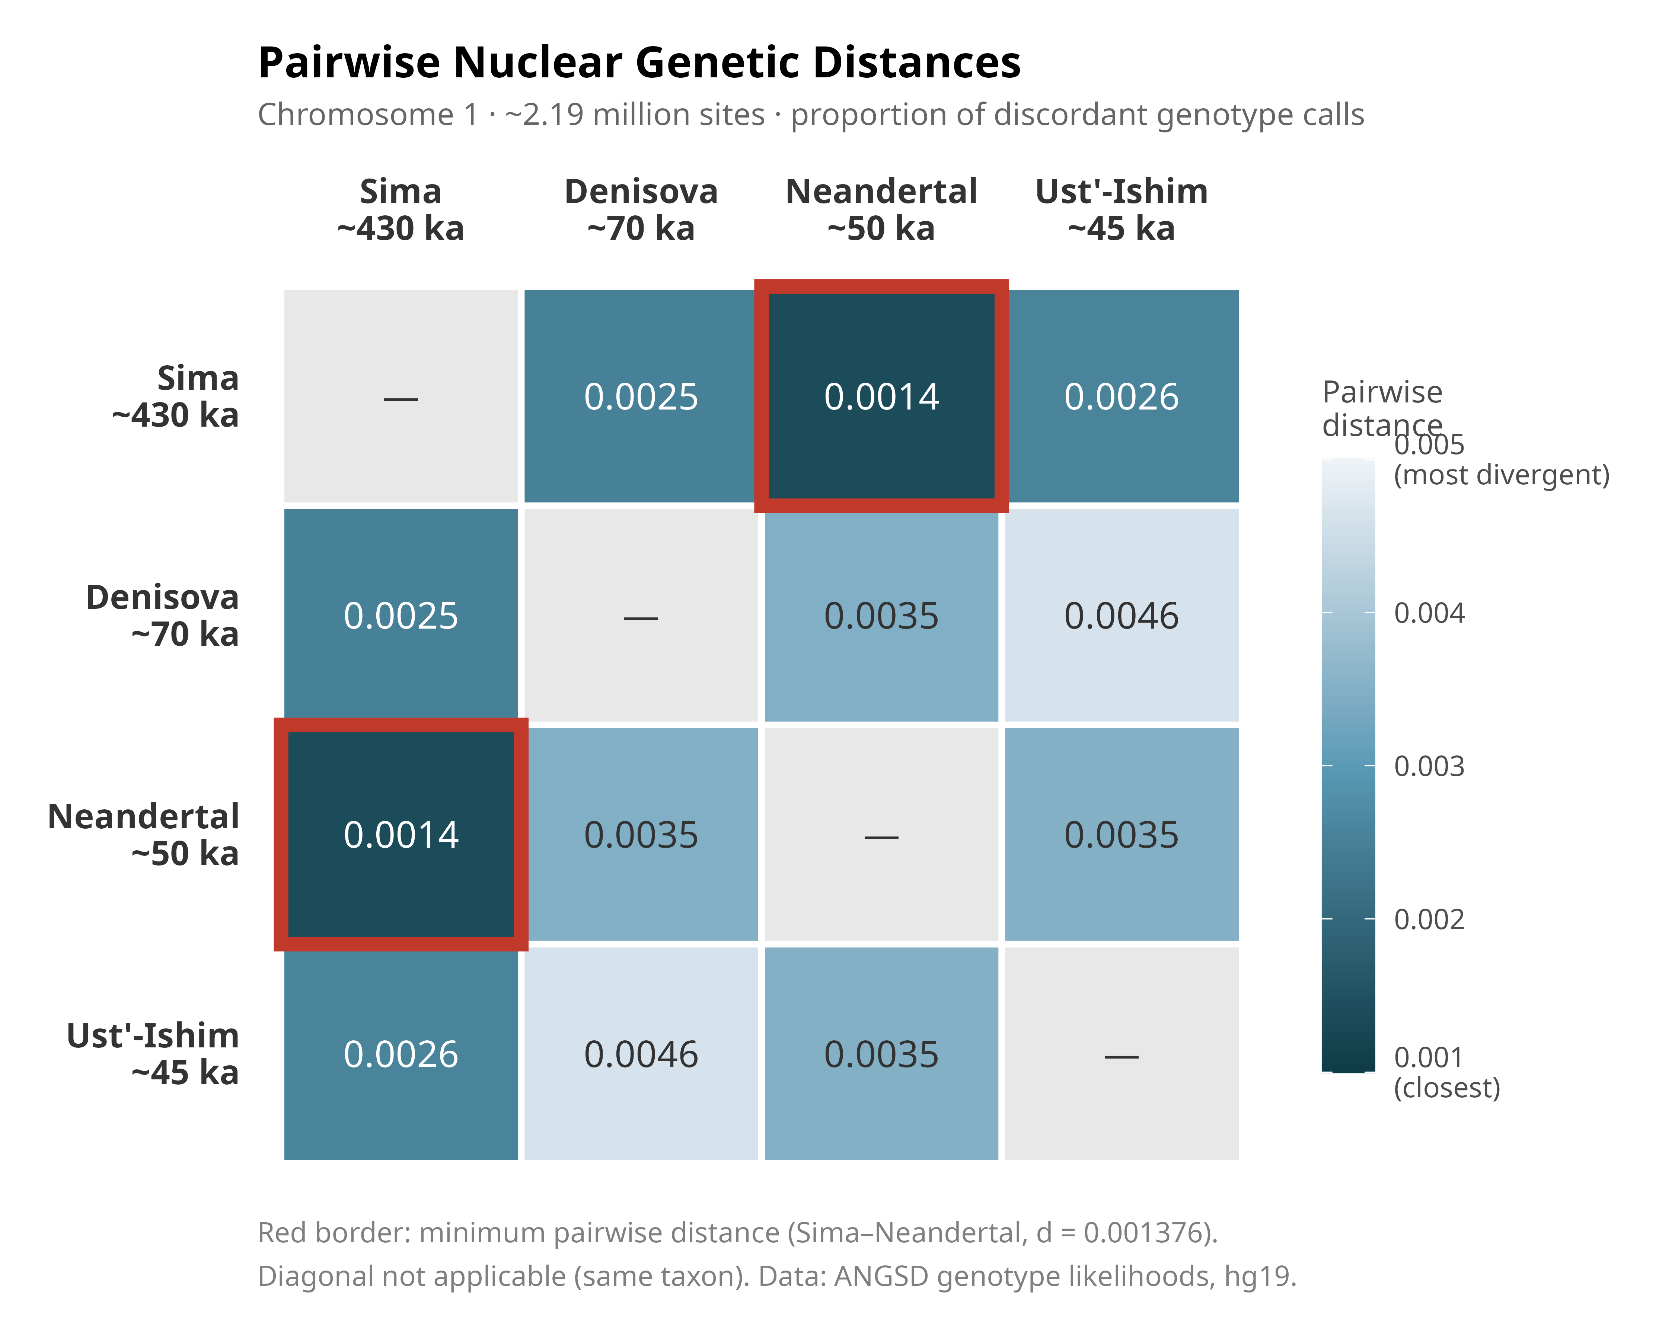
Figure 3. Spatial gradient of nuclear genetic affinity across Eurasia. Colour gradient represents inverse-distance-weighted (IDW) spatial interpolation of pairwise nuclear genetic distances (chromosome 1, ~2.19 million filtered sites) onto a 0.20° geographic grid. Red pole: Sima de los Huesos (~430 ka, Atapuerca, Spain); blue pole: Ust’-Ishim (~45 ka, Western Siberia). The continuous red-to-blue gradient across the Eurasian landmass, with no spatial discontinuity between archaic taxa, indicates that nuclear genetic structure in Pleistocene Eurasia follows geographic distance more closely than chronological distance. Both European specimens (Sima, Vindija) fall within the red affinity zone despite their ~386,000-year age difference. Grid resolution: 0.20°; basemap: Natural Earth 1:110m; coordinates: WGS84.
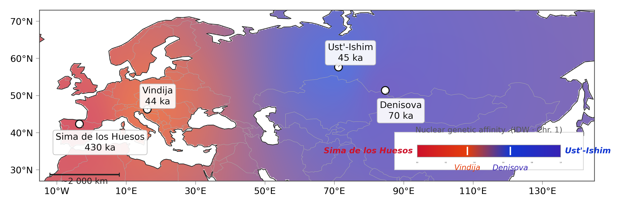

Acknowledgements
The author thanks the Equipo de Investigación de Atapuerca for the original recovery and curation of the Sima de los Huesos specimens, and the curators of ENA and NCBI GenBank for maintaining public access to the sequence data used in this study. Computational analyses were performed on Amazon Web Services EC2 infrastructure (eu-west-1).
AI Use Declaration: In accordance with AJBA’s editorial policy on Artificial Intelligence Generated Content (AIGC), the author discloses that Claude (Anthropic, PBC; claude.ai), a large language model (LLM)-based tool, was used during the preparation of this manuscript for the following specific tasks: (1) drafting and editorial revision of manuscript text; (2) generation of bioinformatic pipeline code (ANGSD parameter configuration, BAM processing scripts); and (3) generation of R scripts for figure production (tanglegram, heatmap, and spatial gradient map). Claude is not listed as an author and cannot fulfill authorship criteria: it did not initiate or design the research, cannot be held accountable for the published work, and has no legal standing. The research design, selection of analytical methods, interpretation of all results, and scientific conclusions are entirely the responsibility of the author. All numerical outputs reported in this manuscript (bootstrap values, log-likelihoods, D-statistics, pairwise distances, Z-scores) were independently verified by the author against raw output files from IQ-TREE v3.0.1, RAxML-NG v1.2.2, and ANGSD v0.941. The author takes full responsibility for the accuracy of all information in this manuscript.

References
Bermúdez de Castro JM, Arsuaga JL, Carbonell E, Rosas A, Martínez I, Mosquera M. 1997. A hominid from the Lower Pleistocene of Atapuerca, Spain: possible ancestor to Neandertals and modern humans. Science 276:1392–1395. https://doi.org/10.1126/science.276.5317.1392
Fu Q, Li H, Moorjani P, Jay F, Slepchenko SM, Bondarev AA, Johnson PLF, Aximu-Petri A, Prüfer K, de Filippo C, Meyer M, Zwyns N, Salazar-García DC, Kuzmin YV, Keates SG, Kosintsev PA, Razhev DI, Richards MP, Peristov NV, Lachmann M, Douka K, Higham TFG, Slatkin M, Hublin J-J, Reich D, Kelso J, Viola TB, Pääbo S. 2014. Genome sequence of a 45,000-year-old modern human from western Siberia. Nature 514:445–449. https://doi.org/10.1038/nature13810
Katoh K, Standley DM. 2013. MAFFT multiple sequence alignment software version 7: improvements in performance and usability. Molecular Biology and Evolution 30:772–780. https://doi.org/10.1093/molbev/mst010
Kishino H, Hasegawa M. 1989. Evaluation of the maximum likelihood estimate of the evolutionary tree topologies from DNA sequence data, and the branching order in Hominoidea. Journal of Molecular Evolution 29:170–179. https://doi.org/10.1007/BF02100115
Kozlov AM, Darriba D, Flouri T, Morel B, Stamatakis A. 2019. RAxML-NG: a fast, scalable and user-friendly tool for phylogenetic analysis. Bioinformatics 35:4453–4455. https://doi.org/10.1093/bioinformatics/btz305
Meyer M, Fu Q, Aximu-Petri A, Glocke I, Nickel B, Arsuaga J-L, Martínez I, Gracia A, Bermúdez de Castro JM, Carbonell E, Pääbo S. 2014. A mitochondrial genome sequence of a hominin from Sima de los Huesos. Nature 505:403–406. https://doi.org/10.1038/nature12788
Meyer M, Arsuaga J-L, de Filippo C, Nagel S, Aximu-Petri A, Nickel B, Martínez I, Gracia A, Bermúdez de Castro JM, Carbonell E, Viola B, Kelso J, Prüfer K, Pääbo S. 2016. Nuclear DNA sequences from the Middle Pleistocene Sima de los Huesos hominins. Nature 531:504–507. https://doi.org/10.1038/nature17405
Minh BQ, Schmidt HA, Chernomor O, Schrempf D, Woodhams MD, von Haeseler A, Lanfear R. 2020. IQ-TREE 2: new models and efficient methods for phylogenetic inference in the genomic era. Molecular Biology and Evolution 37:1530–1534. https://doi.org/10.1093/molbev/msaa015
Posth C, Wißing C, Kitagawa K, Pagani L, van Holstein L, Racimo F, Wehrberger K, Conard NJ, Kind CJ, Bocherens H, Krause J. 2017. Deeply divergent archaic mitochondrial genome provides lower time boundary for African gene flow into Neandertals. Nature Communications 8:16046. https://doi.org/10.1038/ncomms16046
Prüfer K, Racimo F, Patterson N, Jay F, Sankararaman S, Sawyer S, Heinze A, Renaud G, Sudmant PH, de Filippo C, Li H, Mallick S, Dannemann M, Fu Q, Kircher M, Kuhlwilm M, Lachmann M, Meyer M, Ongyerth M, Siebauer M, Theunert C, Tandon A, Moorjani P, Pickrell J, Mullikin JC, Vohr SH, Green RE, Hellmann I, Johnson PLF, Blanche H, Cann H, Kitzman JO, Shendure J, Eichler EE, Lein ES, Bakken TE, Golovanova LV, Doronichev VB, Shunkov MV, Derevianko AP, Viola B, Slatkin M, Reich D, Kelso J, Pääbo S. 2014. The complete genome sequence of a Neanderthal from the Altai Mountains. Nature 505:43–49. https://doi.org/10.1038/nature12886
Prüfer K, de Filippo C, Grote S, Mafessoni F, Korlević P, Hajdinjak M, Vernot B, Skov L, Hsieh P, Peyregne S, Reher D, Hopfe C, Nagel S, Maricic T, Fu Q, Theunert C, Rogers R, Skoglund P, Chintalapati M, Dannemann M, Nelson BJ, Key FM, Rudan P, Kućan Ž, Gušić I, Golovanova LV, Doronichev VB, Patterson N, Reich D, Eichler EE, Slatkin M, Schierup MH, Stefanović S, Kelso J, Meyer M, Pääbo S. 2017. A high-coverage Neandertal genome from Vindija Cave in Croatia. Science 358:655–658. https://doi.org/10.1126/science.aao1887
Reich D, Green RE, Kircher M, Krause J, Patterson N, Durand EY, Viola B, Briggs AW, Stenzel U, Johnson PLF, Maricic T, Good JM, Marques-Bonet T, Alkan C, Fu Q, Mallick S, Li H, Meyer M, Eichler EE, Stoneking M, Richards M, Talamo S, Shunkov MV, Derevianko AP, Hublin J-J, Kelso J, Slatkin M, Pääbo S. 2010. Genetic history of an archaic hominin group from Denisova Cave in Siberia. Nature 468:1053–1060. https://doi.org/10.1038/nature09710
Schoetensack O. 1908. Der Unterkiefer des Homo heidelbergensis aus den Sanden von Mauer bei Heidelberg. Leipzig: Wilhelm Engelmann.
Slon V, Hopfe C, Weiß CL, Mafessoni F, de la Rasilla M, Lalueza-Fox C, Rosas A, Soressi M, Knul MV, Miller R, Stewart JR, Derevianko AP, Jacobs Z, Li B, Roberts RG, Shunkov MV, de Lumley H, Perrenoud C, Günther I, de Filippo C, Meyer M, Pääbo S. 2017. Neandertal and Denisovan DNA from Pleistocene sediments. Science 356:605–608. https://doi.org/10.1126/science.aam9695
Zavala EI, Jacobs Z, Vernot B, Shunkov MV, Kozlikin MB, Derevianko AP, Essel E, de Filippo C, Nagel S, Nickel B, Richter J, Roberts RG, Prüfer K, Kelso J, Pääbo S, Meyer M. 2021. Pleistocene sediment DNA reveals diverse archaic hominin contributions to modern humans. Nature 599:86–92. https://doi.org/10.1038/s41586-021-04006-z

