Politecnico di Milano

AA 2018/2019



DD – Design Document

Version 1.0 - 10/12/18

*Authors: Professor:*

Emilio Imperiali Elisabetta Di Nitto

Giorgio Labate

Mattia Mancassola

**Table of contents**

1. Introduction 4

1.1 Purpose 4

1.2 Scope 4

1.3 Definitions, acronyms, Abbreviations 6

1.3.1 Definitions 6

1.3.2 Acronyms 6

1.3.3 Abbreviations 6

1.4 Revision history 6

1.5 Reference documents 6

1.6 Document Structure 7

2. Architectural Design 8

2.1 Overview: High-level components and their interaction 8

2.2 Component View 11

2.3 Deployment View 16

2.4 Runtime View 19

2.4.1 Make an individual request 19

2.4.2 Make an aggregate request 20

2.4.3 Report an emergency 21

2.4.4 Organize a run 23

2.4.5 Watch a run 25

2.5 Component interfaces 27

2.6 Selected architectural styles and patterns 32

2.7 Other design decisions 34

3. User interface design 36

4. Requirements Traceability 37

5. Implementation, integration and test plan 41

5.1 Component integration 44

6. Effort spent 49

1. Introduction

1.1 Purpose

The purpose of this document consists of giving more technical details than the RASD concerning the TrackMe application.

Indeed, if the RASD has as its objective to provide a more abstract view of the system with its functionalities, the Design Document goes deeper into detail about the design, providing an overall guidance to the architecture of the system. Here all the components forming part of the system are described, with the related run-time processes and all the design choices are listed and motivated.

In particular, the following topics are touched by the document:

* The high-level architecture;
* The main components, their interfaces and deployment;
* The runtime behavior;
* The design patterns;
* A mapping of the requirements on the architecture’s components
* Implementation, integration and testing plan;

1.2 Scope

The Data4Help service is offered to common users and to third parties that want to acquire data (health status and location) about them. The S2B will give to the user the possibility to insert his own body measurements, possible pathologies and eating habits (it’s not mandatory to insert these data) and will monitor and register his heartbeat, his position, his body temperature, his walking/running covered distance and his energy consumed. The system will also allow the user to choose which data to register and which not. Data4Help, besides helping users to monitor their health and position statistics and to consult their inserted data, supports companies in the analysis of the mentioned types of users’ data. The user can, obviously, accept or refuse the data acquisition’s request by the third party. It must be assumed that users’ devices are capable of acquiring the mentioned data (sensors + GPS): if a sensor for some kind of data is not present, that data won’t be available. The authorized personnel of the third party can access the data logging in and querying the TrackMe platform on the computer systems of the company (both users and third parties have first to register to the system). The system relies on the fact that all the users can be identified with a unique key (their fiscal code) and so the third party can ask to access their data through it. Data can be queried in two ways: the third party can make a request to the system to retrieve health status’ or location’s data of a single customer or it can ask for aggregate data on the base of some parameter (ex: data of all users with a certain age, with certain body measures, of all users that work in a certain area etc.). The third party can also request to the system to receive users’ data in a live way, as soon as they are produced without the necessity to make a query. Users will be notified of individual requests and will have the possibility to accept or refuse them. Individual requests may also represent requests of subscription to user’s data and, also in this case, users will have the possibility to accept or refuse them. In case of acceptance, they will be then allowed to remove their subscription at any time. The aggregate requests are handled directly by the Data4Help applicative that will provide data only if they can be showed in an anonymous way, otherwise it will notify the third party that is impossible to satisfy the request: TrackMe makes data available if, and only if, the query is satisfied by at least 1000 users’ data.

To offer the AutomatedSOS service the user directly agrees to his data processing when adding the service (he won’t be queried every time, but will give his consent only once at the beginning). In this case the service monitors the users’ health parameters and automatically signals the emergency to the third party that is notified when certain health’s parameters go below or over certain thresholds so that an ambulance can be sent to the customer’s location to help him (this responsibility is left to the third party exploiting AutomatedSOS service: AutomatedSOS has just to report theemergency*).* The service should guarantee a reaction time in reporting the emergency of less than 5 seconds from the moment in which the parameters go out of certain bounds: in this case it must be assumed that the users’ device collect and sends data in real time to guarantee a right functioning of the service.

For what concerns the Track4Run application, in this case TrackMe offers a service that can be exploited by an organizer of a run to arrange the run and its path, by the users willing to participate to a run to enroll for the competition and also just to follow the evolution of the run. The system offers the possibility to organize runs to recognized third parties and to enroll for them to all users.

Both AutomatedSOS and Track4Run rely on the assumptions made for Data4Help and exploit its features.

1.3 Definitions, acronyms, Abbreviations

1.3.1 Definitions

* **User:** the ‘normal’ customer of the application that exploits the application only to collect his own data or to be monitored for SOS and to enroll for a run or follow its development;
* **Third party:** the customer of the application that exploits it to monitor data of ‘normal’ customers, to provide the SOS service or to organize a run;
* **Customer:** general TrackMe customer, can be a user or a third party;
* **Individual Request:** request on some single user’s data made by a third party;
* **Aggregate Request:** request on some users’ grouped data made by a third party.

1.3.2 Acronyms

* API: Application Programming Interface
* DD: Design Document
* RASD: Requirements Analysis and Specifications Document
* DMZ: DeMilitarized Zone
* UI: User Interface
* HTTP: HyperText Transfer Protocol
* TSL: Transport Layer Security
* JSON: JavaScript Object Notation
* SQL: Structured Query Language

1.3.3 Abbreviations

* Rn = nth requirement

1.4 Revision history

* Version 1.0:
  + First Release

1.5 Reference documents

* Specification document: “Mandatory Project Assignment AY 2018-2019”
* IEEE Standard for Information Technology—Systems Design— Software Design Descriptions
* UML diagrams: <https://www.uml-diagrams.org/>

1.6 Document Structure

**Chapter 1** is an introduction to the design document. Its goal is to explain the purpose of the document and to highlight the differences with the RASD, whilst showing the link between them.

**Chapter 2** aims to provide a description of the architecture design of the system, it is the core section of the document. More precisely, this section is divided in the following parts:

* Overview: High-level components and their interaction
* Component view
* Deployment view
* Runtime view
* Component interfaces
* Selected architectural styles and patterns
* Other design decisions

**Chapter 3** specifies the user interface design. Actually, this part is already contained in the RASD in the mockups’ section. However, we decided to insert some UX diagrams to better describe the interaction between the User and the application.

**Chapter 4** provides the requirements traceability, namely how the requirements identified in the RASD are linked to the design elements defined in this document.

**Chapter 5** includes the description of the implementation plan, the integration plan and the testing plan, specifying how all these phases are thought to be executed.

**Chapter 6** shows the effort which each member of the group spent working on the project.

1. Architectural Design

2.1 Overview: High-level components and their interaction

The application to be developed is a distributed application and the three logic software layers of Presentation (P), that manages the user interaction with the system, Application (A), that handles the business logic of the application and its functionalities, and Data access (D), that manages the information with access to the database, are thought to be divided on three different hardware layers (tiers) that represent a machine (or a group of machines), so that any logic layer has, in principle, its own dedicated hardware: we have a so called three-tier architecture. This architecture is thought to guarantee to the system characteristics of scalability and flexibility and to lighten the server side splitting it into two nodes. In particular, the second tier is thought to contain only the business logic to physically separate clients and data to guarantee more safety in accessing to data since the system deals with sensitive data.

The following image show the high-level architecture of the system without providing any detail through the ArchiMate modeling language that is lighter than the UML language for such a simple representation.

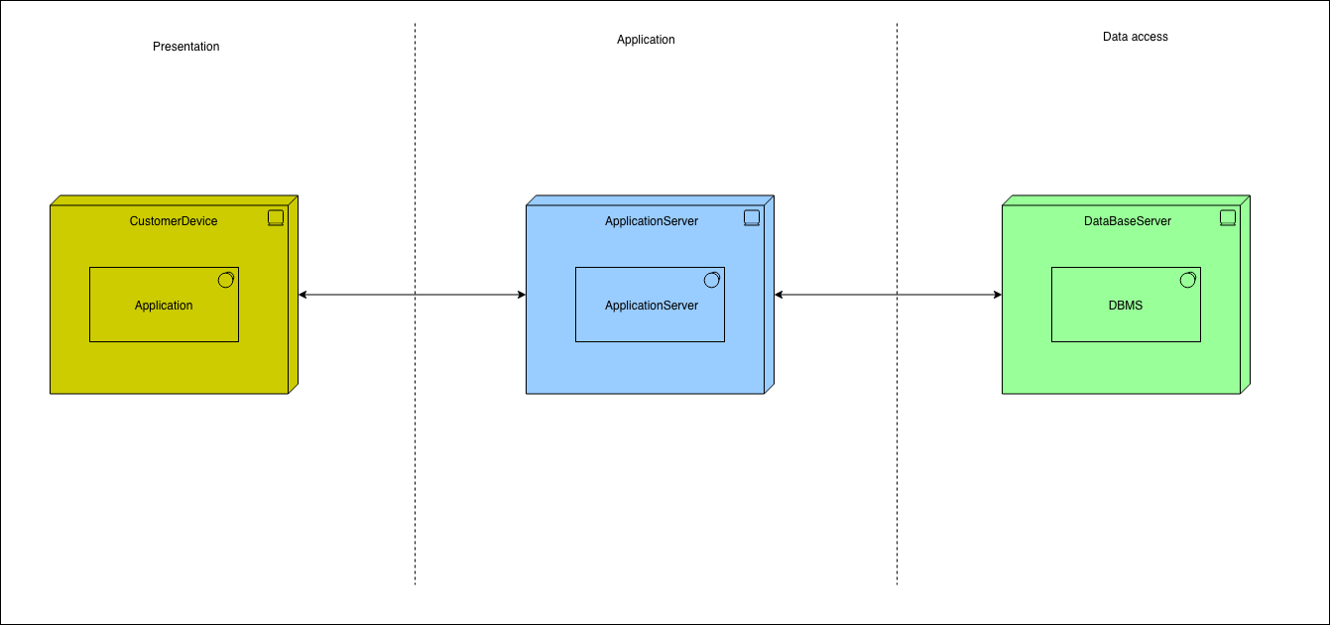

Figure 1 – High-level system architecture

For what concerns the third parties, they can communicate through their devices with the application level to make queries and to organize competitions with a synchronous message flow (the server implementing the business logic have to provide an answer). The server of the application level will interact with the customers also when sending notifications (SOS etc.) in an asynchronous way (they don’t wait for an answer). Instead, for what concerns the users, they interact with the application level providing answers to queries and their data (asynchronous messages) and to retrieve their data and stats, enroll themselves for competitions or watch them (synchronous messages). Finally, the server in the application layer communicates synchronously with the database server (data access layer) to retrieve information or asynchronously to store information when needed.

To augment the system scalability a scale-out approach is followed: performances improvement is obtained through nodes replication. This approach, that requires the adding of a load-balancing system to distribute the working load among the various nodes, allows to exploit the downsizing principle that affirms that low-end servers have minor costs of high-end servers for the same computational power. Moreover, cloning with shared disk configuration (clones share the memory disks; shared nothing configuration is not convenient since the offered service is very ‘write intensive’ and the same writing should be duplicated with this configuration) is exploited both to distribute computational load and to replicate data for security reasons. So, this technique increases both scalability properties and faults tolerance of the service and it’s important in particular because of the critical service offered through AutomatedSOS. Finally, to guarantee an appropriate packets control that is crucial because of the sensitivity of the treated data, firewalls are installed before and after the application tier to create a Demilitarized Zone (DMZ) for the application servers so that the external network can access only to the resources exposed in the DMZ. The web servers don’t guarantee the same security level and this is another reason why, in general, they forward the requests to the application servers in the DMZ. This level of security is required, as mentioned, since the offered service deals with sensitive data of the users.

A more detailed, but still informal view of the system is provided in the following image.

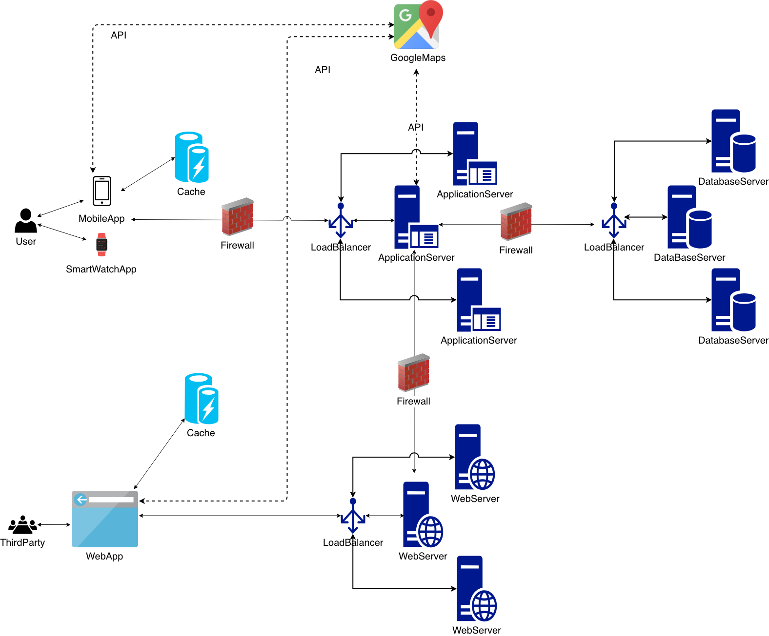

Figure 2 – System Architecture

In the Application tier we have an application server to provide the customers with access to the business logic which generates dynamic content (customable, extensible, interactive and seamless). Then we have a Web server that works in case of communication with the third parties’ web application, but to lighten its load the Web server is not supposed to generate dynamic content through plugins for scripting languages: it will forward the requests to the Application server if that is the case. To fasten and lighten the communication, caches are used in front of the Presentation tier: the cache needs to have an appropriate knowledge of data that makes up the business objects data, business logic and changes that can transform them at UI level: this knowledge is required to invalidate data when needed (some alterations occurred). Through the cache mechanism the users’ mobile app stores part of the users’ data and stats (most recent ones and manually inserted ones) in their dispositive so that they do not even have to be connected to the Internet to consult their data and stats (the same idea holds for the third parties’ web app).

It is worth to note that caches for applications servers can’t be exploited because of node replications: it is not possible to know what have been requested from a certain application server and what from another one, so it is impossible to provide a cache that would prevent them from accessing the database server every time.

Finally, TrackMe exploits data mining techniques to exploit the big quantity of data available and to extract from them relevant information and recurrent patterns that can be useful for the third parties that want, for example, find ‘hidden’ information and characteristics about their own clients or, more generally, about certain sets of TrackMe’s users. This can be obtained through various learning techniques: association rules, classification and clustering.

2.2 Component View

The following diagram contains all the components (logical or physical ones, for the sake of simplicity the only physical component represented is the ‘ApplicationServer’) of the system showing their interactions. The ports that represent the external interface exposed by components are shown only among different subsystems for the sake of simplicity.

In the diagram only the application server subsystem is analyzed in detail because it is the core component of the system: it contains the business logic (Application layer). The other components of the Presentation layer, of the Data access layer and the web server are represented (through their software components only) just to represent their interactions with the application server.

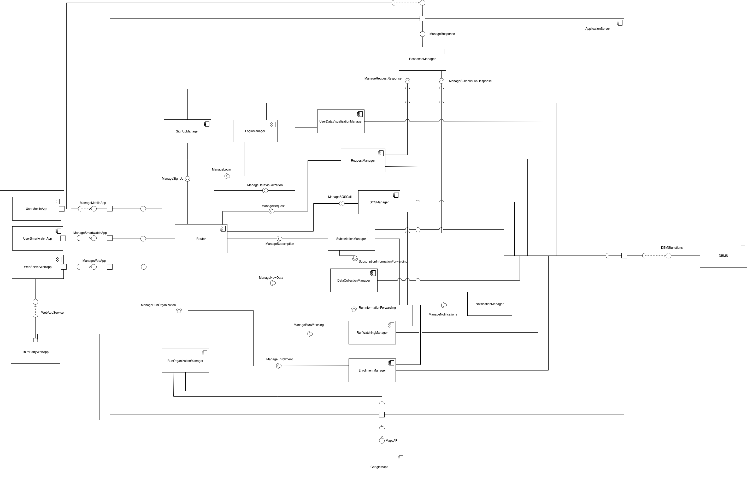

Figure 3 – Component Diagram

The components’ functions contained in the ‘ApplicationServer’ are described in the following:

* **Router**: it manages all the ‘messages’ and all the function call coming from the other subsystems to pass the data to the correct component and eventually call the right method/function on it. The router is partitioned according to the type of component it has to interact with because the functionalities offered are quite different among them. The **MobileAppRouter** handles the interaction with the users’ mobile app: it allows them to sign up, to login, to consult their own data and stats and to watch or enroll for a run. This component also forwards the received data (all the data among the required ones that a smartphone is able to collect) to the ‘DataCollectionManager’ in the case that the smartwatch is turned off. The **SmartwatchAppRouter** is indeed concerned with messages coming from the users’ smartwatches (by default, data are collected only through them unless the device is turned off): it has to forward the received data to the ‘DataCollectionManager’ and to forward the SOS call in case of emergency to the ‘SOSManager’. Finally the **WebAppRouter** offers the interface for the interaction with third parties’ web application: it must forward to the appropriate components the login and sign up data, the individual and aggregate requests, the subscription requests and the data concerning the organization of a run. A more detailed view of the Router component to show the described partitioning is provided below.

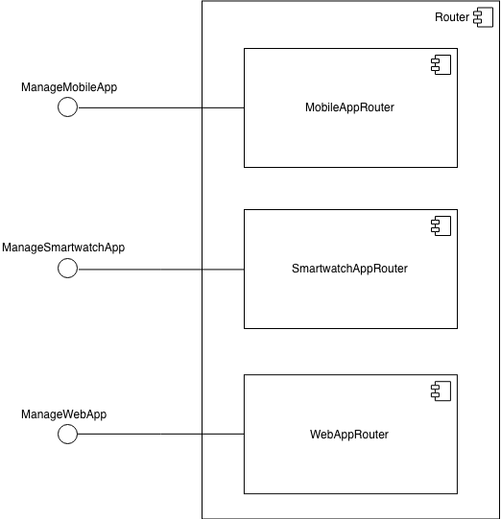

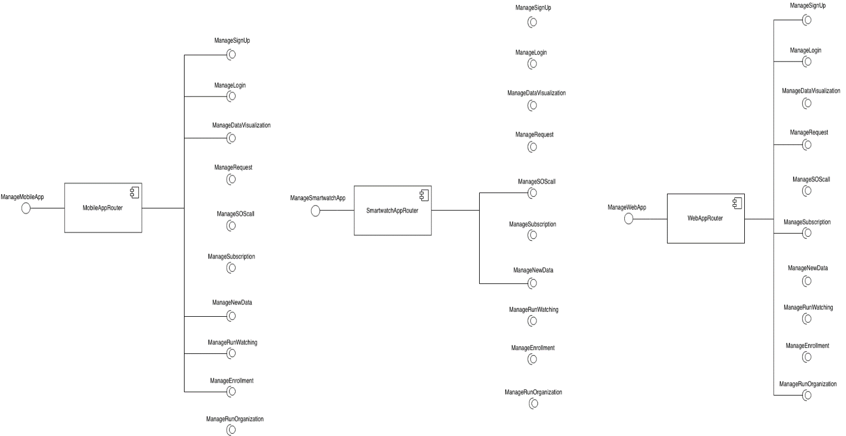

Figure 4 – Detailed view of the Router component and its provided interfaces

Figure 5 – Detailed view of the interfaces exploited by the Router components

* **SignUpManager**: this component contains all the procedures to allow the customers to register to TrackMe expressing also to which service they want to register for. It has to interact with DBMS to store data about the registration and performing controls about the chosen username and password.
* **LoginManager**: it manages all the logic inherent to the authentication of the customers. It interacts with the DBMS to check that the authentication parameters match the stored ones.
* **UserDataVisualizationManager**: it comes into play when the user wants to access to its own data and stats, for example accessing at his own monthly stats about heartbeat. It contains the applicative logic to handle the requests and provide the correct answers and has to invoke the DBMS to retrieve from the database the requested information.
* **RequestManager:** this component deals with requests by third parties about single individuals or groups of individuals. It has to retrieve the requested data from the database (it shall interact with the DBMS), makes the privacy controls in case of aggregate requests, forwards the queries to the requested users, handles their answers in case of individual requests and provides the right feedback to the requesting third parties.
* **SubscriptionManager:** it contains all the logic about subscriptions to users’ data for the third parties. It handles the requests for subscriptions for individual users or groups, the provided answers for the subscription and it is concerned in forwarding the data as soon as they are produced in case of a successful individual or group subscription (it provides an interface to the ‘DataCollectionManager’ to be able to do this: every time that a new data arrives the ‘DataCollectionManager’ reports it to the ‘SubscriptionManager’ that will query the database and forward the new data to the subscripted third party, if any). In case of subscription to an aggregate request this component has also to control if the number of users satisfying the request goes below 1000 and, in that case, it has to warn the subscripted third parties (through the ‘NotificationManager’) that the data won’t be no more provided until that number of users becomes again greater or equal than 1000.
* **SOSManager:** this component receives the emergency call from the user’s mobile app and is concerned in finding the third party that is the nearest to the user to forward to it the SOS. The control to check if parameters are out of the defined bound is performed client side, this component is concerned only in handling the emergency call (this is why it offers its interface only to the ‘Router’ and not to the ‘DataCollectionManager’).
* **RunWatchingManager:** this component is concerned in providing to all the willing users the possibility to follow a desired run. It receives continuously information from the ‘DataCollectionManager’ about the new collected data (updates on the location of the runners) for which the component has ‘registered’ exploiting the architecture of the Observer/Observable pattern and it forwards them to the users that asked to follow the run. It exploits the ‘NotificationManager’ to remind with one hour in advance that the competition for which the user has expressed the will to watch is beginning in short time.
* **EnrollmentManager:** it manages all the requests of enrollment to organized competitions. This component has only to verify the availability for the requested run and send the confirmation to the requesting user providing him with an identifier for the competition he has enrolled for. It exploits the ‘NotificationManager’ to remind with one day in advance about the competitions for which the user has enrolled.
* **RunOrganizationManager:** it deals with the organization of a competition asked by some third party. This component has to verify that all the inserted data are correct, for example it has to control that the defined path is feasible, that it doesn’t cross an already defined path for another defined competition in the same time slot and this kind of things (that’s why it must exploit Google Maps APIs).
* **DataCollectionManager:** this component receives all the data transmitted by users and has to store them and forward the proper information about them to the other components needing them: the ‘SubscriptionManager’ that can retrieve the eventually needed data from the database and the ‘RunWatchingManager’ that receives directly the data.
* **NotificationManager:** this component deals only with the logic for push notifications, it sends to the customers only asynchronous messages (doesn’t expect for any feedback by them). All the other components that have to forward some message to a client (for example the ‘RequestManager’) has to exploit the interface offered by this component. This component has been conceived to maintain single responsibility of the components: the type of messages sent are asynchronous (they are different from the general response messages provided by the server) and so it is more correct to use a different component rather than sending push notifications directly from the components where they were originated. When a notification is sent the dedicated client’s interface in ‘ResponseManager’ for the handling of the client’s response is provided (in our system this happens in case of a request of subscription or individual request). This mechanism of providing the interface of ‘ResponseManager’ only when ‘needed’ is exploited to show the interface only to authorized clients (i.e. clients that have to response to a request sent as an asynchronous notification).
* **ResponseManager:** this component is the handler of the client’s answer to a request of subscription or to an individual request and, in general, for all the responses that a client will eventually be able to provide if some new functionality will be introduced in future versions of the system.

It is important to notice that the only components that exploit the APIs offered by Google Maps are the clients’ ‘UserMobileApp’, ‘ThirdPartyWebApp’ and the ‘RunOrganizationManager’ on the server side: this is because all the visualization and interaction tools offered by Google Maps’ APIs have to be directly encoded on the clients’ app and on the application server the APIs are exploited only for the functionalities concerning the organization of a competition (ex: checking if two paths overlap in some point in the case of simultaneous competitions).

2.3 Deployment View

In the following image the TrackMe deployment diagram is represented: it shows the execution architecture of the system and represents the distribution (deployment) of software artifacts to deployment targets (nodes). Artifacts, in general, represent pieces of information that are used or are produced by a software development process and are deployed on nodes that can represent either hardware devices or software execution environments.

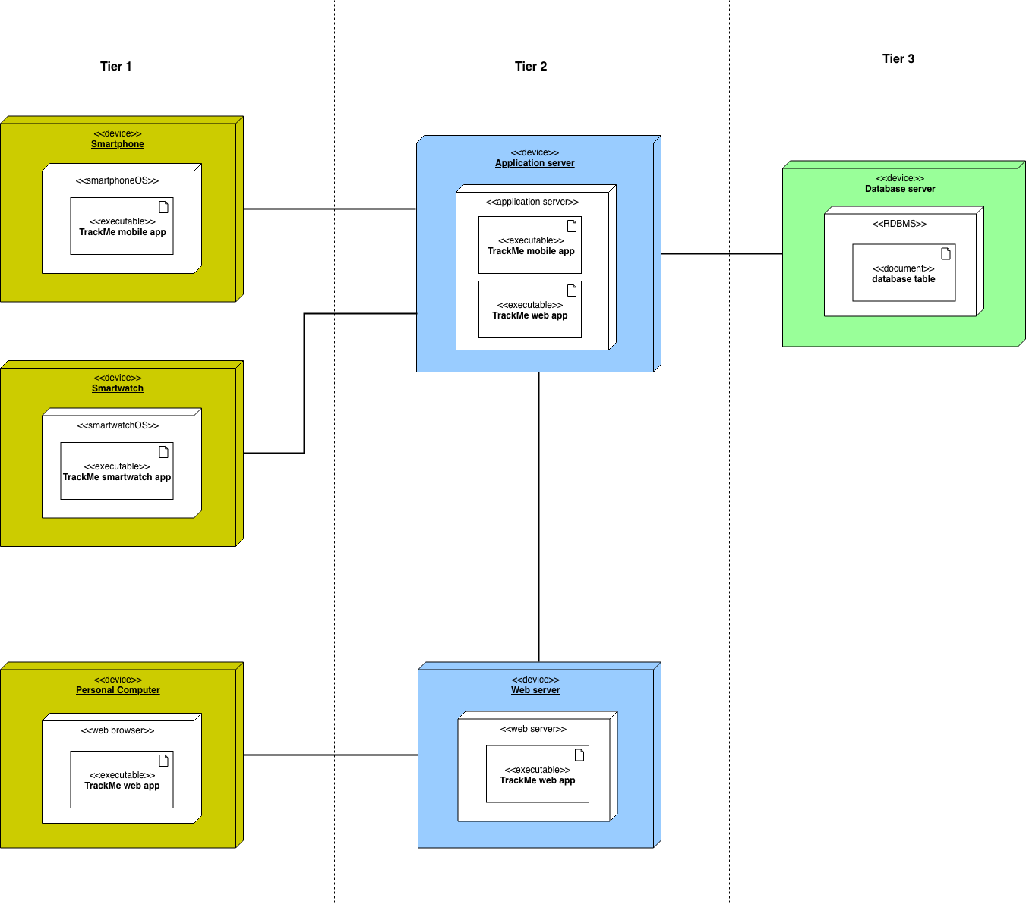

Figure 5 – Deployment Diagram

In the diagram ‘<<executable>>’ and ‘<<document>>’ are standard UML stereotypes that apply to artifacts: the former represents a program file that can be executed on a computer system while the latter represents a generic file that is not a «source» (another UML standard stereotype) file or «executable», in this case it represents the tables in the database.

In the diagram, external systems, as well as some other components (like load balancers and firewalls), are not represented to focus only on the components that host the core functionalities of the application or on the components for which the deployment is effectively executed (Google Maps is already built and deployed). The three tiers respectively contain:

* Tier 1: here the presentation logic must be deployed. Users must be provided with a mobile application on their smartphone and third parties with a web application accessible from their web browsers: the mobile application is the most comfortable way for a user to have access to the services and the web application has been chosen instead of a website because the services are most concerned in the interaction with the third party. The mobile application must be available for both Android and iOS to make it available on most of the devices. For the same reason the smartwatch app must be implemented for WatchOS and Android Wear and the web application must be compatible with at least Google Chrome, Safari, Internet Explorer and Firefox.

Users ask to communicate with the application server to retrieve their own data and stats, to report an emergency or to enroll or follow a competition. Third parties ask to communicate with the web server to retrieve users’ data, receive emergency reports or organize run competitions.

* Tier 2: here is deployed the application logic. The application server implements all the business logic, handles all the requests and provide the appropriate answers for all the offered services. It is directly addressed by the mobile application and handles also some requests that are forwarded by the web server and sent by the web application in all the cases in which the web server can’t provide information either because it doesn’t have them in its local disk or because some dynamic content has been requested.
* Tier 3: here the data access must be deployed. The database server is conceived to execute a relational DBMS (RDBMS): the database is relational. This is because the structure of a relational database allows to link information from different tables through the use of foreign keys (or indexes), which are used to uniquely identify any atomic piece of data within that table and this is very important for applications that are heavy into data analysis like TrackMe. Moreover the application has to handle a lot of complicated querying, database transactions and routine analysis of data and for all these reasons a relation approach is what is needed. A non-relational database would be inappropriate because it would not be able to represent some structures (as the users’ account etc.): it can’t express rules and constraints and have no fixed structure. However for future releases a hybrid approach (relational + non-relational) for the database design can be taken into account since TrackMe has to deal with a huge amount of data and non-relational database characteristics can be suitable for this reason.

2.4 Runtime View

2.4.1 Make an individual request

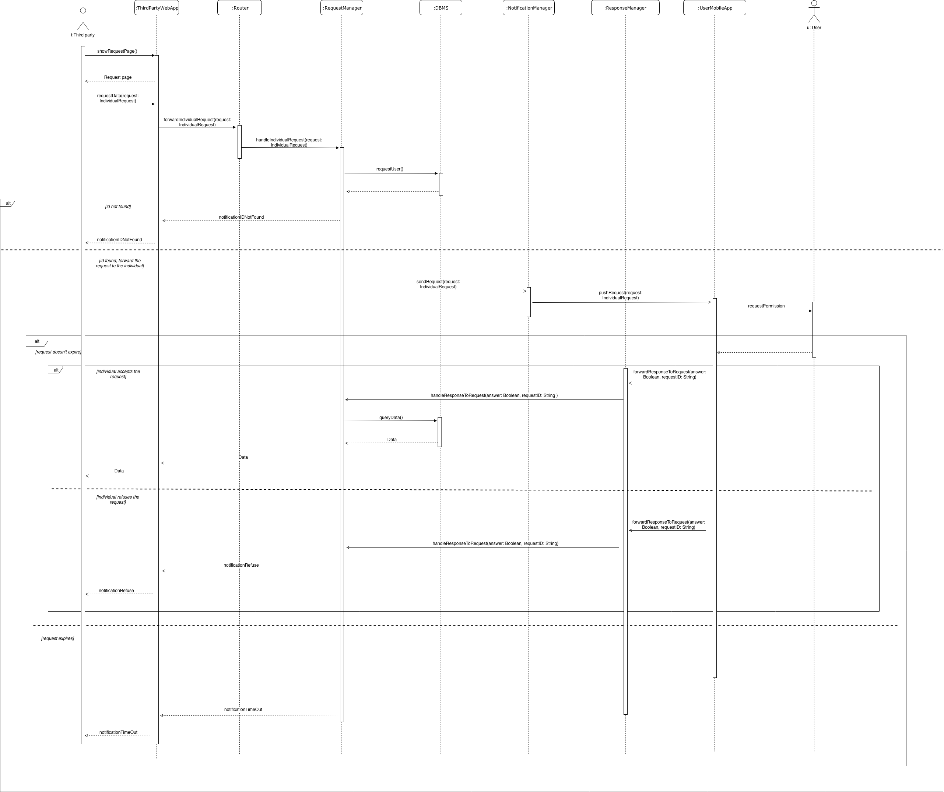

Figure 6 – Make an individual request sequence diagram

In this sequence diagram the process through which a third party can request the data of an individual is shown. Once the web app has rendered the page for making the request, the third party can insert all the needed input data to perform the action (the data are here thought to be contained in the Request object). When submitted, the request is sent to the Router, which forwards it to the right component, i.e. the ‘RequestManager’. The latter is responsible for checking, communicating with the DBMS, if the request is valid: if the requested id does not exist in the database, an error message is sent back to the third party. Otherwise, if the check goes through, the ‘NotificationManager’ is in charge of warning the individual. At this point, the user can decide whether to accept the request or not. There is a specific component in charge of receiving the user’s response, the ‘ResponseManager’, which ‘talks’ to the ‘RequestManager’. The ‘RequestManager’, then, according to the user’s decision, either queries the database for retrieving data or forwards to the third party a message which contains the user’s refusal. There is also a third case, which plays its part when the user doesn’t answer to the request within a time limit.

2.4.2 Make an aggregate request

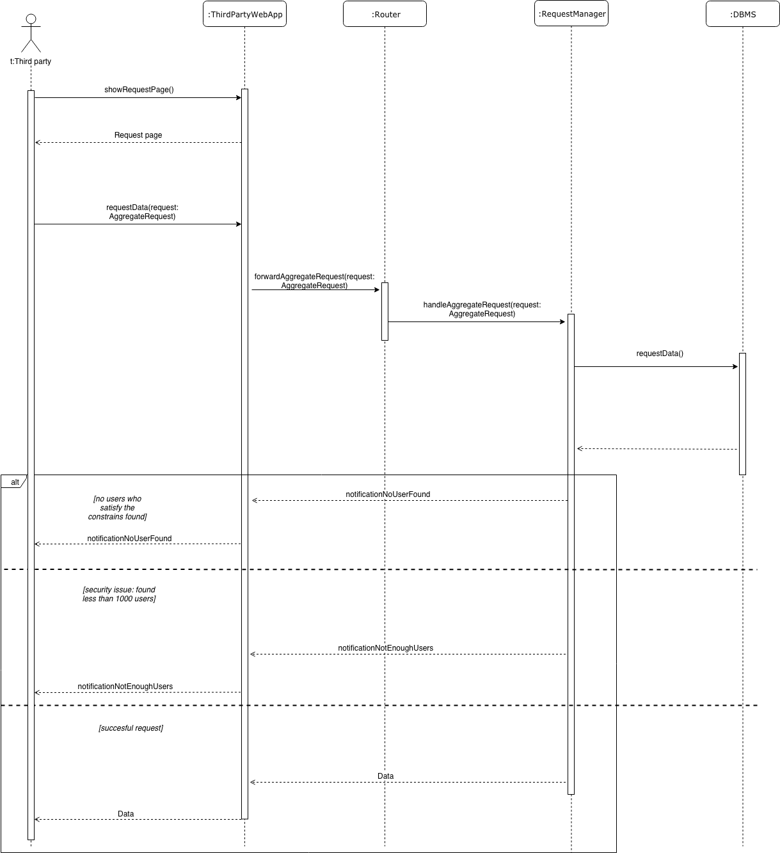

Figure 7 – Make an aggregate request sequence diagram

In this sequence diagram the process through which a third party can request the data of a group of users, on the basis of some criteria, is shown. At first the flow is similar to the individual request one, the third party asks for the request page and when this is rendered, it can insert the parameters. Of course here the difference is that there are no identifiers, but only a bunch of filters, which the third party can add to select a specific population. Once the needed data are inserted, the request is sent to the Router and then forwarded to the Request Manager, which ‘talks’ to the DBMS to check its validity. Here three scenarios can occur:

* There is no user who satisfies the selected criteria in the database; in this case the third party is notified with a dedicated message.
* There aren’t enough users who satisfy the selected criteria in order to guarantee their privacy, i.e. the query’s result contains less than 1000 rows.
* The query goes fine and the data are provided to the third party.

2.4.3 Report an emergency

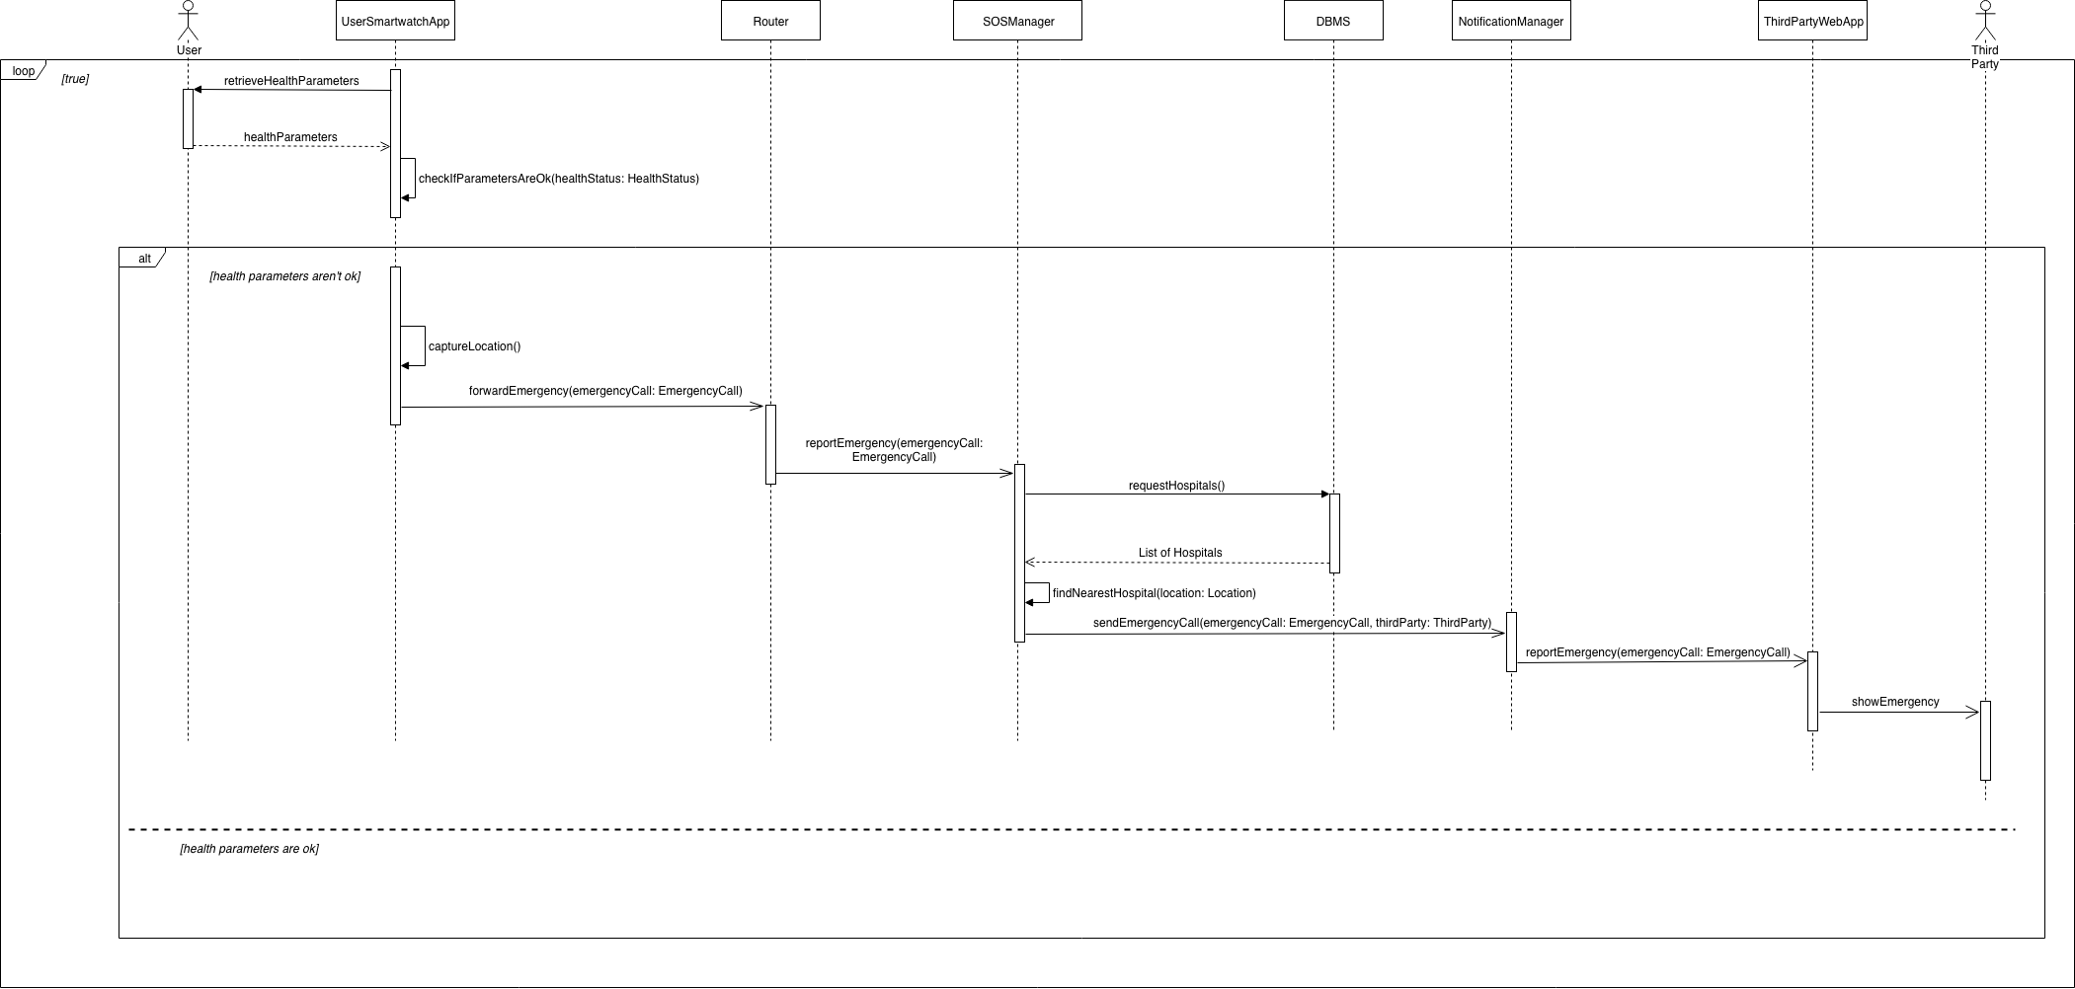

Figure 8 – Report an emergency sequence diagram

In this sequence diagram the process through which health parameters of the users are checked and, if any of them is out of the defined thresholds, an emergency is reported, is shown. At first, the app checks the health parameters and this operation is done in loop, until it finds out that those are below the thresholds. In that case, the app gets the location of the user (through GPS) and then reports to ‘Router’ the fiscal code (that is an identifier), the health status (that contains all the health parameters of the user) and the location. The ‘Router’ forwards that data to ‘SOSManager’, that queries the database in order to get all the third parties that provide emergency assistance services. In particular, ‘SOSManager’ needs the location of those third parties, because it must find out which one is the nearest to the user. After that, the ‘EmergencyCall’, that contains data about the user, his health parameters and his location, is reported to the ‘NotificationManager’ with the third party that must be contacted. The ‘NotificationManager’ then sends a push notification to the right third party.

It is worth to note that some methods of the components are represented here and are not present in the ‘Component Interfaces’ section: this happens when the mentioned methods are not part of the interface, but are internal to the components.

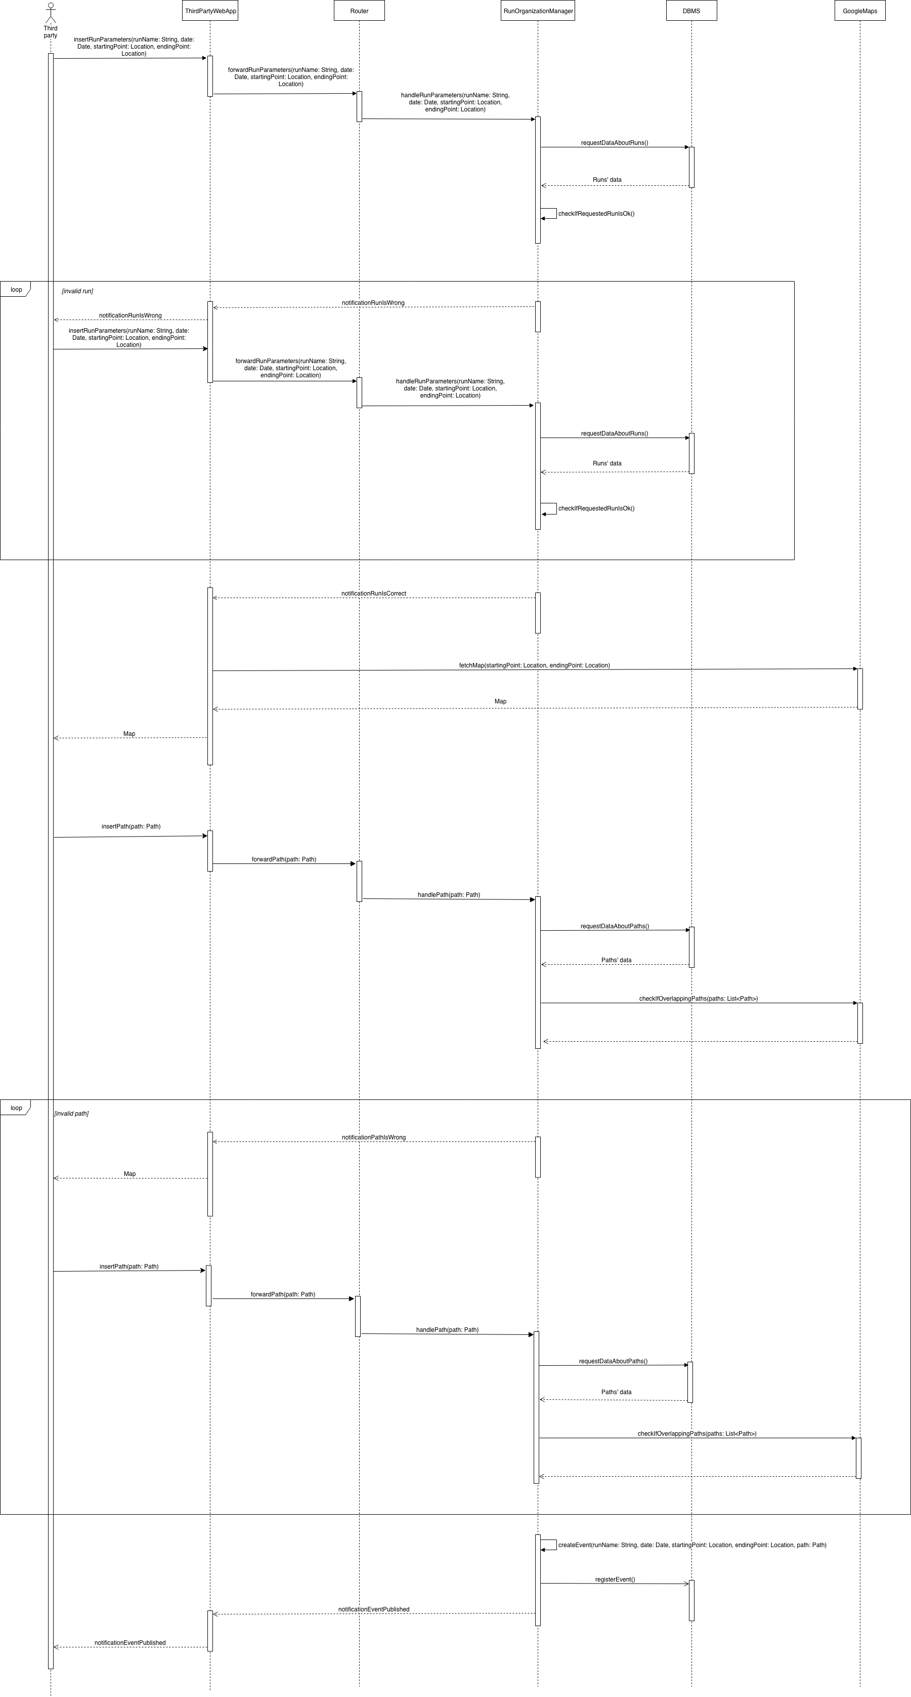2.4.4 Organize a run

Figure 9 – Organize a run sequence diagram

In this sequence diagram the process through which a third party organizes a run and the run is registered in the system is shown. At first, the ‘ThirdPartyWebApp’ forwards the run parameters inserted by the third party to the ‘Router’. Then, the ‘Router’ forwards them to ‘RunOrganizationManager’ that queries the database in order to check if the run to be prepared is compatible with the other ones (for example there must not be runs with the same name). If the proposed run isn’t ok, ‘ThirdPartyWebApp’ is notified and the third party is requested to rewrite the run parameters, so the loop restarts. Otherwise, the ‘ThirdPartyWebApp’ is notified that the run is ok. At this point, the third party will have to provide the path. To do so, the ‘ThirdPartyWebApp’ uses the GoogleMaps API to fetch a map, providing starting point and ending point of the run, so that the map is centered according to where the run will take place. This map is showed to the third party which selects the path of the run. All this information is then sent to the ‘Router’, which forwards it to ‘RunOrganizationManager’ in order to check if it’s ok (i.e. there are no overlapping paths already chosen for other competitions). ‘RunOrganizationManager’ queries the database to get the paths of the other runs, and uses the GoogleMaps API to check if there are overlap with the requested path. Similarly to the check of the run, if the path is not ok then the third party will be asked to provide a new path and the loop will restart (in this case GoogleMaps API will not be used to fetch the map anymore: the one already fetched before is used). Otherwise, the run is created and linked to its path, saving it in the database, and the third party is notified.

It is worth to note that some methods of the components are represented here and are not present in the ‘Component Interfaces’ section: this happens when the mentioned methods are not part of the interface, but are internal to the components.

2.4.5 Watch a run

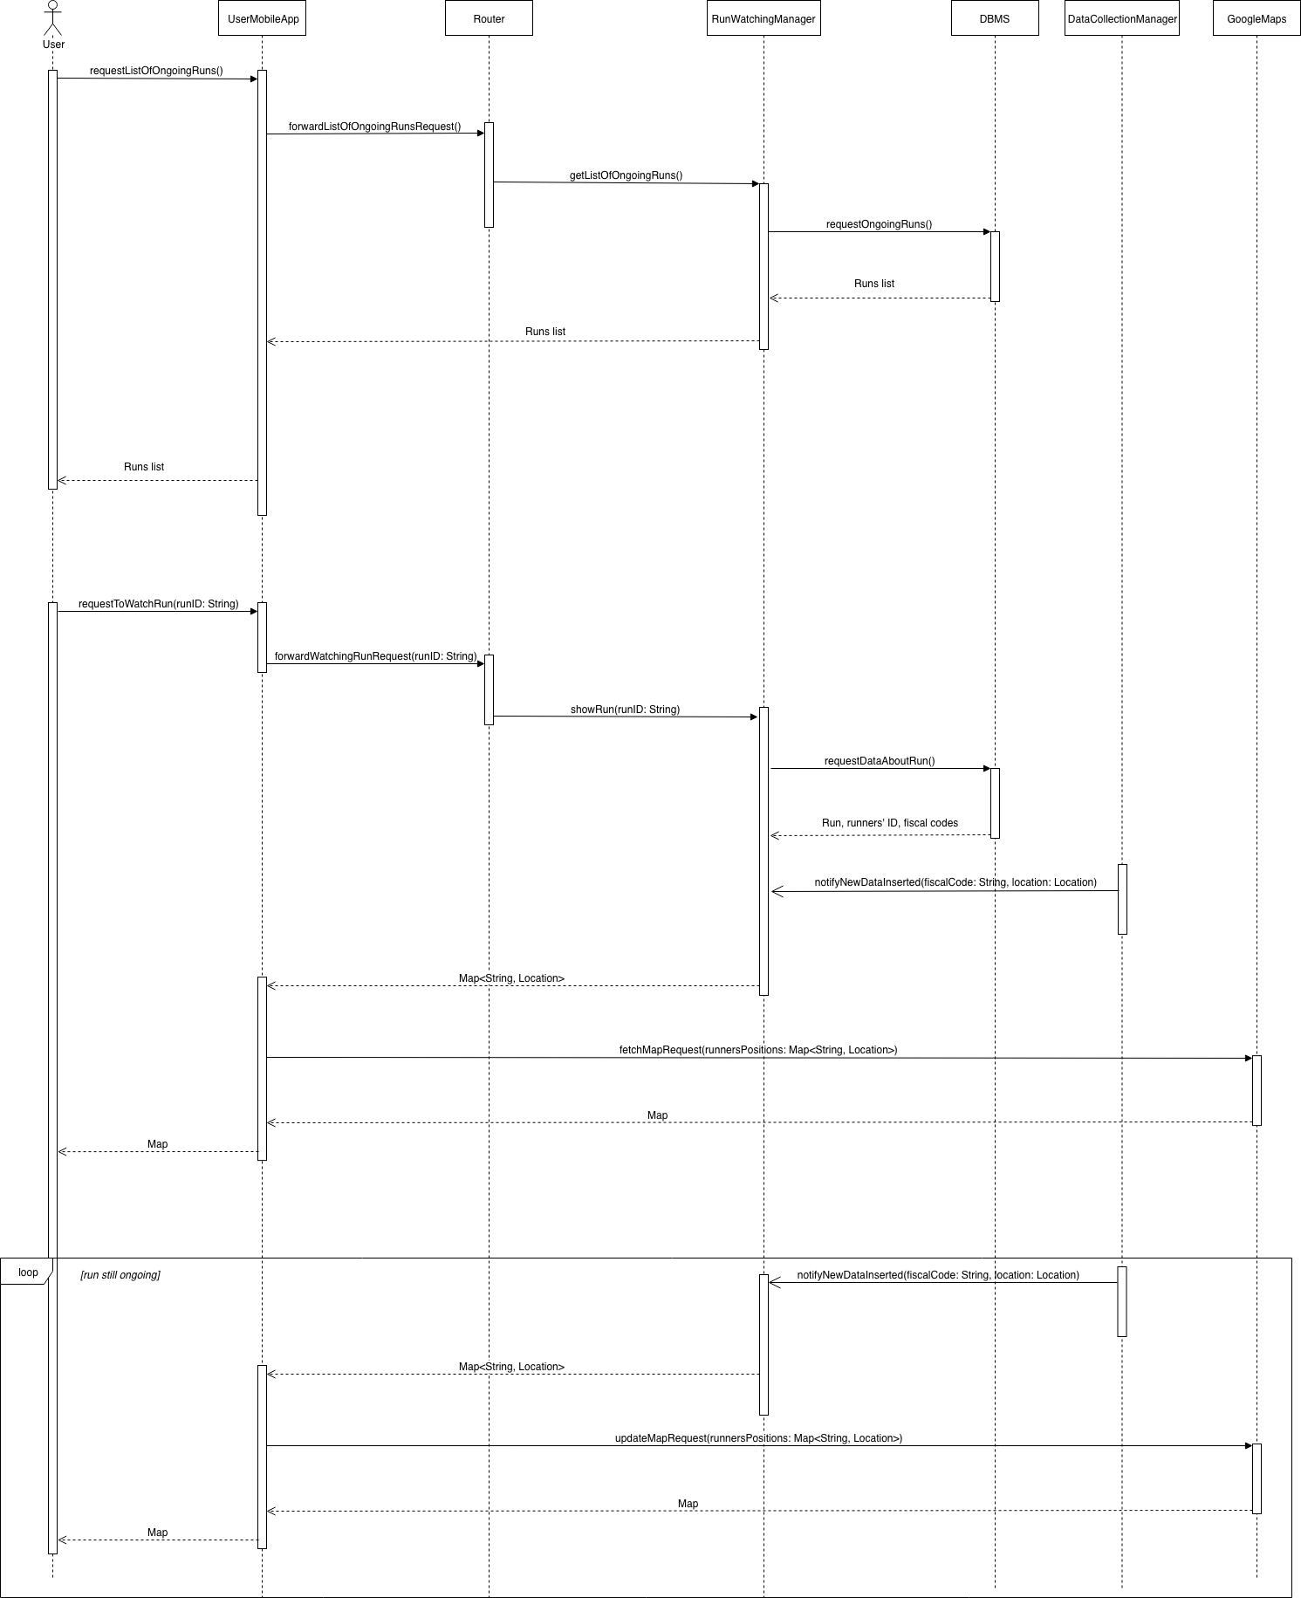

Figure 10 – Watch a run

In this sequence diagram the process through which a user follows an ongoing run is shown. It’s important to underline that a user can either watch an ongoing run or ask to watch a run that is not ongoing, and will start in another moment. In the latter case, he will be notified when the run is about to start by the ‘NotificationManager’ component. Anyway, it was chosen to represent the former case in this sequence diagram, so the case in which the run is already ongoing.

At first, the user requests to provide the list of ongoing runs through the ‘UserMobileApp’, and this request is forwarded to the ‘Router’. The ‘Router’ then forwards it to the ‘RunWatchingManager’, which queries the database and gets the ongoing runs. It also sends them to the user. The latter chooses which is the run he wants to watch and his choice is forwarded to the ‘Router’ and then to the ‘RunWatchingManager’. ‘RunWatchingManager’, at this point, needs to query the database to get the required data about the chosen run, including fiscal code and runnerID of the runners (note that only the runID was passed, so it’s assumed that RunWatchingManager needs to query the database in order to get data about the run with that runID). Now ‘RunWatchingManager’ needs to communicate to ‘DataCollectionManager’ the fiscal codes of the runners whose location must be notified to the the former as soon as they are passed to the latter: it must ‘register’ on that data. Since this can be considered just an application of the Observer/Observable architectural pattern, it was chosen not to represent the method that is called for the registration of ‘RunWatchingManager’ on ‘DataCollectionManager’, so this is not showed in the sequence diagram. ‘RunWatchingManager’, after having properly processed the provided data to send the correct informations only to the correct users, just provides a map (ex: Hash Map), having runnerID as key and with the respective location. ‘UserMobileApp’ then uses GoogleMaps API to fetch the map, using those locations in order to let the user see where the runners are and the runnerIDs are displayed on each “point” on the map associated to each runner. This process, which starts with ‘RunWatchingManager’ sending to ‘UserMobileApp’ the list of refreshed locations and IDs, is looped until the run is finished. So the user will see those “points” moving as the run procedes. While looping, the GoogleMaps API will not be used to fetch a new map, but just to refresh the positions of the runners on the already fetched map.

It is worth to note that some methods of the components are represented here and are not present in the ‘Component Interfaces’ section: this happens when the mentioned methods are not part of the interface, but are internal to the components.

2.5 Component interfaces

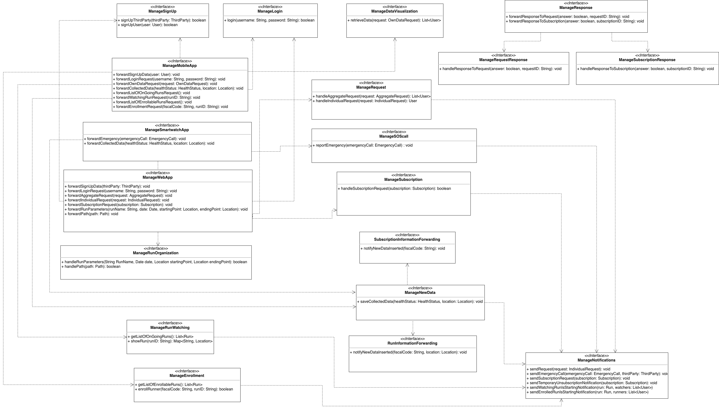

Figure 11 – Component interfaces

In the above figure the component interfaces belonging to the application server, with reference to what was shown in the Component diagram, are represented. The arrows represent a dependency relation.

There are some things that have to be pointed out, in order to give a better understanding of how those component interfaces are intended:

* Only the interfaces offered by the application server are chosen to be represented.
* Both classes Request and Subscription (that are represented in the Model provided at the end of this section) contain a unique ID that is also the primary key that identifies them in the database. Those IDs are assigned by the server when they are saved into the database. However, as it can be seen, the interface ‘ManageWebApp’ offers for example the method *forwardSubscription(subscription: Subscription)*. An instance of Subscription needs to be sent, but it can’t have an ID, since it’s assigned by the ‘SubscriptionManager’ when it’s saving it in the database. Therefore it’s assumed that in this case the ID is set to null. The same considerations hold for all methods offered by all the interfaces that take as parameter a Subscription’s instance or a Request’s instance, and that are called before the ID was assigned.
* When a third party signs up, the application server saves his data in the database and assigns to it a unique ID. As said, regarding the ID of Subscription and Request, when *forwardSignUpData* is called in the context of ManageWebApp interface, the ID of the ThirdParty’s instance passed is set to null, because its ID does not exist yet. The sign up of the user works in a slightly different way: when a user signs up, he must provide his fiscal code, which will be used as his unique ID and as primary key in the database. In both cases however, the respective method called in the ‘ManageSignUp’ interface returns a boolean, that is “true” if the sign up was successful, “false” otherwise.
* The *retrieveData(request: OwnDataRequest)* method offered by ‘ManageDataVisualization’ interface returns *List<User>* because a user can request to see for example his walked distance in the past 5 days: a “User” instance contains data about the user in a single instant, so, if he wants to see his walked distance in the past 5 days, he will receive a User instance for each location. That’s because, as just said, every User’s instance contains a single set of data.
* The interfaces ‘SubscriptionInformationForwarding’ and ‘RunInformationForwarding’ have a similar purpose and it’s important to describe them in detail. Every time that new data are collected by the system and arrives to the ‘DataCollectionManager’ component, the latter saves them in the database. Then the ‘SubscriptionManager’ component needs to be notified, because it could happen that one or more third parties are subscripted to that data, so they must receive them. That’s why ‘SubscriptionManager’ offers the ‘SubscriptionInformationForwarding’ interface to DataCollectionManager: the *notifyNewDataInserted* method is the one called in this case. The fiscal code is passed, because it’s sufficient for the ‘SubscriptionManager’ to do the right query to the database and to get the new data to be forwarded to third parties (in case there are any). This mechanism can be considered an application of the Observer/Observable pattern at an architectural level.

As said before, ‘RunInformationForwarding’ has almost the same purpose. In the context of the Track4Run service, when a runner is participating to a competition, he sends to the system his location in real time, so that other users can watch the run. One of the main differences between this mechanism and the one described above, is that the ‘RunWatchingManager’ component is not always notified when a user’s location is collected. As introduced in the “Watch a run” sequence diagram, ‘RunWatchingManager’ communicates to ‘DataCollectionManager’ the fiscal codes of the users whose locations needs to be notified to it. In this way, ‘RunWatchingManager’ will get the locations only of the runners, not the location of every possible user. It has been chosen not to show an interface offered by ‘DataCollectionManager’ to ‘RunWatchingManager’ in order to achieve the ‘registration’ of the latter on the former for the sake of simplicity (it’s just an application of the Observer/Observable pattern at an architectural level). ‘RunInformationForwarding’ is the interface offered by ‘RunWatchingManager’ to be notified when a new location of a runner is passed to the ‘DataCollectionManager’. Another important difference between this mechanism and the one used with the subscriptions is that, in this case, the location is passed along with the fiscal code because there is no reason to save all the locations that a runner sends in the database and so the ‘RunWatchingManager’ will not get them by querying the database, but will receive them directly from the ‘DataCollectionManager’.

* Regarding ‘ManageRequest’ interface, it’s important to underline that *handleAggregateRequest(request: AggregateRequest)* method returns a list of User, which is intended as a list of instances of User that represents the users matching the aggregate request passed. Those instances will contain the requested data, but won’t contain in any case the fiscal codes of the users nor any identification data (at the implementation level, those fields can be set to ‘null’ for example) because otherwise that would violate the privacy constraints.
* Since all the methods offered by the ‘ManageNotifications’ interface are called by an internal component of the application server, and since their only functionality is to send a push notification to a customer in an asynchronous way, they don’t need to return anything and this is why their return type is “void”. The methods offered by interfaces that are called in a synchronous way, like for example ManageRequest’s ones, return something instead: the data requested that has to be sent to the customer. Regarding the parameters passed, the methods offered by the ‘ManageNotifications’ interface need to take as parameter the customer to which the notification must be sent to. Anyway, with reference to the reported Class Diagram, it can be noticed that this information is already encapsulated in IndividualRequest (the user that has to accept or refuse the request) and Subscription (the user that has to accept or refuse the subscription request) classes, so it’s not needed to pass it explicitly as a parameter. *reportEmergency(emergencyCall: EmergencyCall, thirdParty: ThirdParty)* needs the explicit parameters instead, because the EmergencyCall class doesn’t contain a reference to the third party to whom the emergency must be forwarded. Same consideration holds for *sendWatchingRunIsStartingNotification(run: Run, watchers: List<User>)* and *sendEnrolledRunIsStartingNotification(run: Run, runners: List<User>)* methods, since Run class doesn’t contain any reference neither to users that wants to watch it nor to users that are enrolled for it.

It could be useful also to better describe a specific method offered by the ‘ManageNotifications’ interface: *sendTemporaryUnsubscriptionNotification(subscription: Subscription)*: this method is called when the users matching a subscription that was done in the context of an aggregate request become less than 1000, so the third party that holds the subscription needs to be notified that he won’t receive the data because of that.

* In general, methods written in the Component Interfaces diagram are not to be intended exactly as the methods that the developers will write, but they are a logical representation of what component interfaces have to offer. This consideration is important in particular with regard to the methods offered by the interfaces provided by ‘Router’ and by ‘ManageResponse’, indeed, since RESTful architecture is used, it must be cleared that they are not method called by means of remote invocation, instead they will be implemented following the RESTful principles.

In the following, the Class diagram is reported: it represents the model of the considered system. We decided to use a Class diagram instead of an Entity-Relationship model since they can be considered pretty interchangeable in this context.

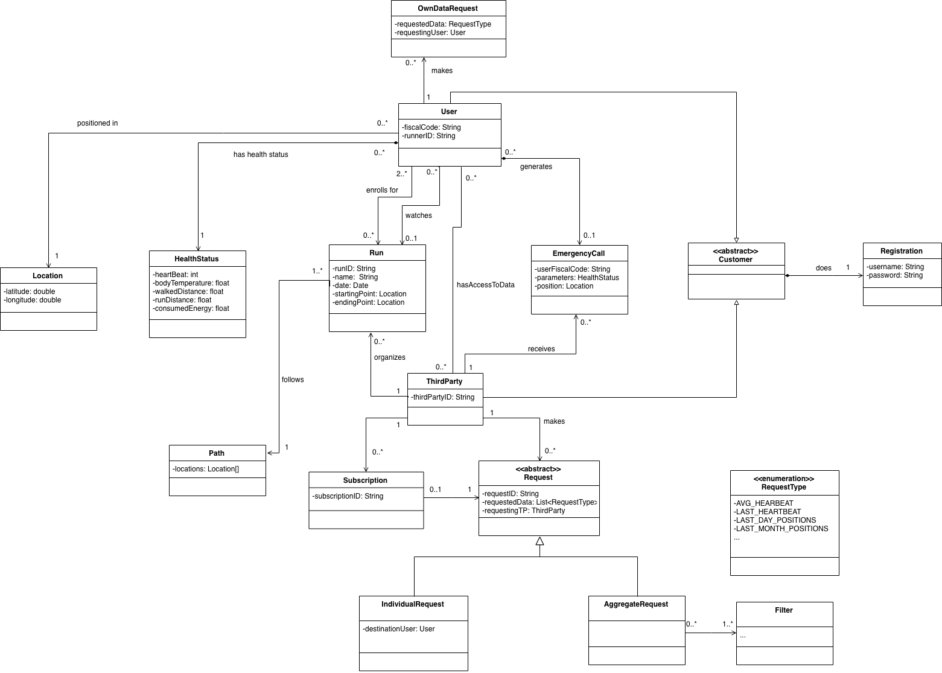

Figure 12 – Class diagram

In the User class the *runnerID* attribute will be set to null if the User is not participating to a Run.

It may be useful to underline also that RequestType represents the type of data that is required in a request. For instance, if a third party wants to know the average heartbeat of a person, the attribute requestedData (whose type is a list of RequestType) of the Request instance will contain only AVG_HEARTBEAT. Of course, the type of data requested may also simply be a last measurement (for example, the last measured heartbeat of a user).

Then, it’s important to note that the Filter class represents the filter of the data requested in an aggregate request. For example, a third party may want some kind of data about all the people younger than 50, in that case there will be a Filter, associated to that AggregateRequest, which express the constraint “younger than 50”.

Finally, as it can be noticed, every subscription is associated with exactly one request, this represents the fact that when a request (individual or aggregate) is successfully done, the third party has the possibility to do a subscription associated exactly to that request, this means that the same Filters (in case of an aggregate request), RequestType, User (in case of an individual request), and ThirdParty characterizing the request will also characterize the subscription. A request instead can be associated to at most one subscription because of the fact that, even if two different third parties do the same request (for example an individual request to the same user with the same RequestType) and therefore do a subscription associated to that, there will necessarily be two different instances of Request, because of the presence of requestingTP attribute, and therefore two different instances of Subscription. This was a choice, as it was thought that associating a request to at most one subscription may result a more ordinated way to model the problem.

2.6 Selected architectural styles and patterns

**RESTful architecture**

To develop the application we decided to use a RESTful architecture, with the goal to reduce the coupling among client and server components as much as possible in mind and also because the centralization of data plays an important role. Moreover, it fits very well for the scope since we are dealing with an application with many clients, on which we don’t have control, while on the contrary we have it on the server and we may want to be able to update it regularly, without touching the client software.

Using a RESTful architecture inevitably leads to an adoption of the following constraints:

* Uniform interface: the goal is to have a common approach to access the resources, so that being familiar with one API means being familiar with all the other APIs.
* Client-server: client and server are two different entities, which evolve separately without any dependency.
* Stateless: the client is responsible for managing the state of the application and this entails a simpler server design: e.g. if a client dies during the communication, the system does not need to clean up the server’s state.
* Cacheable: this allows to avoid some interactions between the client and the server, speeding up the communication.
* Layered system: the advantages of this choice are better described later, but substantially this allows to have a more flexible architecture and also to handle the security of the system, by inserting firewalls and proxies.

Concerning the client-server architecture, the third party will use the appropriate web app, which communicates with the web server, which in turn communicates with the application server. The user, instead, will use the mobile application to access directly the application server.

Finally, the application server acts like a client, querying the database server.

All the communication in question exploit the HTTP protocol, using TSL when dealing with sensitive data in order to guarantee the security and the reliability of the connection and also to authenticate the identity of the communicating parties. Regarding the format in which the data are transmitted, JSON is used because it is suitable for the data interchange between client and server and, despite its simplicity, it is enough to satisfy our purposes.

**Three Tier Client-Server**

A multilayered architecture is a client-server architecture in which presentation, application and data access functions are physically separated.

We choose a multitier architecture because it allows to decouple the complexity of the system, making it more flexible and reusable. Indeed, the developers acquire the power of modifying or adding specific layers without disrupting the entire application. Moreover, this kind of architecture allows to separate completely the access to data from the layer where the logic for presentation and for the interaction with the customers is located: this is very important to make the system safer since the treated information are sensitive data.

More precisely, we adopted a three tier architecture, composed of a Presentation (P) tier, an application (A) tier and a data access (D) tier: the mentioned separation between the clients and the data is possible thanks to the A tier.

**Model View Controller (MVC)**

MVC is one of the most quoted design pattern, which separates an application into multiple layers of functionalities: the model, the controller and the view. This is done in order to split the internal representation of information from the ways that information is presented to the user.

We decided to use this pattern in order to guarantee the reusability of code and also to promote a parallel development as much as possible.

MVC, indeed, with the separation of concerns allows flexibility and opens up the doors to other design approaches, which without it would be difficult to use.

In our case, the clients represent the front-end, i.e. the view, that interact with the controller, through which the information flows to and from the database, namely, the model.

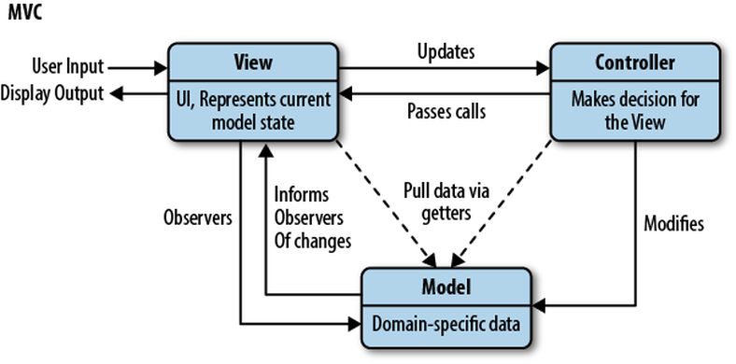

Figure 13 - MVC pattern

2.7 Other design decisions

**Thin client**

A thin client is characterized by the fact that it is primarily designed to communicate with a server: its features are produced by servers.

We opted for a thin client to maintain the line of thought underlined till now. Indeed, this allows us to have an architecture in which the real business logic is implemented on the server. However, we decided not to rely on external services to collect the data necessary to provide the application’s services, but instead we chose to implement some logic to collect the data client-side. For this reason, our client does not really respect the thin client paradigm: it could be considered a hybrid version, since little pieces of business logic reside on the client side. Also the Google Maps API, for example, are exploited internally to the client when the service which allows to watch a run and visualize the runners in real time on the map is in use; another example is the fact that the controls about the health parameters of a user to check if they are out of the determined thresholds are made on the client side. These choices have been taken to avoid to overload the server.

This choice has also another big advantage: thin clients are strictly dependent on a network connection, and in our case this is not an issue, since the application was conceived to operate most of the time online. Nevertheless, especially with mobile devices, it could happen that the network connection is not available, so it is extremely important to guarantee to the users the possibility to use at least some of the offered services offline.

**Relational database**

Relational databases are a good choice when there is the need to deal with several transactions and when the data are linked by some relationships (users, third parties, runs etc.). This fits for our purposes, which can be catalogued as data analysis, and, even if for some reasons (ex: the huge collection of data) a non-relational database would be more performing, a relational one has been chosen because it is necessary to create complex and dependent data structures and use a very expressive and known query language as SQL.

1. User interface design

The mockups of the application were already exposed in the RASD document in the appropriate section 3.1.1.

Here we present some UX diagrams to show the flow which the Customer will follow to navigate inside the application, in accordance with the mockups contained in the RASD. Regarding this fact, to avoid misunderstandings, it’s important to underline that in the following diagrams a few windows have been added to make the flow more complete, e.g. the ‘Startup Page’ screen, from which the customer can login or sign up, which does not appear in the RASD. On the other hand, some other windows are not shown neither here nor in the RASD, because they were not taken into account since the beginning.

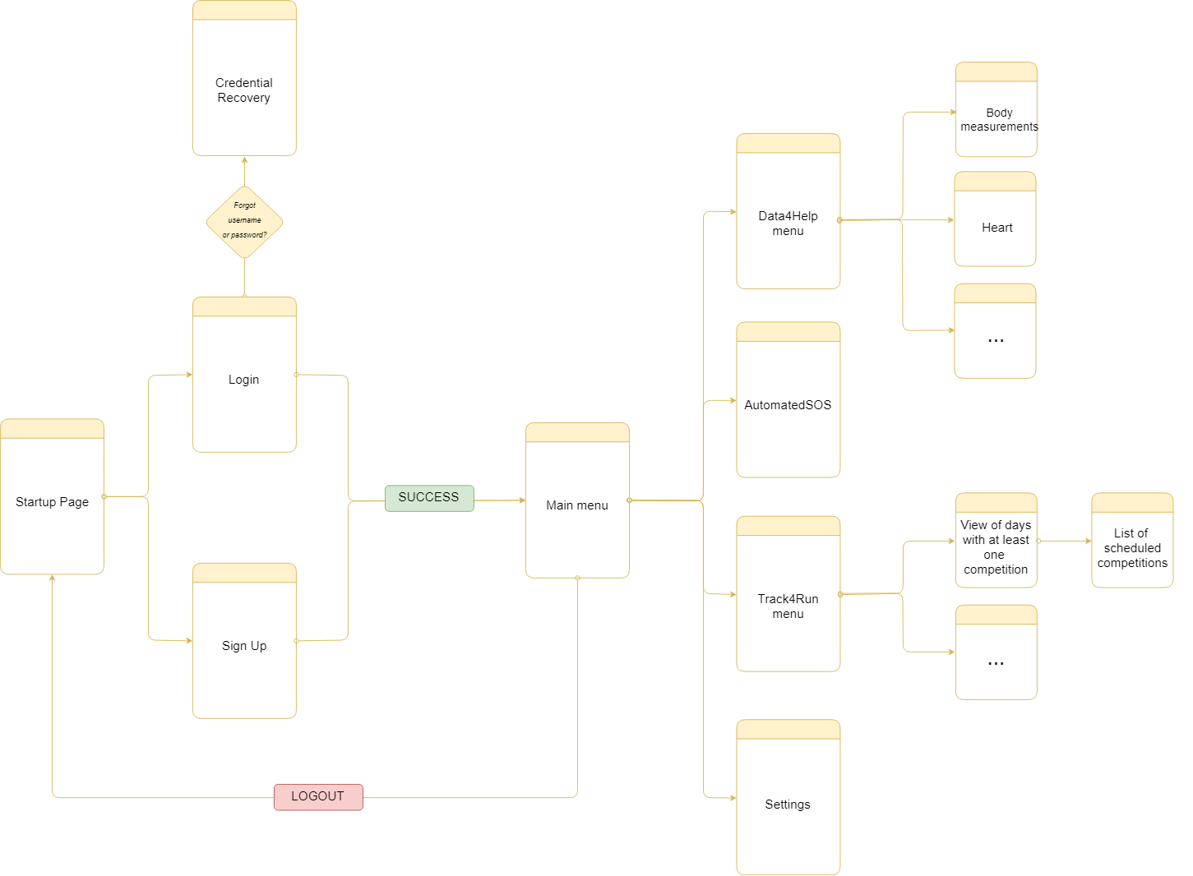

Figure 14 – UX diagram - User

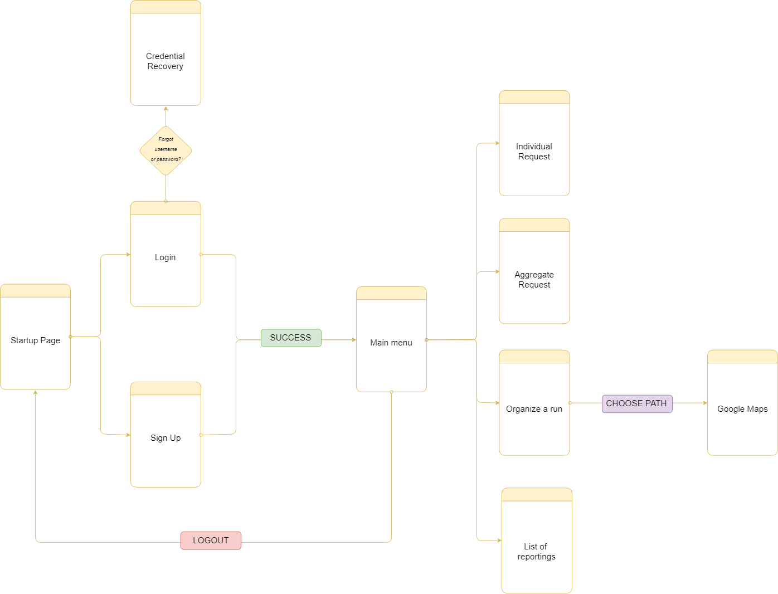

Figure 15 – UX diagram – Third Party

1. Requirements Traceability

The whole design has been thought to guarantee that the system is able to enforce the requirements defined in the RASD (and, as a consequence, to achieve the prefixed goals). Here a mapping between those requirements and the design components in the application server that will ensure their fulfillment in a direct way (some other components that are indirectly needed to enforce some requirements are not mentioned in the list, but their role has been made clear through some comment) is shown:

* **R1**: The system must save the collected data of users registered to Data4Help in real time.
  + **DataCollectionManager:** this component manages to save the received data in the database in a correct way.
* **R2**: The system has to allow the third party that wants to retrieve some data to choose between an individual request or an aggregate one.
  + **RequestManager:** manages both individual and aggregate requests, it is able to distinguish the choice made by the third party on the ‘ThirdPartyWebApp’.
* **R3**: In case of a query for data of an individual the system has to ask to the third party the individual’s fiscal code.
  + **RequestManager:** contains the logic about individual requests, it retrieves the data of the right user thanks to his fiscal code. The fiscal code field is shown client-side through the ‘ThirdPartyWebApp’.
* **R4**: In case of a query for aggregate data the system has to ask to the third party which parameters to use to filter data.
  + **RequestManager:** contains the logic about aggregate requests, it retrieves the correct data exploiting the filters provided. The filters are inserted client-side through the ‘ThirdPartyWebApp’.
* **R5**: When a request for a specific individual’s data is made the system must allow the individual to accept the request or not.
  + **NotificationManager**: sends to the user a push notification with the information about the request that has been made and that is provided by the ‘RequestManager’.
  + **ResponseManager**: handles the user’s answer allowing him to accept or refuse the request.
* **R6**: When a request for data is approved the system has to make the previously saved data available to the third party.
  + **RequestManager**: in case of a positive answer by the system (for both individual and aggregate requests), sends the data to the requesting third party.
* **R7**: The system must provide to the third party the possibility to subscribe to new data and receive them as soon as they are produced both for individuals and for groups of individuals.
  + **SubscriptionManager**: handles the subscription requests, the response of the interested user (in case of individual subscription) and it sends the new data (that are forwarded by the ‘DataCollectionManager’) as soon as they are produced to the third party that has done a successful subscription.
* **R8**: The system must allow the user to accept or refuse a possible request for subscription by a third party.
  + **ResponseManager**: it handles the user’s answer allowing him to accept or refuse the request of subscription.
  + **NotificationManager**: it sends to the user a push notification with the information about the request of subscription that has been made (and forwarded by the ‘SubscriptionManager’).
* **R9**: The requests by third parties on aggregate data must provide them if and only if the number of individuals whose data satisfy the request is higher than 1000.
  + **RequestManager:** it contains the logic to make privacy controls on the requested data and provides them to the requesting third party if, and only if, the controls are passed.
* **R10**: When the number of users satisfying an aggregate request (for which a subscription was made) becomes less than 1000 the subscription is automatically canceled until the matching users become again more than or equal to 1000.
  + **SubscriptionManager:** it controls that the privacy controls are passed for subscriptions to data of groups of individuals and provides new data as soon as they are produced only in that case.
* **R11**: The system must allow the User to analyze its own data and stats providing him a way to access to all registered data and stats and giving him the possibility to consult both their aggregate (ex: daily average) values and precise measurements.
  + **UserDataVisualizationManager:** provides the requested data and stats requested by the user.
* **R12**: The application, if AutomatedSOS is activated, must send the user’s health parameters and location to the third party that is the nearest to him as soon as it is detected that his parameters are out of the defined bounds.
  + **SOSManager**: handles the SOS call and sends it to the ThirdParty providing the AutomatedSOS service that is closer to the user. The problem is detected client-side: it is the ‘UserSmartwatchApp’ that has to analyze user’s data and control if they are in the defined bounds or not.
  + **NotificationManager**: it is concerned in sending the SOS message to the third party chosen by the ‘SOSManager’.
* **R13**: The system has to allow third parties that have activated the Track4Run service to schedule a run providing name, starting and ending point coordinates, the path, the date and time of the competition and the maximum number of participants.
  + **RunOrganizationManager**: handles the interaction with the third party that wills to organize a run competition.
* **R14**: The system has to allow users who have activated the Track4Run service to enroll for an organized run showing them the organized competitions on a calendar.
  + **EnrollmentManager**: handles the users’ requests of enrollment.
* **R15**: The system has to allow users who have activated the Track4Run service to follow the development of a run selecting an ongoing competition from a list that identifies runs by their name.
  + **RunWatchingManager**: contains all the business logic to allow users willing to watch a chosen competition to follow it on a map through their mobile application. The data needed to provide this function come from the ‘DataCollectionManager’.

It is worth noting that in the provided mapping the ‘Router’ components are not mentioned for the sake of simplicity, but they are directly or indirectly connected to the fulfillment of the system functionalities because they route to the right component every message coming from the client’s side (except for the ones handled by the ‘ResponseManager’): the interfaces exposed by the application server are the ones provided by the three ‘Router’ components.

1. Implementation, integration and test plan

The system is divided in various subsystems:

* UserMobileApp
* UserSmartwatchApp
* ThirdPartyWebApp
* WebServerWebApp
* ApplicationServer
* External systems: DBMS, GoogleMaps

These subsystems will be implemented, but also tested and integrated exploiting a bottom-up strategy, but considering also the importance of the various functionalities and trying to provide at each step of the plan a visible application feature. The components building the same subsystems will be implemented, integrated and tested for each subsystem and the integration and testing of the different subsystems will take place at a later stage (here we will focus only on the ApplicationServer subsystem). It is worth to notice that the external systems’ components need not to be implemented and tested just because they are external and they can be considered reliable.

A table that lists the main features available for a TrackMe customer, their importance and implementation difficulty is shown below to better understand the decisions about implementation, testing and integration that will be taken in the rest of this section.

|  |  |  |
| --- | --- | --- |
| Feature | Importance for the customer | Difficulty of implementation |
| Sign up and login | Low | Low |
| Visualize personal data and stats | High | Medium |
| Request data of an individual or of a group of individuals | High | High |
| Subscription to data of an individual or of a group of individuals | Medium | High |
| Handling of emergency calls | High | Medium |
| Organization of run competitions | High | Medium |
| Enrollment for run competitions | High | Low |
| Watching a competition in live mode | Medium | Medium |

It’s important to stress that the Data4Help functionalities have to be implemented, tested and integrated as a first step: the other services (AutomatedSOS and Track4Run) rely on them, they are built on top of Data4Help.

For this reason and looking at the table that maps the features on their relevance for the customer and their overall complexity, the components have to be implemented and tested (unit tests have always to be performed for each component in parallel with its implementation) with the following order for what concerns the ApplicationServer:

* **Request data of an individual or of a group of individuals**: for this feature it is necessary to implement and produce unit tests on the ‘DataCollectionManager’, the needed parts of the ‘RequestManager’, of the ‘ResponseManager’ and of the ‘NotificationManager’ following a bottom-up approach (starting from the leaves of the ‘uses’ hierarchy: the ‘ResponseManager’ uses the ‘DataCollectionManager’ and the ‘DataCollectionManager’ uses the ‘NotificationManager’ while the ‘DataCollectionManager’ is independent from them). Then, to provide this functionality, the ‘RequestManager’ has to be integrated with the ‘NotificationManager’ in order to notify a customer about a request and also with the ‘ResponseManager’ to handle in a correct way the customer’s answer: the interaction with these two modules have to be tested.
* **Visualize personal data and stats**: this is another core function of the system and to achieve it the ‘UserDataVisualizationManager’ has to be fully implemented and tested.
* **Subscription to data of an individual or of a group of individuals:** to provide this function the ‘SubscriptionManger’ must be implemented, unit-tested and properly integrated with ‘DataCollectionManager’ to allow the third party to receive the data in case of a successful subscription and with ‘NotificationManager’ and ‘ResponseManager’ to forward messages to and from the clients-side. So, before this integration, the implementation and unit testing of the components with which the ‘SubscriptionManager’ has to be integrated with must continue (the missing parts have to be added) following the described bottom-up approach to guarantee a correct behaviour.
* **Sign up and login:** the sign up and login features are obviously an entry condition for the right functioning of the system, but they are not core features and they are not very complex, so the ‘SignUpManager’ and ‘LoginManger’ components must be implemented and tested in any order (they are independent components) only at this point to complete the Data4Help functioning.
* **Handling of emergency calls**: this feature is more critical than the ones related to Track4Run, so the ‘SOSManager’ must be implemented and unit-tested before them. A proper integration with the ‘NotificationManager’ is then necessary to guarantee that the SOS message is sent to the third party. So, the code that has to be added to the ‘NotificationManager’ for this integration must be implemented and unit-tested before the integration tests with ‘SOSManager’ always following the described bottom-up approach (it is the ‘SOSManager’ that ‘uses’ the ‘NotificationManager’).
* **Organization of run competitions**: this is the core functionality of Track4Run service, so the ‘RunOrganizationManager’ must be implemented and tested at this point.
* **Enrollment to run competitions**: to guarantee this feature the ‘EnrollmentManager’ must be implemented, unit-tested and integrated with the ‘NotificationManager’ and the missing code parts have to be previously added to the ‘NotificationManager’ for this reason. Again, the usual bottom-up approach must be followed to define the order of implementation and testing between these two dependent components following the ‘uses’ hierarchy (it is the ‘EnrollmentManager’ that ‘uses’ the ‘NotificationManager’).
* **Watching a competition in live mode**: this feature is provided thanks to the ‘RunWatchingManager’, so this component must be implemented and unit-tested at this point and a correct integration with the ‘NotificationManager’ must be performed and tested. So, again, before the integration tests, to follow the defined bottom-up approach, the missing part of code for the integration has to be added to the ‘NotificationManager’ and unit tests must be performed for it (it is the ‘RunWatchinManager’ that ‘uses’ the ‘NotificationManager’).

Finally, the ‘Router’ component has to be implemented and unit-tested and then its integration with the rest of the components in the application server must be performed: this component has only to redirect the clients’ requests and messages and it has no very interesting business logic, although it is obviously a fundamental component for the right behavior of the system: this is why it is implemented and tested only at the end (furthermore it is on top of all the other components, because it ‘uses’ almost all the present interfaces).

It is important that the verification and validation phases start as soon as the development of the system begins in order to find errors as quickly as possible. As mentioned, the program testing to find bugs has to proceed in parallel with the implementation: unit testing has to be performed on the individual components and, as soon as the first (partial) versions of two components that have to be integrated is implemented, the integration is performed and tested: we perform integration in an incremental way to facilitate bug tracking. Moreover, scaffolding techniques must be used when needed.

Since the TrackMe system is a relatively small system, the chosen integration technique is a structural one: bottom-up approach is followed, but taking into account that Data4Help has to be implemented and tested before the other services for the reasons explained before (the same argument holds for the most important features of each offered service).

Once the system is completely integrated, it must be tested as a whole to verify that functional and non-functional requirements hold, in particular, besides load and stress testing, performance testing has a crucial role: it helps identifying bottlenecks that affects response time and this is very critical for the AutomatedSOS’ requirements; it is concerned in identifying query optimization possibilities and this is also very important since the amount of data handled by the system is very large and therefore the interaction with the database is heavy.

5.1 Component integration

In the following diagrams we are going to show which components will go through the process of integration for a further clarification. The arrows start from the component which uses the other one.

**Integration of the internal components of the Application Server**

All the components are implemented and unit tested. Subsequently some components are integrated and the integration is tested as well.

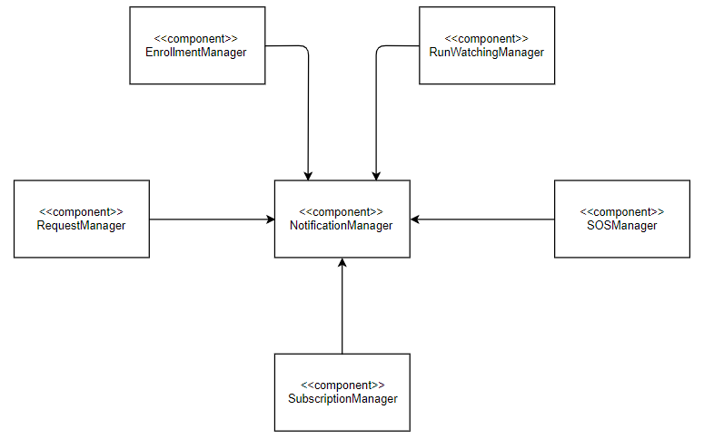

Figure 16 - Notification Manager integration

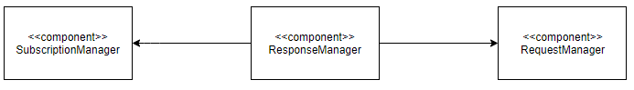

Figure 17 - Response Manager integration

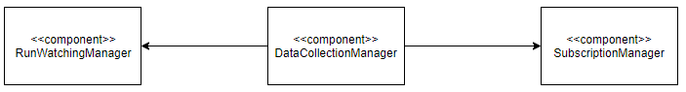

Figure 18 - Data Collection Manager integration

**Integration of the frontend with the backend**

The integration (and testing) between the frontend and the backend happens only once all the components of the respective parts have been implemented and tested.

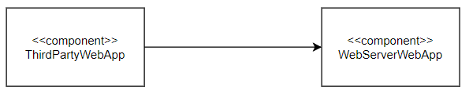

Figure 19 - Third Party Web App – WebServerWebApp integration

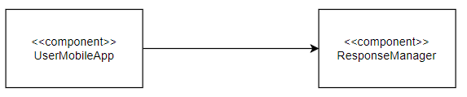

Figure 20 - UserMobileApp – ResponseManager integration

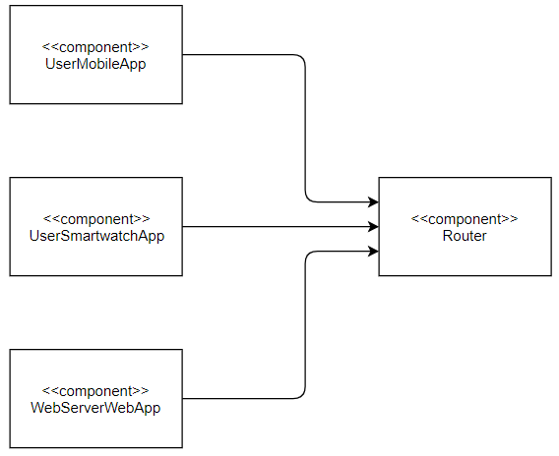

Figure 21 – Router integration

**Integration with the external services**

The integration with the external services is done after all the needed components have been implemented and unit tested.

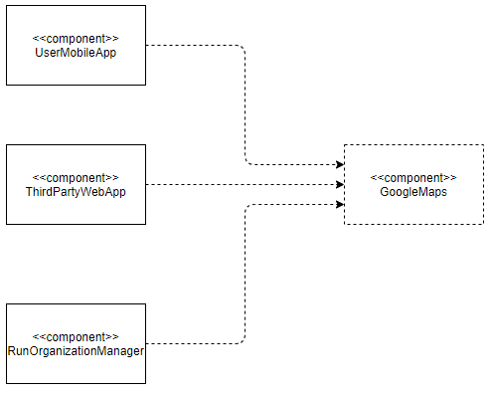

Figure 22 - Google Maps integration

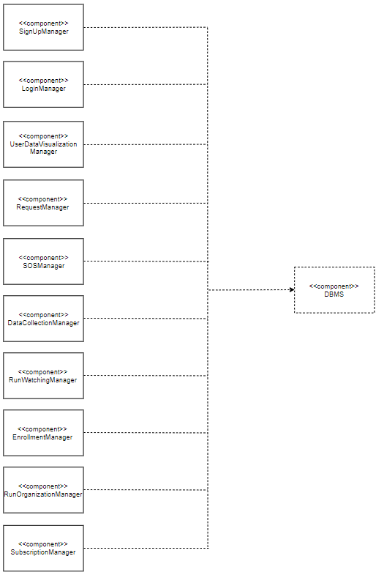

Figure 23 – DBMS integration

1. Effort spent

**Emilio Imperiali**

|  |  |
| --- | --- |
| **Description of the task** | **Hours** |
| Introduction | 0.5 |
| Architectural design | 48 |
| Requirements traceability | 1 |
| Implementation, integration and test plan | 2 |

**Giorgio Labate**

|  |  |
| --- | --- |
| **Description of the task** | **Hours** |
| Introduction | 1 |
| Architectural design | 43 |
| Requirements traceability | 5 |
| Implementation, integration and test plan | 7.5 |

**Mattia Mancassola**

|  |  |
| --- | --- |
| **Description of the task** | **Hours** |
| Introduction | 0.5 |
| Architectural design | 26 |
| Requirements traceability | 2 |
| Implementation, integration and test plan | 5 |