**XAVIER UNIVERSITY – ATENEO DE CAGAYAN**

**COLLEGE OF COMPUTER STUDIES DEPARTMENT OF INFORMATION TECHNOLOGY**



Xavier University Athletics Office Reservation System

Submitted by:

Emilio Rafael A. Rubio Brett Rainiel Espiritu Nathaniel R. Enguio Karlos Miguel R. Hiponia Franz Nicholas Fortunado

ITCC 15.1 B

April 24, 2025

# Introduction

The UAO Reservation System is a web-based application developed to streamline the process of booking sports and event facilities at Xavier University. Currently, reservations are managed manually, resulting in scheduling conflicts, inefficiencies, and communication delays. This project aims to address these issues by developing a centralized, real-time reservation platform that allows students, guests, and staff to view availability and make bookings easily and securely.

The mission of the XUAO reservation system is to provide an efficient and user-friendly reservation system that enhances facility access and resource management at Xavier University.

The vision is to become a model institution in modernizing facility management through accessible, secure, and fully automated systems that benefit both users and administrators.

The goals of the enterprise include Implement a User Authentication System, Develop a Real-Time Facility Reservation System and Integrate a Conflict-Free Scheduling Mechanism.

This project is important because it helps fix the common problems with how facility bookings are currently done. Right now, the process is manual, which often leads to mistakes, delays, and confusion. By creating an easy-to-use online reservation system, we can avoid double bookings, save time, and make the whole process smoother for everyone. Students and staff will be able to check availability and make bookings anytime, while administrators can manage everything more easily.

# Problem Statement and Objectives

The current manual process of reserving facilities at Xavier University is inefficient and often leads to issues such as double bookings, unclear schedules, and time-consuming coordination between users and staff. These challenges cause delays, increase the workload for users and administrators, and reduce overall user satisfaction. In addition, the absence of an automated system makes it difficult to manage changes, track usage, or generate useful reports for planning purposes.

Goals and objectives:

* Implement a secure login system with different access levels for users and administrators.
* Create an interactive calendar that shows real-time availability and allows easy booking.
* Develop a feature that prevents overlapping or conflicting reservations.
* Set up automated notifications to confirm bookings and remind users.

The target users of the UAO Reservation System include students, athletes, guests, and administrators who are directly involved in the booking and management of university facilities.

# Requirement Specifications Functional Requirements

1. Submit reservation requests for sports facilities, including gymnasium, covered court, field, and table tennis dug-out with facility availability check.
   1. Input: Facility name, date of use, start time, end time, organizer name, contact number, event type, number of participants (insiders and outsiders), additional equipment and manpower requested.
   2. Output: Confirmation message and pending reservation record if the facility is available; error message if already booked.
2. Update or cancel submitted reservations before approval.
   1. Input: Reservation ID, updated reservation details (date, time, facility, etc.) or cancellation request.
   2. Output: Confirmation message with updated reservation record or cancellation notice.
3. View list of reserved facilities and reservation statuses (approved, pending, rejected).
   1. Input: User ID (to view user-specific reservations) or admin access credentials (to view all reservations).
   2. Output: List of reservation records with details and current statuses.
4. Approve or reject reservation requests by the administrator.
   1. Input: Reservation ID, admin decision (approve/reject), optional admin remarks.
   2. Output: Updated reservation status (approved/rejected) and notification sent to the user.

# Non-Functional Requirements

|  |  |
| --- | --- |
| Performance | Response time: User interactions must be processed within 200 milliseconds; page loads within 2 seconds.  Scalability: The system must support increased users and transactions through horizontal or vertical scaling.  Load handling: The system must remain stable under peak load conditions without crashing or significant delays. |
| Security | Data encryption: All sensitive data must be encrypted both in transit (HTTPS) and at rest (AES encryption).  Authentication: Secure user authentication must be implemented (e.g., two-factor authentication or single sign-on).  Access control: Role-based access control (RBAC) must ensure users access only authorized data and actions.  Secure coding practices: The system must prevent common vulnerabilities such as SQL injection and cross-site scripting (XSS) through proper input validation and error handling. |

|  |  |
| --- | --- |
| Usability | Intuitive user interface (UI): The interface must be easy to navigate, allowing efficient task completion.  Responsiveness: The application must display correctly and consistently across different devices, screen sizes, and browsers.  Accessibility: The system must comply with Web Content Accessibility Guidelines (WCAG) to support users with disabilities. |

**Architectural Frameworks**

1. Application of the Zachman Framework
   1. Identification of key perspectives (Planner, Owner, Designer, etc.): Identify the stakeholders who will be involved in the project and their roles. \
      * Planner – Uao Staff, Students
      * Owner – Uao Staff
      * Designer – System Designer, Database Engineer
      * Builder – Developers (Frontend, Backend), Db Admins
      * Subcontractor – Programmers, Testers
      * User – Students, Uao Personnel, Guests
   2. Addressing the 6x6 matrix (What, How, Where, Who, When, Why): Describe how the project addresses the six aspects of the Zachman Framework for each perspective. In this section, you are to provide the context, conceptual, and logical perspectives in the 6x6 table.

|  |  |  |  |
| --- | --- | --- | --- |
| Zachman Aspect | Planner (Contextual) – Admin | Owner (Conceptual) – Facility Manager | Designer (Logical) – Systems Architect |

|  |  |  |  |
| --- | --- | --- | --- |
| What (Data) | List Of Facilities & Rooms | Facility Types, Booking Schedules | Tables: Users, Facilities, Bookings |
| How (Function) | Reservation Workflow | Booking Process (Check, Confirm, Notify) | Restful Api For Booking Logic |
| Where (Network) | Xavier University (Campus Scope) | Web App (Accessible Online) | Hosted On Cloud Server |
| Who (People) | Admins, Students, Staff | Users: Students/Guests, Managers | Roles: Admin, User, Superuser |
| When (Time) | Term-Based Calendar Planning | Daily/Hourly Schedule Access | Cron Jobs For Notifications, Db Timestamps |
| Why (Motivation) | Improve Efficiency, Modernize System | Eliminate Double Bookings | Meet Security, Usability, And Scalability Needs |

1. **(AS-IS)** TOGAF Architecture Layers (include illustration using ArchiMate)

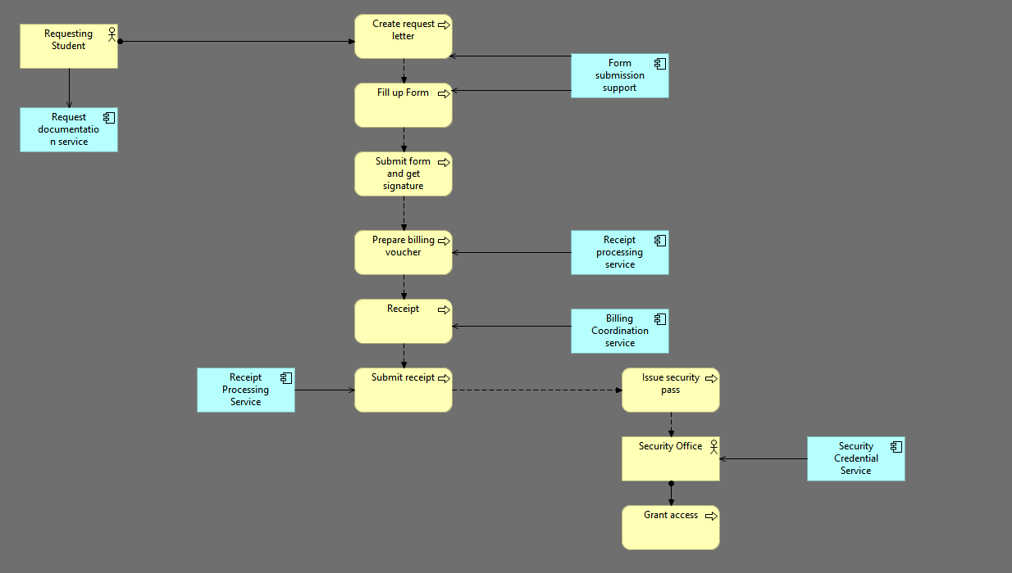

## Business Architecture: Describe the business processes, organization, and strategy related to the project.

The procedure is entirely manual and includes a student asking for documents, filling out forms, handling payments, and securing access through the Security Office. Manual handling is used for business services such as form submission and receipt processing.

## Data Architecture: Describe the data entities, relationships, and storage mechanisms.

All information is in paper form—request letters, billing vouchers, receipts, and security passes are manually generated, signed, and delivered physically.

## Application Architecture: Describe the software components, interfaces, and interactions.

No real software programs are utilized. Services are conducted manually, yet they indicate possible future automation opportunities such as form processing, receipt validation

## Technology Architecture: Describe the hardware, network, and infrastructure supporting the system.

There is no digital infrastructure. The whole procedure functions without computers, networks, or electronic devices.

## (TO-BE) Proposed SOLUTION ARCHITECTURE

1. **High-level architecture: Provide a high-level overview of the proposed (target) solution architecture, including major components and their interactions. The solution architecture should be based on the baseline (as-is) architecture utilizing ArchiMate. It should reflect the integration solution encompassing all layers of the enterprise architecture.**

The proposed system consists of a front-end user interface for reservation and administration. The backend handles user registration, verification, and administration. The deployment will be on a cloud-based platform with a web server and database. Supports automated email notifications.

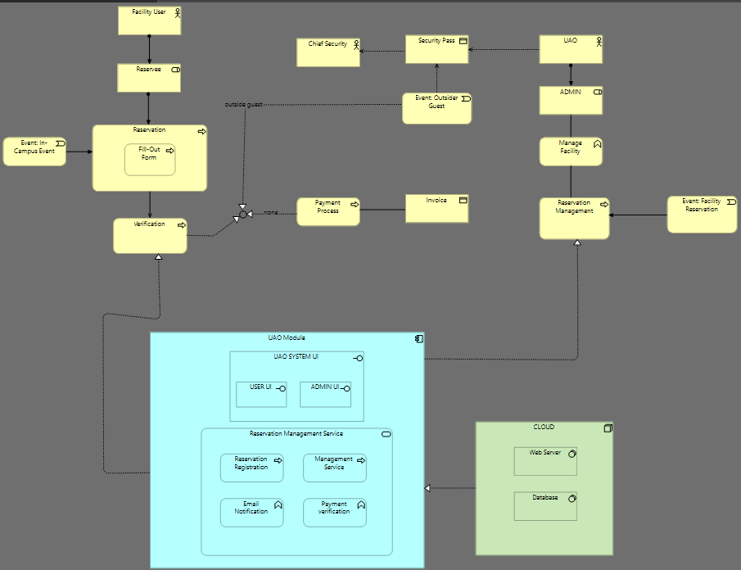

1. Main components and their roles: Describe the main components of the system and their responsibilities.
   * Facility user: Reserves an on-campus event using the system UI
   * UAO/ADMIN: Administer, manage reservations, and issue security passes for outsiders
   * Chief Security: Receives the security to allow an outsider guest.
   * UAO UI: Front end for both users and admins to interact with the system
   * Reservation Management service: The core backend for registration, reservation, email notification, and administration.
   * Payment process: Facility users upload an invoice for the admin to verify.\
   * Security pass: Issued when they are an outsider guest

# Technologies and Tools

## Technologies, frameworks, and languages: List the specific technologies, frameworks, and programming languages that will be used in the project.

The project will utilize HTML, CSS, and JavaScript for the front-end interface, Django for the back-end, and MongoDB for the database. Django REST Framework will also be used for building and managing APIs.

## Development tools and environment: Describe the tools and environment that will be used for development, such as IDEs, version control systems, or project management tools. Each group shall be provided with a GitHub repository which can be used also for project collaboration.

The development environment will include Visual Studio Code as the Integrated Development Environment, Git for version control, and GitHub for collaboration and repository management.

## Rationale for choices: Explain the reasons behind the chosen technologies and tools, including their benefits and suitability for the project.

Django was chosen for its rapid development capabilities, built-in authentication, and security features, which are well-suited for a reservation system. MongoDB offers a flexible and scalable database solution that efficiently manages user and reservation data. HTML, CSS, and JavaScript provide the foundational tools for creating a responsive and user-friendly interface. Git and GitHub support collaborative development and version control, essential for team coordination.

# Project Plan

1. Timeline and milestones: Provide a high-level project timeline, including milestones and deadlines for each stage of the project.

The project will follow a structured timeline to ensure organized and efficient development. During Week 1 to 2, the team will focus on Project Planning, establishing objectives, scope, and initial strategies. Week 3 to 4 will be dedicated to Requirements Gathering, where the team will identify and document user needs, system features, and functional requirements. In Week 5 to 6, the team will work on Mock-up Design, creating interface prototypes and visual layouts to guide frontend development. Week 7 to 10 will involve Frontend Development, where the user interface will be built using web technologies like HTML, CSS, and JavaScript. From Week 11 to 13, the focus will shift to Backend

Development, implementing the system logic and database integration using Django and MongoDB. Week 14 to 15 will cover Integration Testing, ensuring that all modules function correctly together and meet the system requirements. Finally, Week 16 to 17 will be allocated for Deployment.

1. Division of tasks (if applicable): Describe the division of tasks and responsibilities among team members.

For the project, the primary function of each team member is full-stack development, with each member responsible for at least one integration module in the proposed system. Emilio Rafael A. Rubio is in charge of the Authentication Module, tasked with implementing a secure login system and role-based access control using Django’s built-in authentication framework. Brett Rainiel Espiritu is responsible for the Reservation Interface Module, focusing on the development of the interactive calendar and user interface for checking facility availability and submitting reservations. Nathaniel R. Enguio will handle the Scheduling Conflict Detection Module, developing the logic to prevent overlapping bookings through real-time validation and database queries. Karlos Miguel R. Hiponia is assigned the Notification Module, integrating automated email and SMS alerts for booking confirmations, updates, and reminders. In addition to their individual roles, all members will collaborate on testing, debugging, and system deployment to ensure the UAO Reservation System is reliable, efficient, and user-friendly.

# Conclusion

## Summary: Summarize the main points of the proposal, reiterating the problem statement, objectives, and proposed solution.

In conclusion, the UAO Reservation System is designed to modernize and streamline the process of booking sports and event facilities at Xavier University. By addressing the inefficiencies of the current manual system, the project aims to provide a secure, user-friendly, and real-time online platform. The system will include essential features such as role-based authentication, an interactive calendar, conflict-free scheduling, automated notifications, and centralized data management.

## Expected challenges and solutions: Briefly discuss any anticipated challenges and potential solutions.

Anticipated challenges include managing real-time conflict detection, ensuring system scalability as user demand increases, and maintaining data security and privacy. To address these, the team will implement validation and scheduling logic, use scalable cloud infrastructure, and follow secure coding practices, including encryption and access control mechanisms. Integration with external systems or future upgrades may also present difficulties, which will be mitigated through modular architecture and thorough documentation.

## Project impact and importance: Reiterate the potential impact and significance of the project.

The successful implementation of the UAO Reservation System will have a lasting impact on Xavier University’s operational efficiency. It will minimize double bookings, reduce manual workload, and improve communication between users and administrators. By transitioning to a centralized, automated platform, the university not only improves service delivery for students and staff but also sets a benchmark for digital transformation in campus facility management.