**Web dev Reviewer**

**Lesson 1: The Internet**

• It is a global network of interconnected computers, servers, and devices that communicate through standardized protocols, allowing the exchange of information and services worldwide.

• LAN

• WAN

**Client-Server**

-A client is a device or application that requests services or resources, while a server is a device or program that provides those services or resources. They communicate over a network with the client making requests and the server responding to fulfill those requests.

-Servers are machines that hold shared resources and always connected to the network (24/7)

-Client are machines for personal use (laptops, computers, phones, etc.).

**Domain Name System (DNS)**

-Domain Name System is a decentralized hierarchical system that translates human readable domain names (www.xu.edu.ph ) into IP addresses, which are used by computers to identify each other on a network.

**NsLookup.io**

Online tool to find all DNS records for a domain name.

**Submarine Cable Map**

-is a free and regularly uploaded resource from TeleGeography

**Uniform Resource Locator (URL)**

-a complete web address pointing to a specific file on the internet.

**Domain Names**

-Identifies the entity you wan to connect to

xu.edu.ph, google.com, microsoft.com

**Protocols**

HTTP - Hypertext Transfer Protocol

HTTPS - Hypertext Transfer Protocol Secure

FTP - File Transfer Protocol

**IP Address**

-An IP (Internet Protocol) address is a numerical label assigned to each device connected to a computer network that uses the Internet Protocol for communication.

-It serves two main purposes. Identifying the host or network interface and providing the location of the host in the network.

**The Request/Response Cycle**

What happens when you type a URL in the Address Bar?

1. The browser looks up the domain in the DNS

2. The DNS returns the IP address

3. The browser sends an HTTP request to the server located at that address

4. The server finds the requested file and sends it back as a response

5. The browser takes the response and renders the HTML code as a nice graphical representation (repeating steps 3-4 as needed to request images and other supporting files).

It requires multiple rounds of communication between the client and server.

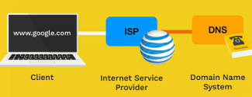

**The Response**

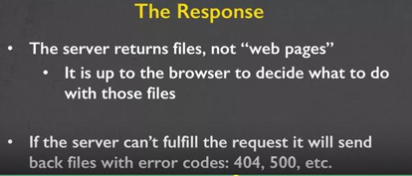

**Code Files**

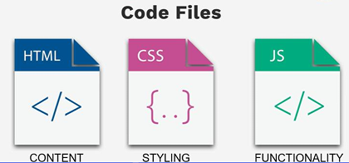

**Browsers**

1. Different browsers have their pros and cons

2. Preferred browsers

3. Test your websites on multiple browsers

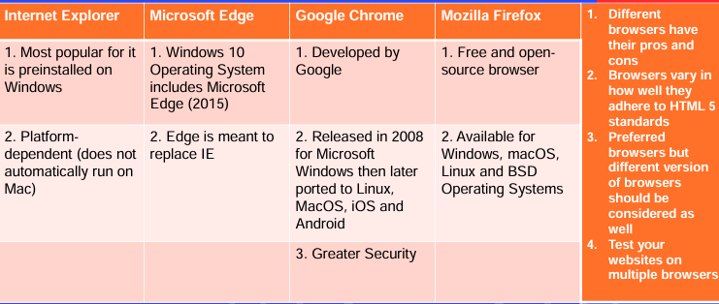

**HTML 5 Accessibility**

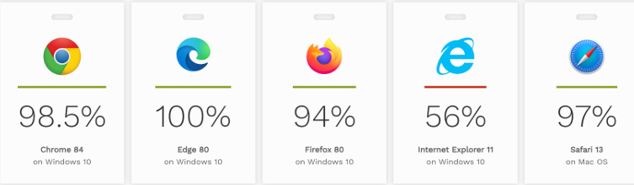

**Using Editor to Create HTML File**

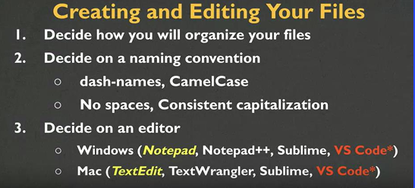

**Lesson 2**

