**Software used:**

Windows 10

Visual studio 2022

DB browser for SQLite

**How to run the project**

Download project and run SocialBrothersBackEndCase.sln file

When visual studio 2022 project is loaded press: tools>>NuGet Package Manager>>Package Manager console

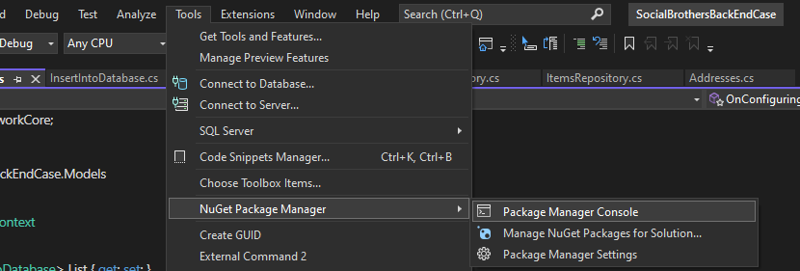

In the console write line:

Update-database

Hit enter

Addresses.db file is spawned in C:\Temp folder

Note: if you have different name for your storage drive you have to edit script inside the project

Models>>Context.cs



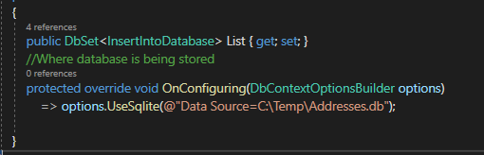

Now we can run the project to fill the database using POST>>execute

We can open addresses.db file in DB browser for SQLite to check the records

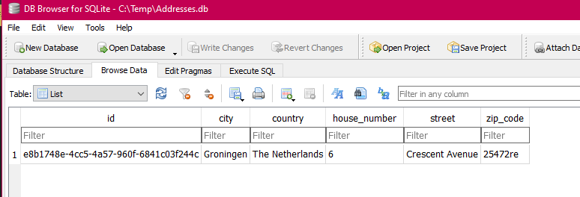

Part 3 in the addresses.cs end google maps api key should be included

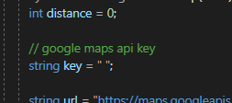

I’m proud of:

Database update method which allows to easily create database from the console without exporting database for project testing

Created Models working properly

GET/addresses/:id

Seems properly working and returns id from the database with or without error exception

POST/addresses

Inserts and saves records into database

DELETE/addresses/:id

Properly deletes record by chosen id

I’m less proud of:

Part 2: Filters

However search is working but it could be more implemented. I’m currently employed and didn’t have enough time to implement all parts.

Also some parts could be more implemented like:

GET/addresses/ should not be firstordefault() but listed and mapped array and give proper not found

error exception

PUT/addresses/:id could have more updatable fields

Addresses strings should be valid addresses and passed to distance calculation instead of writing distance addresses by hand.

If you feel like this is not enough and you are willing to give me more time I would implement everything as neatly as possible