# Homework

## Software Development Models

### Guess which methodology corresponds to the diagram

Below you have 6 diagrams that represent 6 different development models, have a good look and fill your suggestions in the table below.

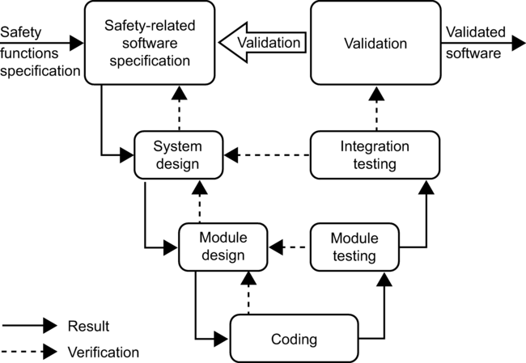

Figure 1

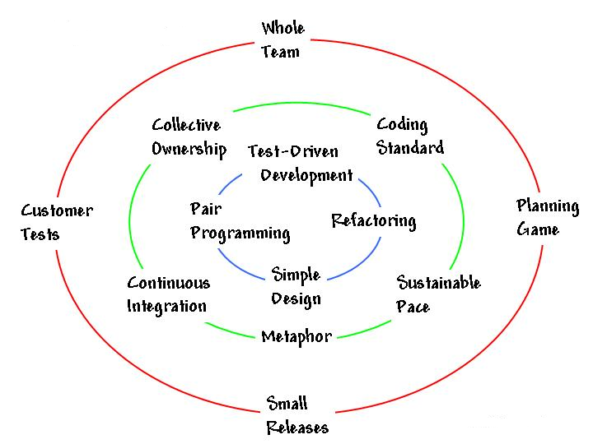

Figure 2

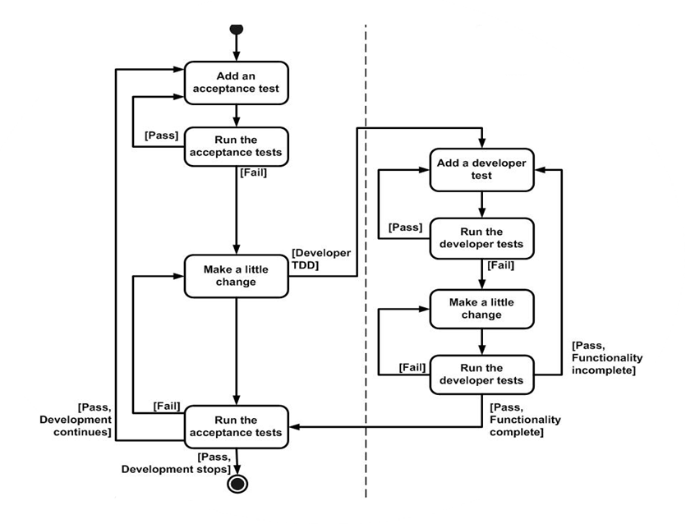

Figure 3

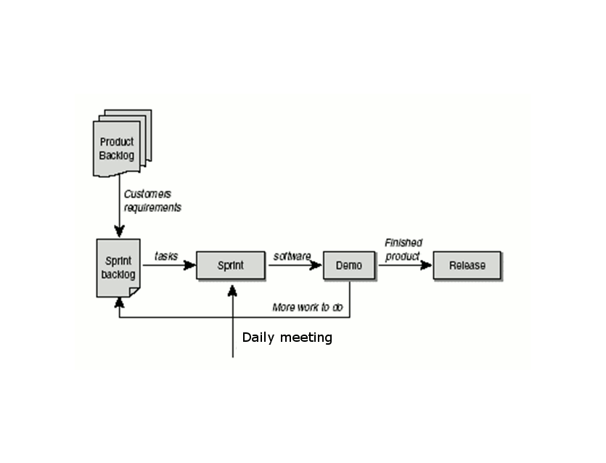

Figure 4

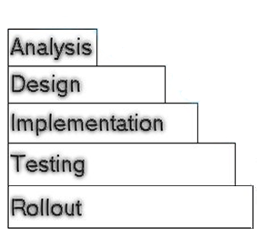

Figure 5

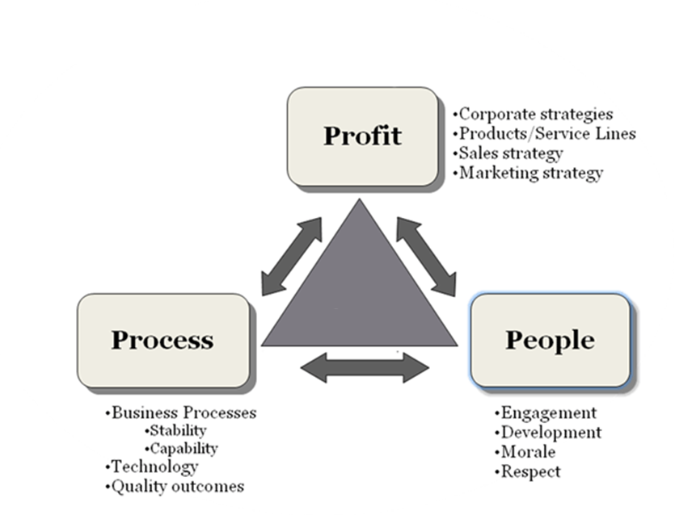

Figure 6

|  |  |
| --- | --- |
| Figure # | Methodology name |
| 1 | **V-model (Sequential Development Model)** |
| 2 | **Agile – Extreme Programming (XP)** |
| 3 | **Test-Driven Development** |
| 4 | **Agile - Scrum** |
| 5 | **Waterfall Development Process** |
| 6 | **3P’s Model** |

*(6 positions X 1 point)* ***6 points***

### Compare the methodologies

Below is a table, where 3 different methodologies are compared. In the first row as a heading you see the names of the methodologies and in the first column there are the aspects of assessment. Your task is to give evaluation of the criteria from the first column by choosing the best suit from the boxes to the right of the table.

~~Required~~/~~Planning and closure only~~

~~Determined during planning/ Set during project~~

~~Determined during planning/ Set during project~~

~~Determined during planning/ Set during project~~

~~Limited – cookbook approach~~/ ~~Unlimited during iterations~~

~~Planning only/ Throughout~~/~~At end of each iteration~~

Low/ Medium/ High

~~Training prior to project~~/ ~~Teamwork during project~~

|  |  |  |  |
| --- | --- | --- | --- |
|  | Waterfall | Iterative | Scrum |
| Defined process | Required | Planning and closure only | Planning and closure only |
| Final product | Determined during planning | Set during project | Set during project |
| Project cost | Determined during planning | Set during project | Set during project |
| Completion date | Determined during planning | Set during project | Set during project |
| Responsiveness to environment | Planning only | At end of each iteration | Throughout |
| Team flexibility, creativity | Limited – cookbook approach | Unlimited during iterations | Unlimited during iterations |
| Knowledge transfer | Training prior to project | Teamwork during project | Teamwork during project |
| Probability of success | Low | High | High |

*(24 positions X 1 point)* ***24 points***

### Which of the following artifacts/ events/ principles/activities belong to the listed methodologies?

|  |  |  |  |
| --- | --- | --- | --- |
| TDD | XP | Lean | Scrum |
| Design before you write your functional code | Pair programming |  | Product owner |
|  |  |  | Burndown chart |
|  |  |  | Daily Stand up meeting |
|  |  |  |  |

~~Product owner~~

Eliminate waste

Courage

~~Design before you write your functional code~~

~~Burndown chart~~

Metaphor

Identify Value

Refactor

~~Daily Stand up meeting~~

Keep it simple

~~Pair programming~~

*(11 positions X 1 point)* ***11 points***