|  |  |
| --- | --- |
| Figure # | Methodology name |
| 1 | V-model |
| 2 | XP |
| 3 | TDD |
| 4 | Scrum |
| 5 | Waterfall |
| 6 | Lean |

|  |  |  |  |
| --- | --- | --- | --- |
|  | Waterfall | Iterative | Scrum |
| Defined process | Required | Required | Planning and closure only |
| Final product | Determined during planning | Set during project | Set during project |
| Project cost | Determined during planning | Set during project | Set during project |
| Completion date | Determined during planning | Set during project | Set during project |
| Responsiveness to environment | Planning only | At end of each iteration | Throughout |
| Team flexibility, creativity | Limited – cookbook approach | Limited – cookbook approach | Unlimited during iterations |
| Knowledge transfer | Training prior to project | Training prior to project | Teamwork during project |
| Probability of success | Low | Medium | High |

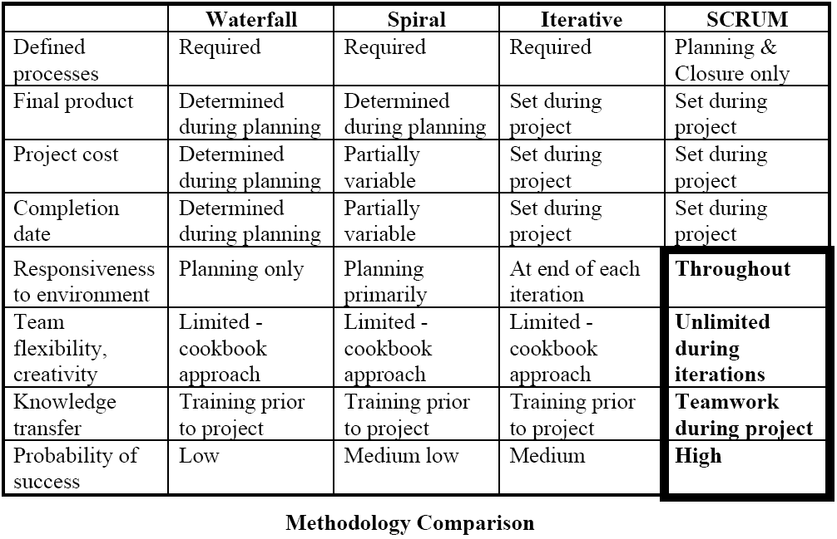

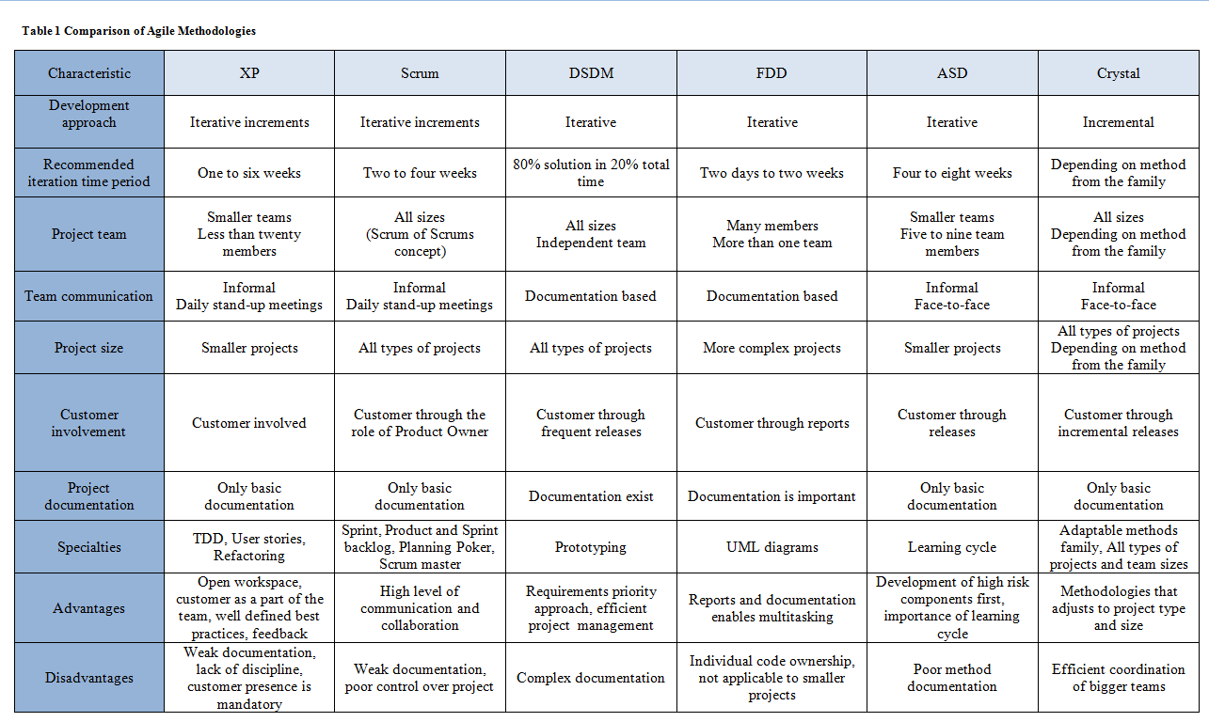

|  |  |  |  |
| --- | --- | --- | --- |
| TDD | XP | Lean | Scrum |
| Keep it simple | Metaphor | Eliminate waste | PO |
| Refactor | Courage | Identify Value | Daily stand up meeting |
| Design before you write your functional code | Pair programming |  | Burndown chart |
|  |  |  |  |
|  |  |  |  |
|  |  |  |  |
|  |  |  |  |
|  |  |  |  |

|  |  |
| --- | --- |
| Fruits | Percent Water |
| Apple | 84 |
| Apricot | 86 |
| Banana | 74 |
| Grapes | 81 |
| Grapefruit | 91 |
| Orange | 87 |
| Peach | 88 |
| Pineapple | 87 |
| Pear | 84 |
| Plum | 85 |
| Strawberries | 92 |
| Watermelon | 92 |

|  |  |
| --- | --- |
| Town | Estimation |
| Haskovo | 3 |
| Plovdiv | 9 |
| Bregovo | 0 |
| Dobrich | 3 |
| Gotse Delchev | 1 |

|  |  |
| --- | --- |
| Animal | Estimation |
| Fox | 89 |
| Sparrow | 1 |
| Moose | ~ |
| Hedgehog | 34 |
| Bechstein's bat | 0 |