AuraDB Knowledge Graph Creation
Emīlija Ostaševska 221RDB231
2.Create a schema and import the data into AuraDB.
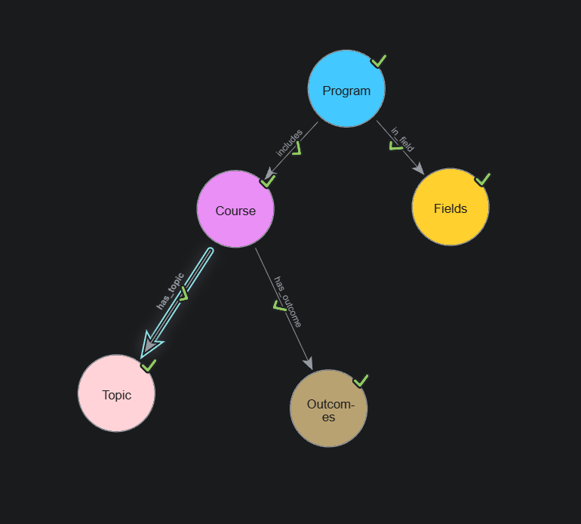
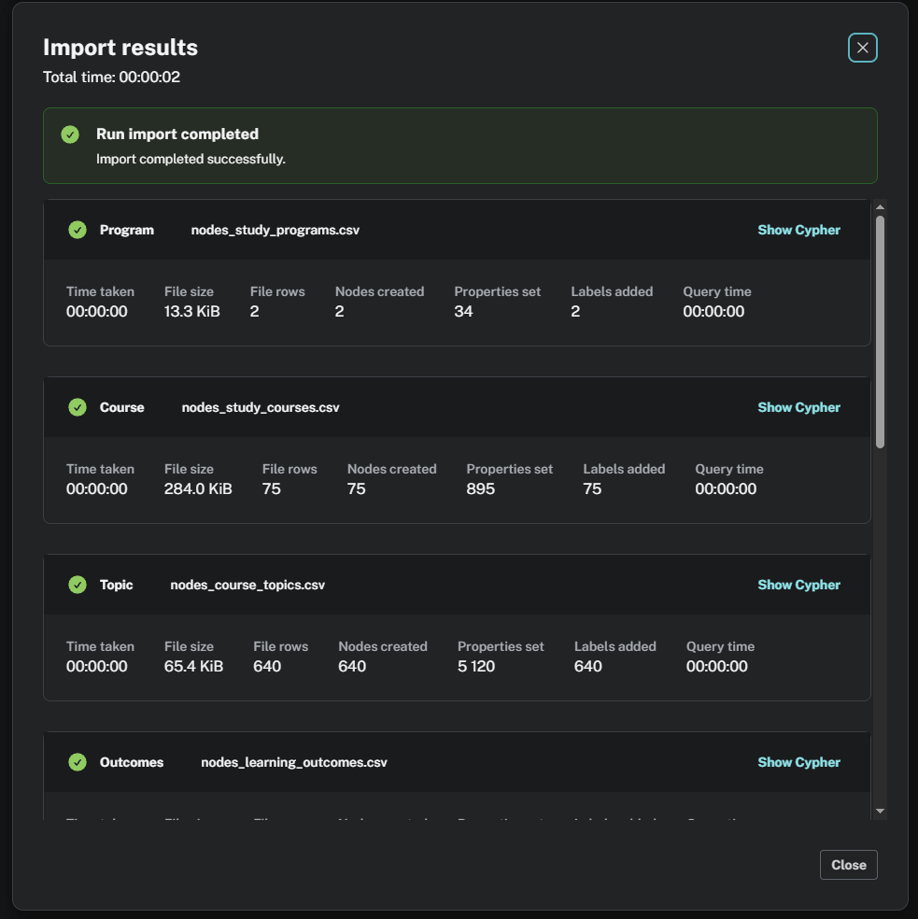
2.Run three to five queries on the created knowledge graph.
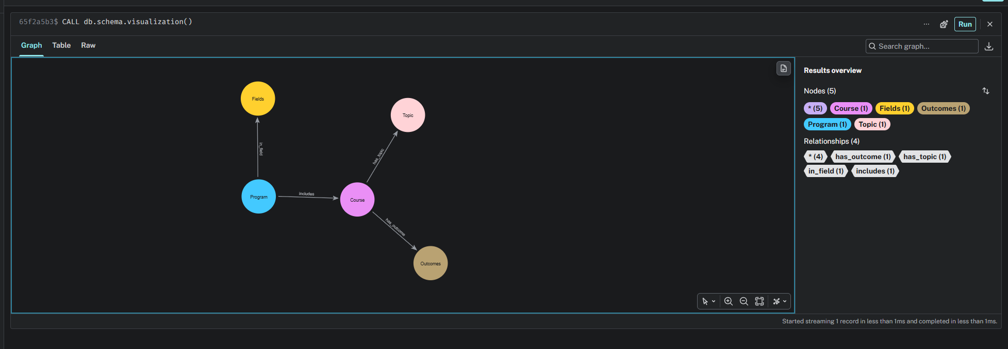

MATCH (p:Program)-[:includes]->(c:Course)
RETURN p, c
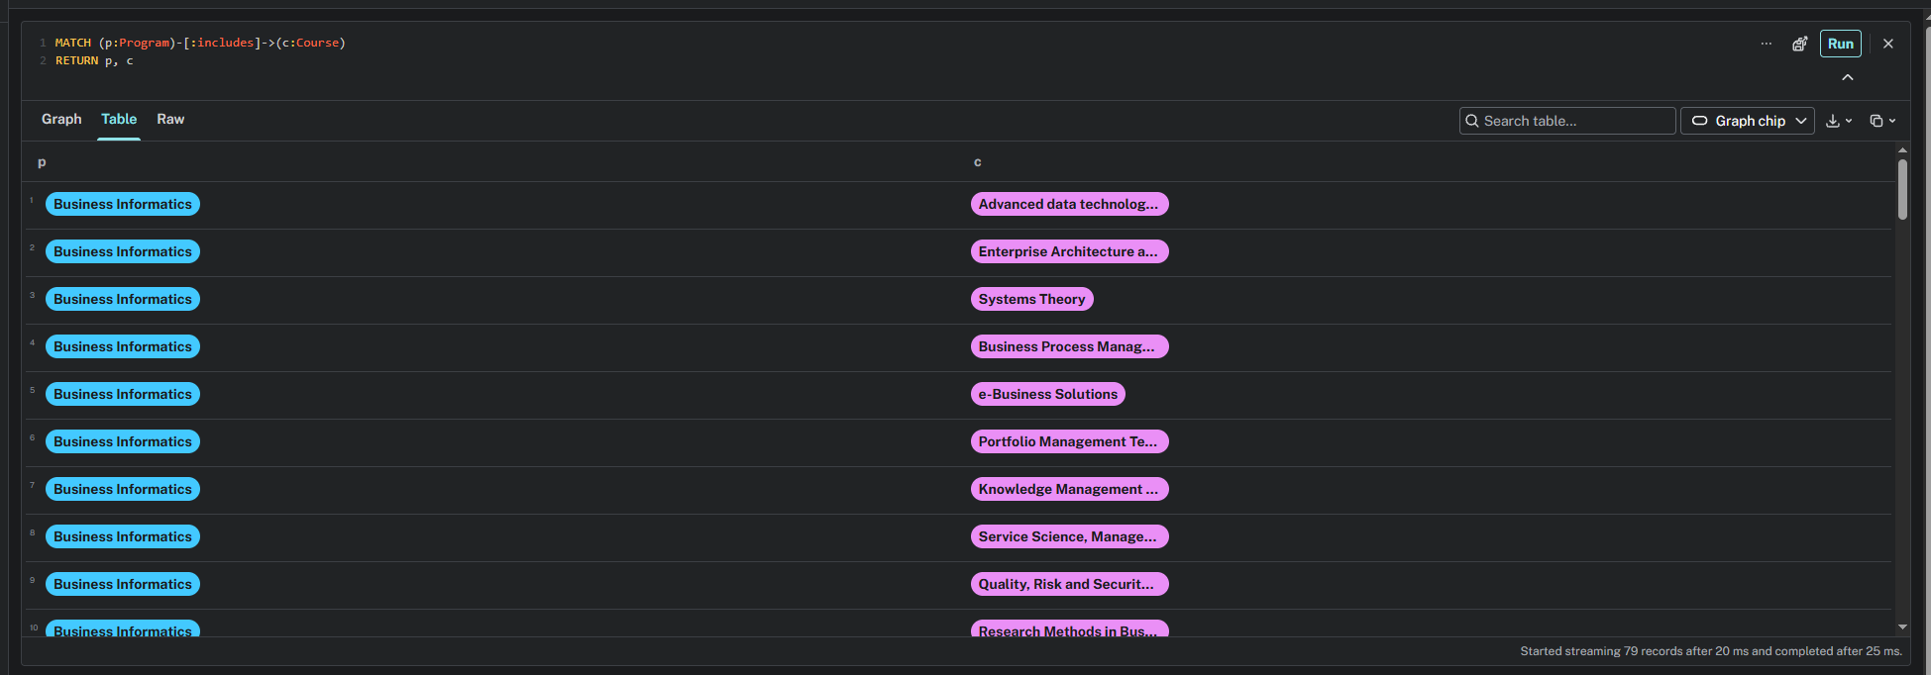

MATCH (c:Course)-[:has_topic]->(t:Topic)
RETURN c, t
ORDER BY c.title, t.ordinal
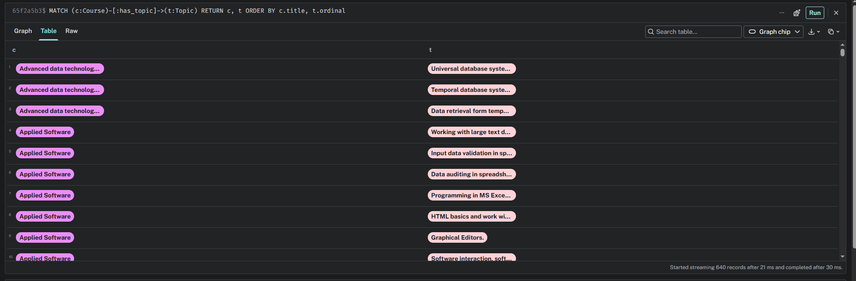
MATCH (c:Course)-[:has_outcome]->(o:Outcomes)
RETURN c.title AS course, o.text AS learningOutcome
ORDER BY c.title
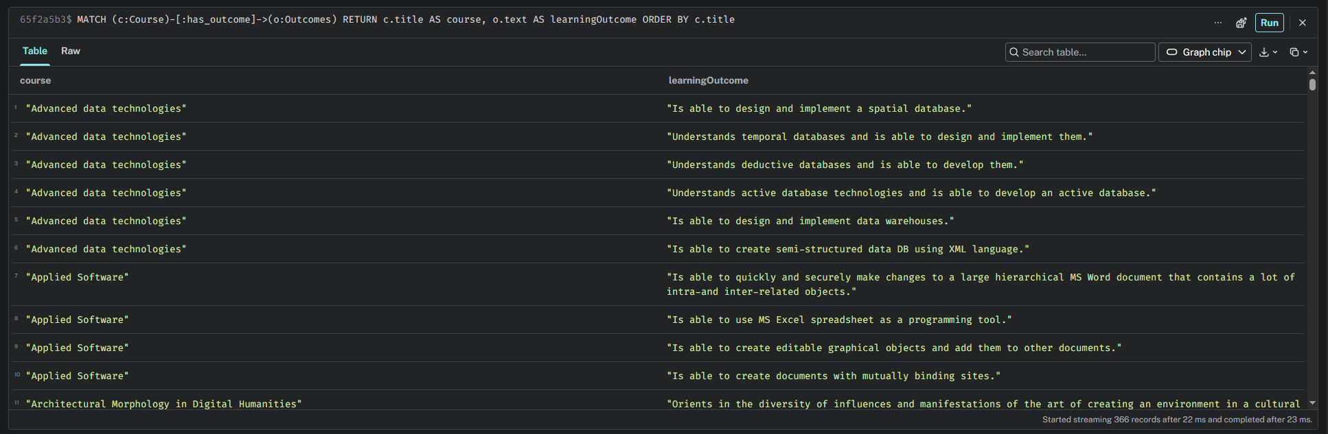

MATCH (c:Course)-[:has_topic]->(t:Topic)
RETURN c.title AS course, count(t) AS numberOfTopics
ORDER BY numberOfTopics DESC
