**מעבדה4**

**כינאן חשאן 316439637**

**אמיל שמאס 211851563**

שאלה 1

def main():

weight = float(input("Please enter your weight in kilograms: "))

height = float(input("Please enter your height in centimeters: "))

height /= 100

bmi = weight / (height ** 2)

if (bmi < 18.5):

status = "Underweight"

else:

if (bmi < 25):

status = "Normal weight"

else:

if (bmi < 30):

status = "increased weight"

else:

if (bmi < 40):

status = "obese"

else:

status = "very high obese"

print(status)

main()

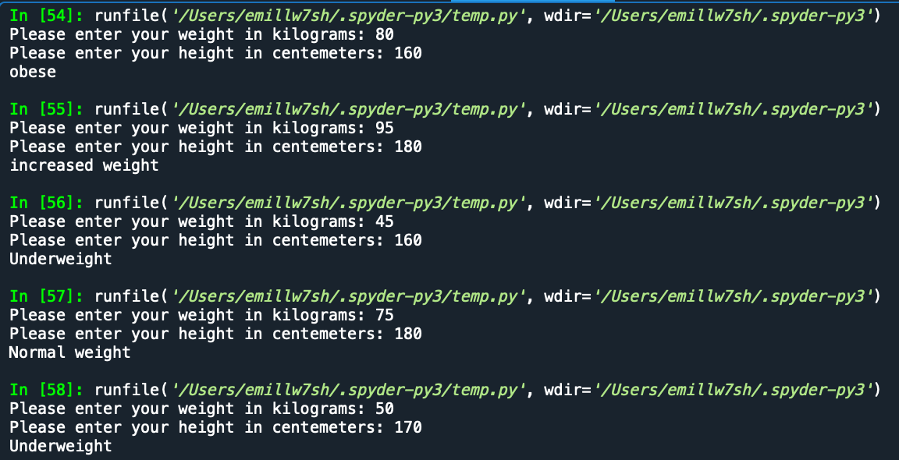

שאלה 2

def main():

num = int(input("Enter a positive 4 digits: "))

if (num < 0):

print (num, "is a negative number, Bye Bye.")

if (num>0 and num < 1000 or num > 9999 ):

print (num, "is not a 4-digits number, Bye Bye.")

if (num>999 and num < 10000):

f = num // 1000

s = (num // 100) % 10

t = (num // 10) % 10

r = num % 10

if (f == s and s == t and t == r):

print ("All digits are the same")

else:

if (r <= t and t <= s and s <= f):

if (t-r == s-t and s-t == f-s):

print ("Decreasing arithmatic sequence (from left to right)")

else:

print ("Decreasing sequence (from left to right)")

else:

if (r >= t and t >= s and s >= f):

if (r-t == t-s and t-s == s-f):

print ("Increasing arithmatic sequence (from left to right)")

else:

print ("Increasing sequence (from left to right)")

else:

print ("Non decreasing and non increasing")

main()

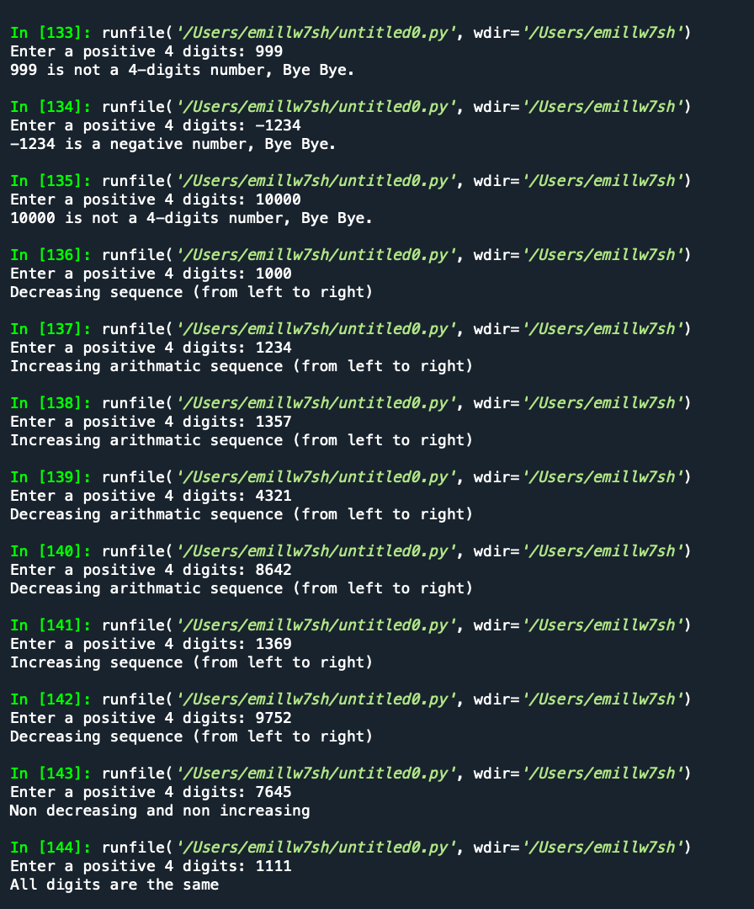

שאלה 3

def main():

children = int(input("Enter number of children: "))

Salary = int(input("Enter your monthly salary: "))

Military = str(input("Military or civil service? enter 'y' for Yes otherwise - any other character: "))

if (Salary > 17500):

print("The mortage is approved with monthly payment of ",Salary * 35 / 100)

else:

if (Military == 'y' and Salary >= 15000):

print("The mortage is approved with monthly payment of ",Salary * 25 / 100)

else:

if(children >= 5 and Salary >= 14000):

print("The mortage is approved with monthly payment of ",Salary * 25 / 100)

else:

print("The mortage is not approved. ")

main()

