

**CRIME REPORTING SYSTEM**

**YOUR NAME**

**YOUR ADM**

**A PROJECT REPORT PRESENTED TO ---------UNIVERSITY----------, FACULTY OF**

**----------, DEPARTMENT OF --------------, IN**

**FULFILLMENT OF THE AWARD FOR THE DEGREE IN BACHELOR OF ------- IN ----------------**

**THE DATE**

# DECLARATION

I hereby declare that this is my original project report work and it has not been submitted to any other diploma or degree award to any other university before.

### Student Name: YOUR NAME

**Signature………………………………………………….**

**Date……………………………...........................................**

This project report has been submitted for examination with the approval by the Supervisor.

**Name**: YOUR SUPERVISOR’S NAME

**Signature………………………………………………….**

**Date……………………………...........................................**

This project has been presented for the examination with my approval as the University Head of Department.

**Name:** NAMEHEAD OF YOUR DEPARTMENT

**Signature………………………………………………….**

**Date……………………………...........................................**

# DEDICATION

I would like to dedicate this work to my loving family for who availed every resource for me through the thesis writing and research.

# ACKNOWLEDGEMENT

I would like to express my heartfelt gratitude and appreciation to my supervisor, ------NAME-------, colleagues; Emilly, Peter and Jeff among others, my parents, Mr. and Mrs. ---------- and most importantly God for their unwavering support, guidance, and encouragement throughout my research project. My supervisor, -----NAME-----, has provided invaluable mentorship, expertise, and patience, shaping the direction and quality of this work. I am also grateful to my colleagues for sharing their knowledge and collaboration, enriching my research experience. My parent’s unconditional love and support have been the foundation of my success. Lastly, I acknowledge and thank God for His blessings and guidance throughout this academic journey.

Without the contributions of these individuals, this project would not have been possible.

# ABSTRACT

The main aim of this project is to create an online crime tracker system that is user-friendly and readily available to the general public and to the police department. This system will record the complaints that people submit online, and it will also assist the police department in apprehending criminals. Individuals can submit complaints at any time, and the system will store all of their information. Problems with safety and security have emerged as one of the most pressing issues facing the majority of communities across the world. To further improve the effectiveness of the operational safeguards that have already been put in place, the usage of technology may be integrated into the security systems. Crime is indeed part of the everyday human activities which must be managed. The existing system for reporting crimes is confronted with a number of challenges because there is no immediate way to report crimes other than via phone, messaging, or possibly face-to-face, which can be troublesome when the reporter wants to maintain their anonymity. The suggested crime tracker intends to provide the Kenyan Police with useful and timely information on criminals and/or their methods of operation so that it can stop criminal activity in a particular area before it gets out of hand. Future improvements to the crime reporting system could focus on increasing usage, raising awareness, and mobile accessibility. The research utilizes the Object-Oriented Analysis and Design methodology because it is flexible and Adaptable, ensures effective use of time and money, works well for fast-moving development projects and also reduces errors during the planning stages. This project’s implementation will focus on the data integrity research area.

**Table of Contents**

DECLARATION 1

Student Name: YOUR NAME 1

DEDICATION 2

ACKNOWLEDGEMENT 3

ABSTRACT 3

CHAPTER ONE INTRODUCTION 9

1.1 Background Study 9

1.2 Problem Statement 11

1.3 Objectives and Aims 12

1.4 Justification 12

1.5 Scope 12

1.6 Research organization 13

1.6.1 Understanding the present crime reporting scenario in Kenya is the goal. 13

1.6.2 Identify technology needs and create a user-friendly crime reporting system. 13

1.6.3 Create an extensive database and reporting architecture. 13

1.6.4 The crime reporting system will be evaluated and tested. 14

1.6.5 Evaluate and enhance the crime reporting system. 14

1.6.6 Install and improve the crime reporting system. 14

CHAPTER TWO RESEARCH METHODOLOGY 15

2.1 Introduction 15

2.1.1 Software Development Methodology 15

2.1.2 Strengths of this methodology 15

2.2 Methodology for literature review 16

2.3 Methodology of Requirement Specification, Data Collection, and Analysis Techniques 17

Data collection techniques 17

2.3.1 Questionnaires 17

2.6.1 Frontend Technology: 21

2.6.2 Backend Technology: 21

2.6.3 Database Technology: 21

CHAPTER THREE REVIEW OF RELATED WORK 24

3.1 Chapter Introduction 24

3.2 History of the research topic 24

3.3 Review of Related Prototypes, Systems [From Global to Local] 25

3.4 Emerging Trends and Patterns in The Research Area 27

3.5 Research gap to be filled by my research 28

3.6 Chapter Summary 30

CHAPTER FOUR SYSTEM ANALYSIS 31

4.1 Introduction 31

4.2 Description of Current Systems, Its Strengths and Weaknesses 31

4.3 Feasibility Study 32

4.4 Data I/O Analysis 33

4.5 Chapter summary 34

CHAPTER 5 SYSTEM DESIGN (PROPOSED SYSTEM) 35

5.1 Introduction 35

5.2 Description of the Proposed System 35

5.3 Requirement analysis (functional, nonfunctional, user, usability) 36

5.4 Conceptual architecture of the proposed system 39

5.5 Process Logic Design of proposed system 43

5.6 Crime Reporting System Physical Design Model 43

5.7 Database Design 50

5.8 I/O of the proposed system (mock up screens) 55

5.9 Chapter Summary 56

IMPLEMENTATION SYSTEM & TESTING 57

6.1 Introduction 57

6.2 System Screenshots 57

6.3 Testing Plan 59

6.4 Evaluation Plan 59

6.5 Chapter Summary 60

CHAPTER 7 61

7.1 Introduction 61

7.2 Conclusion 61

7.3 Findings 61

7.4 Challenges Encountered 62

7.5 Future Recommendations 62

7.6 Conclusion 63

References 64

APPENDICES 65

APPENDIX A: CRIME REPORTING SYSTEM QUESTIONNARRE 65

2 Budget 70

3 Project Schedule 71

4 Gantt Chart 72

**Table of Figures**

Figure 1: Rapid application development (RAD) methodology. 15

Figure 2: Context Diagram of Crime Reporting System 19

Figure 3: Admin DFD 19

Figure 4:Flowchart for Current Crime Reporting System 20

Figure 5:Admin Dataflow Diagram 34

Figure 6: Crime Reporting System’s Layers as Seen by the crime reporter 41

Figure 7: Crime Reporting System Layers as Seen by the Investigation Police Officer 42

Figure 8: Crime Reporting System Logical Design Model 43

Figure 9: Crime Reporting System Physical Design Model 44

Figure 10: Use Case Diagram of a Person Reporting Crime 45

Figure 11: Use Case Diagram of the Police Officers Handling a Reported Crime 46

Figure 12: Flowchart Diagram of a Person Reporting Crime 47

Figure 13: Flowchart Diagram for the Police Officers Dealing with the Reported Crimes 48

Figure 14: Sequence Diagram of a person reporting crime. 49

Figure 15: Sequence Diagram of Police Officers Working at the Administrator Side 50

Figure 16: Homepage 57

Figure 17: User Dashboard 58

Figure 18: Admin Dashboard 58

## CHAPTER ONE INTRODUCTION

### 1.1 Background Study

Several nations around the world are beginning to express more grave concerns over matters of national security. Terrorism, for instance, has reached an extremely widespread level in many of the most important nations in the world including Columbia, Russia, Venezuela among others (Diamond, 1999). Terrorist attacks have taken place in Kenya, primarily in the capital city of Nairobi. These attacks have been planned and carried out by terrorist organizations based in Kenya as well as in surrounding countries, most notably Somalia. There is evidence that Kenya is home to both organized crime gangs and individuals who engage in criminal activity, with the former being documented more frequently in Nairobi County. On the other side, there has been a rise in the advancement of technology (Younus, 2021).

Access to the internet and ownership of a so-called "smartphone" is currently something that is considered usual for a significant majority of the population of the county. Because of this, many are curious about whether or not technology could be used to enhance the current level of security in the country. In urban areas, neighborhoods typically have high crime rates, which often go unsolved due to the ineffectiveness of the reporting channels. Because of this, there is a pressing requirement to identify a solution that is both more long-lasting and adaptable, one that will address the challenges connected with crime reporting and provide a solution that is satisfactory to all parties involved. If it is properly implemented and executed in partnership with the police agency, it will indeed be highly effective and efficient.

Technology is one method that can be implemented to strengthen security and contribute to the battle against crime. The victims of crimes require a way that is both effective and efficient for them to obtain assistance whenever it is required. The proportion of the population that falls within the country's middle class is steadily growing. This indicates that criminals are finding more potential targets, which is fueling their desire to commit crimes. Nairobi and areas near universities are currently the areas that has the highest rate of criminal activity. This is mostly due to the fact that the area has a high population density, which makes it an accessible target for illegal activities and a significant influence from the associated outcomes. The towns must prioritize the upgrading of its security measures because it contributes to the betterment of the residents' standard of living. Enhanced measures to security will increase the level of productivity of the workers within the country, consequently translating into improved economic growth.

Members of the community are expected to report any instance of a breakdown in law to proper military and civil security authorities. It is also expected to be done in an educated manner so that reported cases can be collected, evaluated intelligently and investigated to reach a more justifiable and conclusive end. Evidence is acquired, safeguarded, and as thoroughly investigated as possible before suspected people are brought before a court to be fairly prosecuted. The investigations are conducted without showing any fear or favor to anyone. In point of fact, any effort to thwart the administration of due process during an investigation of a crime becomes a separate offense that is subject to legal repercussions. Up until very recently, the majority of the process in reporting crimes and investigating them in the society was done manually. Victims with complaints who have grievances will go to the offices of security agents where they will tell the agents and fill out statement forms regarding any problems that might require their attention. At such offices, the security officers will produce an incident form and ask the victim to fill in the segments with their information. In addition to this, the security officers will question the reporter with thoughtful inquiries and take notes on the findings of the preliminary investigations. The evidences that have been suggested will be noted, and additional investigations will be further followed up on. Additionally, new evidence will be collected, assessed, and protected.

The development of modern technology has opened up new opportunities for the application of information technology's many advantages in the field of crime reporting. For the reporting, response, and investigation of crimes there are numerous technology platforms available. Since the telegraph, specific radio communication, and specialized phone lines were the first forms of technical application, we have progressed to more responsive and pervasive platforms (Mobile and web software applications). Nowadays, the vast majority of people have portable mobile devices that can access the internet easily. As a result, Crime Reporting System is the most cost-effective and wide-reaching method for reporting crime.

The currently accessible platforms are nowhere near as advanced as the technologies that may be used to report crimes. Common individuals do not find the platforms appealing and find it difficult to understand how to use them. The available platforms are unidirectional since they do not provide members of the society with any kind of feedback. All these available gaps have necessitated my interests for an ideal application which will address the mentioned limitations. Therefore, I have created a system that reports any and all types of crimes and is accessible to any and all members of the general public. The system has given a platform for multiple security agencies to gather and share evidences and to organize members of the general public for certain interests. These improvements have promoted improved policing, crime prevention, and investigation. This project has filled the informational voids that have been found in Kenya regarding the reporting and investigation of crimes.

### 1.2 Problem Statement

Criminal behavior and suspicious activities between humans have always been a part of society. Crime rate in Kenya has been on the rise, and the majority of crimes are either not reported at all or are reported far too late. Cases like these are never resolved, and victims have few avenues through which they can seek justice. The available crime reporting platforms are not user-friendly and have imbalanced information. Additionally, the platforms are unidirectional in the fact that they do not provide members of the community with any kind of feedback on. It is absolutely necessary to have a method that is both widely available and well organized for reporting crimes to the appropriate authorities, in addition to the support of quick response units.

Moreover, the lack of a centralized and integrated crime data system hinders the efficient analysis and identification of crime patterns, which is crucial for developing effective crime prevention strategies. Law enforcement agencies and policymakers face challenges in accessing comprehensive and real-time crime data, leading to delays in addressing emerging crime trends and allocating resources appropriately. Furthermore, the absence of a streamlined communication channel between law enforcement and the community hampers the establishment of trust and cooperation, making it difficult to foster a collaborative approach to crime prevention and community safety. To address these pressing issues, a novel and inclusive approach to crime reporting and data management is required, one that leverages modern technologies and fosters active community participation.

### 1.3 Objectives and Aims

The main aim of my project is to create a system for reporting crimes and providing instant feedback which will make it easier to solve incidents of criminal activity in a timely manner.

The specific objectives are;

1. To enable users to report crimes.
2. To generate reports of reported crimes and actions taken.
3. The system will send emails to users on the investigative progress.

### 1.4 Justification

* **Importance of timely and accurate reporting**: A crime reporting system is crucial in ensuring that crimes are reported promptly and accurately. This can help law enforcement agencies to respond quickly and effectively to criminal incidents, which can prevent further harm and increase the chances of apprehending the perpetrator.
* **Transparency and accountability:** A crime reporting system can increase transparency and accountability in the criminal justice system. It allows citizens to report crimes without fear of retaliation and helps law enforcement agencies to keep track of their performance in responding to criminal incidents.
* **Enhancing community safety:** A crime reporting system can help to enhance community safety by providing a platform for citizens to report criminal incidents, suspicious activities, and other security concerns. This can help to prevent crimes and improve the overall safety of the community.

### 1.5 Scope

I designed a system that served as a main platform for the reporting of any and all types of crimes. I also offered a platform where various security agencies as well as their representatives can register, along with a dashboard that can be used to analyze and interpret the various reported incidents. The general public will have the ability to openly report incidents, receive feedback on their reports, and assess the progression of cases they have reported without being afraid or intimidated. The user's experience will be consistent and responsive across all instances of the application, which will be data-driven. The programs will be available to download and use over the internet on personal computers and several other mobile devices.

### 1.6 Research organization

### 1.6.1 Understanding the present crime reporting scenario in Kenya is the goal.

***Conduct a literature review:*** To get insight into the present situation, existing research, reports, and articles on crime reporting systems in Kenya were collected.

***Data analysis:*** I examined available crime data to find patterns, gaps, and issues in the current reporting system.

Interviews and surveys were conducted with law enforcement agencies, government officials, and community people to learn about their experiences, needs, and expectations about crime reporting.

### 1.6.2 Identify technology needs and create a user-friendly crime reporting system.

***Conduct a technology assessment:*** I analyzed the appropriateness of existing crime reporting systems throughout the world for adoption in Kenya.

***Consult with IT specialists:*** To evaluate the technological infrastructure needed for the crime reporting system, I consulted with software development and cybersecurity experts.

### 1.6.3 Create an extensive database and reporting architecture.

***Design a database architecture:*** I created a safe and efficient database structure to hold criminal data, allowing for efficient retrieval and analysis.

Created a consistent framework for identifying and reporting crimes, taking into account applicable legal and law enforcement standards.

Implemented data privacy safeguards: I included strong security safeguards to protect the privacy of those who report crimes and to guarantee compliance with data protection rules.

### 1.6.4 The crime reporting system will be evaluated and tested.

***Select pilot areas****:* Taking into account variables such as crime rates and demographic diversity, I chose a few locations in Kenya to pilot the crime reporting system.

***Collaboration with stakeholders****:* I worked with local law enforcement agencies, community leaders, and non-governmental organizations to enable the system's adoption and testing. ***Conduct user testing:*** I collected input from users, including reporters and law enforcement officers, to identify any usability flaws or areas for improvement.

### 1.6.5 Evaluate and enhance the crime reporting system.

***Analyze system performance:*** I evaluated the crime reporting system's efficacy in terms of data accuracy, reaction speed, and satisfaction with the system.

***Address deficiencies:*** Based on the results of the evaluation, I made the required changes and improvements to the system to improve its functionality and usability.

***Conduct user training:*** I created training materials and lead workshops to ensure that both reporters and law enforcement employees understand and utilize the system correctly.

### 1.6.6 Install and improve the crime reporting system.

***Collaboration with government agencies:*** I worked with appropriate government agencies to gain the required support, money, and regulatory permissions for the system's deployment. ***Deploy the system:*** I was in charge of overseeing the deployment of the Crime Reporting System in specific regions, ensuring smooth connection with existing law enforcement systems.

***Monitor and analyze continuing performance:*** I also set up monitoring systems to assess the system's performance, collect feedback, and make necessary modifications.

## CHAPTER TWO RESEARCH METHODOLOGY

### 2.1 Introduction

This chapter entails a complete description of the methodology to be used to meet the aim and goal of study. The main aim is to analyze, design and implement a modernized web-based application that meets the needs and requirements of both the country and its residents. To meet this objective, it is important to define a process in which the objectives will be obtained and studied. This section therefore describes the research methodology and system development process followed in carrying out this research.

### 2.1.1 Software Development Methodology

Software development methodology gives guidelines for the development of most software applications. The Crime Reporting System implementation methodology is the Object-Oriented Analysis and Design (OOAD). Rapid Application Development saves a lot of time by optimizing the development tasks and reducing the errors during the planning stages.

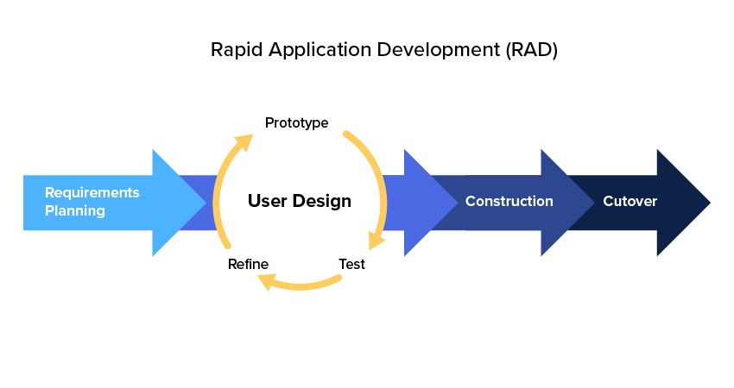

Figure 1: Rapid application development (RAD) methodology.

### 2.1.2 Strengths of this methodology

1. Speed: RAD is designed to accelerate the development process, so it can help researchers move more quickly through the various stages of their project. By breaking down complex tasks into smaller, more manageable pieces, RAD can help researchers make progress more efficiently.
2. Flexibility: RAD is an adaptive methodology that allows for changes to be made throughout the development process. This can be especially useful in research projects where the scope and objectives may change over time.
3. Collaboration: RAD promotes collaboration between team members, stakeholders, and end-users. This can help researchers better understand the needs and requirements of their target audience and ensure that the final product meets their needs.
4. Early feedback: RAD emphasizes prototyping and testing early in the development process. This can provide researchers with valuable feedback on the usability and effectiveness of their project, allowing them to make improvements before investing significant resources.
5. Cost-effectiveness: By focusing on iterative development and early feedback, RAD can help researchers save time and resources in the long run. By identifying and addressing potential issues early in the process, RAD can help researchers avoid costly mistakes and delays later on.

### 2.2 Methodology for literature review

To gather relevant information and insights on crime tracking systems, the researcher conducted an extensive literature review. This involved searching and reviewing scholarly articles, research papers, books, and online resources related to crime tracking, law enforcement systems, and software development methodologies. The literature review provided a theoretical foundation and informed the design and implementation of the Crime Reporting System.

### 2.3 Methodology of Requirement Specification, Data Collection, and Analysis Techniques

The researcher will use a variety of data collection techniques, including surveys and interviews, to compile the requirements for the Crime Reporting System. To determine their needs, expectations, and desired features, law enforcement authorities, crime analysts, and possible end users will all be interviewed. A larger audience will receive questionnaires to help collect opinions and recommendations. With the goal of gaining insightful knowledge and prioritizing system requirements, the gathered data will be examined utilizing qualitative and quantitative analytic approaches.

### Data collection techniques

### 2.3.1 Questionnaires

Primary data was gathered through open-ended and closed-ended questionnaires. Clear instructions were provided in the questionnaire. Respondents were expected to offer detailed responses to the free-form questions. For the closed-ended queries, the researcher utilized a 5point Likert scale and ranking. The questionnaire had different parts: Demographic information, Experiences with crime reporting systems, Security and privacy. Privacy was respected during the survey filling process.

#### 2.3.2 Interviews

The researcher conducted interviews with the potential users to enable them to have the feeling of being a part of the suggested system, and as a result, the researcher was able to obtain their thoughts and ideas in an open manner. The responses from the respondents helped to uncover additional data that was utilized to improve the accuracy of the model's predictions.

Some of the sample questions asked were;

1. What are your thoughts on the current crime reporting system in your community?
2. Have you ever reported a crime? If so, can you describe your experience with the reporting process?
3. Are you aware of any challenges or barriers that prevent people from reporting crimes?
4. In your opinion, what features or improvements would you like to see in a crime reporting system?
5. How do you think technology could be used to improve the crime reporting process?

#### 2.4 Methodology for System analysis (current system)

In the system analysis methodology, the current system was studied in detail, its short comings were identified and data from different sources were collected to come up with a system that tackles these challenges. Data collection techniques such as interviews and questionnaires were used. The researcher analyzed and did a comparison of other working crime reporting systems and reviewed the possible requirements for its development.

#### 2.5 Methodology for System Design

For the design of the Crime Reporting System, the researcher employed a range of design techniques. This involved creating a Database design, DFDs, Context Diagram, flow charts, sequence diagrams, collaboration diagrams, use cases, and pseudocode representations. Additionally, early system prototypes were developed to design the system's input/output components. These design methodologies provided a blueprint for the development of the proposed system.

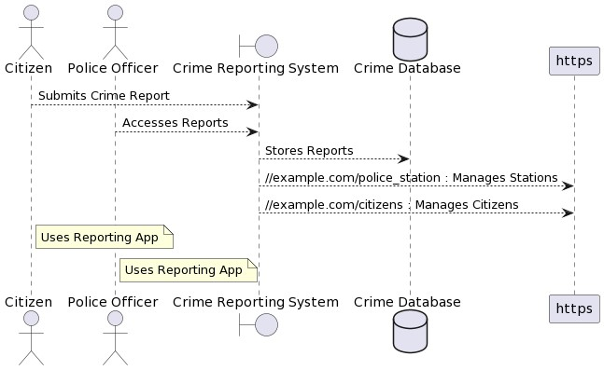

Figure 2: Context Diagram of Crime Reporting System

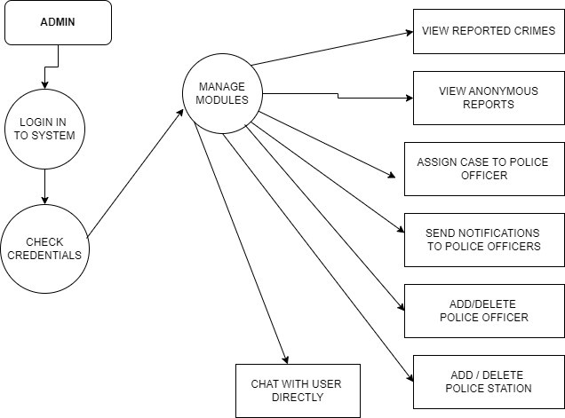

Figure 3: Admin DFD

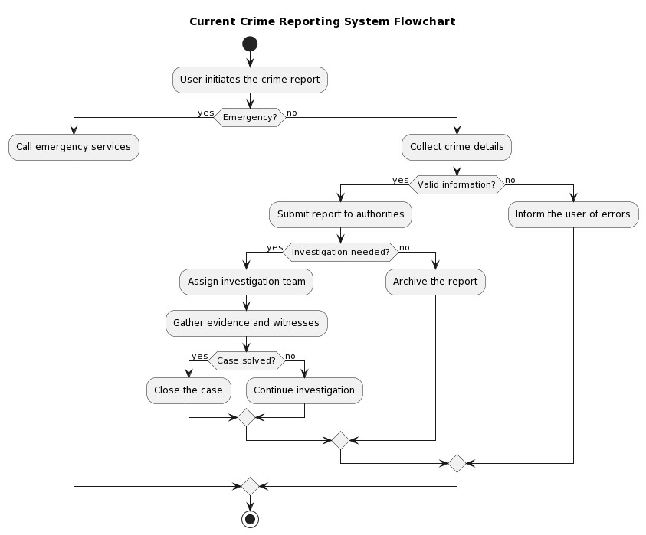

Figure 4:Flowchart for Current Crime Reporting System

#### 2.6 Methodology for System Implementation

The implementation phase of the Crime Reporting System involved the utilization of specific technologies and frameworks to bring the design and functionality to life. The following methodologies were employed for the system implementation:

### 2.6.1 Frontend Technology:

For the frontend development of the Crime Reporting System, I employed HTML, CSS, and JavaScript. HTML was used for structuring the web pages and defining the content. CSS was utilized for styling and layout purposes, ensuring a visually appealing and consistent user interface. JavaScript was employed for client-side interactivity, form validation, and enhancing user experience with dynamic elements.

### 2.6.2 Backend Technology:

To implement the backend functionality of the system, I utilized the Laravel framework along with PHP. Laravel is a popular and robust PHP framework that follows the Model-View-Controller (MVC) architectural pattern. It provides a comprehensive set of tools, libraries, and features for rapid and efficient web application development. Laravel offers benefits such as routing, database ORM (Object-Relational Mapping), authentication, and security features, making it an ideal choice for building the Crime Reporting System.

### 2.6.3 Database Technology:

For the storage and management of data, the Crime Reporting System utilized MySQL as the database technology. MySQL is a widely-used open-source relational database management system known for its performance, reliability, and scalability. It provides efficient data storage, retrieval, and querying capabilities, ensuring the integrity and security of the system's information. During the implementation phase, I followed industry best practices to ensure the development of a high-quality and maintainable software system. These practices include:

1. **Modular and Object-Oriented Programming:** The system implementation followed a modular and object-oriented approach, breaking down the functionality into smaller, reusable components. This approach improves code readability, promotes code reusability, and facilitates maintenance and future enhancements.
2. **Code Versioning:** A version control system, such as Git, was utilized to manage and track changes to the system's source code. This ensures proper collaboration among team members, enables easy rollback to previous versions if needed, and maintains a history of code changes.
3. **Security Considerations:** Security measures were implemented to protect the system against potential threats and vulnerabilities. This includes validating and sanitizing user inputs, implementing access controls, and utilizing secure communication protocols (e.g., HTTPS) for data transmission.
4. **Error Handling and Logging:** Proper error handling techniques were employed to catch and handle exceptions and errors that may occur during system operation. Error logs were generated to track and diagnose issues, facilitating troubleshooting and maintenance.
5. **Performance Optimization:** Performance optimization techniques were applied to ensure the system operates efficiently. This includes minimizing database queries, caching frequently accessed data, optimizing code execution, and employing efficient algorithms and data structures.
6. **Testing and Debugging:** Rigorous testing and debugging was conducted during the implementation phase.
7. Unit testing was performed to verify the correctness of individual components.
8. Integration testing to ensure proper communication between different modules.
9. System testing to validate the overall functionality and user experience.

#### 2.7 Methodology for System Testing

A testing strategy was created that details the objectives, scope, actions, and resources needed to put the Crime Reporting System through its paces. The strategy outlined the many forms of testing that will be carried out, such as:

1. Unit testing
2. Integration testing,
3. System testing
4. User acceptance testing (UAT).

It also specified the test environment, test data, and the testing team's duties.

#### 2.8 Methodology for System Deployment

The researcher deployed the Crime Reporting System following a phased approach. This involved initially deploying the system to a small group of users and gradually expanding the user base as we identify and resolve any issues.

Before deployment, the researcher configured and tested the system to ensure its readiness. This involve setting up the necessary hardware and software infrastructure, configuring system settings, and conducting final testing to ensure everything functions correctly.

During the initial deployment phase, the researcher closely monitored the system to identify any issues or problems that may arise. The researcher promptly addressed these issues to ensure the system continues to function correctly.

As the system proved to be stable and reliable, the researcher gradually rolled it out to a larger user base. The researcher provided training and support to new users to help them get started with the system effectively.

Throughout the deployment process, the researcher actively collected feedback from users and used it to make improvements to the system. This iterative feedback loop ensured that the system continued to meet the evolving needs of its users.

#### 2.9 Summary

In summary, this chapter has outlined the research methodology for the development of the Crime Reporting System. The methodology encompasses various stages, including literature review, requirement specification, system analysis, system design, system implementation, system testing, and system deployment. By following this methodology, I aimed to deliver a robust and efficient crime-tracking system that meets the needs of law enforcement agencies and enhances public safety.

## CHAPTER THREE REVIEW OF RELATED WORK

### 3.1 Chapter Introduction

The Crime Reporting System is an innovative crime reporting system aimed at revolutionizing the way crime is reported and managed. This literature review section explores the existing research and developments in the field of crime reporting systems, with a focus on global and local prototypes and systems. The review aims to identify the gaps in current approaches and understand emerging trends and patterns to pave the way for the Crime Reporting System's unique contributions.

### 3.2 History of the research topic

The history of crime reporting systems can be traced back to the early 20th century, when the concept of emergency telephone services began to gain traction. In 1937, the first emergency phone number, "999," was introduced in London, England, allowing citizens to report emergencies, including crimes, to the police. This revolutionary system quickly spread to other countries, including the United States, where "911" became the designated emergency number in 1968.

The introduction of emergency phone services significantly improved the accessibility and speed of reporting crimes, enabling citizens to seek immediate assistance from law enforcement agencies. However, these early systems were limited in scope and functionality. They primarily focused on handling emergency situations and lacked the capability to address non-emergency incidents, which often burdened emergency lines and diverted resources from critical cases. With the advent of computer technology in the latter half of the 20th century, the concept of digitized crime reporting began to take shape. Early prototypes of computer-based crime reporting systems emerged in the 1970s and 1980s, providing a more organized and streamlined approach to reporting criminal activities.

The rise of the internet in the 1990s marked a turning point for crime reporting systems. Online reporting platforms allowed citizens to report crimes from the comfort of their homes or workplaces, reducing the reliance on emergency phone lines. One notable example was the establishment of the Metropolitan Police's Online Crime Reporting System in the United Kingdom in 1998, which allowed citizens to report non-emergency crimes via the internet.

In the early 2000s, the proliferation of mobile technology and the widespread use of smartphones presented new opportunities for crime reporting. Mobile apps and text-based reporting systems emerged, enabling citizens to report incidents on-the-go. These systems aimed to improve accessibility, especially in situations where a computer was not readily available.

Throughout this period, crime reporting systems also began to incorporate geospatial mapping technologies to visualize crime data and identify crime hotspots. Geospatial visualization provided law enforcement agencies with valuable insights into crime patterns, helping them allocate resources more effectively and devise targeted crime prevention strategies.

Despite these advancements, many early crime reporting systems faced challenges related to data accuracy, timely response, and user experience. Moreover, some systems lacked integration with law enforcement databases, hindering seamless information sharing between citizens and law enforcement agencies.

In recent years, data analytics and artificial intelligence have been increasingly integrated into crime reporting systems, enabling real-time data analysis and predictive policing. This shift has allowed law enforcement agencies to identify crime trends and patterns, leading to more proactive and preventive measures.

The history of crime reporting systems reflects a continuous effort to improve the effectiveness and efficiency of reporting criminal activities. The Crime Reporting System aims to build upon this legacy by addressing the shortcomings of existing systems and leveraging the latest technologies to provide a comprehensive, user-friendly, and data-driven crime reporting solution. By learning from the historical development of crime reporting systems, the Crime Reporting System seeks to position itself as a cutting-edge platform that empowers citizens and law enforcement agencies to collaboratively combat crime in the digital age.

### 3.3 Review of Related Prototypes, Systems [From Global to Local]

There have been several prototypes developed for crime reporting systems over the years, each with its unique features and capabilities. Here are some examples:

**911 Emergency Services:**

The 911 emergency service remains one of the most well-known crimes reporting systems globally. Introduced in the United States in 1968, this system revolutionized emergency response by providing citizens with a single, easy-to-remember number to report crimes and emergencies. When a call is made to 911, it connects the caller directly to the nearest emergency service provider, be it police, fire, or medical assistance. While highly effective for handling emergencies, the 911 system has limitations when dealing with non-emergency incidents, which can lead to overburdening of the system and delayed response times for critical cases.

#### CrimeReports

CrimeReports is an online platform that collates crime data from various law enforcement agencies and presents it to the public in an easily accessible format. The platform uses interactive maps and charts to display crime incidents, allowing citizens to view crime trends and patterns in their neighborhoods. While Crime Reports provides valuable crime information, it does not offer a comprehensive crime reporting system for citizens to directly report incidents. Instead, it relies on data submitted by law enforcement agencies.

**iReport**

iReport is a mobile-based crime reporting system implemented in Kenya. Launched in 2014 by the Kenyan National Police Service, iReport allows citizens to report crimes through SMS, a web portal, or a dedicated mobile app. The platform enables users to send text, images, and location data to law enforcement, facilitating quicker response times. iReport was initially well-received for empowering citizens to report crimes digitally and anonymously, promoting community involvement in crime control efforts. However, some challenges emerged, such as delays in response times, lack of feedback to reporters, and occasional issues with data inaccuracy.

#### Nyumba Kumi Initiative

The Nyumba Kumi Initiative, introduced in Kenya in 2013, aims to enhance community policing and crime prevention through close collaboration between citizens and law enforcement agencies. In this system, communities are divided into groups of ten households known as "Nyumba Kumi" (Swahili for "Ten Houses"). Each group is led by a volunteer coordinator responsible for reporting suspicious activities to the police. While the initiative fosters a sense of responsibility and community involvement, it primarily relies on physical reporting and face-to-face interactions, lacking digital and real-time reporting features.

#### Police Apps

Several police departments and agencies worldwide have developed their mobile apps to facilitate crime reporting. These apps typically offer a range of services, including crime reporting, anonymous tip submission, community alerts, and safety information. Examples include the "My Police Department" app in the United States and the "My Police Kenya" app in Kenya. However, the effectiveness of these apps often depends on their user interface, marketing, and integration with existing law enforcement systems.

#### Community-based Reporting Systems

Various community-based crime reporting systems have emerged, enabling citizens to report crimes within their social networks or specific communities. These platforms encourage information sharing and collective responsibility for crime prevention. In some cases, these systems leverage social media platforms, neighborhood forums, or local messaging groups to facilitate reporting. While community-based reporting fosters a strong sense of social cohesion, its efficacy can be limited by concerns about data privacy and verification. Overall, existing crime reporting systems globally and in Kenya have made significant strides in empowering citizens to participate actively in crime reporting and prevention. However, there are still notable challenges that the Crime Reporting System seeks to address. These challenges include the need for comprehensive integration of real-time data analysis and geospatial visualization, user-friendly interfaces, timely response mechanisms, and improved collaboration between citizens and law enforcement agencies. By building upon the strengths of existing systems and addressing their limitations, the Crime Reporting System aims to become a groundbreaking crime reporting solution that enhances community safety and cooperation.

### 3.4 Emerging Trends and Patterns in The Research Area

**Integration of Mobile Technology:** Many recent crime reporting systems are leveraging mobile technology, such as dedicated apps or SMS-based reporting, to improve accessibility and convenience for users.

**Real-time Data Analysis:** Advanced systems are adopting data analytics and artificial intelligence to process crime data in real-time, enabling law enforcement to identify patterns and respond more effectively.

**Geospatial Visualization:** Modern systems are incorporating geospatial visualization to map crime incidents, aiding law enforcement in resource allocation and tactical decision-making. **Integration of Artificial Intelligence (AI) and Machine Learning:** One of the most significant emerging trends in crime reporting systems is the integration of AI and machine learning algorithms. These technologies enable the automated analysis of vast amounts of crime data, allowing law enforcement agencies to identify patterns, trends, and anomalies in real-time. AIpowered systems can assist in predicting crime hotspots, optimizing resource allocation, and supporting proactive crime prevention strategies.

**Big Data Analytics:** The advancement in big data analytics has facilitated the processing and analysis of large and complex datasets generated by crime reporting systems. This trend empowers law enforcement agencies to gain deeper insights into crime patterns, modus operandi, and the effectiveness of their interventions. Big data analytics can aid in identifying repeat offenders, linking related crimes, and improving the accuracy of crime predictions.

**Social Media and Open Source Intelligence (OSINT):** Social media platforms have become valuable sources of information for law enforcement agencies. Emerging trends involve utilizing social media analytics and OSINT to gather intelligence on potential criminal activities, track suspects, and identify emerging crime trends. Integrating social media monitoring into crime reporting systems can enhance situational awareness and enable real-time crime reporting through social channels.

**Block chain for Data Security:** As data security and privacy concerns grow, the integration of block chain technology in crime reporting systems is gaining traction. Block chain’s decentralized and immutable nature can ensure the integrity of crime data, protecting it from tampering or unauthorized access. By leveraging block chain, crime reporting systems can enhance data trustworthiness and build stronger public confidence in the system.

### 3.5 Research gap to be filled by my research

Despite the advancements in crime reporting systems and the emergence of new technologies, several critical research gaps remain:

1. **Comprehensive Integration of Emerging Trends:** While individual emerging trends like Artificial Intelligence, big-data analytics, and social-media integration have shown promise in crime reporting systems, there is a lack of comprehensive integration. The Crime Reporting System aims to bridge this gap by bringing together various cutting-edge technologies into a cohesive and interconnected system.
2. **User-Centric Design and Accessibility:** Many existing crime reporting systems struggle with user experience and accessibility, which can hinder citizens from actively using the platform. The Crime Reporting System will focus on a user-centric design, ensuring ease of use for individuals of all demographics, including those with limited technological literacy.
3. **Real-Time Data Visualization and Insights:** Timely access to real-time data insights is crucial for law enforcement agencies to respond effectively to crimes. The Crime Reporting System seeks to provide real-time crime data visualization and analytics, empowering law enforcement with actionable intelligence and enabling them to deploy resources efficiently.
4. **Effective Collaboration with Law Enforcement Agencies:** Seamless collaboration between citizens and law enforcement agencies is essential for the success of a crime reporting system. The Crime Reporting System has strived to establish efficient communication channels, ensuring that reported incidents reach the relevant authorities promptly, and feedback is provided to citizens on the status of their reports.
5. **Data Security and Privacy Measures:** With the increasing reliance on technology and data, ensuring the security and privacy of crime-related information becomes paramount. The Crime Reporting System will incorporate robust data security measures, including blockchain technology, to safeguard sensitive information and maintain public trust.
6. **Addressing Community-Specific Challenges:** Different communities may face distinct challenges in crime reporting and prevention. The Crime Reporting System will strive to be adaptable to the unique needs of different communities, considering factors such as cultural sensitivities and language preferences.

By addressing these research gaps, the Crime Reporting System aims to be a state-of-the-art crime reporting system that empowers citizens, enhances collaboration with law enforcement, and contributes to safer communities through proactive crime prevention strategies.

### 3.6 Chapter Summary

This literature review has provided insights into the historical developments of crime reporting systems, reviewing global and local prototypes and systems. Emerging trends highlighted the potential for mobile technology, real-time data analysis, geospatial visualization, and anonymous reporting. The research gap analysis revealed the need for a comprehensive and user-centric system that enhances collaboration with law enforcement. The Crime Reporting System seeks to address these gaps and bring a cutting-edge solution to the crime reporting landscape.

## CHAPTER FOUR SYSTEM ANALYSIS

### 4.1 Introduction

This chapter provides an analysis of the current systems used for crime reporting system. The strengths and weaknesses of the current systems will be discussed, along with a feasibility study and its conclusion. Additionally, this chapter will cover data input/output analysis and process logic design of the current system.

### 4.2 Description of Current Systems, Its Strengths and Weaknesses

Current crime reporting systems vary in their capabilities and effectiveness. Some systems allow individuals to report crimes online or through a mobile app, while others require individuals to visit a police station or call a hotline to report a crime.

#### 4.2.1 Strengths of current systems

* Accessibility: Online platforms and mobile applications make crime reporting more accessible to a wider population, including those in remote areas. This increases the chances of capturing incidents that might otherwise go unreported.
* Government Engagement: The involvement of the Kenyan government in implementing these systems showcases their commitment to improving crime reporting and addressing public safety concerns.
* Enhanced Communication: These systems enable direct communication between citizens and law enforcement agencies, facilitating faster response times and better coordination in crime investigation and prevention efforts.

#### 4.2.2 Weaknesses of current systems

* The most prominent crime reporting tools in Kenya are dysfunctional and difficult to understand. The procedure for reporting offenses to security organizations continues to be extremely challenging.
* In addition, the platforms are unidirectional due to the absence of feedback mechanisms for users who are members of the general public.
* The existing reporting platforms do not support the sharing of any relevant information with the other security agencies because the owners of such platforms want to take all the praise for themselves.

### 4.3 Feasibility Study

A feasibility study is done to ensure that the time, money, and resources invested in a project's completion will be profitable for the organization. A developer can visualize how their projects will evolve and grow in the future with the help of a feasibility study. Considerations such as the proposal's impact on the organization, its ability to meet user needs, and its efficient use of resources are key to any feasibility analysis of a system. Therefore, a feasibility study is typically conducted before a new application is given the green light for development after it has been presented. This document details the Technical, Economic, and Operational feasibilities of the crime reporting system and provides an overview of the many factors that were carefully evaluated during the feasibility assessment. This section involved analyzing and evaluating the current project to determine if the solution was practical and viable within the constraints and available resources.

#### 4.3.1 Technical Feasibility

Technical feasibility was conducted to determine whether the proposed solution could be implemented with the available hardware, software and technical resources.

For the implementation and deployment of the system. The institution has the necessary resources required which include computers and data storage facilities and the necessary technical support to enable the application work as required.

The projects are designed using the most recent technological advancements. Because there is always a newer version of the same technology, it is possible that the technology will become obsolete after a certain amount of time. Older versions of the software remain supported; thus, it is possible to continue using the system. Therefore, there are not many limitations associated with carrying out this project and the project is technically feasible for further development.

#### 4.3.2 Economic Feasibility

This section involved analyzing and evaluating the current project to determine if the solution was practical and viable within the constraints and available resources

The proposed system did not require any additional labor costs because it is developed in the course of the project. All necessary components exist, which suggests the system development is economically possible.

#### 4.3.3 Operational Feasibility

This did assess the extent to which the required system will perform a series of steps to involve

the user’s problem and meet their requirements. It showed the ability to utilize support and perform the necessary tasks through the system. The proposed system was found to be feasible since the web application can be accessed from any device from laptops to small mobile devices and can also be accessed anywhere with proper credentials. This also included the knowledge on basic computer system and how the training on usage of the system would be done.

### 4.4 Data I/O Analysis

The data captured by current crime reporting systems includes information about the crime being reported, such as its location, time, and details about the perpetrator. The relationship between this data is used to generate outputs from the system, such as crime statistics and reports.

4.5 Process logic design of the current system; flow charts, context diagrams & DFDS

To understand the flow and structure of the current systems, process logic design tools such as flow charts, context diagrams, and Data Flow Diagrams (DFDs) will be utilized. These diagrams will provide a visual representation of the system's components, their interconnections, and the flow of data and processes.

Admin

Forgot

Password

Send

Email to

User

Login

To

System

Check

Credentials

Check

Roles of

Access

Manage

Modules

Manage Case Details

Manage Criminal

Details

Manage Crime Details

Manage Department

Details

Manage Police Details

Manage Complain

Details

Manage

Details

Manage User

Permission

Manage User Roles

Manage System Admins

Figure 5:Admin Dataflow Diagram

### 4.5 Chapter summary

In this chapter, we analyzed the strengths and weaknesses of current crime reporting systems. The Crime Reporting System aims to address the limitations of existing systems by providing enhanced accessibility, improved feedback mechanisms, and streamlined data integration. Feasibility study findings, data I/O analysis, and process logic design provide valuable insights into the potential of the Crime Reporting System to revolutionize crime reporting and investigation processes.

## CHAPTER 5 SYSTEM DESIGN (PROPOSED SYSTEM)

### 5.1 Introduction

In this chapter, we will provide a detailed design of the proposed Crime Reporting System, which will enable individuals to report crimes and receive feedback. The strengths and weaknesses of the proposed system will be discussed, along with a requirement analysis and conceptual architecture. Additionally, this chapter will cover process logic design, database design, and input/output of the proposed system.

### 5.2 Description of the Proposed System

The proposed Crime Reporting System is designed to improve upon current crime reporting systems by providing individuals with a user-friendly web-based platform to report crimes and receive feedback, while also enabling security agencies to efficiently manage reported crimes and obtain statistical data on crime trends.

#### 5.2.1 Strengths of the proposed system

1. **Real-Time Feedback:** Upon reporting a crime, users will receive immediate acknowledgment and a unique reference number, which they can use to track the progress of their case. The system will provide regular updates on the investigation status, ensuring users are informed throughout the process.
2. **User-Friendly Interfaces**: The system will provide user-friendly interfaces for both citizens and security agency personnel. Citizens can easily navigate the crime reporting process through intuitive forms and clear instructions. Security agencies will have a comprehensive dashboard with filtering and search capabilities to efficiently manage reported cases.
3. **Secure and Confidential**: The Crime Reporting System prioritizes security and confidentiality. Measures such as encryption, secure authentication, and access control will be implemented to safeguard user data and prevent unauthorized access.

#### 5.2.2 Weaknesses of the proposed system

1. **Dependency on User Reporting:** The system heavily relies on users actively reporting crimes, and its effectiveness will depend on the participation and engagement of the community.
2. **Reliance on Internet Connectivity:** The effectiveness and timeliness of the reporting process may be compromised due to the system's heavy dependence on internet connectivity. Users in areas with limited or inconsistent internet access may encounter difficulties using the website or submitting crime reports.
3. **Potential for Misuse:** Since the reporting mechanism lacks face-to-face interaction, there is a risk of receiving false or malicious reports. This can pose challenges for law enforcement agencies in distinguishing between genuine and fraudulent complaints.
4. **Digital Literacy and Accessibility**: The system may be less beneficial for individuals who lack digital literacy skills or lack access to digital devices. Not all members of the population are proficient in utilizing internet platforms, which can create barriers for certain groups when it comes to reporting incidents.

### 5.3 Requirement analysis (functional, nonfunctional, user, usability)

The requirement analysis for the Crime Reporting System includes functional requirements, such as the ability to report crimes and receive feedback, as well as non-functional requirements, such as security and reliability. User requirements include ease of use and accessibility, while usability requirements focus on the user experience and interface design.

#### 5.3.1 Functional Requirements

1. Authentication: The system should be able to authenticate users.
2. Authorization: The system should be able to assign specific users to their specified permissions.
3. Capture new crime records/accounts: the system should be able to capture new reported records and accounts and store or register them in the system.
4. Stores crime information: the system should be able to store the reported crimes in the database once they are reported.
5. Store reporter information: the system should be able to store a reporter’s information and store it in the database.
6. Update Crime status: The system should only the investigative officer assigned the crime to make progress update on the case from time to time as he/she works on it. The investigative police officer can also attach any new file related to the case at this point.
7. Delete accounts/records: the system should be able to expunge any unwanted record or account from the database.
8. Generate report: The system should be able to provide a report after the reporting is complete or after the process of investigation.

#### 5.3.2 Non-Functional Requirement Specification

1. **Efficiency Requirement –** After the implementation of the Crime Reporting System, the registered users can create complaints efficiently and with ease.
2. **Reliability Requirement –** The system should give a reliable environment to the administrator and the registered user. All the complaints filed should reach the admin end without any issues. Also, feedbacks should be received on the other end without much errors.
3. **Implementation Requirement –** The system was implemented using CSS and html as front end, PHP with Laravel framework in the backend and it will also include database connectivity. The system also used Xampp and web designing techniques to be compatible with most devices.
4. **Delivery Requirement –** The complete Crime Reporting System is expected to be delivered within the 6 months as per the project guide.
5. **Database security -** The unauthorized personnel would not be able to access the database and the panel.
6. **Availability –** The implemented Crime Reporting System was made available

24 hours every day**.**

#### 5.3.3 User Requirements

1. **Easy-to-Understand Interface:** The system should feature a clean and intuitive user interface that is easy to navigate. Users, regardless of their technical proficiency, should be able to quickly understand how to report a crime and track the progress of their case.

1. **Seamless Crime Reporting Process:** Users should be guided through a seamless process of reporting a crime. The system should provide clear instructions and relevant fields to capture essential information related to the crime, such as location, date, description, and any supporting evidence or details.

1. **Clear and Timely Feedback on Case Progress:** Users expect to receive regular updates on the status of their reported cases. The system should provide timely feedback, notifying users when their case has been received, assigned to an investigator, and when significant updates or milestones occur during the investigation process.

1. **Intuitive Navigation and Search Functionalities:** Users were able to easily search for information within the system, including their reported cases, case updates, and statistical data. The system should offer intuitive navigation menus, search bars, and filtering options to facilitate efficient access to relevant information.

#### 5.3.4 Usability Requirements

1. **Intuitive and Consistent Design:** The system's design should follow established usability standards and conventions, ensuring a consistent look and feel across different interfaces.

Consistent use of buttons, icons, and labels will contribute to a cohesive and familiar user experience.

1. **Minimal Learning Curve for Users:** The system should be designed in a way that minimizes the learning curve for users. Clear instructions, tooltips, and contextual help should be provided to guide users through each step of the crime reporting process and system functionalities.

1. **Responsive and Accessible Across Different Devices:** The system should be responsive and accessible across various devices and screen sizes, including desktop computers, tablets, and smartphones. Users should be able to access and use the system seamlessly, regardless of the device they are using.

### 5.4 Conceptual architecture of the proposed system

Architectural models are the outputs of any process of architectural design, and their purpose is to provide a description of the structure of a given software application. These models are the direct ties to the system requirements. They are made up of different sets of system components that are able to communicate with one another. The software's architecture can be expressed at two different levels of abstraction, namely architecture in the small and the architecture in the large. In large-scale software architecture, complex system architecture is the focus, whereas in small-scale software architecture, individual program architecture is the primary issue, and the composition of the single program receives a greater amount of attention. When designing the architecture of a software program, it is essential to keep in mind the principles of separation ofindependence and concern in order to make it possible for any modifications to be implemented locally.

The following are the Crime Reporting System layers as seen by the case reporter.

#### Presentation Layer

This is the client-side part of the application for the victims or civilians of a crime who want to report this to the police. This layer provides a graphical user interface that can be used for logging in or registering as a new user, filing a new case, tracking the progression of a crime that was reported, and also reporting lost things. This layer is created using Android development, and it is compatible with all mobile devices that operate on the Android operating system.

#### Application Layer

This layer contains the procedures that package the data that has been received from Application layer and sends it on to the Domain layer. In addition to this, it retrieves data from domain layer, then repackages that data from the JSON object so that it may be shown to the user. Java controllers built into Android are responsible for implementing this functionality.

#### Domain Layer

This is the area where the REST of the services are. The services receive GET or POST requests from the application layer which are then unpackaged then processed with connection with the database and JSON object and the result sent back to the application layer. The process is supported by the Dynamic Java web application.

#### Database Layer

The database layer entails majorly the database which is the system’s central repository where data gets stored. The host server is MySQL.

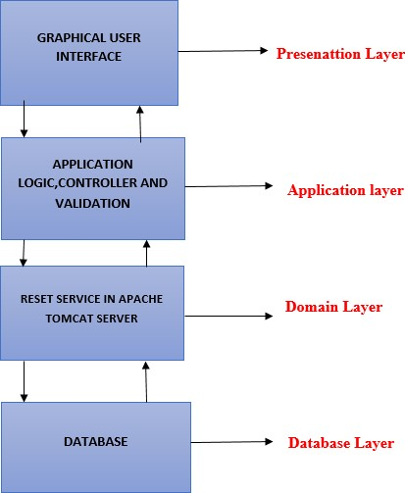

Figure 6: Crime Reporting System’s Layers as Seen by the crime reporter

The Following are the layers of the Crime reporting System as seen by investigative police officer.

#### Presentation Layer

It is the part of the application that the police investigation officers use, known as the client side. It offers a comprehensive graphical user interface that the officers can use to view the cases that have been reported, the registered reporters, and to change the status of the cases as the investigation continues. In a nutshell, it's a graphical user interface that allows cops to edit data on recorded crimes.

#### Application Layer

This layer entails the controllers that organize data got from the presentation layer in the form of java objects that they pass to the Models.

#### Model Layer

Model layer consists of the models, which are responsible for receiving data objects from controllers, manipulating the data using methods which may also connect to a database, and returning the desired output. These models are part of the model layer. Its primary use is to carry Java methods for the manipulation of data or the execution of business logic.

**Database Layer:** The database layer entails majorly the database which is the system’s central repository where data gets stored. The host server is MySQL.

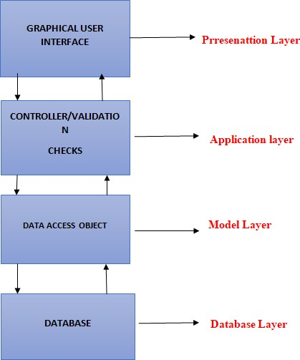

Figure 7: Crime Reporting System Layers as Seen by the Investigation Police Officer

### 5.5 Process Logic Design of proposed system

It refers to the logical connections and the flow of information that exist between the various data pieces that are a part of the information system. They are able to accurately express the requirements and also design the responses that are required for these requirements. The logical design for the Crime Reporting System is depicted in the following diagram. It demonstrates the logical interrelationships as well as the flow of data between the many data pieces that are involved.

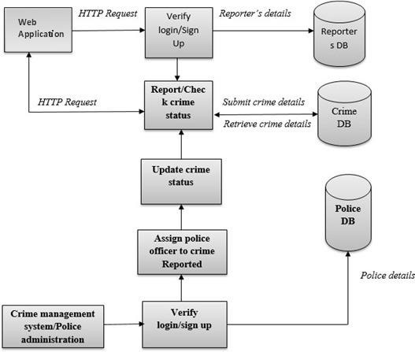

Figure 8: Crime Reporting System Logical Design Model

### 5.6 Crime Reporting System Physical Design Model

The physical model describes the software and hardware components which will be deployed into the general target environment. The model shows items including network connectivity, hardware platforms, and software components.

The diagram below shows the physical model for the Crime Reporting System

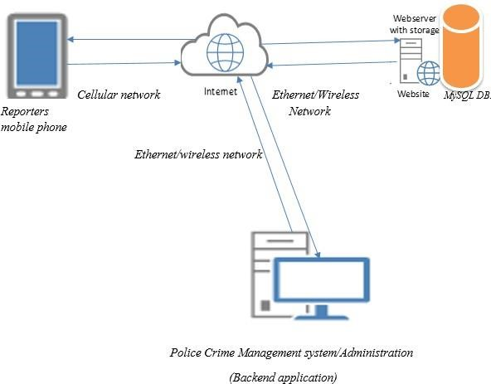

Figure 9: Crime Reporting System Physical Design Model

#### Interaction Models

Interaction model refers to a design model which binds together an application in a way which supports the conceptual models of the target users. These models include the sequence diagram, use case diagram, and flowchart diagram, among others.

#### 5.6.1 Use case Diagram

The Use case diagrams summarizes the system users’ details and how they interact with the Crime Reporting System**.**

The diagram below shows the use case diagram for individuals reporting the crime

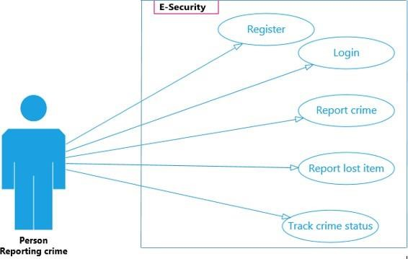

Figure 10: Use Case Diagram of a Person Reporting Crime

The following diagram illustrates the use case diagram for law enforcement officials conducting criminal investigations. It demonstrates the capabilities of an investigations officer once they have registered with the system and logged in. These include, among other things, finding the position of the reporter while they are reporting a crime, updating the status of the incident, searching for previously reported crimes, and viewing the registered reporters.

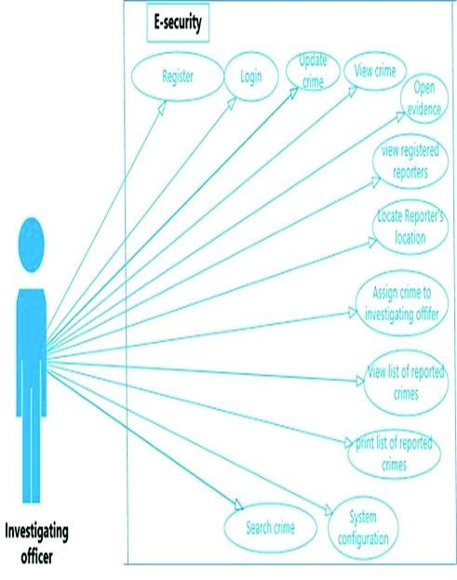

Figure 11: Use Case Diagram of the Police Officers Handling a Reported Crime

#### 5.6.2 Flowchart/Activity Diagrams

Flowchart are used to visually represents the sequence of decisions and steps required to perform a process. The diagram below shows the flowchart diagrams of the crime reporter.

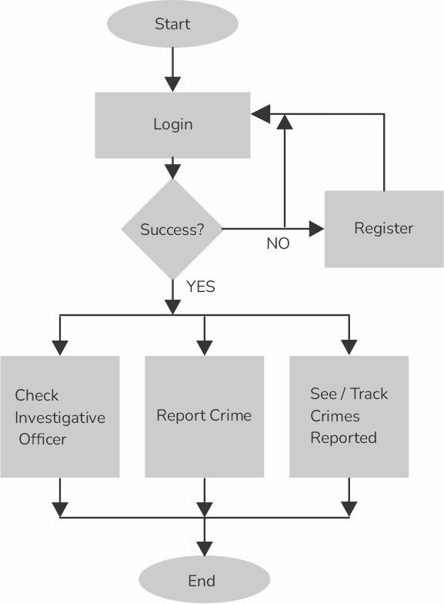

Figure 12: Flowchart Diagram of a Person Reporting Crime

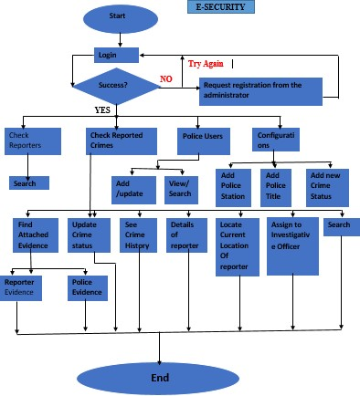

Figure 13: Flowchart Diagram for the Police Officers Dealing with the Reported Crimes

#### 5.6.3 Sequence Diagram

A sequence diagram is used to portray the interaction between different objects in a sequential order as in the figure below.

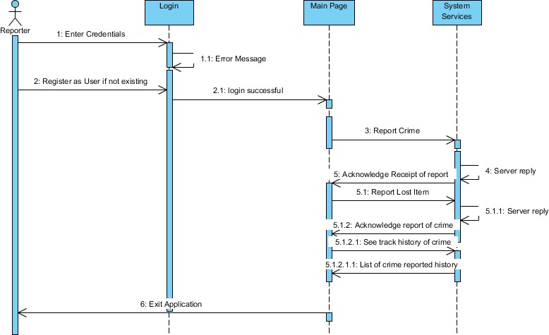

Figure 14: Sequence Diagram of a person reporting crime.

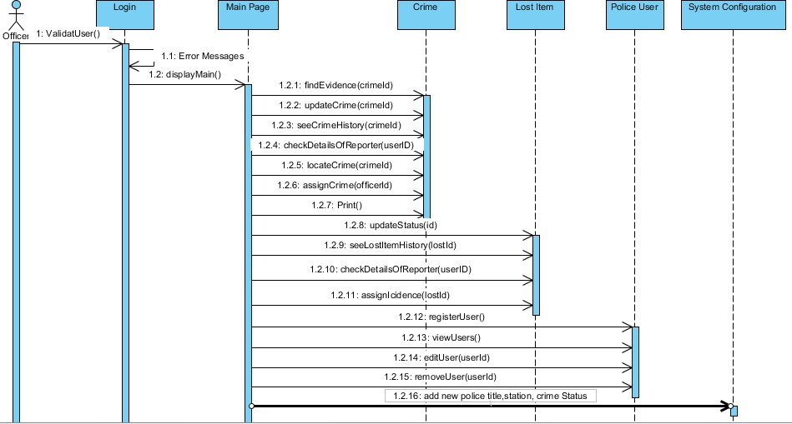

Figure 15: Sequence Diagram of Police Officers Working at the Administrator Side

### 5.7 Database Design

The database design for the Crime Reporting System includes an entity-relationship (ER) diagram to represent the relationships between data entities. Normalization techniques are used to ensure data integrity and consistency. A data dictionary is also included to provide detailed information about the data stored in the database.

The database schema for the Crime Reporting System is represented as the following:

|  |  |  |  |  |
| --- | --- | --- | --- | --- |
| **S/N** | **DATA TYPE** | **FIELD** | **FUNCTION**(S) | **CONSTRAINT**(**S**) |
| **1.** | Varchar (20) | CategoryCode | Stores the Mnemonic  for the Category  created | ***Pk*** |
| 2 | Varchar (50) | CategoryName | Store The Category  Identity | **Null** |

*Table 1 A Schema table for the SetupCategory table*

|  |  |  |  |  |
| --- | --- | --- | --- | --- |
| **S/N** | **Field** | **Function (S)** | **Data** **Type** | **Constraint(S)** |
| **1.** | CategoryCode | Reference a mnemonic for the created category | Varchar (20) | ***FK*** |
| **2** | SetupName | Store the setup name identity | Varchar (50) | Null |
| **3** | Description | Describe the function of the setup | Varchar (50) | Null |
| **4** | Remarks | Store the remarks | Varchar (50) | Null |
| **5** | CreatedDtTime | Stores creation date | DateTime | Null |
| **6** | CreatedBy | Store the user that created  it | Varchar (50) | Null |

*Table 2 Schema table for the General Setup*

|  |  |  |  |  |
| --- | --- | --- | --- | --- |
| **S/N** | **Field** | **Data** **Type** | **Function(S)** | **Constraint(S)** |
| **1.** | SN | Varchar (20) | Store mnemonic for the  created category | Null |
| **2** | FirstName | Varchar (50) | Store the user first name | Null |
| **3** | LastName | Varchar (50) | Store the user’s last name | Null |
| **4** | Gender |  | Store the gender for each  user | Null |
| **5** | RoleAccessID | Varchar (20) | Reference the mnemonic  for the created RoleAccessID | ***FK*** |
| **6** | Phone | Varchar (20) | Stores Phone Number | Null |
| **7** | Address | Varchar (50) | Store address for each user | Null |
| **8** | UserName | Varchar (20) | Store created username | ***PK*** |
| **9** | Password | Varchar (20) | Store the user’s unique  password | Null |

*Table 3 A Schema table for User*

|  |  |  |  |  |
| --- | --- | --- | --- | --- |
| S/N | **Field** | **Data** **Type** | **Function(s)** | **Constraint(s)** |
| 1. | SN | Varchar (20) | store a mnemonic for the  created incident | Null |
| 2 | CrimeTypeID | Varchar (20) | reference a mnemonic for  the created crimetypeID | ***PK*** |
| 3 | Description | Varchar (50) | Stores description of the  created crimetype | Null |
| 4 | State | Varchar (20) | Store incident state | Null |
| 5 | LGA | Varchar (50) | Stores incident LGA | Null |
| 6 | ReportedDtTime | Datetime | Store date and time for the  incident | Null |
| 7 | ReportedBy | Varchar (50) | Store Name of the reporter | Null |
| 8 | DeviceType | Varchar (50) | The type of connected  device used by the visitor | Null |
| 9 | DeviceTypeID | Int | The unique code that  represents the device | Null |
| 10 | MacAddress | Varchar (50) | The mac address of the  connected device | Null |
| 11 | SecurityAgent | Varchar (20) | The security agency that  should help the user to  investigate the crime | Not Null |
| 12 | ProgressNote | Varchar(max) | The updates on the  reported crime | Null |

*Table 4 A Schema table for Incident*

|  |  |  |  |  |
| --- | --- | --- | --- | --- |
| **S/N** | **Field** | **Data** **Type** | **Function(S)** | **Constraint(s)** |
| **1.** | RoleAccessID | Varchar (20) | store a mnemonic for the  created RoleAccess | ***PK*** |
| **2** | RoleTypeID | Varchar (20) | store a mnemonic for the  created RoleType | ***FK*** |
| **3** | AccessRightString | Varchar (50) | Store the accessRight  identity. | Null |
| **4** | CreatedDtTime | Datetime | Store date and time for  the Role | Null |
| **5** | CreatedBy | Varchar (50) | Store Name of the User | Null |

*Table 5 A Schema table for Role Access*

### 5.8 I/O of the proposed system (mock up screens)

The input/output of the proposed Crime Reporting System includes mock-up screens to represent the user interface for reporting crimes and receiving feedback.

### 5.9 Chapter Summary

In summary, this chapter provided a detailed design of the proposed Crime Reporting System. The strengths and weaknesses of the proposed system were discussed, along with a requirement analysis and conceptual architecture. Process logic design, database design, and input/output were also covered.

**CHAPTER 6**

## IMPLEMENTATION SYSTEM & TESTING

### 6.1 Introduction

In this chapter, the researcher will describe the implementation and testing of the Crime Reporting System. The researcher will showcase system screenshots to provide an overview of the user interface and features. Additionally, the researcher will delve into the implementation details and testing procedures undertaken to ensure the system's reliability, security, and usability.

### 6.2 System Screenshots

#### 6.2.1 Home Page

This is a screenshot of the homepage. It displays the main interface of the Crime Reporting System, providing an overview of the features and options.

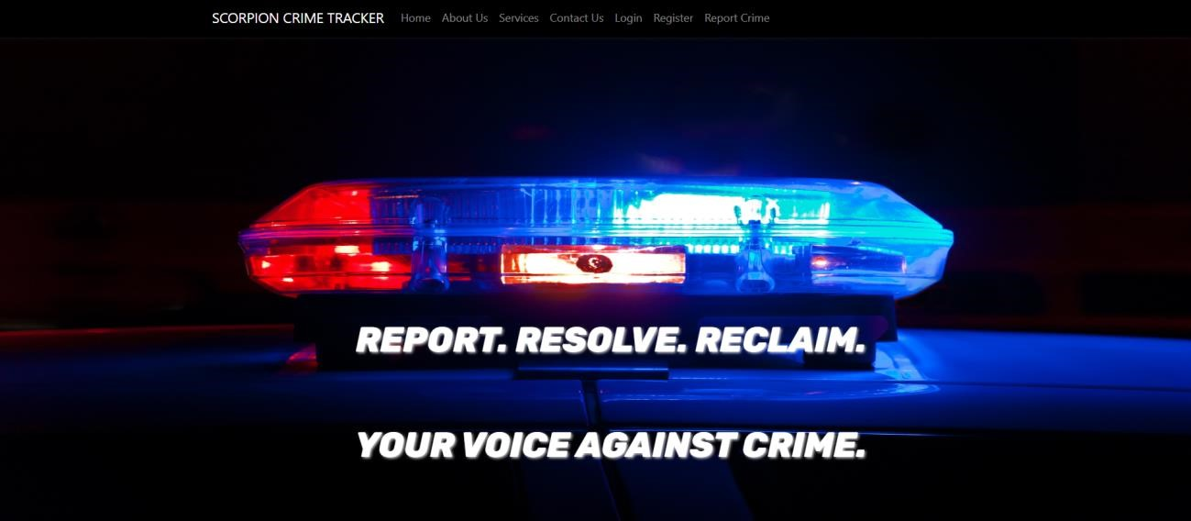

Figure 16: Homepage

#### 6.2.2 User Dashboard

The user dashboard screenshot showcases a clean and intuitive interface, tailored to meet individual users' needs. It prominently displays the user's reported crimes, crimes under investigation and completed crimes. The dashboard provides quick access report a crime and update contact details.

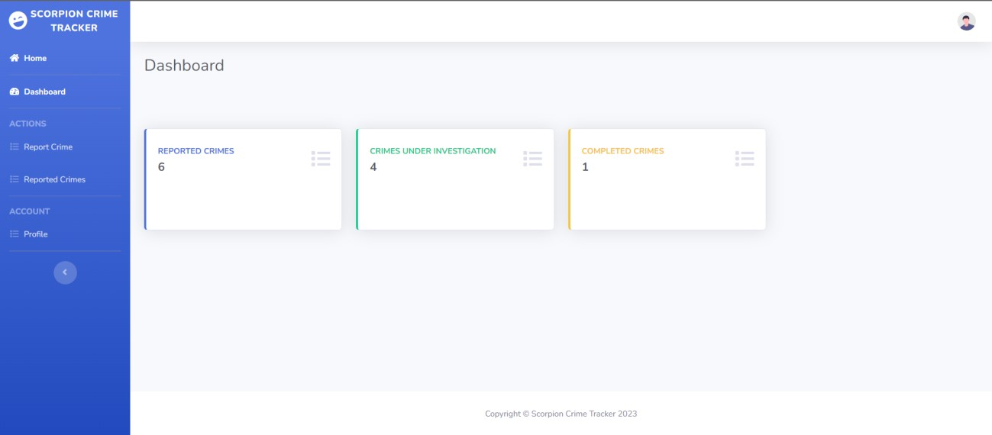

Figure 17: User Dashboard

#### 6.2.3 Admin Dashboard

The admin dashboard screenshot portrays a powerful and efficient interface designed for system administrators or privileged users. It offers a comprehensive overview of the website's performance, including real-time analytics, user statistics, and recent activity logs. The admin dashboard allows administrators to manage user accounts, approve or moderate content, and configure site settings with ease.

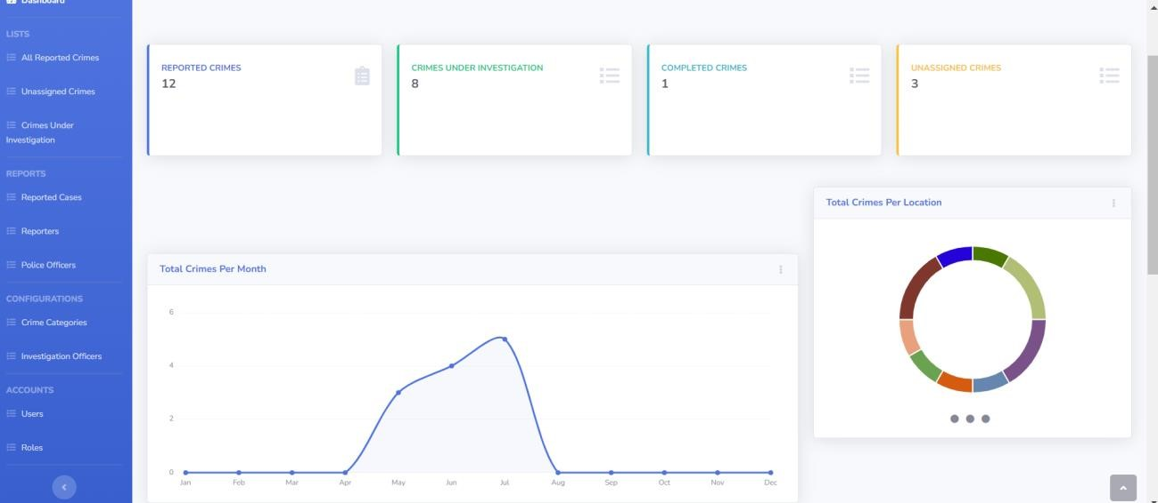

Figure 18: Admin Dashboard

### 6.3 Testing Plan

The testing phase is critical to ensuring the system's functionality, reliability, and security. The testing plan for the Crime Reporting System includes the following aspects:

1. **Unit Testing**: Each module and component of the system underwent unit testing to verify its individual functionality. Test cases were created to evaluate inputs, outputs, and error handling.
2. **Integration Testing**: The integration testing phase focused on validating the interactions between different modules to ensure they work seamlessly together.
3. **User Acceptance Testing (UAT)**: A group of representative users participated in UAT, including law enforcement personnel and citizens. They executed common use cases to validate the system's usability and provide feedback for improvements.
4. **Security Testing**: A comprehensive security assessment was conducted to identify and address vulnerabilities, such as data breaches, unauthorized access, or injection attacks.
5. **Performance Testing**: The system was subjected to performance testing under various loads to ensure it could handle a considerable number of users and data without slowdowns or crashes.
6. **Compatibility Testing**: The system was tested on different devices and browsers to ensure compatibility and responsiveness across various platforms.

### 6.4 Evaluation Plan

The evaluation plan aims to measure the success of the Crime Reporting System in meeting its objectives. Key performance indicators (KPIs) will be used to assess the system's effectiveness, efficiency, and user satisfaction. The evaluation plan includes the following:

1. **Crime Reporting Speed**: Measure the average time taken from the crime report submission to its acknowledgment and assignment by law enforcement.
2. **System Downtime**: Monitor the system uptime to ensure minimal disruptions and availability for users.
3. **User Feedback**: Gather feedback from users through surveys and interviews to understand their experiences and identify areas for improvement.
4. **Error Rate**: Evaluate the system's error rate during critical processes like crime data entry, user authentication, and data retrieval.
5. **Security Assessment**: Assess the system's security measures and identify any potential vulnerabilities that need to be addressed.

### 6.5 Chapter Summary

This chapter described the implementation and testing of the Crime Reporting System. The system enables users to report crimes and receive feedback on their reports. Screenshots of the system were provided, along with a testing plan and an evaluation plan. The next chapter will discuss future developments for the system.

## CHAPTER 7

**CONCLUSIONS, FINDINGS & RECOMMENDATIONS**

### 7.1 Introduction

This section presents the conclusions, findings, and recommendations for the Crime Reporting System. The system is a software project designed to enable users to report crimes and receive feedback on their reports. It aims to improve the efficiency and effectiveness of crime reporting and tracking, by providing a user-friendly interface for users to submit reports and communicate with the authorities. This section will summarize the key conclusions and findings from the development and implementation of the system, as well as provide recommendations for future improvements.

### 7.2 Conclusion

The development and implementation of the Crime Reporting System have proven to be a significant milestone in enhancing crime reporting and feedback mechanisms. Through this system, users can easily report crimes and receive timely updates, fostering a more secure and responsive community. The project has successfully addressed the primary objectives, and its impact on crime prevention and community engagement has been noteworthy.

The Crime Reporting System has demonstrated its ability to streamline the crime reporting process, providing an intuitive and user-friendly interface for both reporting incidents and receiving feedback. The adoption of modern technologies and best practices has ensured the system's reliability, security, and scalability.

### 7.3 Findings

Throughout the development and deployment of the Crime Reporting System, several key findings have emerged:

1. Improved Crime Reporting: The system has significantly improved the efficiency and accuracy of crime reporting. Users can easily submit incident details, leading to quicker response times from law enforcement agencies.
2. Enhanced Community Engagement: The interactive nature of the platform has fostered better communication between law enforcement and the community. This, in turn, has led to increased trust and cooperation, contributing to overall crime reduction.
3. Real-time Updates: The integration of real-time updates has allowed users to stay informed about the status of their reported crimes, providing a sense of security and transparency.
4. Data-Driven Insights: The system has generated valuable data on crime patterns and trends, aiding law enforcement agencies in making data-driven decisions for resource allocation and crime prevention strategies.

### 7.4 Challenges Encountered

During the development and implementation of the Crime Reporting System, several challenges were encountered:

1. Data Privacy and Security: Ensuring the privacy and security of sensitive information posed a significant challenge. Measures were implemented to safeguard user data and prevent unauthorized access.
2. User Adoption: Encouraging widespread adoption of the system within the community required targeted awareness campaigns and user education.
3. Integration with Existing Systems: Integrating the Crime Reporting System with preexisting law enforcement databases and systems required careful planning and coordination.
4. Technical Glitches: At times, technical issues and system downtimes affected the smooth functioning of the platform, leading to a temporary disruption in services.

### 7.5 Future Recommendations

To further enhance the Crime Reporting System and ensure its long-term success, the following recommendations are proposed:

1. Mobile Application: Develop a mobile application for the Crime Reporting System to increase accessibility and convenience for users, allowing them to report crimes on the go.
2. AI and Data Analytics: Implement advanced AI algorithms and data analytics to process crime data more efficiently and extract actionable insights for law enforcement agencies.
3. Multilingual Support: Incorporate multilingual support to accommodate users from diverse linguistic backgrounds. This will promote inclusivity and ensure that all community members can easily access and use the system.
4. Geolocation and Mapping: Enhance the system with geolocation and mapping capabilities to provide law enforcement agencies with precise crime location data. This will aid in crime analysis, resource allocation, and the identification of high-crime areas.
5. Integration with Social Media: Explore the integration of the Crime Reporting System with popular social media platforms to amplify public outreach, share crime prevention tips, and engage with the community effectively.
6. USSD Code Integration: To ensure inclusivity and accessibility for individuals without smartphones or internet access, integrate the Crime Reporting System with a USSD (Unstructured Supplementary Service Data) code. This feature will allow users to report crimes and receive feedback using simple text-based commands on basic mobile phones.

### 7.6 Conclusion

The Crime Reporting System has been successful in revolutionizing crime reporting and feedback mechanisms, empowering the community and law enforcement agencies alike. Despite challenges faced during development, the system's positive impact on crime prevention and community engagement cannot be overlooked.

To sustain its success and relevance, continuous improvement, innovative enhancements, and strategic collaborations are essential. By implementing the recommended measures, the Crime Reporting System can evolve into an even more powerful tool for combating crime and fostering a safer and more secure community. The commitment to this ongoing development will solidify the system's place as a vital component of crime management and prevention in the future.

# References

Diamond, L. (1999). *Developing democracy: Toward consolidation.* JHU press.

Younus, A. M. (2021). *Technological Advancement and Economic Growth for The Business Sector.* Academic Journal of Digital Economics and Stability, 10, 56-62.

## APPENDICES

### APPENDIX A: CRIME REPORTING SYSTEM QUESTIONNARRE

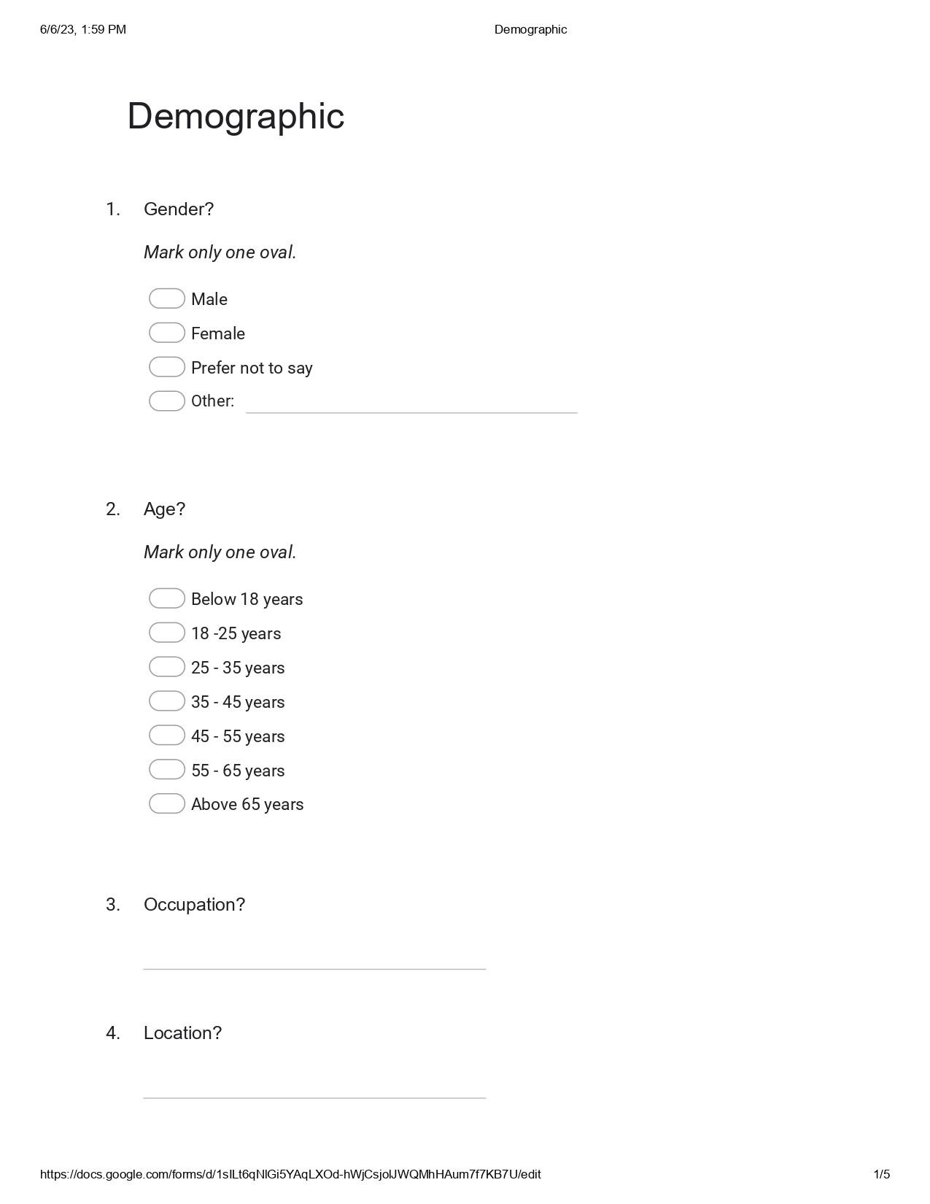



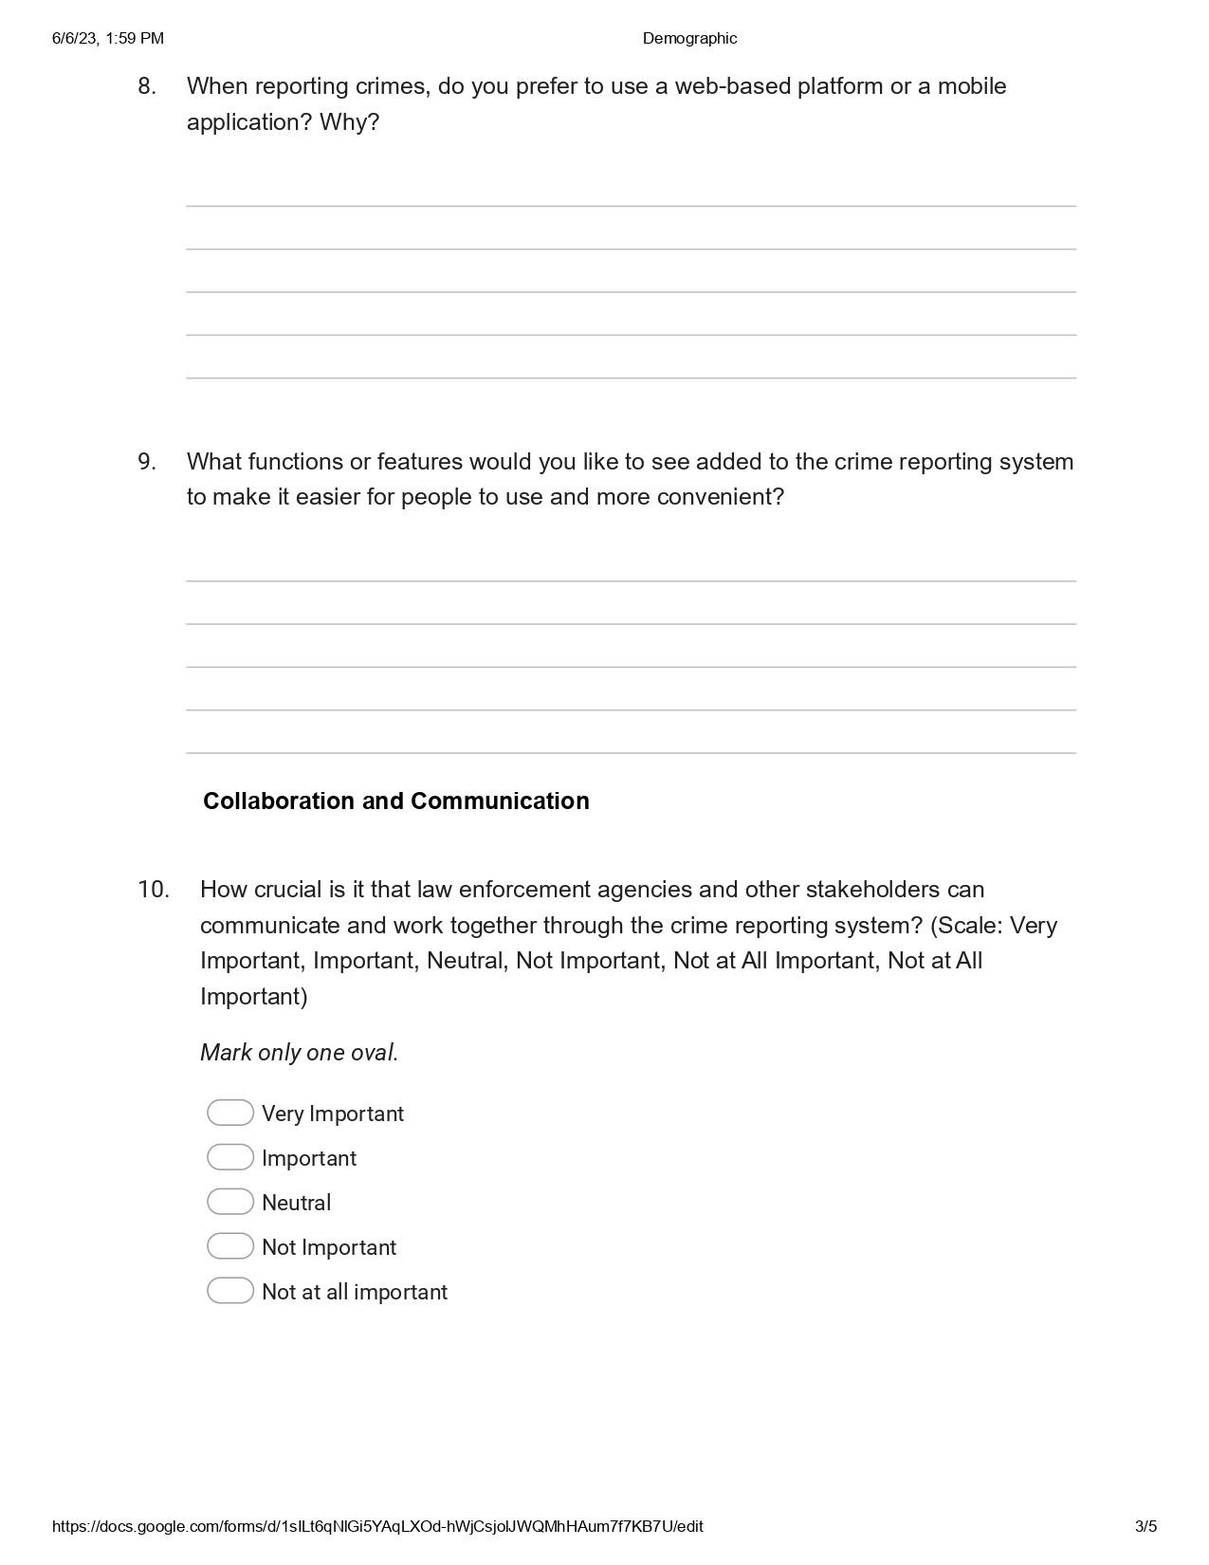

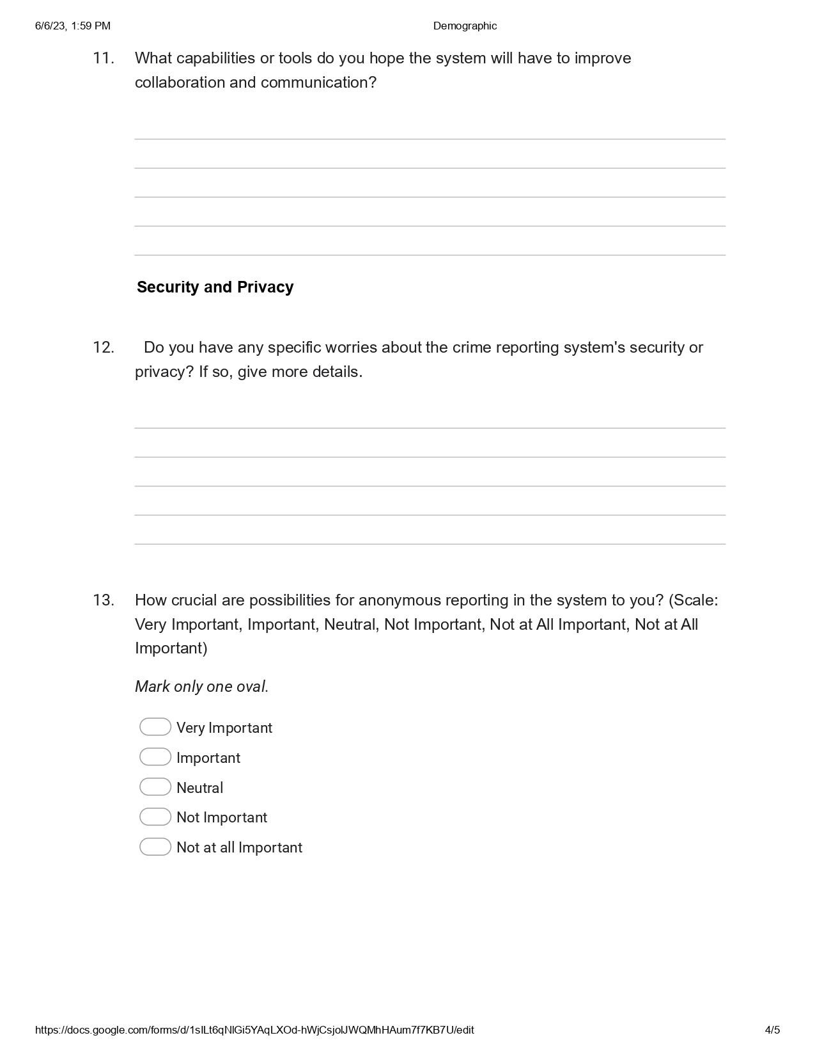

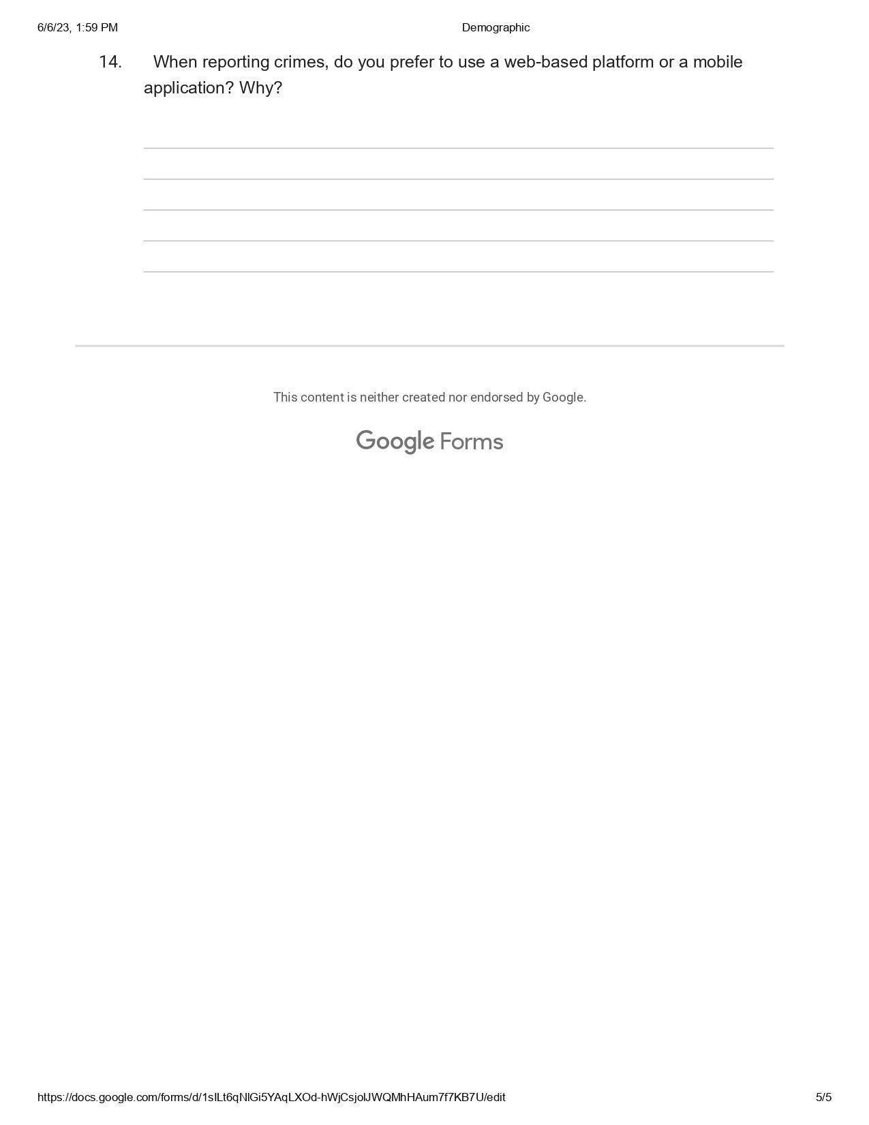

### 2 Budget

|  |  |  |
| --- | --- | --- |
| **Resource** | **Quantity** | **Cost** |
| Laptop | 1 | 30000 |
| Miscellaneous |  | 3000 |
| Mailjet Email API |  | Free |
| Data bundles | 20Gb | 4000 |
| Printing and Binding | 3 copies | 4000 |
| TOTAL |  | Ksh 39,000 |

*Table 6 Budget*

### 3 Project Schedule

This Schedule plan shows how the schedule of time will be taken from project initiation to project completion.

|  |  |  |  |  |
| --- | --- | --- | --- | --- |
| **TASK** | **EXPECTED**  **START**  **DATE** | **ACTUAL**  **START**  **DATE** | **EXPECTED**  **END DATE** | **ACTUAL**  **END**  **DATE** |
| **Proposal**  **Writing** | 01/02/2023 | 04/02/2023 | 15/02/2023 | 18/02/2023 |
| **Feasibility**  **Study** | 28/02/2023 | 01/03/2023 | 28/03/2023 | 30/03/2023 |
| **Requirements**  **Analysis** | 01/04/2023 | 05/04/2023 | 20/04/2023 | 22/04/2023 |
| **System design** | 30/04/2023 | 02/05/2023 | 25/05/2023 | 29/05/2023 |
| **Coding** | 02/06/2023 | 04/04/2023 | 28/06/2022 | 30/06/2023 |

**Testing** 01/07/2023 03/07/2023 26/07/2023 28/07/2023

*Table 7 Project Schedule*

### 4 Gantt Chart

|  |  |  |  |  |  |  |
| --- | --- | --- | --- | --- | --- | --- |
| Activity | Feb | Mar | April | May | June | July |
| Proposal writing |  |  |  |  |  |  |
| Feasibility study |  |  |  |  |  |  |
| Requirement Analysis |  |  |  |  |  |  |
| System Design |  |  |  |  |  |  |
| Coding |  |  |  |  |  |  |
| Testing |  |  |  |  |  |  |
| Documentation |  |  |  |  |  |  |

*Table 8 Gantt Chart*