Global Monetary Regimes & Canadian Monetary Policy Analysis
Author: Emilomo Joan Atale
Project: Interest Rate and Macroeconomic Data Analysis
Date: March 2026

1. Introduction
This project analyzes how interest rate changes influence key macroeconomic indicators, including inflation, GDP growth, and unemployment in Canada. In addition to examining domestic monetary policy effects, the study compares the Bank of Canada's policy decisions with those of other major central banks to better understand global monetary policy dynamics.

By analyzing historical policy rate data and macroeconomic indicators, this project aims to identify patterns in monetary policy transmission and evaluate the broader economic effects of interest rate adjustments.

2. Research Question
- How do interest rate changes influence inflation, GDP growth, and unemployment in Canada, how closely does Canadian monetary policy follow global central bank trends, particularly those of the U.S. Federal Reserve, most aggressive vs. most stable central banks and how the central banks Synchronization During Crises?

3. Data Sources (Kaggle – Top 8 Central Bank Interest Rates)
The analysis utilizes two structured datasets stored in a relational SQL database.

InterestRate_CD
Contains historical policy interest rates for major global central banks including:
- Federal Reserve
- Bank of Canada
- European Central Bank
- Bank of England
- Swiss National bank
- Peoples Bank of China
- Reserve Bank of Australia

CanadaMacro_CD
Contains Canadian macroeconomic indicators including:
- Inflation rate
- GDP growth
- Unemployment rate

These datasets were combined to evaluate relationships between monetary policy decisions and economic performance.

4. Tools Used
The analysis was conducted using multiple analytical tools:
- SQL Server – Database storage and query execution
- SQL – Data extraction, aggregation, and transformation
- Python – Statistical analysis and visualization
- Power BI – Interactive dashboard development
- Microsoft Word – Documentation and report preparation

5. Methodology
This project follows a structured data analytics workflow, consisting of data collection, cleaning, exploration, analysis, modeling, interpretation, visualization, and reporting.

5.1 Data Collection
Macroeconomic and central bank policy rate data covering the period 1980–2025(Q1) were collected from Kaggle.

The dataset was imported into SQL Server and stored in relational SQL tables to enable efficient querying, structured storage, and time-series analysis.

5.2 Data Cleaning
Data cleaning and preparation were conducted using Power Query and DAX in Power BI to ensure the datasets were accurate and ready for analysis.

Data Integrity
Both datasets (InterestRate_CD and CanadaMacro_CD) were reviewed in the Power Query Editor to examine column structures, verify data types, and identify potential inconsistencies.

- Handling Missing Values: Missing values were identified in the European Central Bank (ECB) interest rate column within the InterestRate dataset. These null values occurred because the dataset begins in 1980, while the ECB was established in 1998. Records containing ECB null values were excluded when analyzing ECB interest rate trends
- Date Formatting: The Date column was converted to the Date data type in Power Query to ensure consistent formatting and enable chronological time-series analysis.
- Data Integration: The InterestRate_CD and CanadaMacro_CD datasets were merged in Power Query using the Date field to align macroeconomic indicators with central bank interest rate observations.
- Data Transformation: Numeric variables such as interest rates, inflation, GDP growth, and unemployment were verified and formatted as numeric data types to support analysis and visualization.

5.3 SQL Analysis
SQL queries were used to prepare and analyze the data.
Key SQL techniques included:
- GROUP BY aggregation for yearly averages
- CASE statements for policy regime classification
- Standard deviation calculations to measure volatility
- JOIN operations between interest rate and macroeconomic datasets
- Window functions such as LAG () to analyze policy changes over time

5.4 Interest Rate Regime Classification
Interest rate levels were categorized into three policy regimes to identify different historical monetary environments:

Regime | Interest Rate Range
High-Rate Regime | Above 6%
Moderate Rate Regime | 2% – 6%
Low-Rate Regime | Below 2%
This classification helps identify periods of tightening and accommodative monetary policy.

- Evolution of Global Monetary Regimes Since 1980
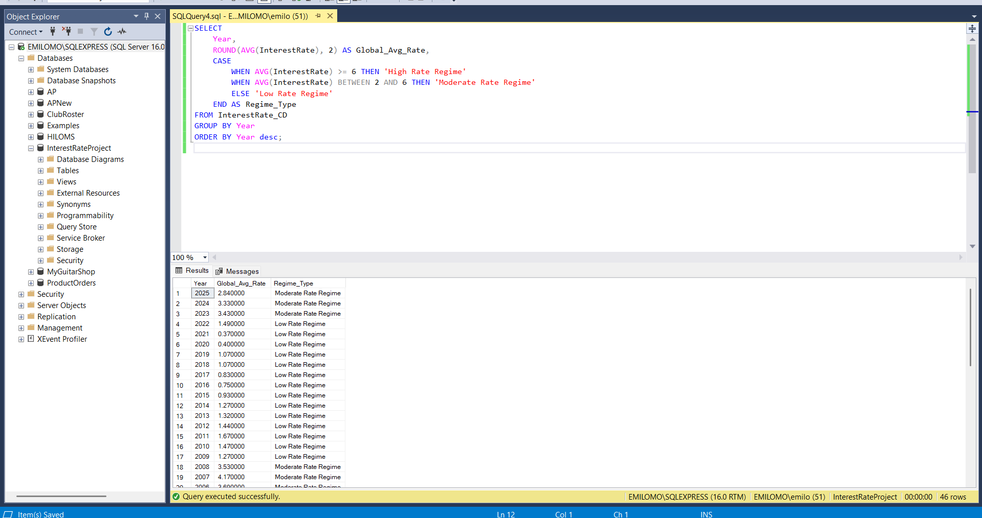Global monetary policy has evolved through several distinct phases.
During the 1980s, central banks maintained high interest rates to combat inflation.
Between the 1990s and early 2000s, interest rates gradually declined as inflation stabilized.
Following the 2008 Global Financial Crisis, many central banks adopted ultra-low interest rates and unconventional policies such as quantitative easing.
More recently (2022–present), central banks have returned to aggressive tightening to address rising inflation.

- Most Aggressive vs. Most Stable Central Banks
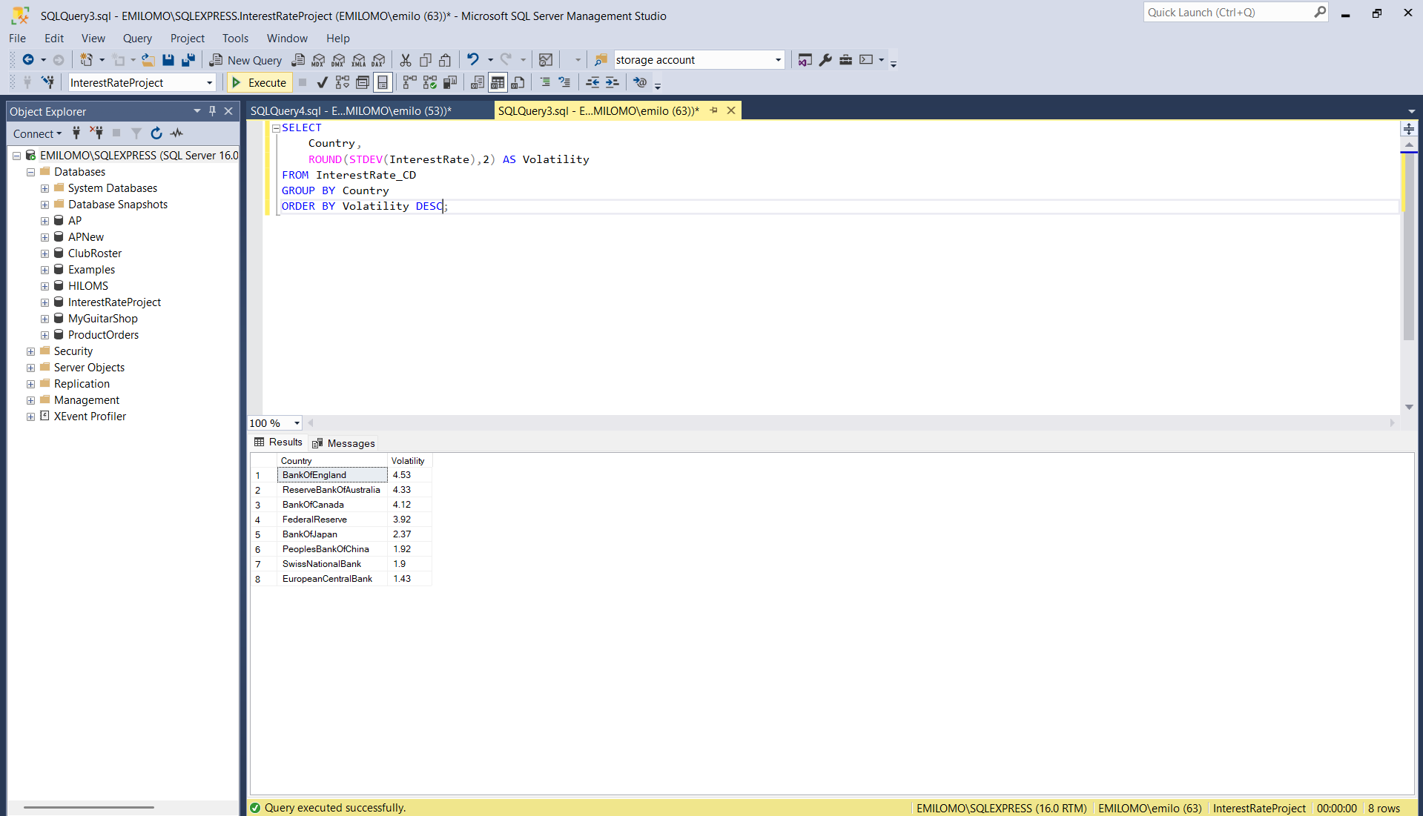
Volatility analysis indicates that the Bank of England and the Reserve Bank of Australia exhibit relatively high-interest rate volatility, reflecting more aggressive policy adjustments.
In contrast, the European Central Bank demonstrates comparatively lower volatility, indicating a more gradual policy approach.
Higher volatility may strengthen inflation control but can increase financial uncertainty, while lower volatility provides stability but may limit policy responsiveness.

- Central Bank Synchronization During Crises
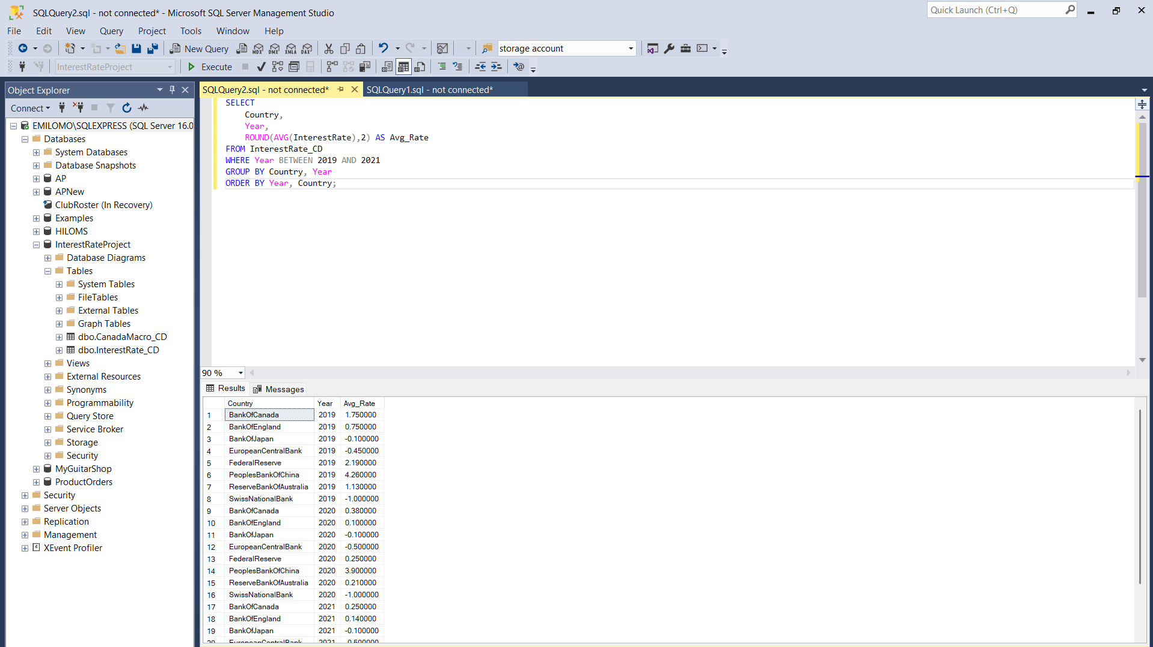During global crises, particularly the 2020 pandemic, major central banks reduced interest rates in a broadly synchronized manner.
Although policy direction was aligned, the magnitude of adjustments varied across economies due to differences in domestic economic conditions and institutional frameworks.

- Monetary Policy Volatility Across Economies
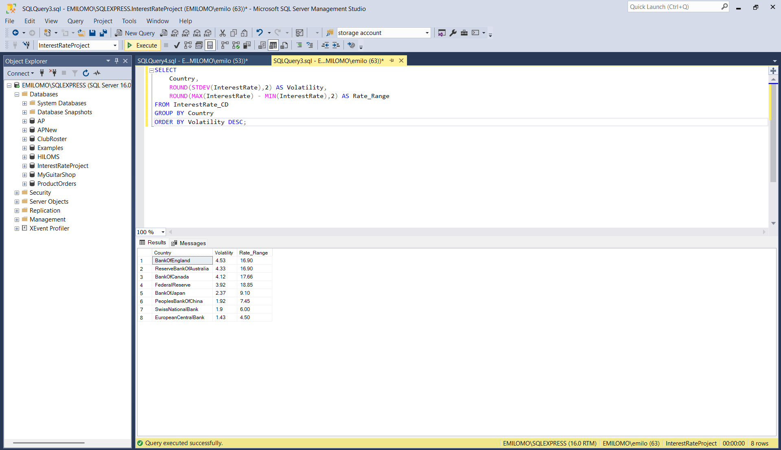Interest rate volatility differs significantly across countries. Economies with higher volatility experience greater fluctuations in borrowing costs and financial conditions, while lower-volatility regimes provide greater predictability but may respond more slowly to economic shocks.

- Canada’s Reactivity to the Federal Reserve
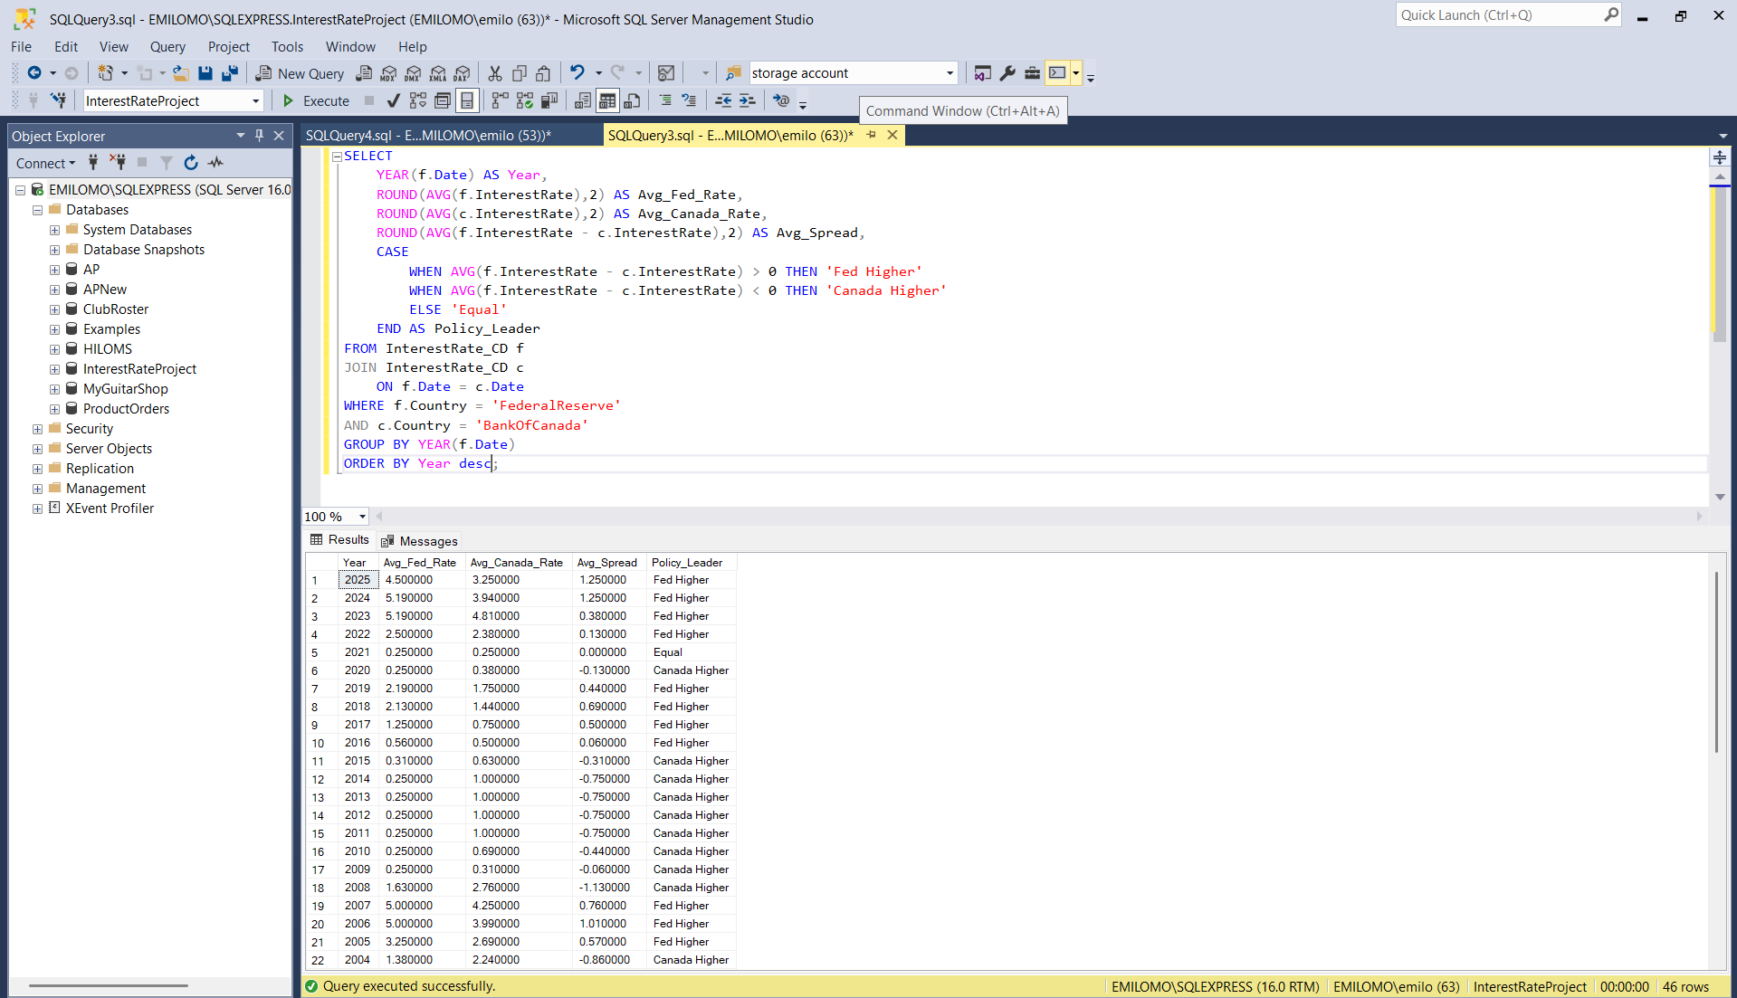Canada exhibits partial responsiveness to U.S. monetary policy due to strong trade relationships, capital mobility, and exchange rate dynamics.
However, the Bank of Canada maintains policy independence, adjusting interest rates primarily based on domestic economic conditions

- Impact of Interest Rates on Inflation in Canada
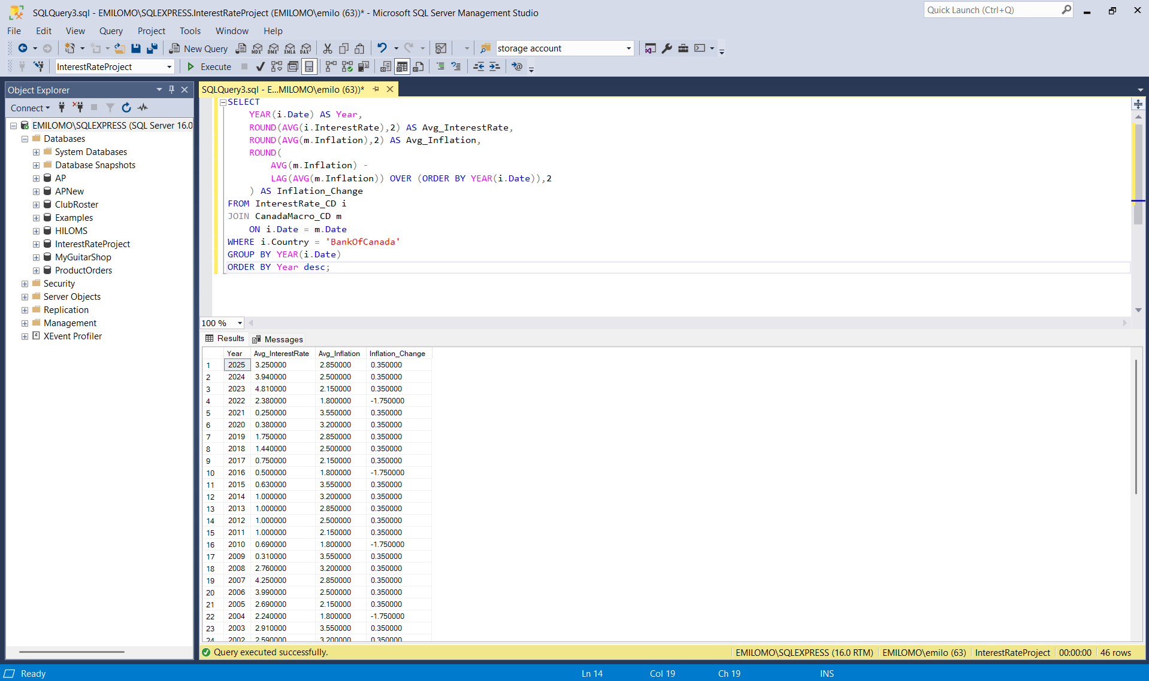The analysis indicates that rising inflation is often followed by increases in policy rates, suggesting reactive monetary policy behavior.
Subsequent declines in inflation after tightening cycles indicate effective transmission of monetary policy decisions.

- Impact of Interest Rates on GDP Growth
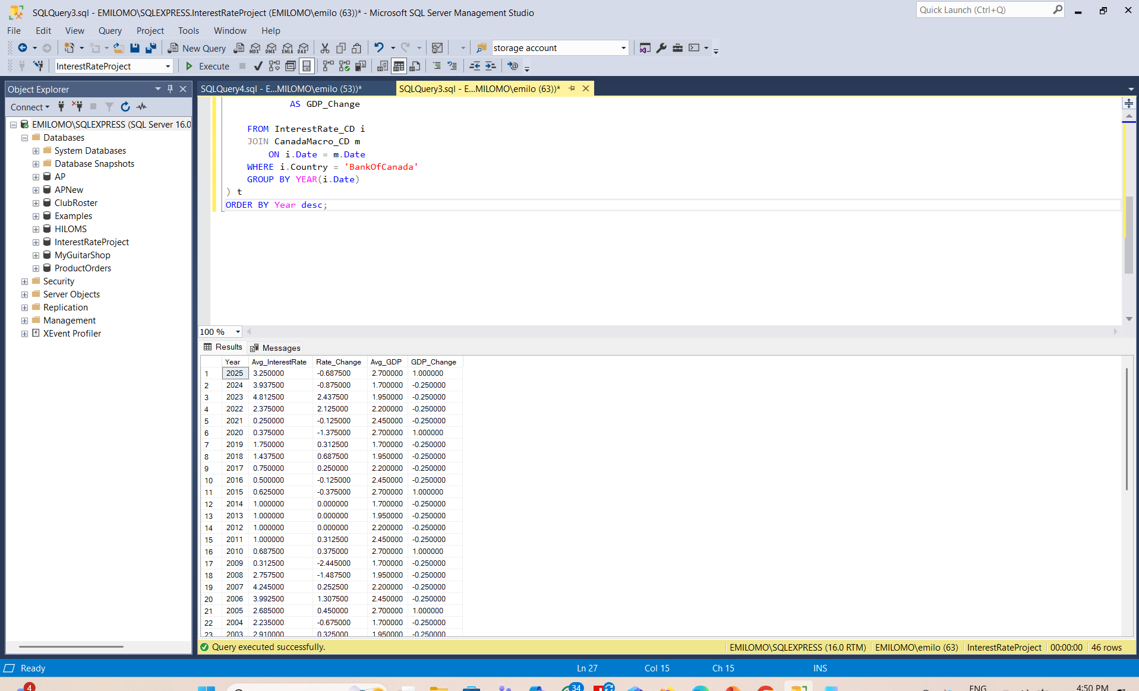Interest rate increases tend to slow economic growth by raising borrowing costs and reducing investment and consumer spending.
Conversely, lower interest rates stimulate economic activity by encouraging credit expansion and investment

- Impact of Interest Rates on Unemployment
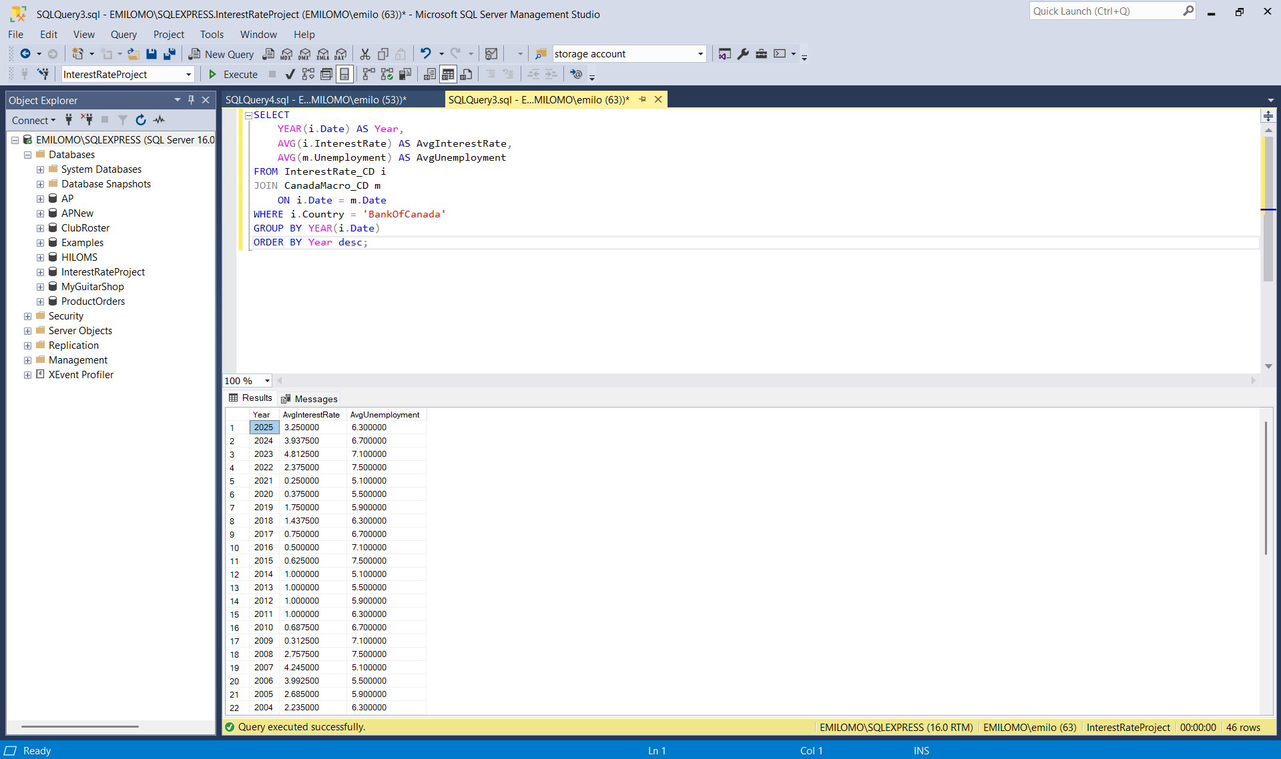Despite significant variation in interest rates, unemployment in Canada has remained relatively stable within a moderate range. This suggests resilience in the labor market and possible lag effects in the transmission of monetary policy.

- Central Bank Rates and Lending Conditions
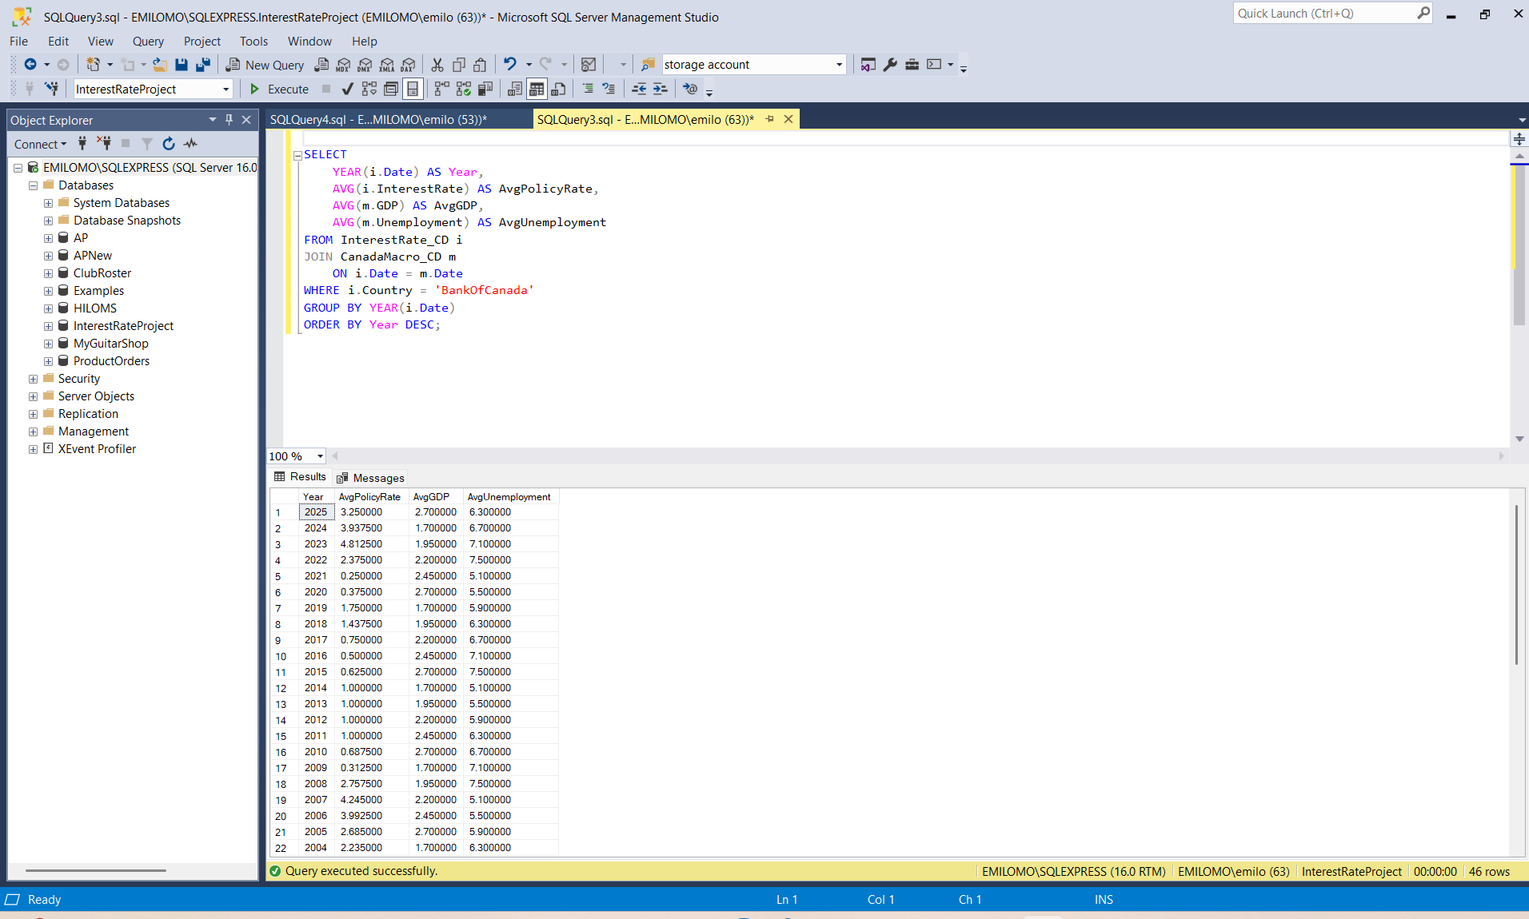Although direct lending data was not analyzed, macroeconomic indicators suggest that higher policy rates increase borrowing costs and tighten credit conditions, while lower rates encourage credit expansion and economic growth.

- High-Interest Rate Periods and Economic Conditions in Canada
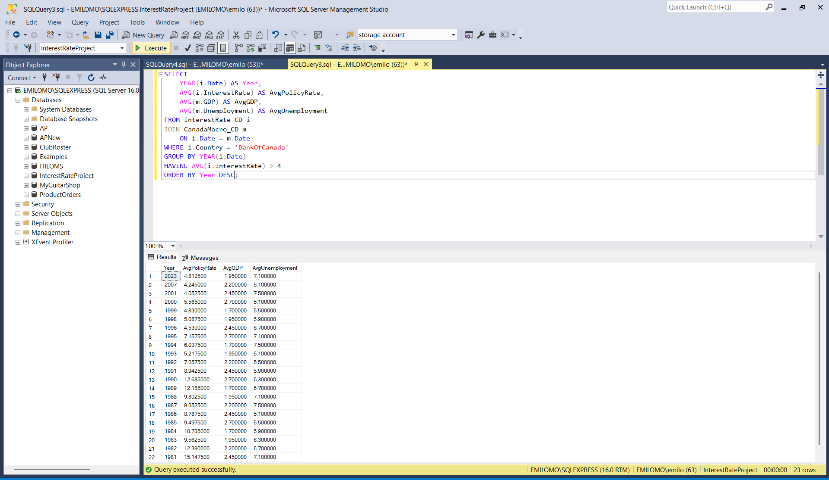Periods of monetary tightening, characterized by higher average policy rates are associated with moderate GDP growth and mild upward pressure on unemployment. Higher financing costs during these periods may discourage business expansion and investment.

6. Python Data Analysis
Python was used to conduct additional statistical analysis and visualization.
Libraries Used
- Pandas – Data manipulation
- Matplotlib – Time-series visualization
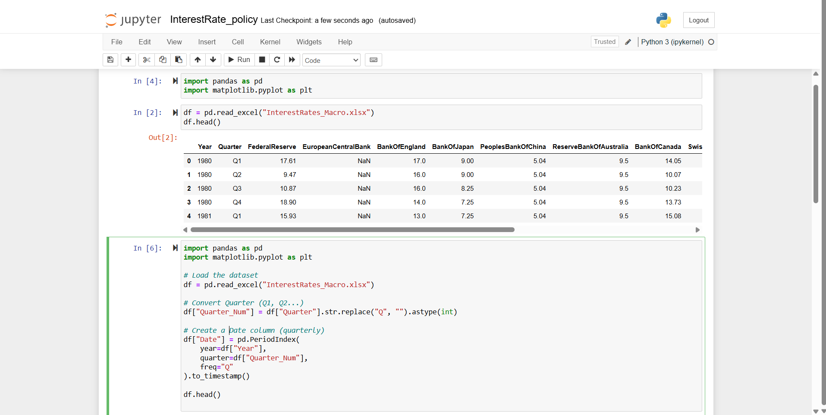

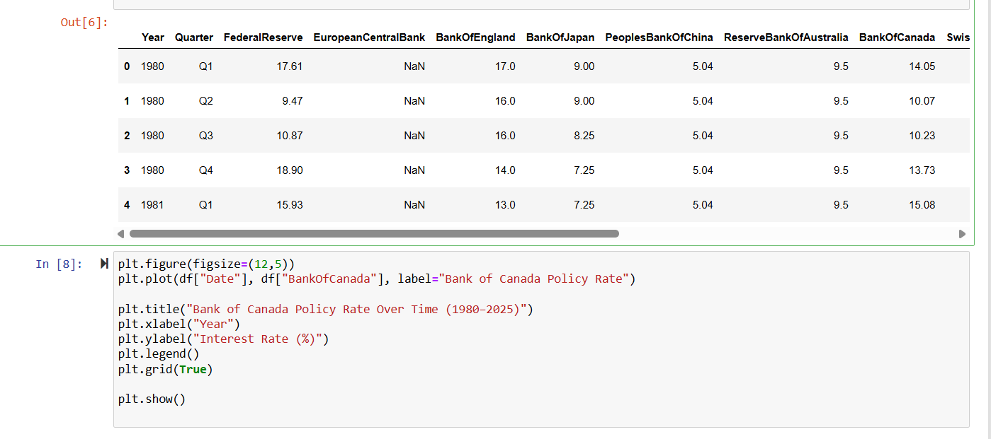
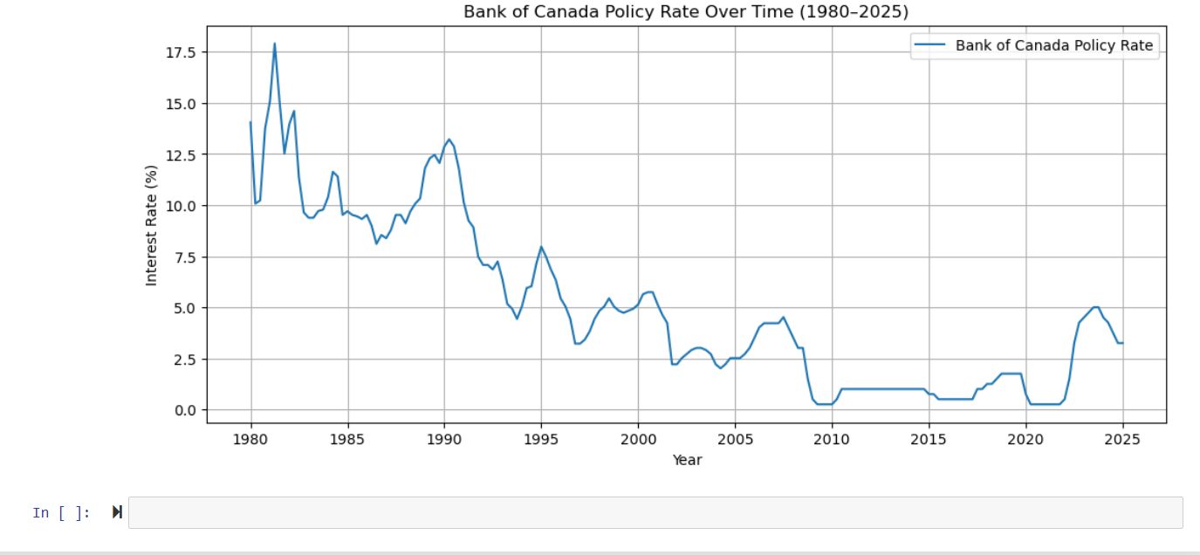

7. Power BI Dashboard
Power BI was used to develop an interactive dashboard to visualize the relationship between interest rates and key macroeconomic indicators. The dashboard enables users to explore trends in monetary policy and examine how interest rate changes influence economic conditions in Canada.
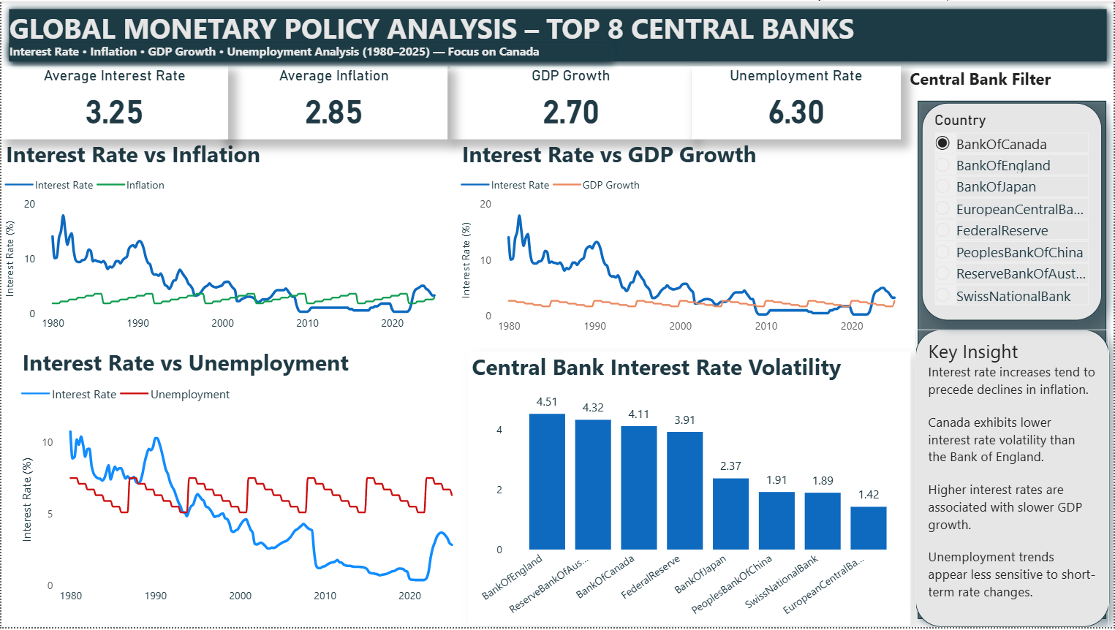

Conclusion
Overall, the analysis demonstrates that monetary policy significantly influences inflation, economic growth, and financial conditions in Canada and globally.
While transmission effects vary in magnitude and timing, interest rate adjustments remain a central tool in stabilizing economic cycles.

Key Findings
- Global interest rates have transitioned from high inflation regimes in the 1980s to ultra-low-rate environments following the 2008 financial crisis.
- Major central banks tend to synchronize policy direction during global crises.
- Canada demonstrates partial monetary policy alignment with the U.S. Federal Reserve.
- Interest rate increases tend to reduce inflation but slow GDP growth.
- The Canadian labor market shows relative stability despite policy rate fluctuations.

Future Work
Future research could extend this analysis in several ways:
First, additional datasets such as government bond yields, credit conditions, and exchange rates could be incorporated to provide a deeper understanding of financial market responses to monetary policy.

Second, more advanced econometric techniques such as regression analysis or vector autoregression (VAR) models could be applied to measure the causal impact of interest rate changes on macroeconomic indicators.

Third, higher-frequency data (quarterly or monthly) could be analyzed to better capture the short-term dynamics of monetary policy transmission.

