

**Morse code app.**

***About and user manual.***

2018, Useless solutions.

**2. Table of contents**

2. Table of contents……………………………………………………...2

3. About *Morse code app* project………………………………………..3

4. System requirements………………………………………………….4

5. Distribution and Installation…………………………………………..5

6. Functionality and features…………………………………………….6

6. 1. Translation from Latin text to Morse code……………………6

6.1.1. Playback………………………………………………7

6.1.2. Playback using flashlight……………………………...7

6.1.3. Playback using sound…………………………………8

6.1.4. Playback using vibrations……………………………..9

6. 2. Translation from Morse code to Latin text…………………..10

7. Troubleshooting and contacts….......………………………………...11

**3. About *Morse code app* project**

*Morse code app* is an app designed by *Accenture Latvia JAVA boot camp* students as a final project of the month long boot camp. Development of the app took approximately two weeks’ time. Development started on 20th of August, 2018 and ended on 30th of August, 2018. Team consisted of 5 members and the name of the team is “Useless Solutions”. The app was written in *JAVA* programming language using *Android studio* and *Eclipse* as the main development environments. Junit was used for unit tests. The app is not completely finished.

*Morse code app* is a native app and is developed for *Android* operating system. *Morse code app* is a utility app designed to translate Latin text into Morse code and Morse code into Latin text.

*Morse code app* was developed as a learning project. Main aims of the app development were to:

* Develop a functioning Android application as a part of *Accenture Latvia JAVA boot camp* curriculum.
* Develop an app which has a real-world application.
* Learn and use tools required for *Android* app development.
* Practise *JAVA* programming language.
* Learn the basics of project management and structure.

**4. System Requirements**

*Morse code app* is currently available on *Android* mobile devices. List of *Android* versions **supported**:

* *Android “Nougat” 7.0(API 24),*
* *Android “Nougat” 7.1(API 25),*
* *Android “Oreo” 8.0(API 26),*
* *Android “Oreo” 8.1(API 27),*

Might work on these *Android* versions but **not supported**:

* *Android “Pie” 9.0(API 28).*

Hardware requirements:

* Flashlight,
* Touch screen,
* Speakers,
* Vibrator.

**5. Distribution and Installation**

*Morse code app* is an open source project. Anyone can freely access the source code and the application for using, testing, improving, modifying etc. Source code is available on our official *GitHub* repository:

* [*https://github.com/telumindel/Useless_Solutions_Repo*](https://github.com/telumindel/Useless_Solutions_Repo)

Morse code app currently is not available on *Google Play* store. To install the application, you must download the **.apk** file from [*https://github.com/telumindel/Useless_Solutions_Repo*](https://github.com/telumindel/Useless_Solutions_Repo)

**How to install the application:**

1. *Open any browser.*
2. *Go to:* [*https://github.com/telumindel/Useless_Solutions_Repo*](https://github.com/telumindel/Useless_Solutions_Repo)
3. *Download the* ***.apk*** *file from “apkfile” folder, open “Downloads” and tap on the* ***.apk*** *file.*

*(In devices running Android 7.1 and older, go to settings – security and tick “Unknown sources” box before opening the file)*

1. *The application should be installing.*
2. *After it is done installing, run the application and enjoy.*

**6. Features and functionality.**

The two main features of the app are translating Latin text to Morse code and vice versa. Morse code, which has been translated from Latin text, can be played back using flashlight (visual reception), sound (auditory reception) or vibrations (sensory reception). Application also provides brief information about Morse code.

**6.1. Translation from Latin text to Morse code.**

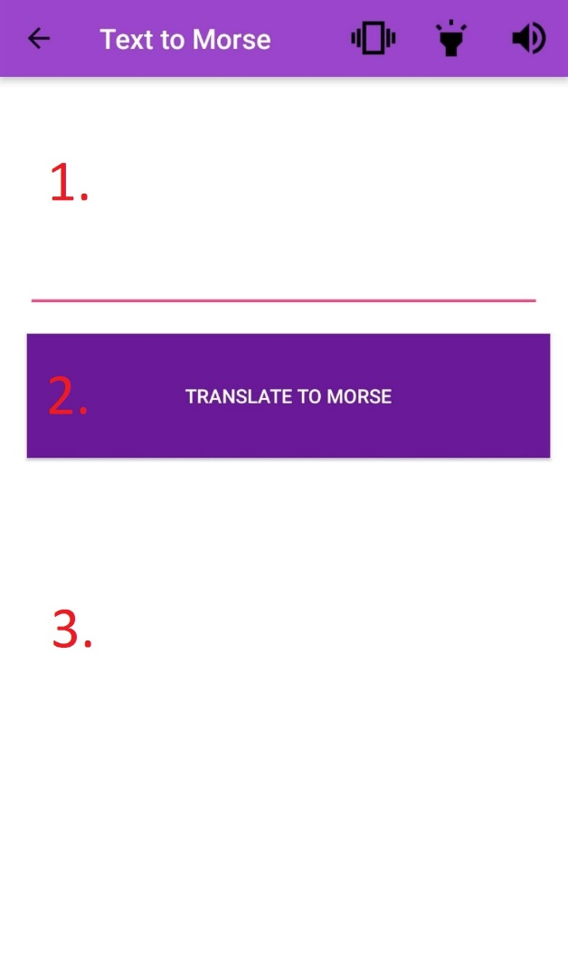1. Input Latin text in the upper text field (1.).

2. Press *convert* (2.).

3. Translation is outputted in form of Morse code in lower text field (3.).

**6.1.1. Playback.**

After the text is translated to Morse code, you can play it back using one of the 3 features: flashlight, vibrations or sound.

**6.1.2. Playback using flashlight**

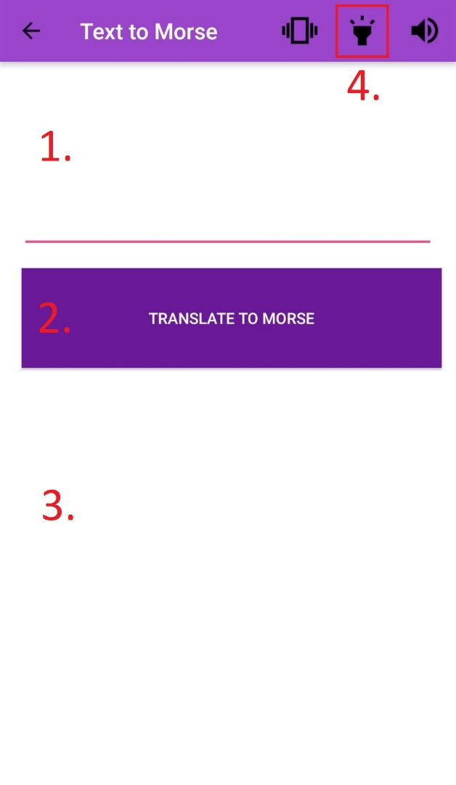

After translation has been done, press the button (4.) to initiate playback using flashlight.

**6.1.3. Playback using sound.**

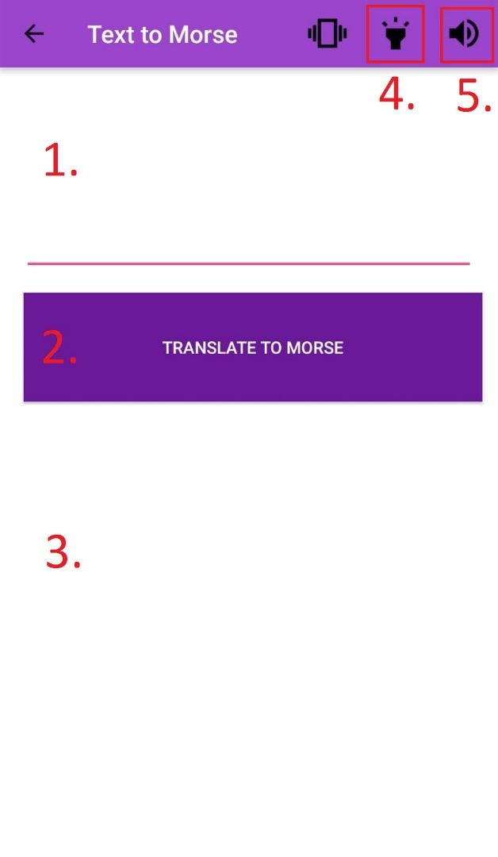

After translation has been done, press the button (5.) to initiate playback using sound.

**6.1.4. Playback using vibrations.**

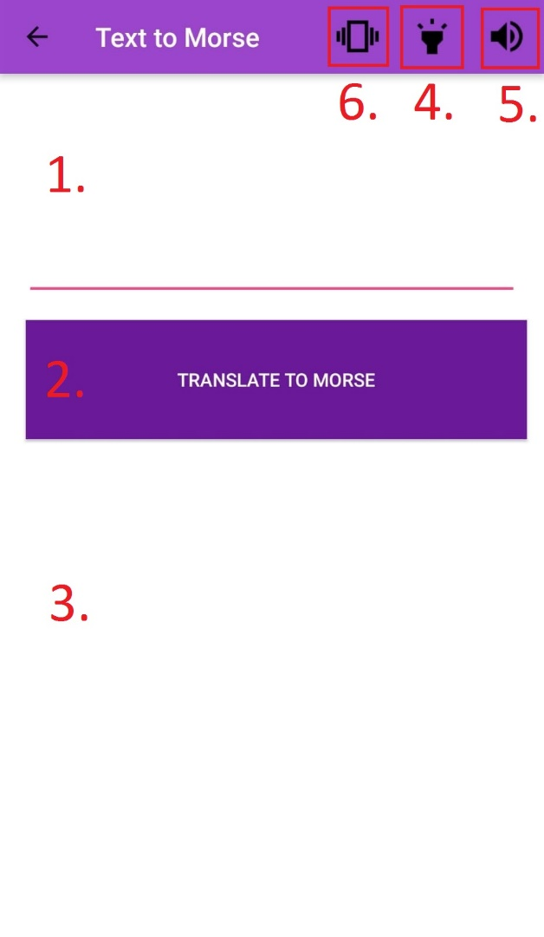

After translation has been done, press the button (6.) to initiate playback using vibrations.

**6.2. Translation from Morse code to Latin text.**

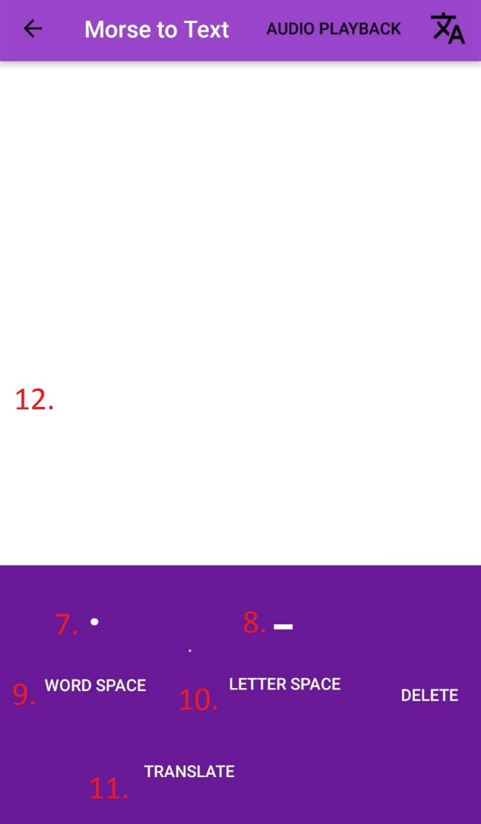

1. Use on screen buttons to input Morse code.

2. Dot button (7.) to input a dot, dash button (8.) to input a dash, letter space button (9.) to specify where letters end and word space button(10.) to specify where words end.

3. Click convert button (11.) which translates Morse code to Latin text.

4. Latin text is outputted in text field (12.).

**7. Troubleshooting and contacts.**

*Useless Solutions* **do not** offer tech support or any other kind of support. We do not expect bug reports or user feedback. *Morse code app* won’t get continuous support or updates and won’t be published on *Google Play* store. If you really have to contact us, do it via *GitHub* using the repository link provided in this document.