Prompt:
Create a website with a Python-based backend that simulates the evolutionary dynamics of strategies in the Prisoner’s Dilemma.
Main Objective:
Simulate how different Prisoner’s Dilemma strategies evolve over time under explicit evolutionary rules, based on population size, strategy set, payoff matrix, and selection dynamics.
This project involves large-scale numerical simulation. Use NumPy and vectorized operations wherever possible to improve efficiency. All code must be clearly annotated using docstrings, type hints, and concise inline comments.

Backend Specification
1. User Inputs
- Initial population size $N_{0}$
- Available strategies (chosen from):
  - Always Cooperate
  - Always Defect
  - Prober
  - Grudge
  - Tit-for-Tat
  - Random
- Initial proportion of each strategy (must sum to 1)
- Prisoner’s Dilemma payoff matrix (2×2, same for all players)
- Total number of generations $G$
- Recording interval $T$(record data every $T$generations)
- Number of rounds per encounter $R$
- Selection rule: bottom $Y\%$of players (by total score) are eliminated each generation
- Mutation rate $Z$: probability per offspring of mutating to a different random strategy
2. Population and Evolution Rules
- Each generation proceeds as follows:
  - Pairing:
Players are randomly matched into disjoint pairs (random matching without replacement). Each player participates in exactly one encounter per generation.
  - Interaction:
Each pair plays $R$consecutive rounds of the Prisoner’s Dilemma.
Players retain memory only within the same encounter (i.e., per opponent). Memory is reset for the next generation.
  - Scoring:
Scores are accumulated across all rounds of the encounter using the payoff matrix.
  - Selection:
Players are ranked by total score.
The bottom $Y\%$are removed from the population.
  - Reproduction:
Each surviving player produces exactly one offspring.
Offspring inherit the parent’s strategy, with probability $Z$of mutating to a uniformly random different strategy.
- Population size is therefore dynamic and determined endogenously by survival and reproduction.
3. Strategy Definitions (Algorithmically Precise)
- Always Cooperate: Always plays Cooperate.
- Always Defect: Always plays Defect.
- Tit-for-Tat:
Cooperates in the first round; thereafter copies the opponent’s previous move.
- Grudge:
Cooperates until the opponent defects once; thereafter always defects for the remainder of the encounter.
- Prober:
Cooperate for a random number of times between R-1 and 1, defect, then repeat the cycle.
- Random:
Cooperates or defects with equal probability each round, independently.
4. Data Recording
- At every $T$generations, record:
  - Total population size
  - Proportion of each strategy

Frontend Specification
Layout:
- Left panel: all user input controls
- Bottom panel: terminal output displaying exact recorded proportions
- Right panel: documentation area (left blank)
- Center panel: visualization area with two switchable modes
Mode 1 (Statistical View):
- 2D stacked area/line plot:
  - x-axis: generation
  - y-axis: population size
  - color: strategy
- Bar chart:
  - x-axis: strategy
  - y-axis: proportion at current generation
Mode 2 (Agent-Based Animation):
- Players represented as colored dots
- Dots arranged on a large circle at “night” (every 2 seconds)
- During “day,” paired players move inward and interact (0.5 seconds per encounter)
- Each player participates in exactly one interaction per day
- Colors correspond to strategies
- Legend displayed in the bottom-right corner
Design Constraints:
- Dark theme: black, deep grey, navy
- High-contrast text and highlights (white or lime)

Picture:
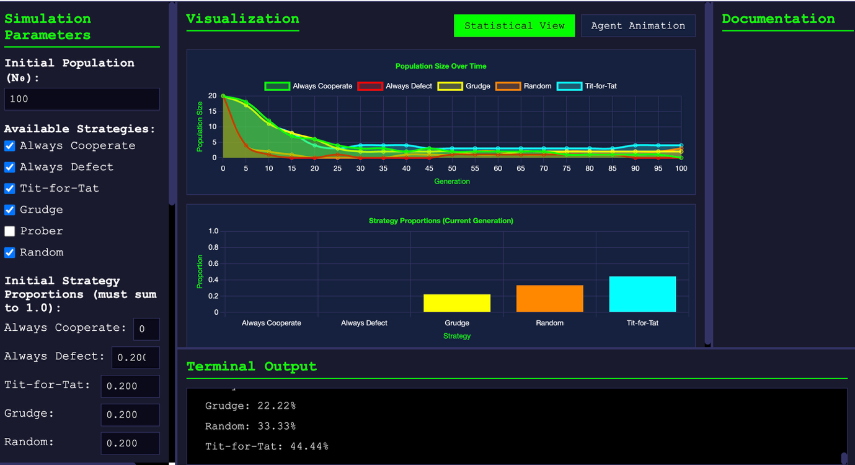

Prompt:
Fix these bugs:
1. There should be an input box for the "total_rounds" attribute of "Prober". Currently it has no source of input.
2. The input spaces after each strategy in "Initial Strategy Proportions" should have equal length, enough to allow at least 3 decimal spaces to be written without scrolling.
3. The input spaces after "Always Cooperate", "Always Defect", "Tit for Tat", "Grudge" and "Prober" in "Initial Strategy Proportions" should have a default value of 0.2, while "Random" has a default value of 0.
Image:
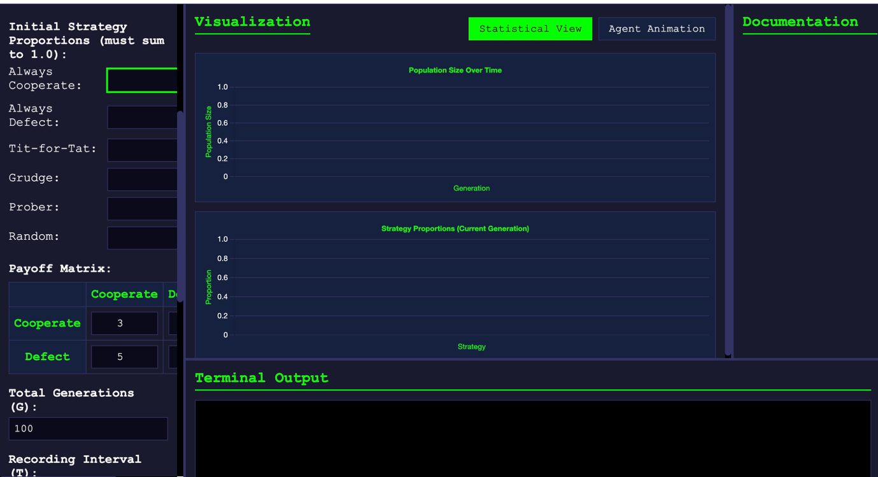

Input:
The input spaces after "Always Cooperate", "Always Defect", "Tit for Tat", "Grudge" and "Prober" in "Initial Strategy Proportions" should have a default value of 0.2, while "Random" has a default value of 0. Currently there is no default value and the spaces are too long and don't allow for typing decimal places.
The system shows "Error: 'Prober' object has no attribute 'total_rounds'" despite the fact that there is an input box for the attribute.

Image:
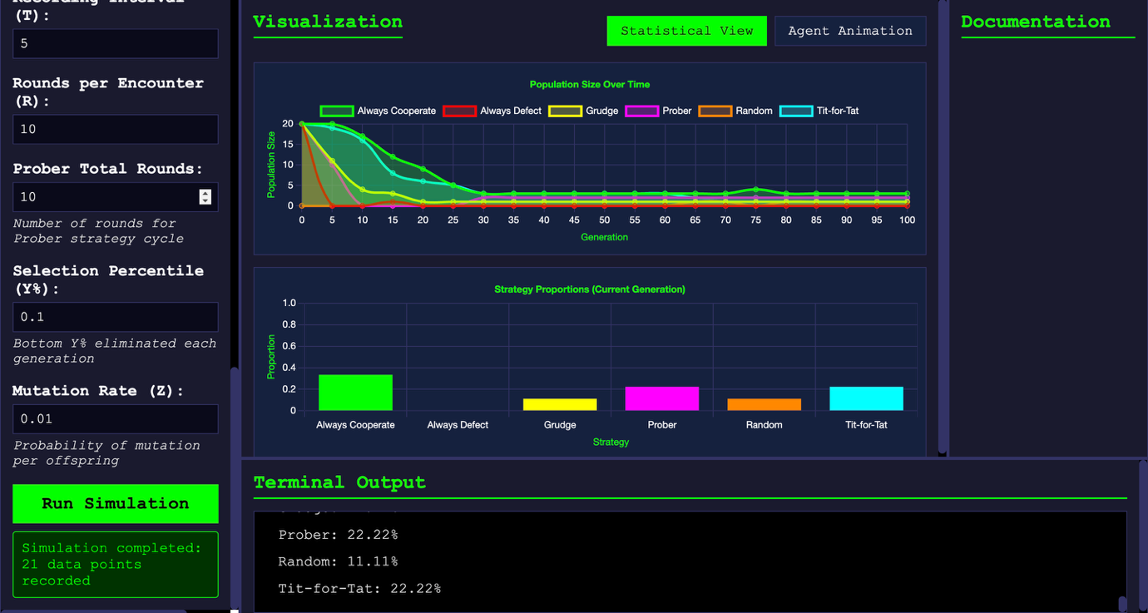

Prompt:
Cancel “Agent Animation”

Image:
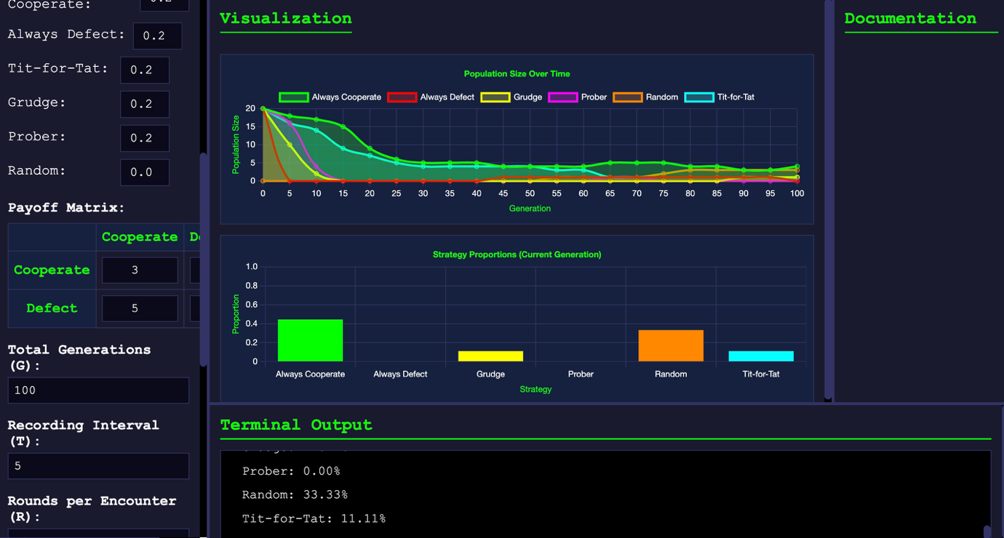
Prompt:
1. Add a population cap of 300 players. When the total exceeds 300, the top 300 players are chosen based on their total scores.
2. Error: Failed to fetch after setting the offspring_per_survivor to 2

Image:
