stSMTP

smtp4dev

One of the best ways to learn about SMTP is to run a real server-server interaction. In order to do this we need an SMTP server that we can connect to. "smtp4dev" [http://smtp4dev.codeplex.com/] is a Windows 7/Vista/XP/2003/2010 compatible dummy SMTP server. It sits in the system tray and does not deliver the received messages. Instead, the received messages can be quickly viewed, saved and the source/structure inspected. This is very useful for testing/debugging software that generates email and exploring the SMTP protocol.

- https://smtp4dev.codeplex.com/downloads/get/269148
- Run the smtpdev.exe executable.
- Tick all the boxes and click 'Allow Access' if prompted.
- You now have an SMTP server running on your local machine listening for connections.

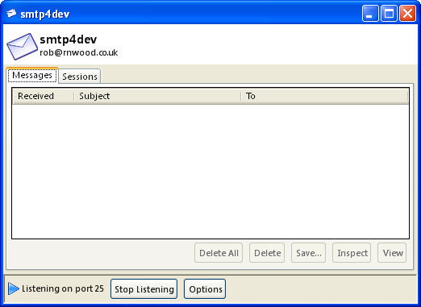
Figure 1: The smtp4dev program running.

Telnet

Telnet is a network protocol that facilitates bi-directional interactive text communication using a virtual terminal (or command line) connection. Telnet client applications allow a user to connect to a network host and run commands on that host (similar to the way you used PuTTY to run commands on a Linux server in CAOS last year).

We will use PuTTY as a telnet client, it is available at https://www.chiark.greenend.org.uk/~sgtatham/putty/latest.html. The advantage of using PuTTY is that the backspace key will work correctly.

Telnet to an SMTP server

The smtp4dev program is an SMTP server that listens for connections on TCP port 25. To establish a connection to this server

- Run PuTTY
- Select the Telnet under the left hand ‘Categories’ pane
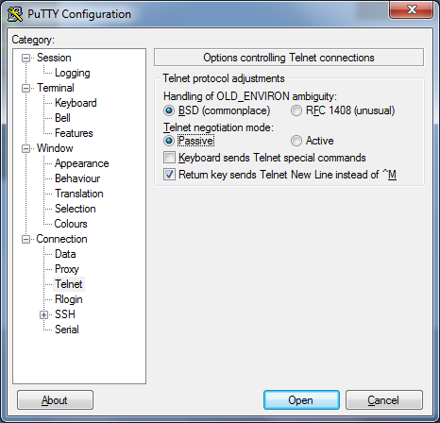
- Ensure Passive is selected here.
- Select Session under the left hand ‘Categories’ pane
- Enter the following details and click open:
  - Hostname: localhost
  - Port: 25
  - Connection type: Telnet

This will open a telnet connection to your local machine on port 25. You can then enter commands and view responses at the interactive telnet terminal.

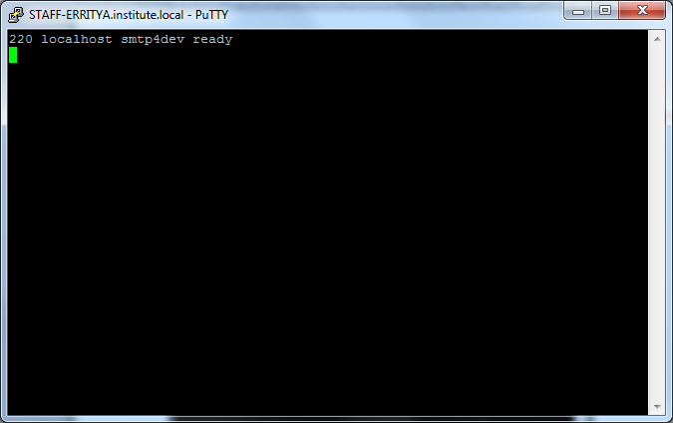
Figure 2: Telnet session with SMTP server awaiting commands.

Recreate the SMTP example from slide 8 of the lecture notes by entering the commands IN RED below. Note: you do not need to type the C: this indicates is the commands are sent from the client, the S: indicates the server’s responses.

S: 220 hamburger.edu
C: HELO crepes.fr
S: 250 Hello crepes.fr, pleased to meet you
C: MAIL FROM: <alice@crepes.fr>
S: 250 alice@crepes.fr... Sender ok
C: RCPT TO: <bob@hamburger.edu>
S: 250 bob@hamburger.edu ... Recipient ok
C: DATA
S: 354 Enter mail, end with "." on a line by itself
C: Do you like ketchup?
C: How about pickles?
C: .
S: 250 Message accepted for delivery
C: QUIT
S: 221 hamburger.edu closing connection

The response codes from the smtp4dev server should match those above, the text descriptions returned by smtp4dev may differ slightly from those above as these text descriptions are optional and differ from server to server.

The above will send an email from alice@crepes.fr to bob@hamburger.edu containing the text:
Do you like ketchup?
How about pickles?

This email should now be visible in smtp4dev:
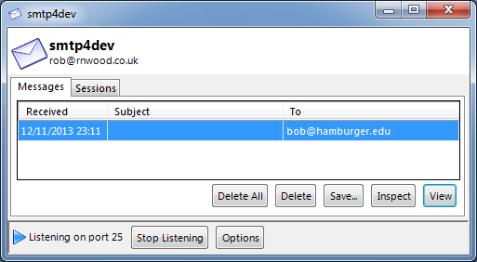
Figure 3: An email received by smtp4dev.

You can click the inspect button to view more details of the email received. Clicking view will open the email in a local mail client (i.e. user agent) if installed.

Now try the following:
- Open a telnet connection to the local smtp server as shown above.
- Enter the commands required to send an email from john@smith.com to joe@bloggs.com containing the text:

Hi Joe,
Can you meet at 5pm?
Regards,
John

If you want a subject for your email, after sending the DATA command type Subject: YOUR SUBJECT LINE then press enter twice, and then enter the content of your message.

Now try the following:
- Open a telnet connection to the local smtp server as shown above.
- Enter the commands required to send an email from joe@bloggs.com to john@smith.com containing the subject line:

Meeting

And the text:

Hi John,
Sure, see you then.
Regards,
Joe

Note: If you want to send multiple mails in one session, you should repeat the ‘RCPT TO:' and 'DATA' commands for each email. There is no need for 'HELO' and 'MAIL FROM:', because the server already knows who you are.

Analyse the communication using Wireshark!

Telnet to an SMTP server on another host

You can connect to an SMTP server, i.e. smpt4dev, running on another host, e.g. another student's PC, by running changing the hostname in PuTTY to the IP address of another student's PC, e.g. 172.18.15.4.

Telnet to the PC of the student nearest you and send them an email using the SMTP procedure described above.

Remember: You can find your IP address by running ipconfig in a command window.

This may not work if college has blocked Telnet!

